MARKING SCHEME PHYSICS PAPER 232/1
ARISE AND SHINE TRIAL EXAM
AUGUST/SEPTEMBER - 2022
SECTION A
- + 0.01mm✔
- P = ₰gh✔
= 1.25 x 10 x 2500
= 31250

31250 = 13600 x 10 x h✔
h = $\frac{31250}{136000}$
h = 0.229779m
= 229.779mm✔

Barometric height = 760 – 229.779
= 530.221mmHg✔
- ✔
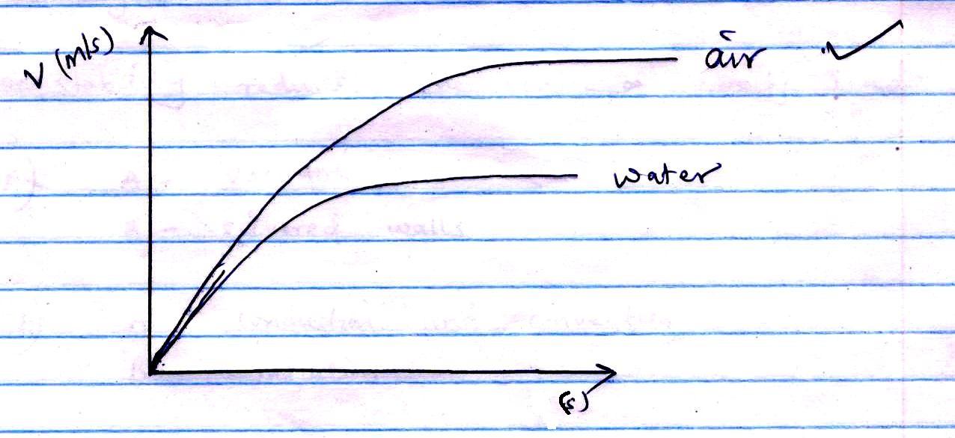
- ✔
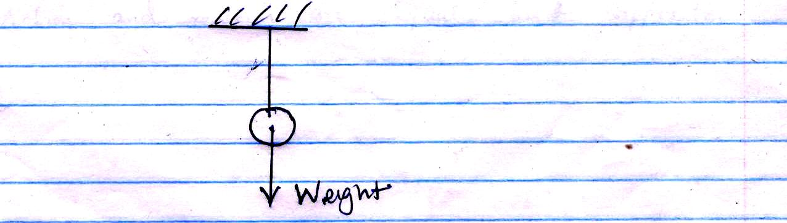

- ✔ (a) Vacuum/freefall
(b) v² = u² + 2gs ✔
V² = O + 2 x 10 x 20
V² = 400
V = 20 m/s✔
- ✔The angle subtended at the centre of a circular path by an arc length equal to the radius of the path.
- ✔No constriction,✔ the thermometric✔ liquid flows back while taking reading.
- ✔The glass block is fully submerged, no further increase✔ in upthrust /maximum upthrust attained.
- ✔Thermodynamics.
- ✔Stability reduces,✔ the centre of gravity rises. ✔
- ✔ (a) A – vacuum
B – silvered walls
(b) A – conduction and convection
B - radiation
- ✔ (a) Action and reaction are equal but opposite
✔ (b) v² = u² + 2as
O = 20² + 2a x 15
O = 400 + 30a
a = $\frac{-400}{30}$
a = -13.33ms⁻²
F = m a ✔
= 900 x -13.33
= 12000N

SECTION B
- ✔ (a) i) P.E = Mgh
= 20x10x0.9 ✔
= 180J ✔
✔ii) ½mv² = E
½ x 20v² = 180 ✔
V² = 18
V = 4.243 m/s
(b) i) w = mgh ✔
= 2000 x 10 x 3
= 60000 J ✔
✔ii) p = $\frac{w}{t}$
= $\frac{60000}{6}$ ✔
10000w or 10kw✔
✔iii) ŋ = $\frac{P output}{P input}$ x 100% ✔
= $\frac{10}{12.5}$ x 100% ✔
= 80% ✔
- ✔ (a) Tension reduces, ✔ upthrust increases ✔
(b) i) w = mg
= 0.5 x 10
= 5N ✔
ii) U = ₰Ug ✔
= 8.0 x 10⁴ x 1000 x 10 ✔
= 8N ✔
iii) T = U – w
= 8 – 5 ✔
= 3 N ✔

(c) ✔ R.d = $\frac{U in liquid}{U in water}$
$\frac{5-4}{5-3}$ ✔
= 0.5
ℓ liquid = 0.5 x 1gcm⁻³
= 0.5gcm⁻³
- ✔ (a) Quantity of heat required to change or raise the temperature of any given mass of a substance by 1⁰C or 1K.
(b) (i) Q = MCΔɵ ✔
= 0.215 x 400 x 9 ✔
= 774J ✔
(ii) Q = MCΔɵ ✔
= 0.1 x 4200 x 9 ✔
= 3780J ✔
(iii) ✔Heat lost by metal block = Heat gained by water + calorimeter
MCΔɵ = MCΔɵ + MCΔɵ ✔
15 x C(100 – 34) = 774 + 3780 ✔
9.9C = 4554
C = 460Jkg⁻¹k⁻¹
✔ (c) pt = MCΔɵ
5 x 8 x 60 = 0.5 x 460Δɵ
Δɵ = $\frac{40 x 60}{0.5 x 460}$
= 10.43⁰

- ✔ (a) Constant change in velocity✔
(b) I
- F = $\frac{{mv}^{2}}{r}✔$1 ✔
= $\frac{{0.3 x 40}^{2}}{0.5}$
= 960N ✔
- $\frac{v_{1}}{r_{1}}$ = $\frac{v_{2}}{r_{2}}$ ✔
$\frac{40}{0.5}$ = $\frac{v_{2}}{1.2}$✔✔
V₂ = $\frac{1.2 x 40}{0.5}$
= 96m/s ✔
✔ II (i) B
(ii) It requires greater centripetal force to maintain because of a longer radius.

- ✔ (a) (i) They are being bombarded by invisible air particle which are in constant random motion.
(ii)
- To maintain temperature
- P₁V₁ = P₂V₂ ✔
2 x 10⁻⁵ x 80 = P₂ x 25 ✔
P₂ = 6.4 x 10⁵Nm⁻² ✔
$✔$(b) A gas that obeys gas laws perfectly.
(c) (I) K = slope
K = $\frac{ΔP}{Δ\frac{1}{v}}$
= $\frac{4.0 x {10}^{5}-0✔ }{4.85 x {10}^{6}-0 ✔ }$

= 0.0823NmoJ ✔

(II) Energy / work done

