Term 1 - 2023
PHYSICS PAPER 1
MARKING SCHEME
FORM THREE

SECTION A (25 MARKS)

- The figure 1 shows a measuring cylinder which contains water initially at level A. A solid mass 11g and density 1.571g/cm³ is immersed in the water. The level rises to B.
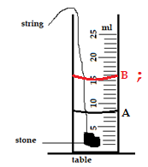
Figure 1
$Volume=\frac{11}{1.571}=7.002{cm}^{3}$ ;
New level = 8 + 7.002 = 15.002cm³ ;

On the same diagram, indicate the level, B (carefully show your working) (3 marks)

- Name two types of forces which can act between objects without contact. (2 marks)
- Gravitational force ;
- Magnetic force ;
- Electrostatic force
(any first two correct)

- Figure 2 shows a beaker placed on a bench. A block of ice is placed in the beaker as shown. State and explain the change in the stability of the beaker when the ice melts. (2 marks)
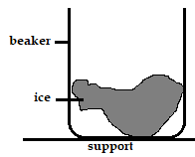
More stable; ice melts and water formed occupies the bottom of beaker hence lowering the position of the centre of gravity;
Figure 2
- Give a reason why water is not a suitable liquid for use in a barometer (1 mark)
Water has longer barometric height due to it lower density;

- An astronaut is on the moon. He drops a hammer from a height of 3.2m and it takes 2.0s to hit the lunar landscape. What is the acceleration due to gravity of the moon? (3 marks)
$s=\frac{1}{2}gt^{2};$

$3.2=\frac{1}{2}×g×4;$

$g=1.6ms^{-2}$;

- Give a reason why a concrete beam reinforced with steel does not crack when subjected to changes in temperature. (1 mark)
The both concrete and steel have similar linear expansivity;

- Liquids expand more than solids. Explain (1 mark)
Liquids have larger intermolecular distance than solids;

- The Screw of micrometer screw gauge has a pitch of 0.5mm. The thimble is divided into 50 equal divisions. What is the smallest unit it can measure? (2 marks)

$accuracy=\frac{0.5}{50};=0.01mm$;

- It is easier to bend an iron rod than a glass rod of the same dimensions at room temperature. Give a reason for this (1 mark)
Iron is ductile while glass rod is brittle;

- A pupil blows a current of air over the surface of a sheet of paper held close to its mouth. State and explain what happens to the paper. (2 marks)
Paper rises; moving air reduces pressure above the paper. Higher atmospheric from below provides the force which pushes the paper upwards;

- Sketch a velocity- time graph showing the motion of a ball vertically upwards with an initial velocity of u. (2 marks)

V, m/s

U
;;

0
Time, s

- The figure shows a speed-time graph for part of the journey of a motorcar
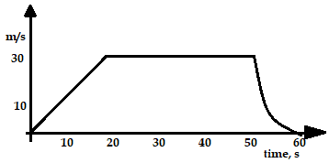
Figure 3
Determine the distance the car travels in the first 40 seconds (3 marks)
Distance = area under the graph;
$s=\frac{1}{2}×\left(20×30\right)+\left(20×30\right)=\left(300+600\right);=900m;$

- In a vacuum flask the walls enclosing the vacuum are silvered on the inside. State the reason for this (2 marks)
Minimize heat loss by radiation; silvered surface reflects away the heat back to the flask contents;

SECTION B (55 MARKS)

- Figure 4 shows a cylindrical can filled with a liquid of density 0.8 gcm⁻³. A hole of diameter 2.0 cm is drilled at a depth of 2.8 m from the top of the can.
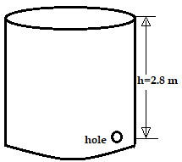
Figure 4
- Determine:
- The cross-sectional area of the hole. (2mks)
A = πr²
= 3.142 1
= 3.142 x 10⁻⁴ m²1

- The maximum pressure exerted by the liquid at the hole. (2mks)
p = hρg1
= 2.8 x 0.8 x 1000 x 10
= 2.24 x 10⁴ Pa1
- The maximum force exerted on a jet of liquid through the hole. (2mks)
F = P x A1
= 2.24 x 10⁴ x 3.142 x 10⁻ ⁴
= 7.0381N1

- State the principle of moments (1mk)
When a body is in equilibrium, the sum of clockwise moments about a point is equal to the sum of anticlockwise moments about the same point
- A metre-rule whose centre of gravity is at the 50cm mark balances at the 35cm mark when a mass of 500g is placed at the 25cm mark as shown in the figure 5 below.

Figure 5
Determine:
- The mass of the meter-rule (3 marks)
Sum of anticlockwise moments = sum of clockwise moments
- With the metre-rule remaining on the knife-edge at the 30 cm mark, a mass of 125g is suspended from the 70 cm mark. The mass of 500g is moved until the rule is balanced. Determine the new position of the 500g mass (3 marks)

0.15m or new position is at the 10 cm mark

- The diagram below (not drawn to scale) shows part of the motion of a tennis ball, which is projected vertically upwards from the ground and allowed to bounce on the ground. Use this information to answer questions that follow.
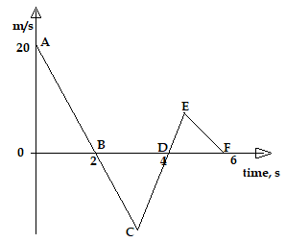
Figure 6
- Describe the motion of the ball relating it to different positions of the ball along the following AB, BC, CD. (3 marks)
- AB
The ball rises with decreasing velocity and reaches maximum height at point B

BC
The ball falls from maximum height with increasing velocity;

CD
The ball bounces back into the air and rises with decreasing velocity;

- From the graph, calculate the acceleration due to gravity. (2 marks)
$g=gradient=\frac{20-0}{2-0};=\frac{10m}{s^{2}};$

- Explain why E is not at the same level as A. (1 mark)
The ball loses some energy on impact with the ground;
- An object dropped from a height h attains a velocity of 6m/s just before hitting the ground, find the value of h. (3 marks)
$V^{2}=U^{2}+2gs;≡36=0+2\left(10\right)\left(h\right);$
$h=\frac{36}{20}=1.8m$ ;
- A helicopter, which was ascending vertically at a steady velocity of 20m/s, released a parcel that took 20 second to reach the ground. State and explain the direction in which the parcel moved immediately it was released. (1 mark)
Upwards; due to inertia;
- An airplane is flying horizontally over a camp at 250m/s and drops a pack. How far from the camp will the pack land if the plane was flying 300m above the ground? (3 marks)
$t=\sqrt{\frac{2h}{g}}=\sqrt{\frac{600}{10}}=7.745seconds$;

Range = ut = $250×7.745;=1936.25 m;$

- Define the following terms:
- Momentum (1 mark)
Product of mass and velocity;

- Terminal velocity (1 mark)
Constant velocity attained by a body falling through a fluid when the sum of viscous drag and upthrust is equal to it’s weight;
- A body is initially in motion. If no external force acts on the body, describe the subsequent motion. (1 mark)
The body continue with the same motion in a straight line
- A force of 6N acts on a 2kg trolley and accelerates at 2 m/s². Calculate the retarding force acting on the trolley. (3 marks)

$\left(F-F_{r}\right)=ma;≡6-F_{r}=(2×2$;)

$F_{r}=\left(6-4\right)=2N$;
- A car of mass 800kg starts from the rest and accelerates at 1.2ms⁻². Determine its momentum after it has moved 400m from the starting point. (3 marks)
$V^{2}=U^{2}+2as$
$V^{2}=0^{2}+2(1.2)(400)$
$V=30.98m/s$;
Momentum, P = mV$≡P=800×30.98;=24784kgm/s;$

- The diagram shows a tall measuring cylinder containing a viscous liquid. A very small steel ball is released from rest at the surface of the liquid as shown.
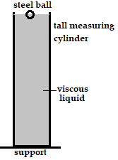
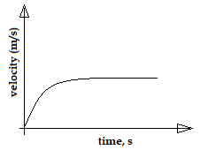
;
Figure 7
- On the space alongside the diagram, sketch the velocity- time graph for the motion of the ball from the time it is released to the time just before it reaches the bottom of the cylinder. (1 mark)
- Name all the forces acting on the ball when it is mid-way through the tall measuring cylinder (3 marks)
- Upthrust ;
- Viscous drag ;
- Weight ;

- The figure 7 below shows a tube of varying cross-section area. V₁, V_{2,} V₃ and V₄ represent the speeds of water as it flows steadily through the section of the tube.
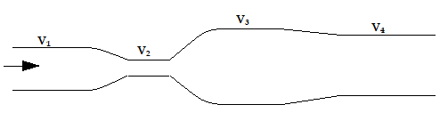
Figure 8
- Arrange the speeds V₁, V_{2,} V₃ and V₄ in decreasing order starting with the highest
(1 mark)
V₂, V₁, V₄, V₃

- Figure 9 shows two identical inflated balloons hanging vertically on light threads. When a stream of air is blown in the space between the balloons, they are observed to move towards each other. Explain this observation. (2 mark)
Pressure between the balloons reduces below atmospheric pressure; the pressure difference causes a force which pushes the balloons towards each other;
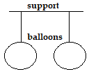
Figure 9

- The figure below is an illustration of a Bunsen burner. Explain how air is drawn into the burner when the gas tap is opened (3 marks)
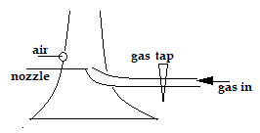
Stream of fast moving air at the nozzle reduces pressure above the nozzle; the higher atmospheric pressure forces air to be sucked into the barrel;

Figure 10

- State Hookes’ law (1 mark)
For an elastic material, extension is directly proportional to the applied force provided elastic limit is not exceeded.

- The figure 11 shows a spring balance of spring constant 125N/m. The scale spreads over a distance of 20 cm.
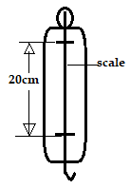
Figure 11
Determine the maximum weight that can be measured using the spring (3 marks)
$F=ke;$
$F=125×0.2;=25N;$

- The figure below shows a liquid being siphoned from one beaker to another.
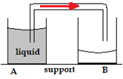
Figure 12

- Indicate on the diagram the direction of flow of the liquid (1 mark)
- State any two conditions necessary for the above machine to operate (2 marks)
- End of tube in A must be below the surface of liquid;
- Tube must be free of air bubbles;
- End of tube in B must be below the level of end of tube in liquid
(Any first two correct points)
- describe the difference between a liquid and gas in-terms of intermolecular distance
(1 mark)
Gases have larger intermolecular distance
State the reason why it is easier to separate water into drops than to separate a solid into smaller pieces (1 mark)
because liquids have weaker intermolecular forces;

- A bottle containing a smelling gas is opened at the front bench of a classroom. State the reason why the gas is detected throughout the room (1 mark)
Diffusion of the gas (gas particles move from the front part of the classroom to the other parts of the classroom)

This is the last printed page

