Term 2 - 2022
PHYSICS (232/2)
FORM FOUR (4)
Time: 2 Hours
Name: …………………………………………………………. Adm No: ……………….
School: ……………………………………………………….. Class: ………………….. Signature: …………………………………………………….. Date: …………………...
Instruction to Candidates
- Write your name, index number in the spaces provided above.
- Sign and write the date of examination in the spaces provided above.
- This paper consists of two sections: A and B.
- Answer all the questions in sections A and B in the spaces provided.
- All working must be clearly shown.
- Silent non-programmable electronic calculators may be used.
- Candidates should answer the questions in English.
For Examiners Use Only
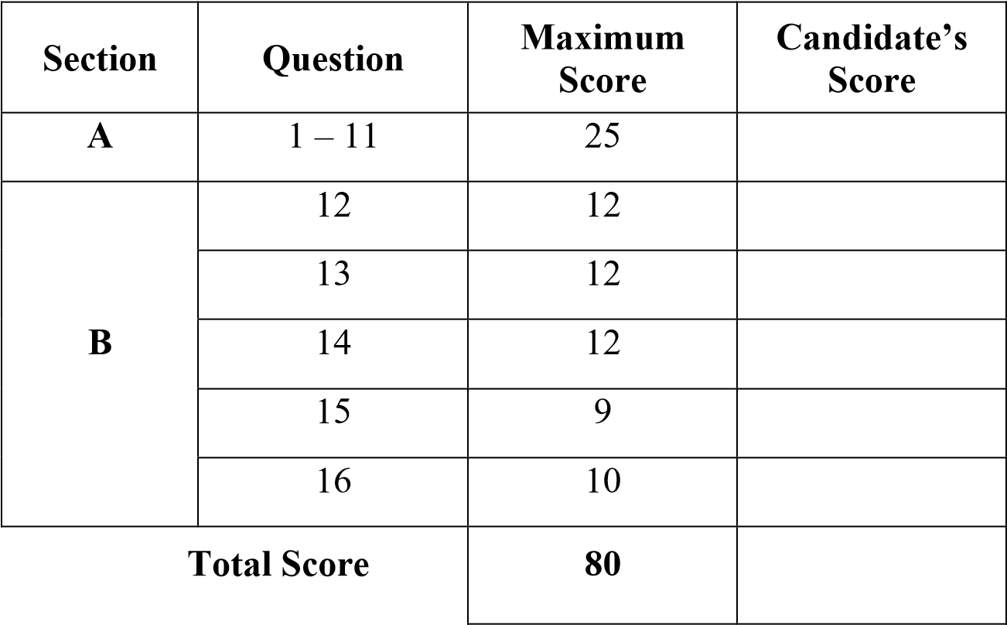
This paper consists of 12 printed pages, candidate should check the questions to ascertain that all pages are printed as indicated and that no questions are missing
SECTION A 25 MARKS
Answer all the questions in the spaces provided.
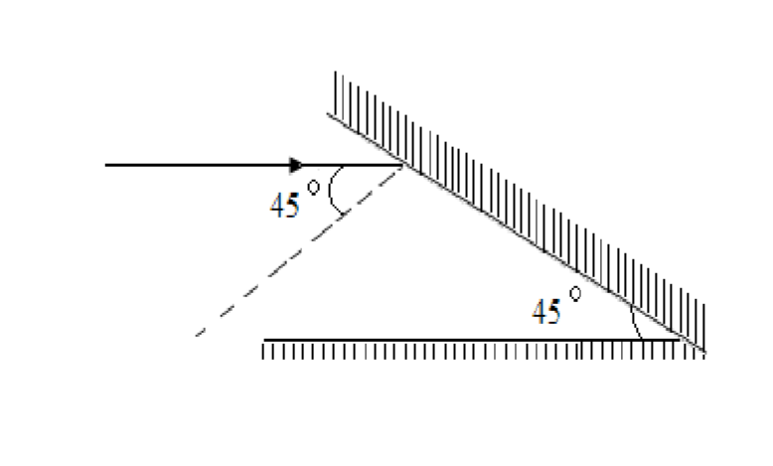
- The figure below shows a ray of light incident on a mirror at an angle of 45º. Another mirror is placed at an angle of 45º to the first one as shown. Sketch the path of the ray until it

emerges. (2 marks )
- State any two ways of reducing the magnetic force of attraction of a magnet (2 marks)
…………………………………………………………………………………………………
………………………………………………………………………………………………… …………………………………………………………………………………………………
- The figure below shows a transverse stationary wave along a string.
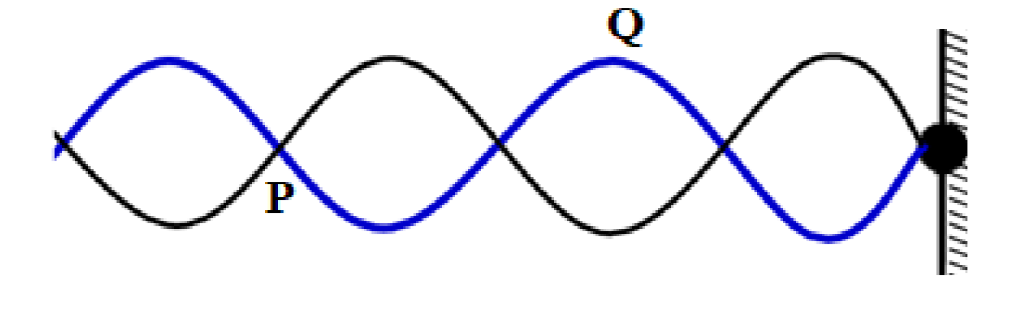
Name P and Q and explain how each is formed.

(3

marks)

…………………………………………………………………………………………………
…………………………………………………………………………………………………
…………………………………………………………………………………………………
- The diagrams below show a positively charged acetate strip and a negatively charged polythene strip freely suspended and isolated.
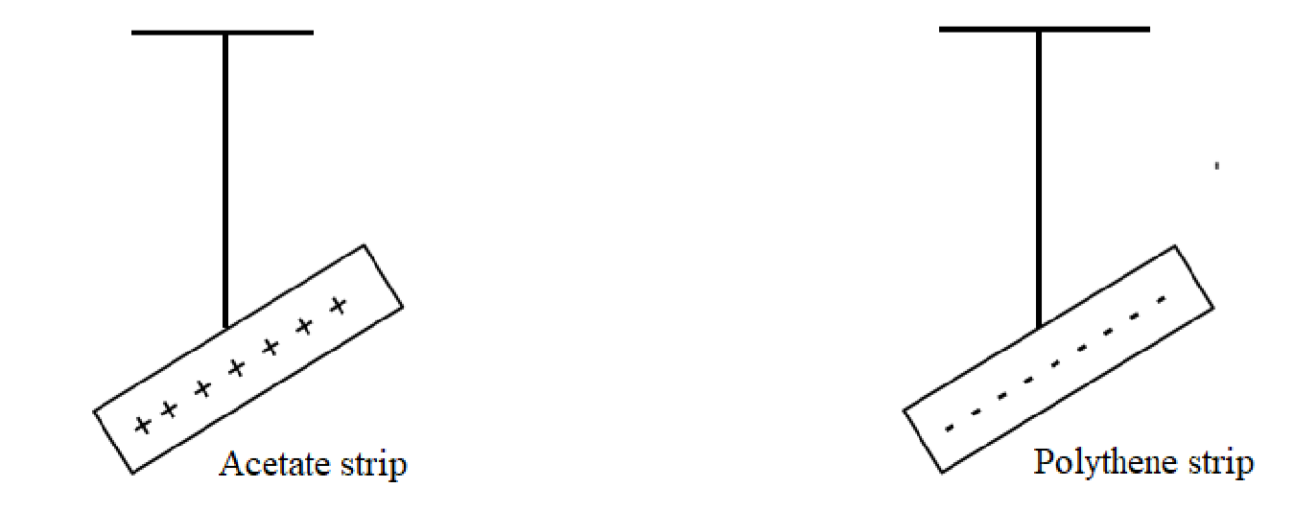
Two rods X and Y are brought up in turn to these strips. X attracts the acetate strip but repels the polythene strip. Rod Y does not repel either the acetate or the polythene. State the type of charge on each rod.
- ............................................................................................................................. (1 mark)
- ............................................................................................................................. (1 mark)
- The diagram below shows waves generated from a tuning fork. If the wave takes 0.1 second to move from point A to B. determine the frequency of the wave. (4 marks)
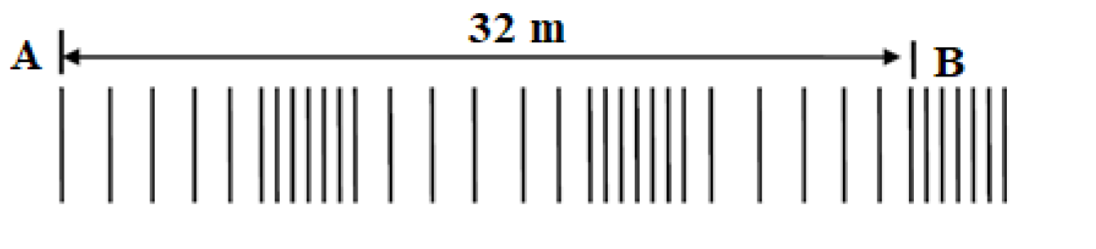
…………………………………………………………………………………………………
…………………………………………………………………………………………………
…………………………………………………………………………………………………
…………………………………………………………………………………………………
…………………………………………………………………………………………………
- Name two detectors of microwave ( 2 marks)
………………………………………………………………………………………………… …………………………………………………………………………………………………
…………………………………………………………………………………………………
- Other than current state two other factors that affect the magnitude of force on a current
carrying conductor placed in a magnetic field. (2 marks)
…………………………………………………………………………………………………
…………………………………………………………………………………………………..
- Give a reason why a concave mirror is not preferred as a driving mirror. ( 1 mark)
………………………………………………………………………………………………
………………………………………………………………………………………………
- A student connected the set up below in the laboratory. Explain the observation made on the bulb when the set-up below is taken to a dark room (2 marks )
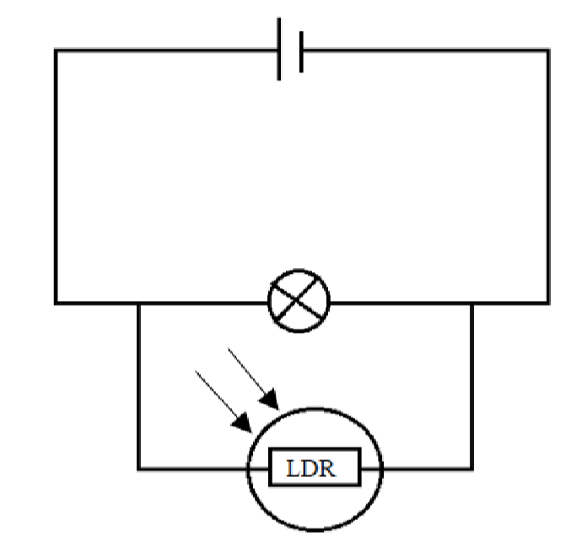
…………………………………………………………………………………………………
………………………………………………………………………………………………… ………………………………………………………………………………………………… ………………………………………………………………………………………………….
- A person standing 110 m from the foot of a cliff claps his hands and hears a sound
0.75 seconds later. Find the speed of sound in air. (3 marks)
………………………………………………………………………………………………… ………………………………………………………………………………………………… …………………………………………………………………………………………………
…………………………………………………………………………………………………
………………………………………………………………………………………………… …………………………………………………………………………………………………
- The figure below is part of electromagnetic spectrum.
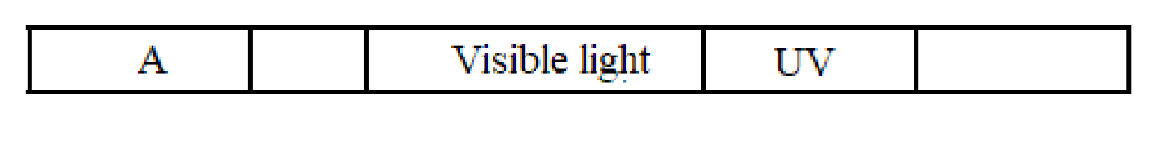
Identify radiation A and state its source. (2 marks)
…………………………………………………………………………………………………
…………………………………………………………………………………………………
………………………………………………………………………………………………… SECTION B 55 MARKS
Answer all the questions in this section in the spaces provided.
- (a) The figure below shows a X-ray tube.
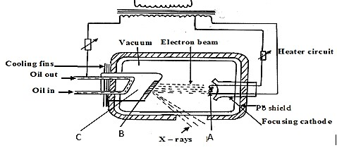
- Name the part labelled C (1 mark)
…………………………………………………………………………………………
- State the property of the material labelled B on the diagram which makes it suitable for use in the X-ray tube. (1 marks) …………………………………………………………………………………………
…………………………………………………………………………………………
- Why is C inclined at an angle of 45º? (1 mark)
…………………………………………………………………………………………
…………………………………………………………………………………………
- State the adjustment that can be made to vary
  - The quality of X-rays (1 mark) ……………………………………………………………………………………
…………………………………………………………………………………….
  - The quantity of the X-rays. (1 mark) ……………………………………………………………………………………
…………………………………………………………………………………….
- An x-ray tube has an accelerating potential of 100KV. Determine the maximum frequency of the x-rays produced.
(Plank’s constant = 6.63 10 ⁻³⁴ Js, e = 1.6 × 10⁻¹⁹C) (3 marks)
…………………………………………………………………………………………
…………………………………………………………………………………………
…………………………………………………………………………………………
…………………………………………………………………………………………
(b) In a CRO, waveform given below was displayed on the screen when the sensitivity at the Y plate was10V/cm and time base set at 20 milliseconds/cm.
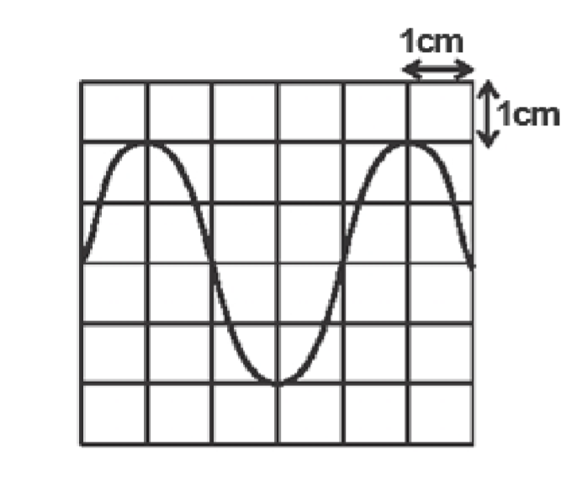
Determine:
- peak voltage (2 marks)
…………………………………………………………………………………………………
…………………………………………………………………………………………………
………………………………………………………………………………………………… …………………………………………………………………………………………………
…………
- frequency of the signal (2 marks)
………………………………………………………………………………………………… ………………………………………………………………………………………………… ………………………………………………………………………………………………… …………………………………………………………………………………………………
…………
13. a) 88226 𝑅𝑎 decays into 86222 𝑅𝑛 by emission of an alpha particle. Write a nuclear
equation for the decay (1 marks)
- i)What do you understand by the term half-life of a radioactive substance? (1 mark)
………………………………………………………………………………………………
……………………………………………………………………………………………… ………………………………………………………………………………………………
………
ii)A G.M tube registers 20 counts. When a radioactive source is brought close to it, it registers 3220 counts and 120 counts 30 hours later. What is the half-life of this substance? (3 marks)
………………………………………………………………………………………………… ………………………………………………………………………………………………… …………………………………………………………………………………………………
………………………………………………………………………………………………… …………………………………………………………………………………………………
- The figure below shows a G.M tube.

Argon gas mixed

with little bromine

Mica window

Anode

Aluminium casing

Scalar or ratemeter

i) What is the purpose of the mica window? (1 mark)
………………………………………………………………………………………………… …………………………………………………………………………………………………
………… ii) Explain the purpose of the bromine (2 mark)
…………………………………………………………………………………………………
………………………………………………………………………………………………… …………………………………………………………………………………………………
………………
- Why should argon gas be kept at low pressure (1 mark)
………………………………………………………………………………………………… …………………………………………………………………………………………………
…………
- What is meant by the term “dead time” as used in GM tube (1 mark)
…………………………………………………………………………………………………
………………………………………………………………………………………………… …………………………………………………………………………………………………
………………
- Briefly explain how GM tube works. (2 marks)
………………………………………………………………………………………………… …………………………………………………………………………………………………
…………………………………………………………………………………………………
…………………………………………………………………………………………………
………………………………………………………………………………………………… …………………………………………………………………………………………………
………………………………
14. (a) State the Ohm's Law (1 mark)
…………………………………………………………………………………………………
………………………………………………………………………………………………… …………………………………………………………………………………………………
………………
(b) You are provided a rheostat, 2 cells, a voltmeter, an ammeter, a switch and a fixed resistor.
- Draw a circuit diagram that can be used to verify Ohm's law. (2 marks)
- Describe how the above set up can be used to determine Ohms law. (4 marks) …………………………………………………………………………………………………
…………………………………………………………………………………………………
…………………………………………………………………………………………………
…………………………………………………………………………………………………
…………………………………………………………………………………………………
………………………………………………………………………………………………… ………………………………………………………………………………………………… …………………………………………………………………………………………………
…………………………………………
(b) Study the circuit diagram below and answer the questions that follow.
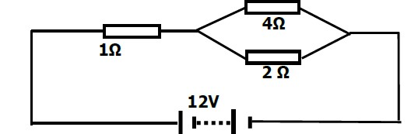
Calculate
- Determine the total resistance in the circuit. (2 marks)
…………………………………………………………………………………………………
………………………………………………………………………………………………… …………………………………………………………………………………………………
………………
- The current through the 4Ω resistor (3 marks)
…………………………………………………………………………………………………
…………………………………………………………………………………………………
…………………………………………………………………………………………………
…………………………………………………………………………………………………
………………………………………………………………………………………………… …………………………………………………………………………………………………
………………………………
15. a) State Snell’s law (1 mark)
…………………………………………………………………………………………………
…………………………………………………………………………………………………
…………………………………………………………………………………………………
………………
- A ray of light travelling from water to glass makes an angle of incident of 30⁰. Find the angle of refraction in the glass. Refractive index of water 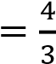. Refractive index of glass
(3 marks)
…………………………………………………………………………………………………
…………………………………………………………………………………………………
…………………………………………………………………………………………………
………………………………………………………………………………………………… …………………………………………………………………………………………………
…………………………
- State the necessary and sufficient conditions for total internal reflection to occur.
(2 marks)
………………………………………………………………………………………………… …………………………………………………………………………………………………
…………
- The figure below shows a human eye defect.
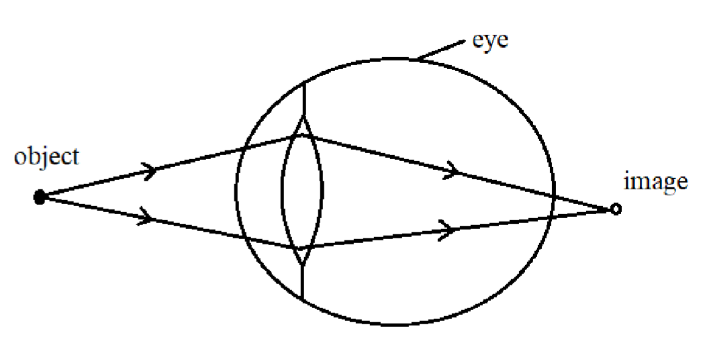
  - State one possible cause of this defect. (1 mark)
……………………………………………………………………………………………
……………………………………………………………………………………………
……………………………………………………………………………………………
  - On the diagram, show how the defect is corrected. (2 mark)
16. (a) State the Lenz’s law of electromagnetic induction. (1 mark)
…………………………………………………………………………………………………
…………………………………………………………………………………………………
…………………………………………………………………………………………………
- A bar magnet is moved into a coil of an insulated copper wire connected to a zero
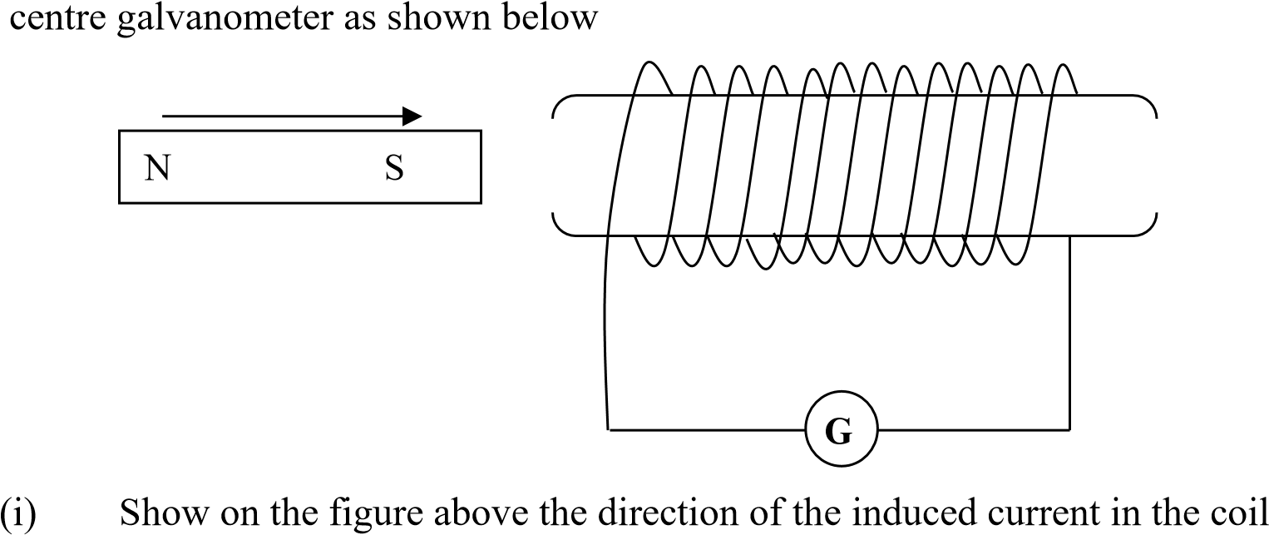
(1 mark)
(ii) State and explain what is observed on the galvanometer when the south pole of the magnet is moved into and then withdrawn from the coil. (2 marks)
………………………………………………………………………………………………… …………………………………………………………………………………………………
…………………………………………………………………………………………………
- A transformer has 800 turns in the primary and 40 turns in the secondary winding. The alternating voltage connected to the primary is 240V and current of 0.5.A. If 10% of the power is dissipated as heat within the transformer, determine the current in the secondary coil.
(3 marks)
…………………………………………………………………………………………………
…………………………………………………………………………………………………
…………………………………………………………………………………………………
…………………………………………………………………………………………………
………………………………………………………………………………………………… (d) The diagram below shows a three-pin plug.
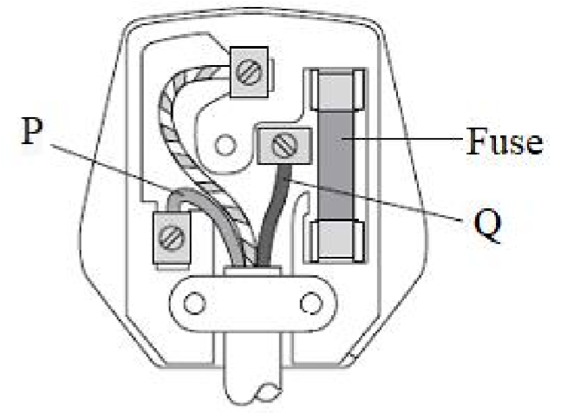
  - Name the colour of conductors P and Q (2 marks)
P…………………………………………………………………………………………… Q……………………………………………………………………………………………
  - Why is the earth pin longer than the rest in the three-pin plug shown above?
(1 mark)
………………………………………………………………………………………………
………………………………………………………………………………………………
………………………………………………………………………………………………
………………………………………………………………………………………………
………………………………………………………………………………………………

