PHYSICS PAPER 2 232/2
PHYSICS FORM 4
MARKING SCHEME

SECTION A (25 MARKS)
Answer ALL the question in this section in the spaces provided
- The figure below represents a point image formed by a mirror.

Sketch rays to show how the image is formed and seen by the eye. (2 mks)
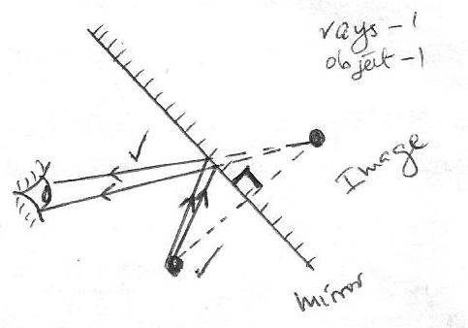

- State any two ways of increasing the size of an image formed by a pinhole camera. (2 mks)
- Moving the object towards the pinhole (Reducing the object distance)
Moving the screen away from the pinhole (increasing the image distance

- A form one student was investigating the brightness of bulbs when set up in circuits. He used identical bulbs and cells.
- State which set up had the brightest bulb (1 marks)

B

- Explain the answer in (i) above. (1mk)

more current was supplied by the batteries to a low resistance circuit.

- A lady holds a large concave mirror of focal length 1.8m from her face. State two characteristics of her image in the mirror (2mks)
Virtual

Magnified
upright

- The figure below shows two parallel thick copper conductors connected to a d.c power supply. A rider made from a thin copper wire is placed on the conductors as shown.
State and explain what is observed on the rider when the switch is closed. (2 mks)
The rider moves to the left.
- The rider experiences a force when placed to a magnetic field according to Fleming’s left hand rule
- The figure below shows how the displacement varies with time for a certain wave.
Displacement (m)
0.2

0.1

0
1.25
0.25
0.50
0.75
1.00
Time (s)
-0.1

-0.2

Determine the frequency of the wave. (3 mks)
$T=0.5 s$
$$f=\frac{1}{0.5}$$

= 2 Hz

- Two pins are hanging from a magnet S shown in diagram below.
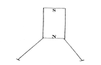
Explain why the nails do not hang vertically downwards. (2mks)
They acquire North Poles at the ends thus they repel.

- Draw diagrams to illustrate what happens when plane waves are incident on a slit. When the width of the slit is large compared with the wavelength of the waves. (2mks)

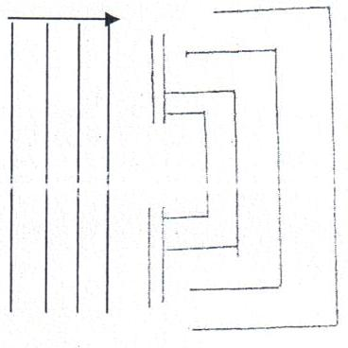

- Determine the reading of the ammeter in figure below. (2mks)
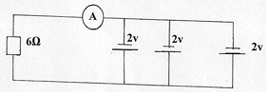
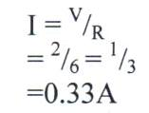
- A ray of light is incident on a glass-oil interface as shown in fig. below. Determine the value of r.
(Take refractive index of glass and oil as ³/₂ and ⁸/₅ respectively) (2mk)
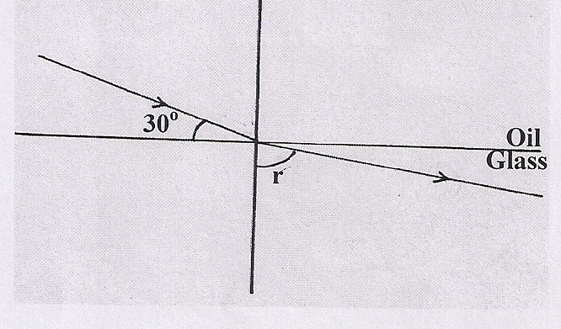
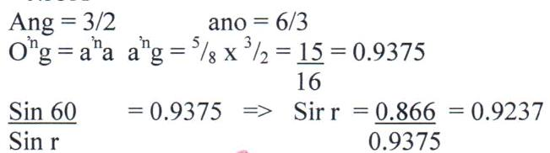

r = 67.47⁰

- Distinguish between hard and soft magnetic materials. (2 marks)
Hard magnetic materials are difficult to magnetize though they retain the magnetism for a longer period. Soft magnetic materials are easily magnetized but don’t keep It for a longer period.

- An electric heater is found to have a resistance of 950Ω when operating normally on 240 V mains. Find the power rating of the heater. (2 marks)
P= V²/R
= 240²/950
=60.63W

…………………………………………………………………………………………………………………………………………………………………………………………………………

SECTION B (55 MARKS)
Answer ALL the questions in this section in the spaces provided
- a) State one difference between light and sound waves (1 mk)

light is an electromagnetic/ transverse wave while sound is a mechanical/longitudinal
wave

- State two factors that affect speed of sound in solid. (2mks)
–temperature
– density
c) Explain how an increase in temperature affects the velocity of sound in air. (2 mks)

- An increase in temperature increases the kinetic energy of the air particles
- This leads to an increase in the speed of sound.

d) The figure below shows a set up made by a Form 2 student to study an aspect of a wave.

Electric bell

Steam from boiling water

Water

- State what happens to the sound from the bell as the bottle and its contents are cooled to 0°C (1 mk)
Sound becomes less audible until it cannot be heard any more.

- Explain the observation in (i) above (2 mks)
Steam condenses, creating a (partial) vacuum in the jar.
Sound, which requires material media for transmission, will not be heard.

- A boy stands some distance from a high wall and claps his hands. He claps again each time he hears an echo.
- What two measurements would need to be made in order to determine the speed of sound? (2mks)
- the distance between the boy and the wall
the time taken to hear the echo

ii) The boy’s friend notes that it takes 10 s to make 10 claps. Determine how far the boy is from the wall, given that the speed of sound in air is 330 m/s. (2 mks)
time for 1 clap = $\frac{10}{10}=1 s$

$$d= \frac{1}{2} ×330 ×1$$

= 165 m

- a) State Ohm’s law. (1 mk)
the amount of current flowing through a conductor is directly proportional to the
potentialdifference across its ends, provided that temperature and other physical
conditions arekept constant.

- You are provided with connecting wires, ammeter, voltmeter, cells in a cell holder, variable resistor, switch and a conductor. With an aid of a diagram, describe an experiment to verify Ohm’s law for a wire. (4 mks)
V

Wire
A
S

Procedure

- Close the switch and adjust the rheostat to obtain the value of current, I and the corresponding value of voltage, V. Record the values in a table.

- Repeat the experiment for other values of I and the corresponding values of V.

- Plot a graph of V against I. The graph should be a straight line through the origin

c) (a) Study the circuit diagram below and answer the questions that follow.
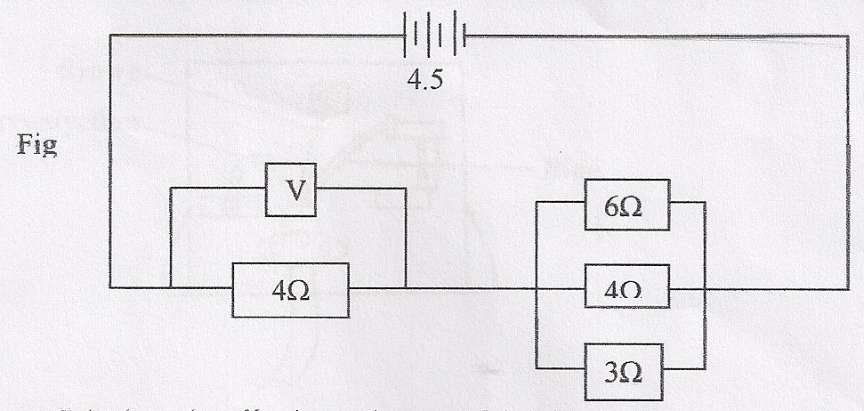
- Calculate the effective resistance of the circuit. (3mks)
Parallel 1 = 1 + 1 + 1
R 6 4 8

1 = 2 + 3 + 4
R 12

1 = 9
R 12

R = 4 = 1¹/₃Ω
R_{t} = 4 + 1¹/₃
= 5¹/₃Ω
- Find the voltmeter reading. (3mks)
V = IR

I = V = 4.5
R 5.33

= 0.844A
V = 4 x 0.844
= 3.377V

(b) c) The graph below shows the variation of potential difference V with current I for a certain cell.
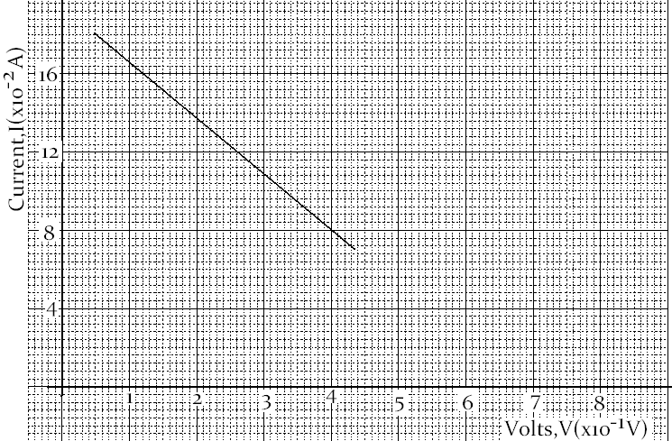
From the graph determine
- The internal resistance of the cell (3 marks)
…$$internal resistance,r=\frac{1}{gradient}=\frac{12-8}{2.6-4}={2.857}^{-1},$$
$$0.35±0.01$$
The e.m.f of the cell (1 mark)

$$e.m.f when I=0 e.m.f=6.8V$$

- a) State two conditions necessary for total internal reflection to occur. (2 mks)
- the angle of incidence in the optically dense medium is greater than the critical angle

- the ray must be travelling from optically dense medium to optically less dense medium

- The figure below shows the part of a ray of yellow light through a glass prism. The
speed of yellow light in the prism is 1.88 x 10⁸ m/s.

- Determine the refractive index of the prism material (Speed of light in air, C = 3.0 x 10⁸ m/s) (2 mks)
n = $\frac{c}{V} = \frac{3.0 × {10}^{3}}{1.88 × {10}^{8}}$

= 1.5957
- Show on the figure the critical angle C, and determine its value. (3 mks)
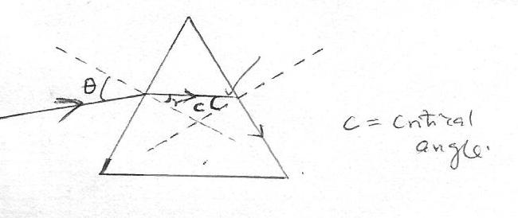

C = critical angle

$$\sin{c}=\frac{1}{n}=\frac{1}{1.5957}$$
c = sin⁻¹$\left(\frac{1}{1.5957}\right)$ = 38.81º

- Given that r = 21.2º, determine angle $θ$. (2 mks)

$\frac{\sin{i}}{\sin{{21.2}^{°}}}$ = 1.5957
$θ$ = sin⁻¹ (1.5957 sin 21.2º) = 35.24°

- The figureshows two rays A and B entering a semi-circular glass block which has a
critical angle of42º. The rays are incident at point O.

- Complete the path of the two rays from point O. Label A¹ and B¹ the corresponding rays. (2 mks)
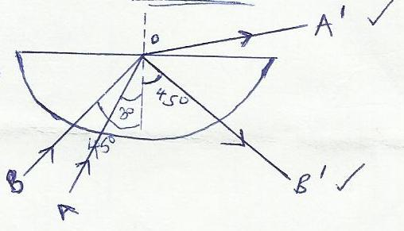

- Calculate the refractive index of the semicircular glass block. (2 mks)

n = $\frac{1}{\sin{{42}^{o}}}$

= 1.4945

- a) define the term eclipse of the moon 1 mark

an eclipse of the moon occurs when the earth comes between the moon and the sun.

b) differentiate between umbra and penumbra shadows. 2marks

umbra is a type shadow that occurs when no light reaches the screen (total darkness)while penumbra is a type of shadow that occurs when some light reaches the screen (partial darkness)
c ) An incident ray forms an angle of 45 degrees with the mirror at point of incidence .If The position of the incident ray is kept constant while the mirror is rotated at an angle of 20 degrees .Find the angle through which the reflected ray is rotated 2 marks

20 x 2
= 40 degrees

d) A tree 25 m high stands, 50 m in front of a pinhole camera whose screen is 30 cm behind the pinhole. What is the height of the image of the tree formed on the screen. 3mks
h_{o} =25 m, u = 50 m, v = 30 m
( h_{o} / h_{i} )= 50 m/ 30 m
h_{i} = 750/50
= 15 m
- a) Define capacitance of a capacitor (1mk)
… aCharge stored per unit volts

b) State two factors that affect the capacitance of a parallel-plate capacitor. (2mks)
… Distance between the plates.
- Area of plates.
- Dielectric material used.

- The figure below shows a voltmeter connected across two charged parallel plates.
When a thin sheet of mica is inserted between the plates, the reading of the voltmeter is observed to reduce. Explain this observation. (2 mks)
- the charges in the plates induces opposite charges at ends of the mica sheet
- the induced charges produce electric field that opposes the electric field due to the plates hence reducing the resultant electric field and since V = $\vec{E}d$, V reduces

- Figure 2 below shows a positive charge near a plate carrying negative charge. Draw the electric field between them. (2mks)

