PHYSICAL AND HEALTH EDUCATION ACTIVITIES - CBC GRADE 4 TERM 1 2023
- Below is 100 and 200metrcs athletic track. Draw the starting and finishing points
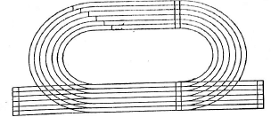
- What is an intercommunity sport .................................................................
- ................................................................. is respect for teammates and rules in games and sports.
- The sport drawn below is a .................................................................
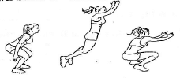
- Write two games that are played by a team.
  - .................................................................
  - .................................................................
- Name four material that can be used to improvise a ball
  - .................................................................
  - .................................................................
  - .................................................................
  - .................................................................
- Below are methods of throwing a ball. Name them
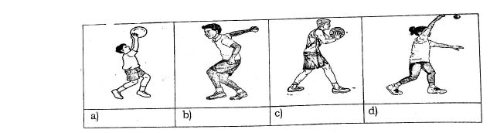
- Name three parts of the foot used to pass a score ball.
  - .................................................................
  - .................................................................
  - .................................................................
- Rounder game is played by how many team .................................................................
- The team that is throwing the ball in a rounder game is called .................................................................
- Name three main items used in a rounder game
  - .................................................................
  - .................................................................
  - .................................................................
- Which parts of the body are involved in the gymnastic roll
  - .................................................................
  - .................................................................
  - .................................................................
- How many players are there in one team of football? .................................................................
- Score ball is made of .................................................................
- Name two parts of the body used to play ball
  - .................................................................
  - .................................................................
- Write two track event in athletics
  - .................................................................
  - .................................................................
- Name three play items in your school
  - .................................................................
  - .................................................................
  - .................................................................

