**BSJE PHYSICS PAPER 2 (232/2) MARKING SCHEME**

**SECTION A**

1. R
2. - The balls will repel

* B will share its net charge with A hence like charges repel

1. It acts as a depolarizer / to help stop gas forming
2. – It is the potential drop in a cell due to internal resistance of the cell
3. T = $\frac{0.5}{2.5}$ = 0.2s

⸫ f = $\frac{1}{T}$ = $\frac{1}{0.2}$ = 5Hz

**I**

**3cm**

**O**

**2cm**

*- the reflected ray passing thro’ F at O*

F

f = 2cm

1. (a) X – Red

Y – Violet

(b) – Wavelength

1. – Hammering disturbs/ loosens the dipoles

* Hence losing their orientation

1. – waves produced are reflected at the fixed points

* Incident and reflected waves interfere constructively at the antinodes
* And destructively at the nodes

1. ***Pattern***

*-at least 3 magnetic field lines*

***Direction***

1. (i) - coiling increases the length hence resistance to increase the heating effect of electric current.

(ii) – high melting point

1. – size of the object

* Distance between the source of light and the object

1. – Amount remaining after 16 days = 190g

⸫ Fraction remaining after 16 days = $\frac{190}{400}$ = $\frac{19}{40}$

**SECTION B**

1. (a) (i) –the meter rule tilts to the side with the magnet

- the iron core is electrically magnetized with the end near the magnet acquiring S-pole

- hence attracts the magnet and metre rule downwards

(ii) – the end of the iron core near the magnet acquires N-pole and repels the magnet making the metre rule to tilt to the side of the suspended weight.

(b) – current through 6Ω resistor = $\frac{V}{R}$ = $\frac{4}{6}$ = 0.6667A

- current through 3Ω resistor = $\frac{V}{R}$ = $\frac{4}{3}$ = 1.3333A

⸫ Total current through 8Ω = 0.6667 + 1.3333 = 2A

Voltage across 8Ω = IR = 2 x 8 = 16V

OR

RParallel = = = 2 Ω

Current flowing in the circuit = $\frac{V}{R}$ = $\frac{4}{2}$ = 2A

Voltage across 8Ω = IR = 2 x 8 = 16V

(c)(i) –distance between the student and the wall

- time taken for the echo to come back to him

(ii) - Speed of sound is calculated as V = $\frac{2 x distance between student and wall}{time taken for the echo to come back}$

(a) (i) f = $\frac{20 + 0.6}{2}$ = 10.3cm

(ii) - Rays from the object pass through the lens and are refracted parallel to the principal axis

- The parallel rays are then reflected back by the mirror to the lens which converge them to a point that coincides with the object.

(b) (i)

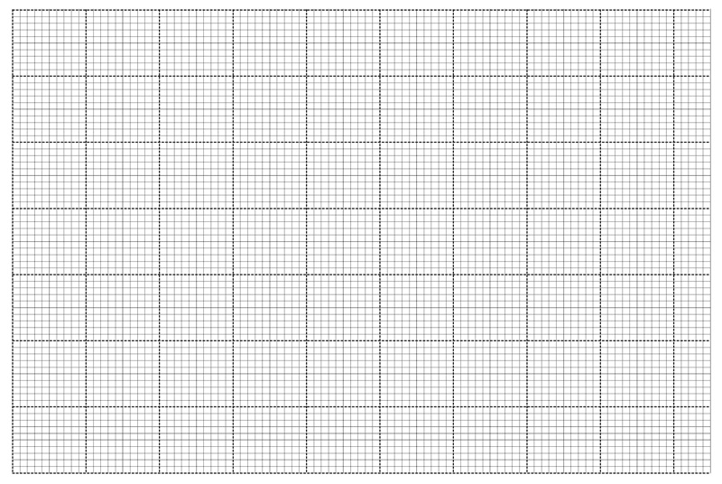

(ii) -ho = 15cm

(iii) v = 20cm

1. (a) (i)

V

*-The circuit diagram must be*

A

*Workabl*e

(ii) – Resistance increases with increase in temperature

(b) (i) – the ammeter reading reduces from maximum to zero

(ii) – electrons move from negative terminal of the cell to B

- at the same time electrons move from plate A to the positive terminal of the

Cell

- equal amounts of positive and negative charges are stored in plate A and

B respectively

1. (a) – Is the pentavalent atoms that donates free electrons to a semiconductor during

Doping.

(b) (i)- L1 lights while L2 does not

(ii) -when the switch is closed D1 is forward biased while D2 is reverse biased

(c)

Diode Vo

R

(d)(i) – Alpha is more massive hence collides with more air molecules

- Alpha is slow moving in air hence takes more time in air

(ii) I) – Beta particle

II) – because of motor- effect / Flemings Left Hand Rule

1. (a) hf = θ + eV

6.63 x 10-34 x 3.0 x 108  = 1.6 x 10-19  x 2.46 + K.E

K. E = 1.989 x 10-18  - 3.936 x 10-19

K. E = 1.5954 x 10-19 J

(b) - due to varying photon energies / different photons have different energies

(c) (i)

**Voltage (V)**

**Time (s)**

- at least 2 crests

(ii) – from 0ᵒ - 90ᵒ magnetic flux linkage changes from high to low/decreasing

- From 90ᵒ - 180ᵒ magnetic flux changes from low to high/increasing

- At 0ᵒ and 180ᵒ magnetic flux change is maximum though in different directions

(d) – Cost = Kwh x unit cost = 3 x $\frac{45}{60}$ x 7 x .60 = ksh 9.45

19. (a) X – Live wire

Y - Earth wire

(b)(i) – increasing the accelerating voltage / potential difference between cathode and anode

(ii) – Reducing the filament / cathode current

(c)(i) Voltage = 4cm x 0.5V/cm = 2V

(ii) $\frac{1}{2}$ T = 8cm 5ms/cm = 40ms

⸫ T = 40ms x 2 = 80ms = 0.08s

f = $\frac{1}{T}$ = $\frac{1}{0.08}$ = 12.5Hz

(d) – cathode rays travels in straight lines