FORM FOUR PHYSICS PRACTICAL
MARKING SCHEME
Question 1

L (cm) | 0.2 | 0.4 | 0.5 | 0.6 | 0.7 | 0.9 | 1.0 | + 0.01  + 0.001
p.d (V) | 2.05 | 2.25 | 2.35 | 2.40 | 2.45 | 2.50 | 2.55
I (A) | 0.825 | 0.625 | 0.525 | 0.475 | 0.425 | 0.375 | 0.350
R ( Ω ) | 2.485 | 3.600 | 4.476 | 5.053 | 5.765 | 6.667 | 7.286
¹/_{I} (A⁻¹) | 1.212 | 1.600 | 1.905 | 2.105 | 2.353 | 2.667 | 2.857

P.d (V) – each point ½ mk max 4 points = 2mks
I (A) – each point ½ mk max 4 points = 2mks
R Ω - All points correct = 2mks
¹/_{I} A⁻¹ – all points correct = 1mk
7mks

(d)

Axis – labelled with units – 1mk
Scale – uniform and simple and should accommodate all points – 1mk
Plotting – at least 6 points – 2mks
Line – straight with positive gradient passing through 4 correctly plotted points 1mk
5mks

(e) Slope, S Δ = ¹/_{I} / ΔR
= (19 – 8.8) x 10⁻¹ √(1) (intervals)
4.5 – 1.5
= 1.02 √ (1) (evaluation)
3.0 = 0.34 A⁻¹ Ω⁻¹ √(1) (Accuracy)
∴ S = 0.33 + 0.01
Range (0.32 – 0.34) 3mks

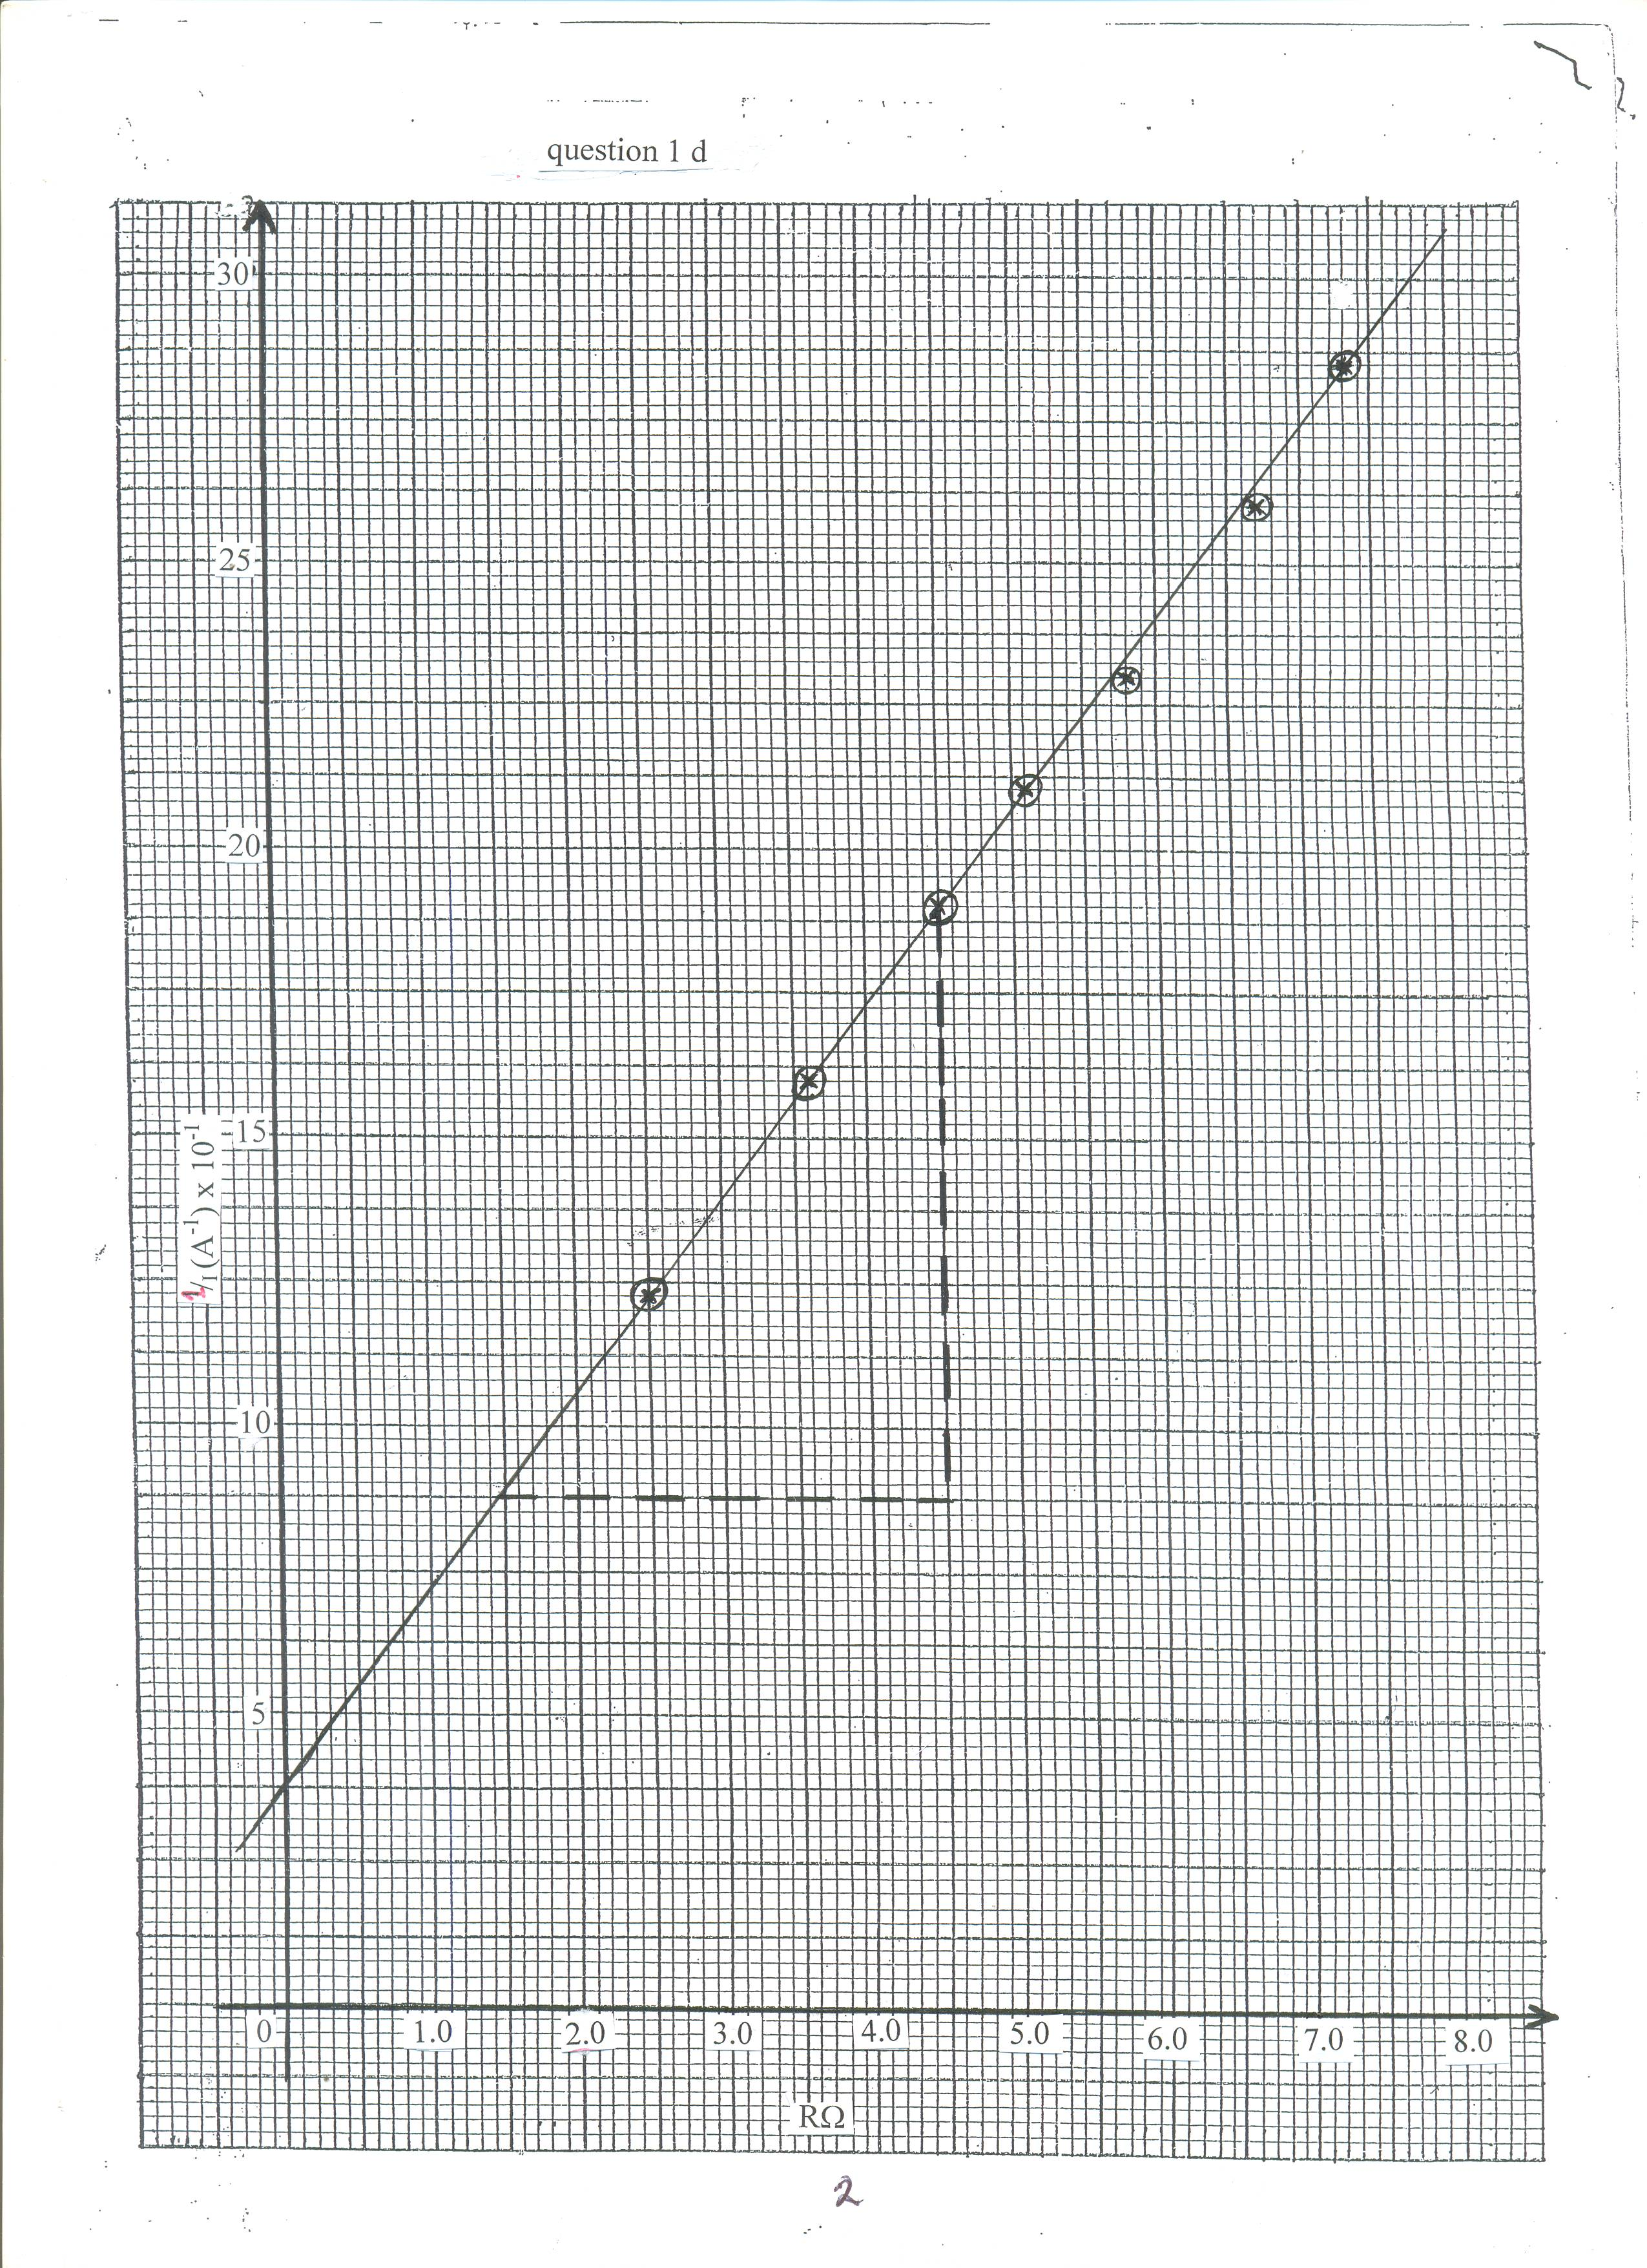

2.
(f) 1 = 1.R + r
I E E
Y = MX + C √
I = slope, S, = 0.34 √
E
E = I = 1 = 2.94√ V
Slope 0.34
3mks

r = y – intercept
E
r = y – intercept x E √
= 3.8 x 10⁻¹ x 2.94
= 1.117Ω
2mks

Question 2
PART A
(a) G = 50.0 + 2.0 cm √
(b)
x (cm) | 5.0 | 10.0 | 15.0 | 20.0 | 25.0 | 30.0
d (cm) | 4.5 | 9.3 | 14.0 | 18.4 | 23.0 | 27.0

Each point ½ mk + 0.1 (3mks)

(c)

Axis – label with units – 1mk
Scale - uniform and simple
Can accommodate all the points 1mk
Plotting – all points correctly plotted – 2mks
Line – straight, passing through four (4)
Correctly plotted points 1mk
5mks

(d) Slope S, Δd = 16 – 0 √ = 16 = 0.9143
Δ x 17.5 – 0 17.5
2mks
(e) (i) W = 100 x 10 = 1N √
1000
F = SW = 0.9143√
2mks

(ii) U = W – F
= 1 – 0.9143 √
= 0.0857 N √
2mks

3.
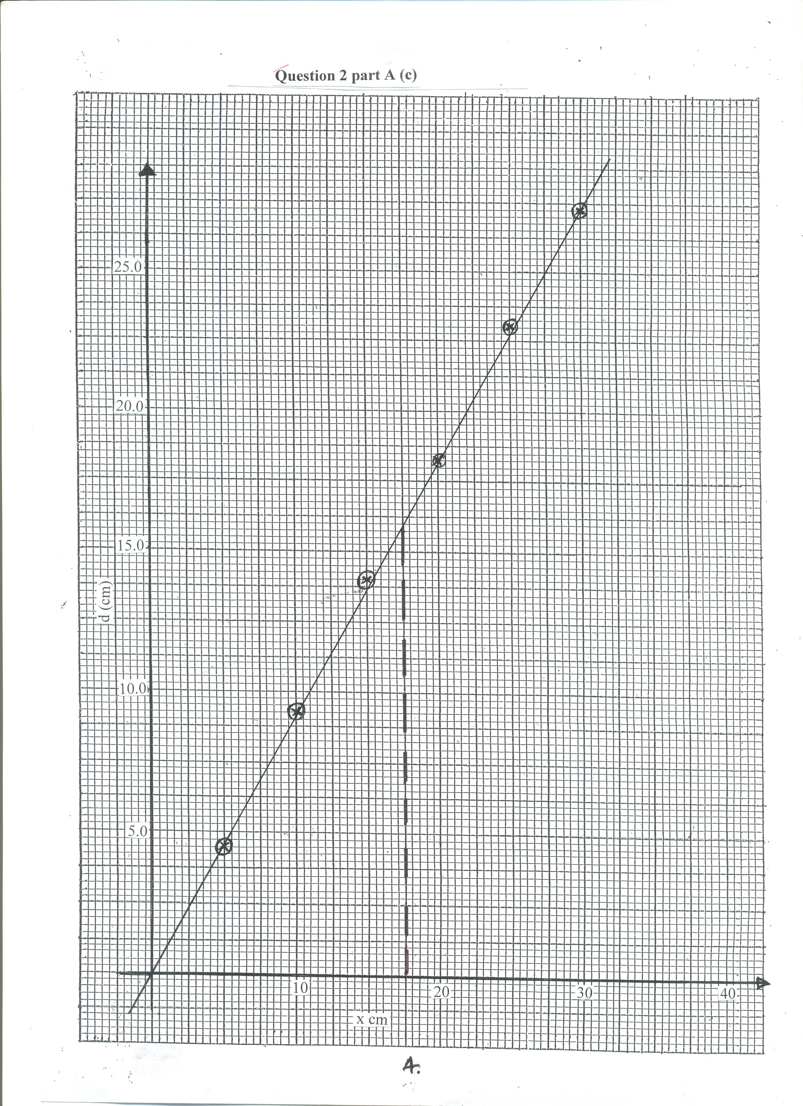

4
Question 2 part A (c)

PART B
(a) t = 28.53 + 0.02 √1
T = ^{t}/₂₀ = 1.4265 √ ½

(b) T² = 4π²L √½
g
g = 4π² x 0.5
(1.4265)² √½
= 9.700 √½ (3mks)
NB g = 10 + 1

PART C
(a) h = 20.0 + 2cm√
(b) h = 20 = 10cm + 1.0√
2 2
(2mks)

