Name …………………………………..……………………...........................Index number………………………..……

Student’s signature…………………………. Date:…………………………………………..

232/3
PHYSICS
(Practical)
Paper 3
Time 2¹/₂ HOURS

SUKELLEMO PRE-MOCK
MAY JUNE 2022 EXAMINATIONS
Kenya Certificate of Secondary Education (K.C.S.E)

INSTRUCTIONS TO CANDIDATES
1. Write your name, index number, class, date and signature in the spaces provided above.
2. This paper consists of two questions 1 and 2.
3. Answer all questions in the spaces provided.
4. Non-programmable calculators and mathematical tables may be used.
5. Show all your workings.

QUESTION 1 | 1 (a) | 1 (e) | 1 f (i) | 1 f (ii) | 1 f (iii) | TOTAL
Maximum score | 1 | 8 | 5 | 3 | 3 | 20
Candidates score

QUESTION 2 | A(a) | A(b) | A(c) | A (g) | A(h) | A(i) | A(j) | A(k) | B(d) | B(e) | B(f) | TOTAL
Maximum score | 1 | 1 | 1 | 2 | 1 | 2 | 1 | 1 | 3 | 5 | 1 | 20
Candidates score

This paper consists of 10 printed pages.
Candidates should check the question paper to ensure that all pages are printed as indicated and no questions are missing

QUESTION ONE
1. You are provided with the following.
- A millammeter.
- A voltmeter.
- A wire mounted on a mm scale.
- A switch.
- A long wire with a crocodile clip at one and (crocodile clip to be used as a
slider or jockey).
- A new dry cell (size D) and a cell holder.
- A micrometer screw gauge (may be shared).
- 5 connecting wires, two with crocodile clips at the end.

Proceed as follows:
- Measure the diameter, d of the mounted at three different points.

Average diameter d = _____________________mm (1mk)

- Set up the apparatus as shown in the circuit diagram in the figure below.
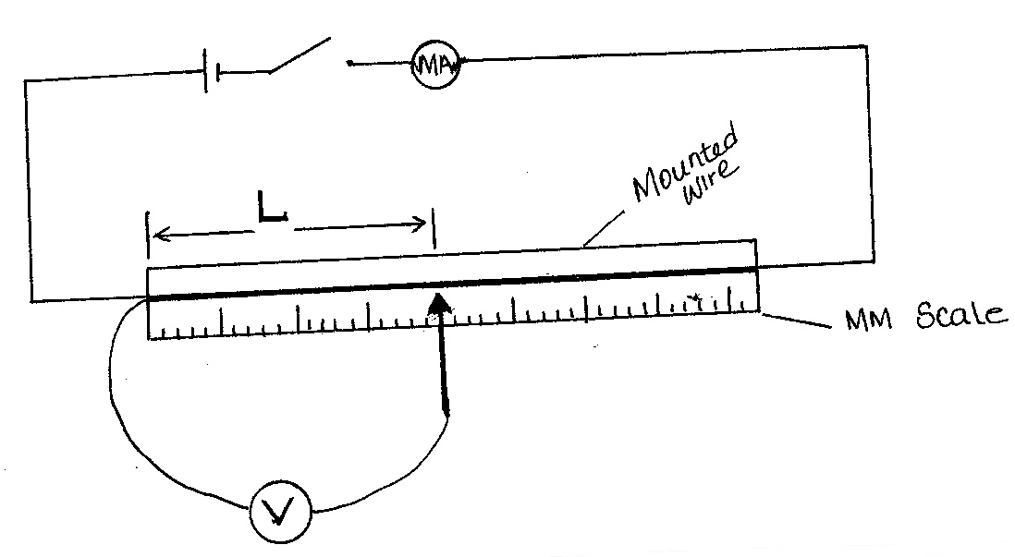

- Close the switch and tap the mounted wire with the crocodile clip as shown in the circuit. Ensure that both meters show positive deflection. Open the switch.

(d) Tap the wire at L = 20cm. Close the switch read and record in the time provided the milliammeter and voltmeter reading.

- Repeat the procedure in (c) for other values of L, shown in the table below and complete the table. (8mks)

L(cm) | L(m) | V (Volts) | I (mA) | I (Amps)
20
30
40
50
60
80

(f) (i) Plot the graph of R (Y-axis) against L(m). (5mks)

(ii) Determine the slope of the graph. (3mks)

(iii) Given that were A is the cross-sectional area of the wire and P is a
constant for the material of the wire, determine the value of the constant P.
(3mks)

QUESTION TWO
This question has two parts A and B. Answer all the parts

PART A
You are provided with the following:
- A metre rule
- Two masses labelled A and B
- 250 ml transparent plastic beaker
- Three pieces of thread, each 30cm long.
- Stand with clamps
- Tissue paper.
- Vernier calipers ( to be shared )
- 200 ml of a liquid L
- Weighing balance ( to be shared )

Proceed as follows:

- Take mass A and measure the diameter d and height h using the Vernier calipers
d=………………………………..m

h=………………………………..m (1mark)
- Determine the volume V given that $V=π(\frac{d}{2})$²h
V…………………………………………m³ (1mark)

- Using a stand and one piece of thread, suspend the metre rule in air such that it balances horizontally. Record the position of the centre of gravity (G)

G = ___________________________________________ cm (1mark)

(NOTE: The metre rule should remain suspended at this point throughout the experiment.)

- Set up the apparatus as shown in Figure 1 below;
- Suspend the mass A at a distance x = 30cm and completely immerse it in liquid L without touching the sides of the beaker.

- Hang mass B and adjust its position such that the rule is balanced and measure the distance d cm.

- Tabulate your results in table 1 below;

$$x (cm)$$ | $$30$$ | $$35$$ | $$40$$
$$d (cm)$$
$$\frac{d}{x}$$

(2marks)
- Determine the weight of mass B in air. Given that
$g=10 N/Kg$

Weight in air =…………………………………… (1mark)

- Using the principle of moments, determine the apparent weight P of mass A when completely immersed in liquid L.

Apparent weight P = …………………….. (2marks)

- Find the upthrust, U on mass A when completely immersed. (1marks)

Upthrust, U =……………….

- Determine the density of liquid L, given that; (1mark)
$ρ=\frac{Un}{V}$ where $n=0.1Kg/N$

PART B
You are provided with the following
- A rectangular glass block
- Four optical pins
- A piece of soft board
- A plain sheet of paper
- 4 thumb pins

Proceed as follows:

- Place the plain sheet of paper on the soft board and fix it using the thumb pins provided .
Place the glass block at the centre of the sheet, draw its outline. Remove the glass block .

P₁ glass block
P₂
Ø
P₃

P₄
d

- Draw a normal at a point 2cm from the end of the longer side of the block outline. This normal line will be used for the rest of the experiment. Draw a line at an angle of angle Ø=25⁰ from the normal .Stick two pins p₁ and p₂ vertically on this line.

- By viewing through the glass from the opposite side, stick two other pins p₃ and p₄ vertically such that they are in line with the images of the first two pins. Draw a line through the marks made by p₃ and p₄ to touch the outline. Extend the line p₁p₂ through the outline (dotted line) .Measure and record in the table the perpendicular distance d between the extended line and the line p₃ and p₄ Record this value in the table.

- Repeat the procedure in (g) and (h) for other values of Ɵ shown in the table. (3marks)
Ɵ (deg) | 25 | 35 | 40 | 45 | 55 | 60 | 65
d(cm)

- plot a graph of d against Ɵ (5mark)

- Use the graph to estimate the value of d when Ɵ =0 (1mark)

