**MOMALICHE JUNE 2022**

**PHYSICS 232/3 MARKING SCHEME**

Question 1 –(20 marks)

|  |  |  |  |  |  |  |
| --- | --- | --- | --- | --- | --- | --- |
| Length L(cm) | 100 | 80 | 60 | 40 | 20 | 0 |
| Voltage V(v) | 0.25 | 0.45 | 0.55 | 0.75 | 1.15 | 1.60 |
| Current I (A) | 0.12 | 0.14 | 0.15 | 0.16 | 0.18 | 0.21 |

( ½ mk each –max5)

iii) Brightness increase. 1

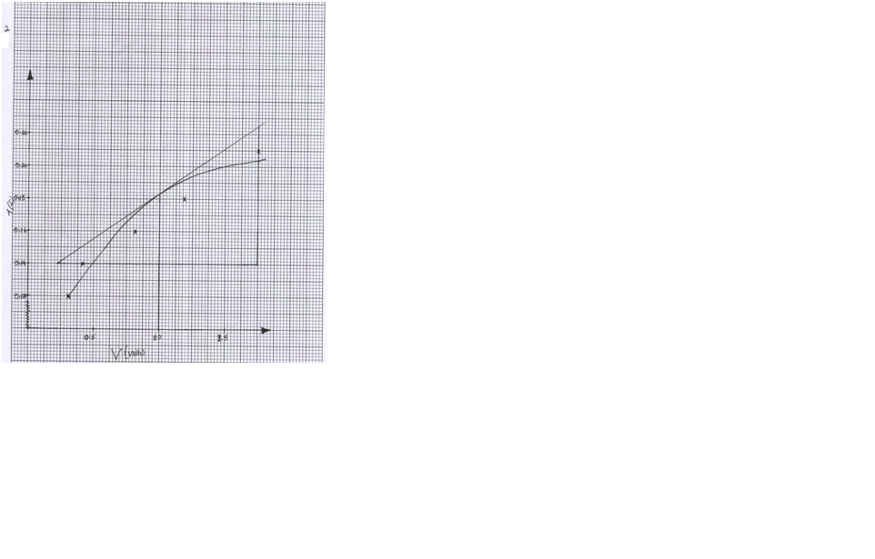

iv) Axes -1

Scale – 1

Plotting – 2 at least four each ½ mark.

Curve – 1

v) Tangent at the point

Slope  1 correct intervals

=0.02

1.1

 1 correct evaluation.

vi) Reciprocal of resistance 1

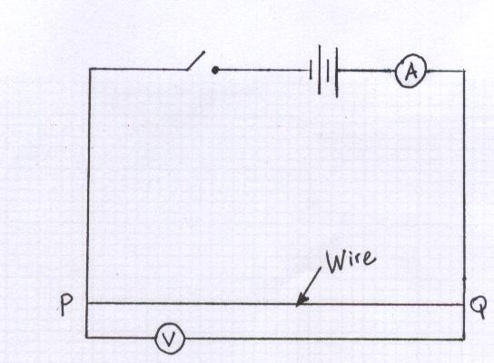

NB – ammeter in cell switch in series voltmeter parallel to wire.

ii) V=1.8V 1

I= 0.14A 1

iii) d= 3.6x10-4m 1



NB: Every teacher is expected to perform the experiment and adjust values given as

appropriate.

2.

1. N=83🗸1
2. D=0.0116M(4d.p)
3. d=6.3🗸1
4. N🗸1/2

M=

1. Lo=50.0

|  |  |  |  |  |  |  |  |  |  |  |  |  |
| --- | --- | --- | --- | --- | --- | --- | --- | --- | --- | --- | --- | --- |
| 1mk | W(N) | 0 | 0.01 | 0.02 | 0.03 | 0.04 | 0.05 | 0.6 | 0.7 | 0.8 | 0.9 | 1N |
| 1mk | L(cm) | 50 | 51.2 | 52.4 | 53.6 | 54.8 | 56.0 | 57.2 | 58.4 | 59.6 | 60.8 | 62.0 |
| 2mk | e(CM) | 0 | 1.2 | 2.4 | 3.6 | 4.8 | 6.0 | 7.2 | 8.4 | 9.6 | 10.8 | 12.0 |
| 2mk | $$\frac{1}{e}{cm}^{-1}$$ | 0 | 0.8333 | 0.4166 | 0.2777 | 0.2083 | 0.1666 | 0.1389 | 0.1190 | 0.1042 | 0.0926 | 0.0833 |

1. Axes=1/2mk well labelled unit a must.

Scale=1/2mk appropriate scale

Plots=2mks 8-11 plots correctly plotted

4-7 correctly plotted 1mk

Less than 4 - 0mks

Smooth curve -1mk

1. Slope= $\frac{5.5}{2.2}-\frac{3.5}{1.4}=\frac{2.0}{0.8}=2.5NCM$

T= $\frac{mx({5+60)}^{2}}{-255}$

= $\frac{0.0887x({2.5+60)}^{2}}{-255}$

T=1.3588N2CM2🗸

