NAME__________________________________INDEX NO.________________
DATE__________________________________SIGNATURE________
ADM NO.______________
232/1
PHYSICS
PAPER 1
(THEORY)
TIME: 2 HOURS

Kenya Certificate of Secondary Education
PHYSICS
PAPER 1
(THEORY)
TIME: 2 HOURS

INSTRUCTIONS TO THE CANDIDATE:
(a) Write your name and index number in the spaces provided above.
(b) Sign and write the date of examination in the spaces provided above.
(c) This paper consists of two Sections A and B.
(d) Answer all the questions in sections A and B in the spaces provided.
(e) All working must be clearly shown in the spaces provided.
(f) Mathematical tables and electronic calculators may be used.

FOR EXAMINER’S USE ONLY:
Section | Question | Maximum  Score | Candidate’s  Score
A | 1 – 13 | 25
 | 14 | 11
 | 15 | 10
B | 16 | 13
 | 17 | 12
 | 18 | 9
Total Score |  | 80

SECTION A (25 MARKS) (Answer ALL the questions in the spaces provided)

- What is the reading on the micrometer screw gauge shown below with an error of +0.5mm? (1mk)
………………………………………………………………………………………………………………………………………………………………………………………………
- In the study of free fall, it is assumed that the force F acting on a given body of mass, m, is gravitational, given by F = ma. State two other forces that act on the same body (1mk)
………………………………………………………………………………………………………………………………..…………………………………………………………….………………………………………………………………………………………………
- State two facts which show that heat from the sun does not reach the earth surface by convection. (2mks)

- The figure below shows a piece of metal stuck in a hollow glass pipe. .Explain how temperature change may be used to separate them (2mks)
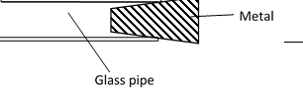

- Thewater in aburetteis30.6cm3, 50 drops of water each of volumeVareadded to thewater in the burette.The final readingof theburettewas 20.6cm3. Calculate theradius of the drop of water.
(2mks)
……………………………………………………………………………………………………………
……………………………………………………………………………………………………………
- Inan experiment to demonstrate Brownian motion, smokewas placed in asmoke celland observed under amicroscope. State and explain the observation. (2mks)
…………………………………………………………………………………………………………

- In the figure below, ammonia gas and an acid gas diffuse and react to form a white deposit on the walls of a long glass tube as shown.
A B
Ammonia gas acid gas
Cotton wool soaked in concentrated ammonia
Cotton wool soaked in concentrate HCl
Cork

- What conclusion can be made from the result of this experiment? (1mk)
………………………………………………………………………………………………………………………………………………………………………………………………………………
- How does the size and mass of a gas affect its rate of diffusion? (1mk)
………………………………………………………………………………………………………
………………………………………………………………………………………………………
- The experiment is performed at a lower temperature. Explain how the time taken to form the white deposit would be affected. (1mk)
…………………………………………………………………………………………………
……………………………………………………………………………………………………………………………………………………………………………………………………

- Determine the change in momentum produced when a force of $3500N$ acts on a body which is at rest for 0.002 secomds.
(2mks)
………………………………………………………………………………………………
……………………………………………………………………………………………………………………………………………………………………………………………………
- The figure below shows a Bunsen burner. Explain how air is drawn into the burner when the gas tap is opened. (2mks)

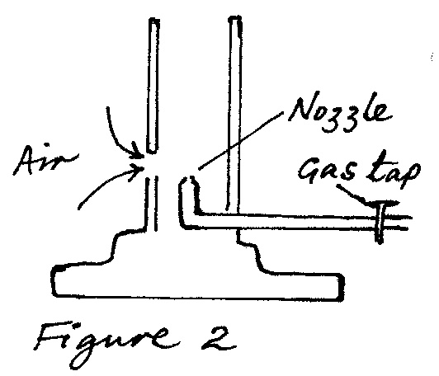

- A mass of 100gis hung at the10cm mark and a50gmass at the70cm markof auniform metre rulebalanced at the40cm marks. Determinetheweight ofthe rule. (3 marks)

……………………………………………………………………………………………

………………………………………………………………………………………………

………………………………………………………………………………………………

………………………………………………………………………………………………

…………………………………………………...…………………………………………

……………..............................................................................................................................
- Form four students were playing football during which the ball got deflated. Explain what happened to its density (2mks)
……………………………………………………………………………………………

………………………………………………………………………………………………

………………………………………………………………………………………………

………………………………………………………………………………………………

- Statethe branch of physics that deal with kinetic energyof matter. (1mk)

………………………………………………………………………………………………

- A student balances a V - shaped uniform wire on a tight string as shown in figure A and B. state with reason the one which is easier to do (2mks)
……………………………………………………………………………………………

………………………………………………………………………………………………

………………………………………………………………………………………………

………………………………………………………………………………………………

SECTION B (55 MARKS)
- A student in LubinuGirls set up an experiment to study the acceleration of a trolley using ticker tape timer. The timer made 50 dots per second on the tape. Dots A to E measured 2.5cm apart and dots E to I measured 4.5cm apart.

- Using a scale drawing show the dots A, B C, D, E, F, G and I as they appeared on the tape.(3mks)

……………………………………………………………………………………………

………………………………………………………………………………………………

………………………………………………………………………………………………

………………………………………………………………………………………………

- Determine the velocity of the trolley from:
- A to E. (2mks)

……………………………………………………………………………………………………………

……………………………………………………………………………………………………………

……………………………………………………………………………………………………………

…………………………………………………………………………………………………………..

- E to I. (2mks)

……………………………………………………………………………………………………………

……………………………………………………………………………………………………………

……………………………………………………………………………………………………………

…………………………………………………………………………………………………………..

- Calculate the acceleration of the trolley. (2mks)

……………………………………………………………………………………………………………

……………………………………………………………………………………………………………

……………………………………………………………………………………………………………

…………………………………………………………………………………………………………..

- What end of the tape was fixed onto the trolley? (1mk)
……………………………………………………………………………………………………………

- State two precautions that the student should take before she takes her final samples of the dots.
(2mks)
……………………………………………………………………………………………………………

……………………………………………………………………………………………………………

……………………………………………………………………………………………………………

- a)Anastronaut in orbit round the earth mayfeelweightlesseven when the earth’s gravitational field still acts on him. Explain (2mks)
……………………………………………………………………………………………………………

……………………………………………………………………………………………………………

……………………………………………………………………………………………………………

…………………………………………………………………………………………………………..

b) Distinguish between angularvelocityand linear velocity (1mk)

……………………………………………………………………………………………………………

……………………………………………………………………………………………………………

……………………………………………………………………………………………………………

c) astone is whirledwith uniform speed in a horizontal circle ofradius 15 cm. it takes the stone 10 seconds to describe an arcof length 4cm. calculate
i)Angularvelocity (3mks)

……………………………………………………………………………………………………………

……………………………………………………………………………………………………………

……………………………………………………………………………………………………………

…………………………………………………………………………………………………………..

ii)Linear velocityof thestone (2mks)

……………………………………………………………………………………………………………

……………………………………………………………………………………………………………

……………………………………………………………………………………………………………

…………………………………………………………………………………………………………..

iii) Periodictime (2mks)

……………………………………………………………………………………………………………

……………………………………………………………………………………………………………
……………………………………………………………………………………………………………

………………………………………………………………………………………………………

- The figure below shows an inclined plane on which a trolley of mass 30kg is pulled up a slope by a force of 100N, parallel to the slope. The trolley moves so that its centre of mass travels from points A to B.
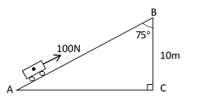

- Determined the work done on the trolley against the gravitational force in moving from A to B. (2mks)
……………………………………………………………………………………………………………

……………………………………………………………………………………………………………

……………………………………………………………………………………………………………

…………………………………………………………………………………………………………..

- Determine the work done by the force in moving the trolley from A to B.
(3mks)

……………………………………………………………………………………………………………

……………………………………………………………………………………………………………

……………………………………………………………………………………………………………

…………………………………………………………………………………………………………..

(iii) Determine the percentage of the work input that goes to waste (3mks)

……………………………………………………………………………………………………………

……………………………………………………………………………………………………………

……………………………………………………………………………………………………………

…………………………………………………………………………………………………………..

- Determine the frictional force. (1mk)

……………………………………………………………………………………………………………

……………………………………………………………………………………………………………

(v) Determine the mechanical advantage of the system. (1mk)

……………………………………………………………………………………………………………

……………………………………………………………………………………………………………

(vi) Find the velocity ratio (1mk)

……………………………………………………………………………………………………………

……………………………………………………………………………………………………………

- a. The figure below shows a set-up that can be used to determine the specific heat capacity of a metal block.
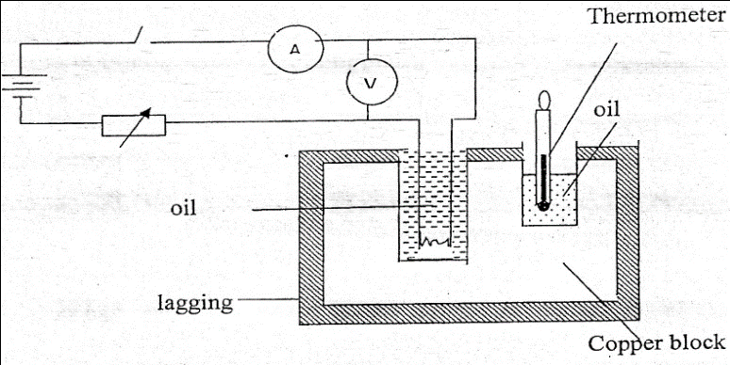

- Other than temperature and current, state two measurements that should be taken in the experiment to determine the specific heat capacity of the block.
(2mks)
……………………………………………………………………………………………………………

……………………………………………………………………………………………………………

- Describe how the method can be used to determine the specific heat capacity of the metal block. (3mks)

……………………………………………………………………………………………………………

……………………………………………………………………………………………………………

……………………………………………………………………………………………………………

…………………………………………………………………………………………………………..

- State the purpose of oil in the set-up. (1mk)

……………………………………………………………………………………………………………

……………………………………………………………………………………………………………

(b) A well lagged copper can together with a copper stirrer of total heat capacity 60JK⁻¹ contains 200g of water at 20⁰C. Dry steam at 100⁰C is passed in while the water is stirred until the content reach a temperature of 50⁰C. Determine the mass of condensed steam. (Specific latent heat of vaporization of water is 2.26 X 10⁶ J/kg and specific heat capacity of water is 4200 J/kgK) (4mks)

……………………………………………………………………………………………………………

……………………………………………………………………………………………………………

……………………………………………………………………………………………………………

…………………………………………………………………………………………………………..

- a) State thelawof floatation (1mk)

……………………………………………………………………………………………………………

……………………………………………………………………………………………………………

……………………………………………………………………………………………………………

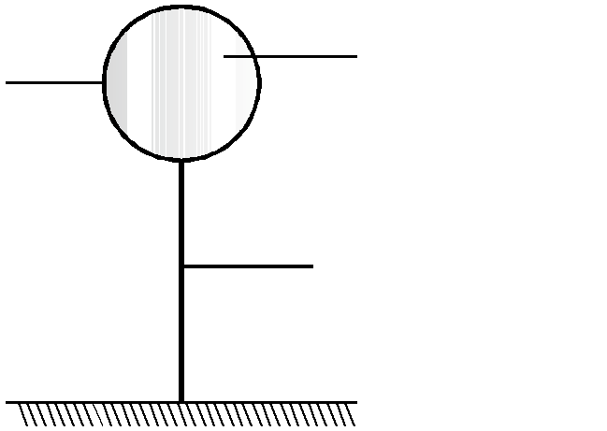
b)Thediagram below shows ahotair balloon tethered to thegroundonacalmday.Theballoon contains 1300m3of hot airof density0.82 kg/m3.Themass ofthe materialmakingthe balloon withouthot airis 420kg.Thedensityof thesurroundingair is 1.35 kg/m3. Determine

Balloon

Hotair
Hydrogengas

String

i)Thetotal weight of hotair balloon (3mks)

……………………………………………………………………………………………………………

……………………………………………………………………………………………………………

……………………………………………………………………………………………………………

…………………………………………………………………………………………………………..

ii) Theweight of air displaced bytheballoon (2mks)

……………………………………………………………………………………………………………

……………………………………………………………………………………………………………

……………………………………………………………………………………………………………

…………………………………………………………………………………………………………..

iii)Upthrust forceon theballoon (1mk)
……………………………………………………………………………………………………………

……………………………………………………………………………………………………………

……………………………………………………………………………………………………………

…………………………………………………………………………………………………………..

iv)The tension in theropeholdingthe balloon in theground. (2mks)

…………………………………………………………………………………………………

……………………………………………………………………………………………………

…………………………………………………………………………………………………

…………………………………………………………………………………………………

v)Theacceleration with which theballoon begins to raise when released. (3mks)
……………………………………………………………………………………………………

……………………………………………………………………………………………………

…………………………………………………………………………………………………

…………………………………………………………………………………………………

……………………………………………………………………………………………………

