232/1
PHYSICS
PAPER 1
(THEORY)
FORM FOUR
END TERM 1 2023 EXAMS

MARKING SCHEME

- 16.21mm1 correct answer with correct units
Accept 1.621cm or 0.01621m
- Momentum is conserved momentum before = momentum after
72 $×$9 = 216 $×$41
⇒ u = $\frac{72 ×9}{216}$1
= 3.0m/s1
- Roofing materials allows radiations to penetrate into the greenhouse1 but not out. Higher concentration of carbon dioxide inside the greenhouse helps to retain higher temperature by trapping/ insulating1 the heat.

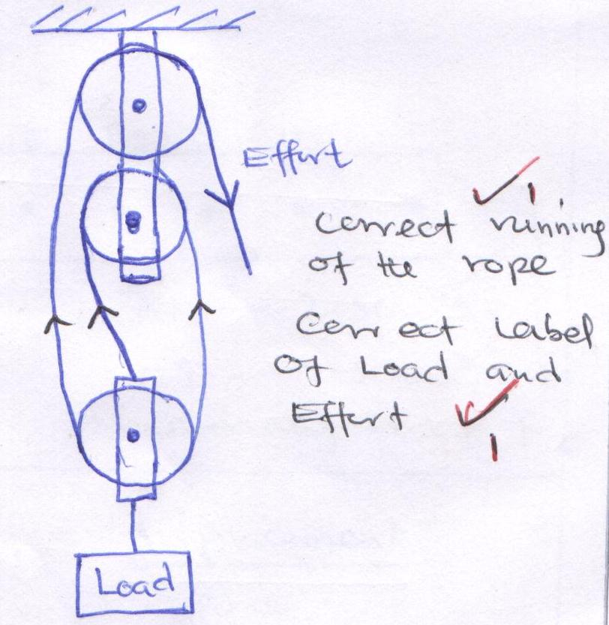
- V.R = 31
- Increase in temperature increases1 the speed of sound.
- i) Convection takes place in air upwards direct due to1 to density defect.
ii) Convection requires a 1 material medium but the space between the sun and the earth i.e. space of the atmosphere has no material medium
- From the equation of continuity
A₁U₁ = A₂U₂1(flow rate is constant)
120 $×$ 0.4 = 4 $×$ U₂
$∴$ U₂ = $\frac{120 ×0.4}{4}$1
= 12 ms⁻¹1
- Work done on the mass
= force $×$ distance
= 25 $×$10 $×$ 120
= 5000J.1
Work done = power $×$ time
= 200 $×$ 301
= 6000J1
But = $\frac{work output}{work input}×$100
= $\frac{5000}{6000}×$ 100
= 83.3% 1
- ΔH = MCΔ$θ$
= $\frac{150}{1000} ×1000×4200 ×\left(70-15\right)$ +
390 $×20×\left(70-15\right)$
= 34650.000 + 429000
= 4636501
Energy dissipation E = pt
3000 $×t=4636501$
⇒t = $\frac{463650}{3000}$ = 154.55 sec1
- At balance
Sum of clockwise = sum of anti-clockwise moments
$\left(\frac{180}{1000}×100\right)×$ 40 = 30 $×$X + (10$×1.8$)1
1.8$×$40 = 30X +18
X = $\frac{1.8 ×40-18}{30}$1
= 1.8N1
- To increase surface area of contact thus reducing pressure exerted on the road1
SECTION B
- a)
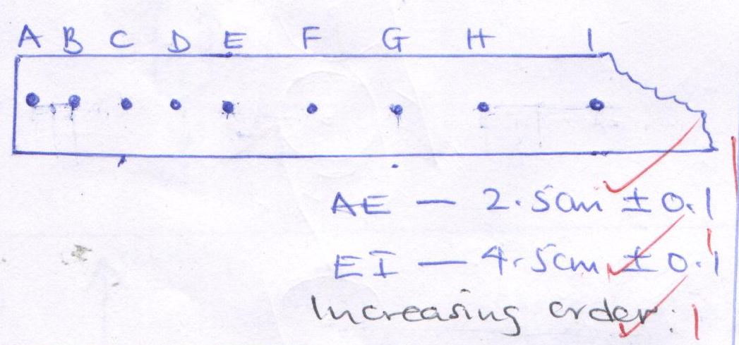
b) i) Velocity = $\frac{displacement}{time}$
=$\frac{2.5}{4×0.02}$1
= 31.25cms⁻¹1 OR0.3125ms⁻¹
ii) E to I
Velocity = $\frac{4.5}{4 ×0.02}$1
= 56.25 cms⁻¹1
c) a = $\frac{u-u}{t}$
= $\frac{0.5625-0.3125}{0.02 ×8}$
= $\frac{0.25}{0.16}$ = 1.5625ms⁻²
d) End A1
e) i) Trolley runs on a straight path on the runway1
ii) Tape lies flat on the horizontal surface. 1
- i) Brownian motion is the continuous erratic/ random motion in either gas or liquid molecules1
ii) - A small glass with air and carbon (smoke) particles1
- the glass cell is strongly illuminated by a filament lamp directed by a perspex rod1
- the particles scatter light and they can be viewed through a microscope1
- they appear as bright specks (spots) moving with the same irregular random motion
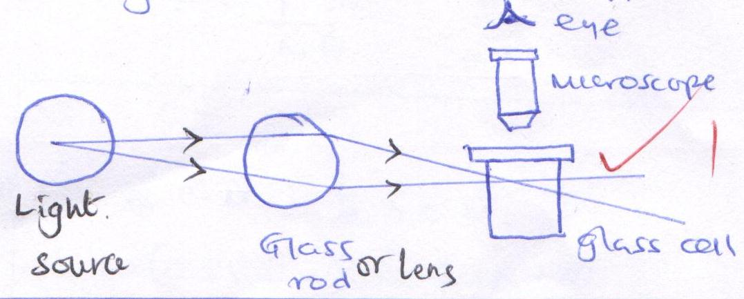
b) i) V= $π$r²h
0.01 $×{\left({10}^{-3}\right)}^{3}$= 3.14 $×$r²$×$h1
h = $\frac{0.01 × {10}^{-9}}{3.14 × r^{2}}$1
= $\frac{0.01 × {10}^{-9}}{500× {10}^{-4}}$ = 2$×{10}^{-10}$m 1
ii) i) Oil spreads to form a monolayer1
ii) Oil patch formed is exactly circular. There is no evaporation of oil molecules movement/ spreading 1 of the oil molecules are elastic.
- a) i) In elastic collision – K.E and momentum of the objects are conserved1
Elastic collision – only momentum is conserved1
ii) Initial momentum = Final momentum
2M_{B}U_{B} + M_{A}U_{A} = 3MV1
0 + MU_{A} = 3Mu1
3Mu = MU
u - $\frac{MU}{3M}$
= $\frac{u}{3}$ ms⁻¹1
b) i)
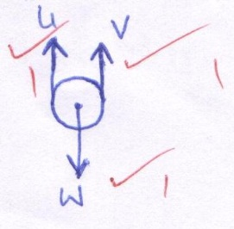

ii)
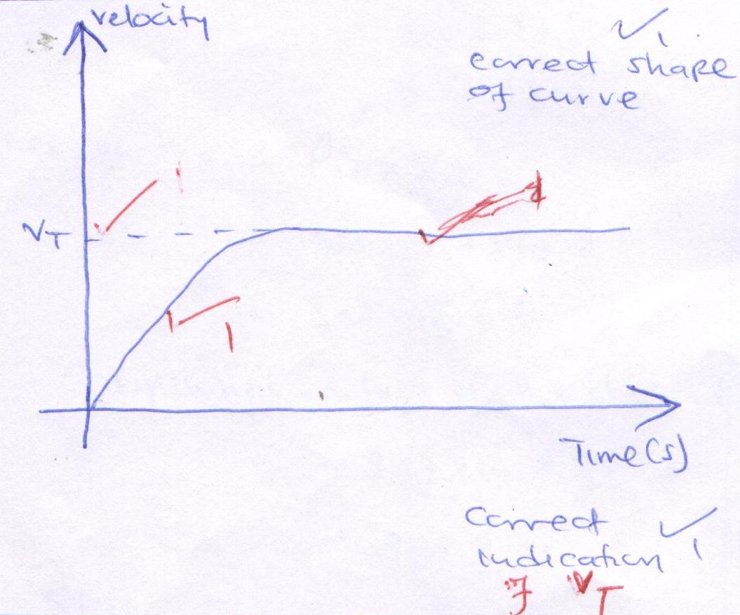
- a) i) $ω$= 2$π$f
= 2$π×$10
= 20$π$rad s⁻¹
= 62.83 rad⁻¹
T_{A} = M$ω$²r – mg
= $\left(1×{62.83}^{2 }×0.5\right)- \left(1×10\right)$1
= 19 + 3.9 – 10
= 1963.9N1
ii) At the lowest point
F_{c} = T – Mg
⇒ Fe + Mg
= mr$ω$² + mg
= 1$×$0.5$×{62.83}^{2}$+ $\left(1×10\right)$1
= 1973.9 + 10
= 1983.9N1
b) i) - Electric heater is switched 1 on.
- Time is obtained for a certain temperature rise1
- Mass of block is obtained1
pt = MCθ
c = $\frac{pt}{Mθ}$1
ii) pt = MCΔ$θ$
⇒C= $\frac{pt}{MCθ}$
= $\frac{90×15 ×60}{2 × \left(30-20\right)}$1
= $\frac{81000}{2 ×10}$1
= 4050JKg⁻¹k⁻¹
- a) i) ∑C.m = ∑ A.C.M
40(0.25 - u) = 30 $×$201
10 – 40u = 600
40u - -590
U = $\frac{-590}{40}$1
= - 14.75N1
$∴$ u = 14.75 (acting upwards)

ii) U = wgt of liquid displaced
14.75 = mg
= v $×ρ×$ g
Vol of liquid displaced = vol of block
= $\frac{M_{b}}{ρ_{b}}$
= $\frac{25}{1000}×200$ = 0.001251
$∴$ 14.75 = 0.00125 $×ρ×10$
⇒$ρ$ = $\frac{14.75}{0.00125 ×10}$1
= 1180kgm⁻³1
b) i) A floating object displaces its own weight of the fluid on which it floats1
ii) Tension + Upthrust = weight
Upthrust = wgt of H₂O displaced
Vol. of H₂O displaced = vol of aluminium
= $\frac{Mass of aluminium}{Density of aluminium}$ = $\frac{1}{2.7 ×{10}^{-3}}$
= 3.7 $×{10}^{-4}$ m³1
Mass of H₂O = $ρ_{w}×v_{w}$
= 1000$×3.7×{10}^{-4}$
= 3.7$×{10}^{-1}kg$
$∴$upthrust = wgt of H₂O displaced
= 3.7$×{10}^{-1}×10$
= 3.7N1
Since T + U = W
T = W – U
= Mg – U
T = (10 $×1$) – 3.7
= 6.3N1

