NAME:…………………………..……………..….. INDEX NO:………….........................

232/1 CANDIDATE’S SIGN:………….……
PHYSICS
PAPER 1 DATE:……….………………………...
(THEORY)
JUNE, 2022
TIME: 2 HOURS

SUKELLEMO JOINT EXAMINATIONS – 2022

INSTRUCTIONS TO THE CANDIDATE:
(a) Write your name and index number in the spaces provided above.
(b) Sign and write the date of examination in the spaces provided above.
(c) This paper consists of two Sections A and B.
(d) There are 14 printed pages, with 18 questions check to confirm that your paper is complete.
(e) Answer all the questions in sections A and B in the spaces provided.
(f) All working must be clearly shown in the spaces provided.
(g) Mathematical tables and electronic calculators may be used.

FOR EXAMINER’S USE ONLY:
Section | Question | Maximum  Score | Candidate’s  Score
A | 1 – 12 | 25
 | 13 | 08
B | 14 | 10
 | 15 | 09
 | 16 | 07
 | 17 | 12
 | 18 | 09
Total Score |  | 80

SECTION A: (25 MARKS)

- A ball bearing is held between the anvil and spindle of a micrometer screw gauge as shown in the Figure 1 below.
Ball bearing
35
30
0
Figure 1

What is the diameter of the ball bearing? (1 mark)
................................................................................................................................................................................................................................................................................................
- State two properties of a liquid that is suitable for use in a thermometer. (2marks)

................................................................................................................................................................................................................................................................................................
- In an experiment to determine the relative density of a substance using a density bottle the following measurements were taken. (Take density of water to be 1g/cm³)
- Mass of empty density bottle = 43.2 g
- Mass of bottle full of water = 66.4 g
- Mass of bottle filled with liquid X = 68.2g
Use the data to determine the density of the liquids. (3marks)
................................................................................................................................................................................................................................................................................................
................................................................................................................................................................................................................................................................................................

- Why are gases more compressible while liquids and solids are almost incompressible? (1mark)
................................................................................................................................................................................................................................................................................................
- The graph shows variation of extension and stretching force F for a spring which obeys Hooke’s law.
Extension e (cm)
0
20
Force F (N)
8
4
12
0
16
12
4
24
8

- Determine the spring constant in SI units. (1mark)
..........................................................................................................................................................................................................................................................................
- The energy stored when the extension is 20cm. (2marks)
...............................................................................................................................................................................................................................................................................................................................................................................................................
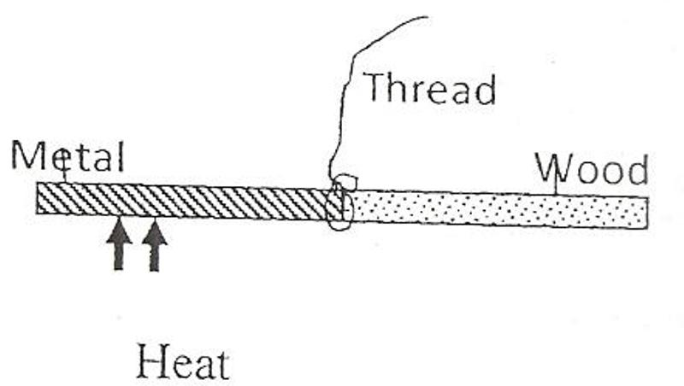
- The figure 2 below shows a rod made of wood on one end and metal on the other end suspended freely with a piece of thread so that it is in equilibrium.

The side made of metal is now heated with a Bunsen flame. State with a reason, the side to which the rod is likely to tilt. (2 marks)
................................................................................................................................................................................................................................................................................................

- State one factor that would increase the surface tension of pure water in a beaker of water. (1 mark)
................................................................................................................................................
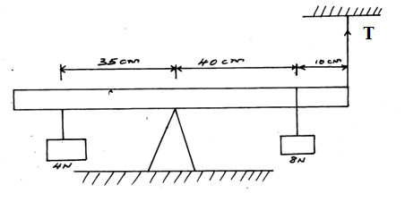
- The figure below (figure 3) shows a uniform metal rod balanced at its Centre by different forces.

Figure 3

Determine the value of T. (3 marks)
................................................................................................................................................................................................................................................................................................
................................................................................................................................................................................................................................................................................................

- Two rods of copper A and B of the same length but different thickness with
candle wax attached to either end are heated as shown below.
Heat
Wax
Wax
A
B

State and explain the observation made. (2 marks)
................................................................................................................................................................................................................................................................................................
- Figure 4 shows a manometer attached to a gas supply. If the atmospheric pressure is 1.0336 x 10⁵Pa. Calculate the pressure of the gas supply.
(Density of mercury = 13600kg/m³) (2 marks)
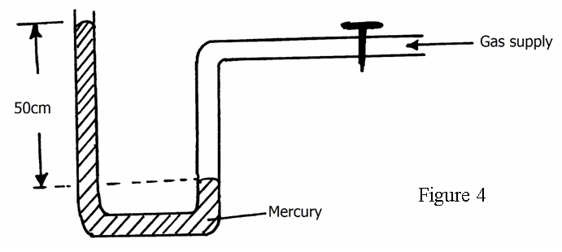
................................................................................................................................................................................................................................................................................................
................................................................................................................................................
- A block of wood measuring 0.8m by 0.5m by 2m floats in water. 1.2m of the block is submerged. (Density of water = 1000kg/m³ , g=10N/kg) Determine the weight of the water displaced. (3 marks)
................................................................................................................................................................................................................................................................................................
................................................................................................................................................

- The figure 5 below shows two light sheets of paper arranged as shown.
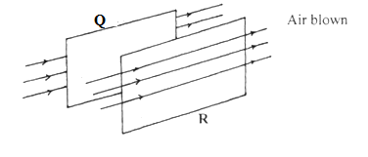
Fig. 5

Its observed that the papers move away from each other when strong air is blown at the same time behind paper Q and in front of paper R as shown. Explain (2 marks)
................................................................................................................................................................................................................................................................................................
................................................................................................................................................................................................................................................................................................

SECTION B (55 MARKS)

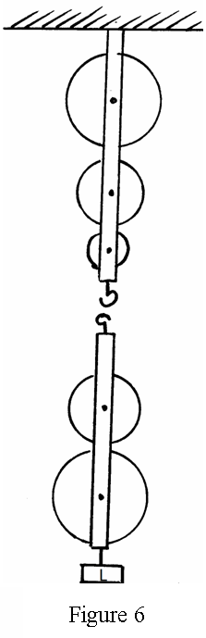
- A block and tackle is made up of three pulley wheels on top and two pulley wheels at the bottom in figure 6

(a) Complete the diagram by drawing the chain which passes over the wheels and indicate where the effort is applied (2 marks)
(b) What is the velocity ratio (V.R) of the machine (1 mark)
................................................................................................................................................
(c) A load of 1120N is lifted by an effort of 250N
Determine
(i) The mechanical advantage (M.A) of the system (2 mark)
..........................................................................................................................................................................................................................................................................

(ii) The efficiency, E, of the system (2 marks)
..........................................................................................................................................................................................................................................................................
(e) Using the axes given below, sketch a graph of efficiency, E, against load (1 mark)

- (a) What is meant by the term specific latent heat of fusion of a substance? (1 mark)
................................................................................................................................................................................................................................................................................................
................................................................................................................................................
(b) Water of mass 200g at a temperature of 60ºC is put in a well lagged copper calorimeter of mass 80g. A piece of ice at 0ºC and mass 20g is placed in the calorimeter and the mixture stirred gently until all the ice melts. The final temperature of the mixture is then measured (Latent heat of fusion of ice = 334000Jkg⁻¹, specific heat capacity of water = 4200Jkg⁻¹K⁻¹)
Determine:
- The heat absorbed by the melting ice at 0ºC (2 marks)
...............................................................................................................................................................................................................................................................................................................................................................................................................

(ii) The heat absorbed by the melted ice (water) to rise to temperature T (2 marks)
....................................................................................................................................................................................................................................................................................................................................................................................................................................................................................................................................................

(iii) The heat lost by the warm water and the calorimeter (Specific heat capacity of the calorimeter = 900Jkg⁻¹K⁻¹) (2 marks)
....................................................................................................................................................................................................................................................................................................................................................................................................................................................................................................................................................
.....................................................................................................................................

(iv) The final temperature T of the mixture (3 marks)
..............................................................................................................................................................................................................................................................................................................................................................................................................................................................................................................................................................................................................................................................................................................................................................................................................................

- A lead shot of mass 40g is tied to a string of length 70cm. It is swung vertically at 5
revolutions per second. (Take g=10m/s²)
(a) Determine;
(i) Periodic time, (1 mark)
..........................................................................................................................................................................................................................................................................
(ii) Angular velocity (2 marks)

..........................................................................................................................................................................................................................................................................
(iii) Linear velocity (2 marks)

..........................................................................................................................................................................................................................................................................

(iv) Maximum tension in the string. (2 marks)

...............................................................................................................................................................................................................................................................................................................................................................................................................

(b) The figure 7 below shows a container with small holes at the bottom in which wet clothes have been put. When the container is whirled in air at high speed as shown, it is observed that the clothes dry faster. Explain how the rotation of the container causes the clothes to dry faster. (2 marks)
Fig 7
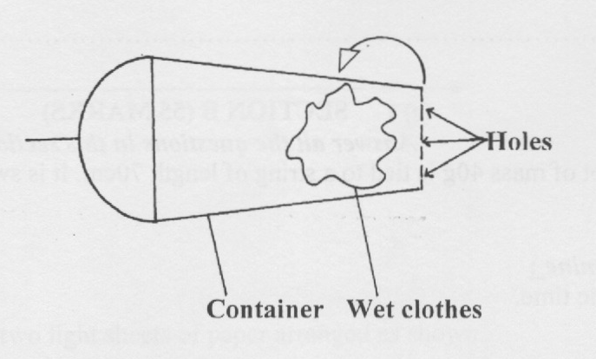
................................................................................................................................................................................................................................................................................................
................................................................................................................................................
- (a) Give a reason why the inside of a helmet is lined with sponge. (1 mark)

................................................................................................................................................................................................................................................................................................

- The figure below shows a balloon filled with air.
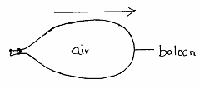

When the mouth is suddenly opened, the balloon moves in the direction shown
above by the arrow. Explain that observation. (2 marks)

................................................................................................................................................................................................................................................................................................

- A rock of mass 150kg moving at 10m/s collides with a stationary rock of mass100kg. They fuse after collision. Determine the
(i) Total momentum before collision. (2 marks)

..........................................................................................................................................................................................................................................................................

(ii) Their common velocity after collision. (2 marks)

...............................................................................................................................................................................................................................................................................................................................................................................................................

- (a) On the axis below, sketch a graph to show how the pressure of a fixed mass of a gas varies with volume at constant temperature. (1 mark)
P
V

(b) The set-up below shows an arrangement that can be used to Verify Charles’ law.
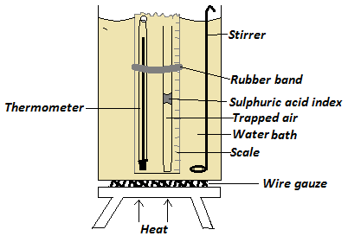
- State any one use of sulphuric acid index in the above set up. (1 mark)
..........................................................................................................................
- What is the use of the stirrer? (1 mark)

...........................................................................................................................
- State two measurements that should be taken in this experiment. (2 marks)

......................................................................................................................................................................................................................................................

- Describe how the set up can be used to verify Charles’ law. (4 marks)
.............................................................................................................................................................................................................................................................................................................................................................................................................................................................................................................................................................................................................................................................................................................................................................................................................................................................................................
- The volume of a gas enclosed with a movable piston is 300 cm³ when the temperature is 290K. Determine the temperature at which the volume of the gas increases to 355 cm³ (Assume pressure does not change) (3 marks)
.......................................................................................................................................................................................................................................................................................................................................................................................................................................................................................................................................................................................................................................

- (a). The section of the tape shown below was produced when a tape running down an incline plane was attached to a ticker-tape timer of frequency 50Hz.

8cm
56cm

i) Indicate above the tape the direction in which the trolley was moving. (1 mark)
ii) What type of current was used to operate the ticker timer? (1 mark)
................................................................................................................................................
iii) Find the acceleration of the trolley in SI units. (3 marks)
................................................................................................................................................................................................................................................................................................................................................................................................................................................................................................................................................................................................
(b). A stone is projected vertically upwards with initial velocity of 40m/s from the ground.
Calculate:
- Time taken to reach maximum height (2 marks)

................................................................................................................................................................................................................................................................................................

- Maximum height reached (2 marks)
................................................................................................................................................................................................................................................................................................

THIS IS THE LAST PRINTED PAGE. BEST OF LUCK.

