**EAGLE JOINT EXAMINATION**

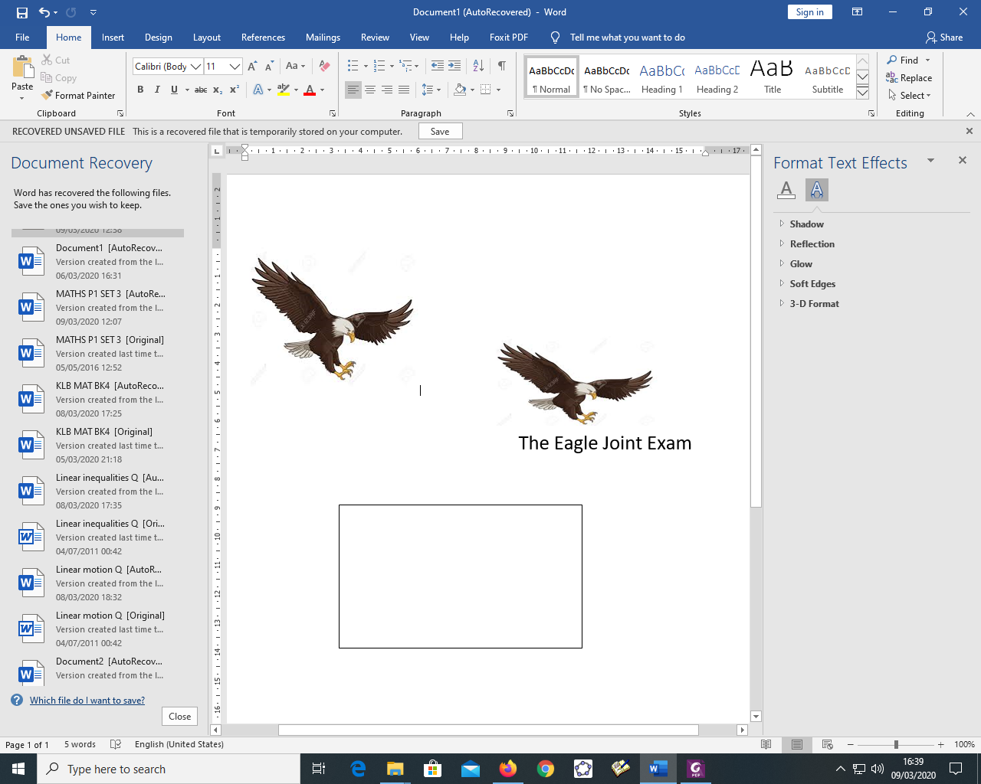

**KENYA CERTIFICATE OF SECONDARY EDUCATION**

**232/3 -PHYSICS- Paper 3**

**(PRACTICAL)**

**Sept. 2021** -**21/2 hours**

**Name:……………………………………………………ADM.NO:…………….Class:……..……**

**School:…………………............................Signature:……………….Date:…………………...…**

**Instructions to candidates**

1. *Write your name, admission number and class in the spaces provided above.*
2. *Sign and write date of examination in the spaces provided above.*
3. *Answer* ***all*** *the questions in the spaces provided in the question paper*
4. *You are supposed to spend the first 15 minutes of the 2 ½ hours provided for this paper reading the whole paper carefully before commencing your work.*
5. *Marks are given for clear record of observations actually made, their suitability, accuracy and the use made of them.*
6. *Candidates are advised to record their observations as soon as they are made*
7. *Non- programmable silent electronic calculators and KNEC mathematical tables may be used.*
8. *This paper consists of 8 printed pages*
9. *Candidates should check the question paper to ascertain that all the pages are printed as indicated and that no questions are missing.*
10. *Candidates should answer the questions in English.*

**FOR EXAMINERS USE ONLY**

|  |  |  |
| --- | --- | --- |
| **Question** | **Maximum score** | **Candidate’s Score** |
| **1** | **20** |  |
| **2** | **20** |  |
| **Grand Total** | **40** |  |

**Question 1**

You are provided with the following apparatus:

* A block of wood with a hook and scale(interval 0.5 cm) attached to one of its long face
* A spring balance
* A half meter rule
* Beaker
* Liquid ‘L’ in a beaker
* A piece of string
* A stand, a boss and a clamp

Proceed as follows:

1. (i) Measure the length and width of the face of the block labeled “B”

Length………………………………………………….. (1 mark)

Width………………………………………………….,. (1 mark)

(ii) Determine the area of the face “B” of the block.

A=……………………………………………………….. (1 mark)

1. Make the block stand inside the empty beaker with its longest side vertical as shown below.

Mm scale

Block of wood

beaker

*spring balance*

(i)

h

Spring balance

Liquid ‘L’

(ii)

1. Raise the spring balance until the block is **not** touching the bottom of the beaker. Fix the spring balance and record its reading in the table 1 below. (for h =0)

Table1

|  |  |  |  |  |  |  |
| --- | --- | --- | --- | --- | --- | --- |
| Depth, h,(cm) | 0 | 0.5 | 1.0 | 1.5 | 2.0 | 2.5 |
| Spring balance reading ‘F’ (N) |  |  |  |  |  |  |

1. Pour Liquid ‘L’ gently into the beaker until the depth ‘h’ is equal to 0.5cm. Read the spring balance and record the value in the table above
2. Repeat the procedure above for the value of ‘h’ given in the table 1 and fill in the corresponding values read on the spring balance, F. (3 marks)

1. Plot a graph of F (y- axis) against h. (5 marks)



1. Determine the slope, ***M*** of the graph (3 marks)

1. (i) Determine the value of B from the expression: (3 marks)

B

==

-***M***

Ag

(Where g = 10N/kg)

(ii) State the SI unit of B (1 mark)

(iii) State the effect of raising the temperature of liquid ‘L’ on the value of **B** calculated in h (i) above (2 marks)

**Question 2**

This question is in two parts

**PART A**

You are provided with the following apparatus

* Two dry cells and a cell holder
* One ammeter
* One voltmeter
* Resistance wire mounted on a millimeter scale
* A switch
* Connecting wires

Proceed as follows

1. Set up a circuit as shown in the figure below

V

A

X

1. Close the switch ‘S’ and adjust the end X of wire until the voltmeter reads a maximum value for example 2.7 volts. (if 2.7 volts is not obtainable, take the maximum possible value and insert it in the table in place of 2.7 volts). Read and record the values of V and the corresponding value of I in the table then open the switch.
2. Repeat the procedure in (b) above for other values in the table. Complete the table (3 marks)

|  |  |  |  |  |  |  |
| --- | --- | --- | --- | --- | --- | --- |
| V(volts) | 2.7 | 2.5 | 2.3 | 2.0 | 1.8 | 1.6 |
| I (A) |  |  |  |  |  |  |

1. Plot a graph of V(y-axis) against I (5 marks)



1. From the graph, determine the internal resistance r and the e.m.f ,E, of the battery given that

E= V+ rI.

1. R (3 marks)

(ii) E (1 mark)

**PART B**

You are provided with the following

* A candle
* A lens and a lens holder
* A screen
* A meter-rule

1. Set up apparatus as shown below. Ensure that the candle flame and the lens are approximately the same height above the bench

V

U

Lens

Screen

Candle

1. Set the position of the lens so that it is 40cm from the candle. (**U**= 40cm). Adjust the position of the screen until a sharp image of the candle is obtained. Measure the distance **V** between the lens and the screen. Record the value of V in the table below.
2. Repeat the procedure in c above for the other values of u in the table below. Complete the table

|  |  |  |  |
| --- | --- | --- | --- |
| U (cm) | 40 | 45 | 50 |
| V (cm) |  |  |  |
| Magnification (M=V/U) |  |  |  |

(4marks)

f

==

v

M+1

1. Given that

Where f is the focal length of the lens, use the results in the table to determine, y, the mean value of f.

f1=……………………………………………………………………………………. (1mark)

f2=……………………………………………………………………………………….(1mark)

f3=……………………………………………………………………………………….(1mark)

y =………………………………………………….…………………………..(1mark)