**FORM 4 END OF TERM 2 EXAM**

***Kenya Certificate of Secondary Education (K.C.S.E.)***

**232/3 - PHYSICS - PAPER 3**

**(PRACTICAL)**

**SEPTEMBER 2022- 2 ½ hours**

**Name----------------------------------------------------- Index No -----------------------**

**School -------------------------------------Candidate sign. ----------Date -------------**

**INSTRUCTIONS TO CANDIDATES**

1. *Write your name and index number and school in the spaces provided above.*
2. *Sign and write the date of examination in the spaces provided above.*
3. *Answer ALL the questions in the spaces provided in the question paper.*
4. *You are supposed to spend the first 15 minutes of the 2½ hours allowed for this paper reading the whole paper carefully before commencing your work.*
5. *Marks are given for a clear record of the observations actually made, their suitability, accuracy and the use made of them.*
6. *Candidates are advised to record their observations as soon as they are made.*
7. *Non-programmable silent electronic calculators may be used.*
8. *This paper consists of 8 printed pages.*
9. *Candidates should check the question paper to ascertain that all the pages are printed as indicated and that no questions are missing.*
10. *Candidates should answer the questions in English.*

**For Examiner’s Use Only**

**Question 1**

|  |  |  |  |  |  |
| --- | --- | --- | --- | --- | --- |
|  | e | f | g(i) | g(ii) | h |
| **Maximum Score** | 7 | 5 | 2 | 2 | 4 |
| **Candidate’s Score** |  |  |  |  |  |

|  |
| --- |
|  |

**Question 2**

|  |  |  |  |  |  |  |  |  |  |
| --- | --- | --- | --- | --- | --- | --- | --- | --- | --- |
|  | a(i) | a(ii) | a(iii) | b(i) | b(ii) | e | f | g | j |
| **Maximum Score** | 1 | 2 | 2 | 2 | 2 | 5 | 2 | 1 | 3 |
| **Candidate’s Score** |  |  |  |  |  |  |  |  |  |

|  |
| --- |
|  |

|  |
| --- |
|  |

**GRAND TOTAL**

***This paper consists of 7 printed pages. Candidates should check to ascertain that all pages are printed as indicated and that no questions are missing.***

**Question 1**

**You are provided with the following:**

* A metre rule
* A spring balance
* A mass of 200g ( 2N) with a hook or (two 100g masses)
* A complete Retort Stand
* Knife edge support.
* Two light strings about 10cm long.

Proceed as follows:

1. Using the string provided make two loops to be used as hooks L1 and L2 in the diagram.
2. Suspended the spring balance from a clamp and using one loop to support the rule from the spring so that the loop L2 is on 85cm mark.
3. Support the other end of the rule with a knife edge at the 10cm mark so that the rule is horizontal.

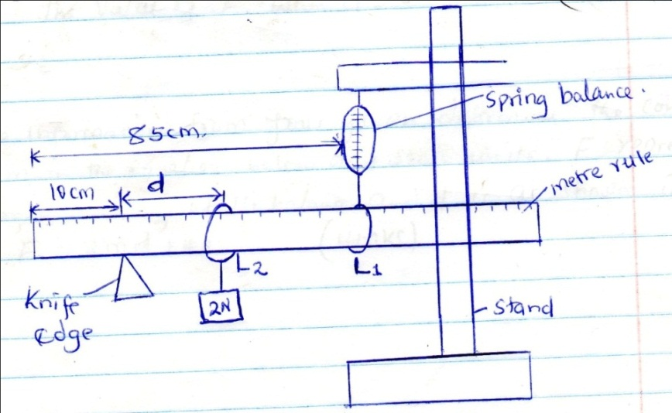

1. Using loop 1 suspended the 2N weight at a distance d=10cm from the knife edge as shown and take the reading of the spring balance, record the results in table 1.
2. Adjust the distance d to 20cm, 30cm e.t.c and each time recording the reading of the balance to complete the table.

Table 1

|  |  |  |  |  |  |  |  |
| --- | --- | --- | --- | --- | --- | --- | --- |
| Distance (d) | 10.0 | 20.0 | 30.0 | 40.0 | 50.0 | 60.0 | 70.0 |
| Force (N) |  |  |  |  |  |  |  |

(7marks)

1. Plot a graph of force F against distance d(cm) (5 marks)

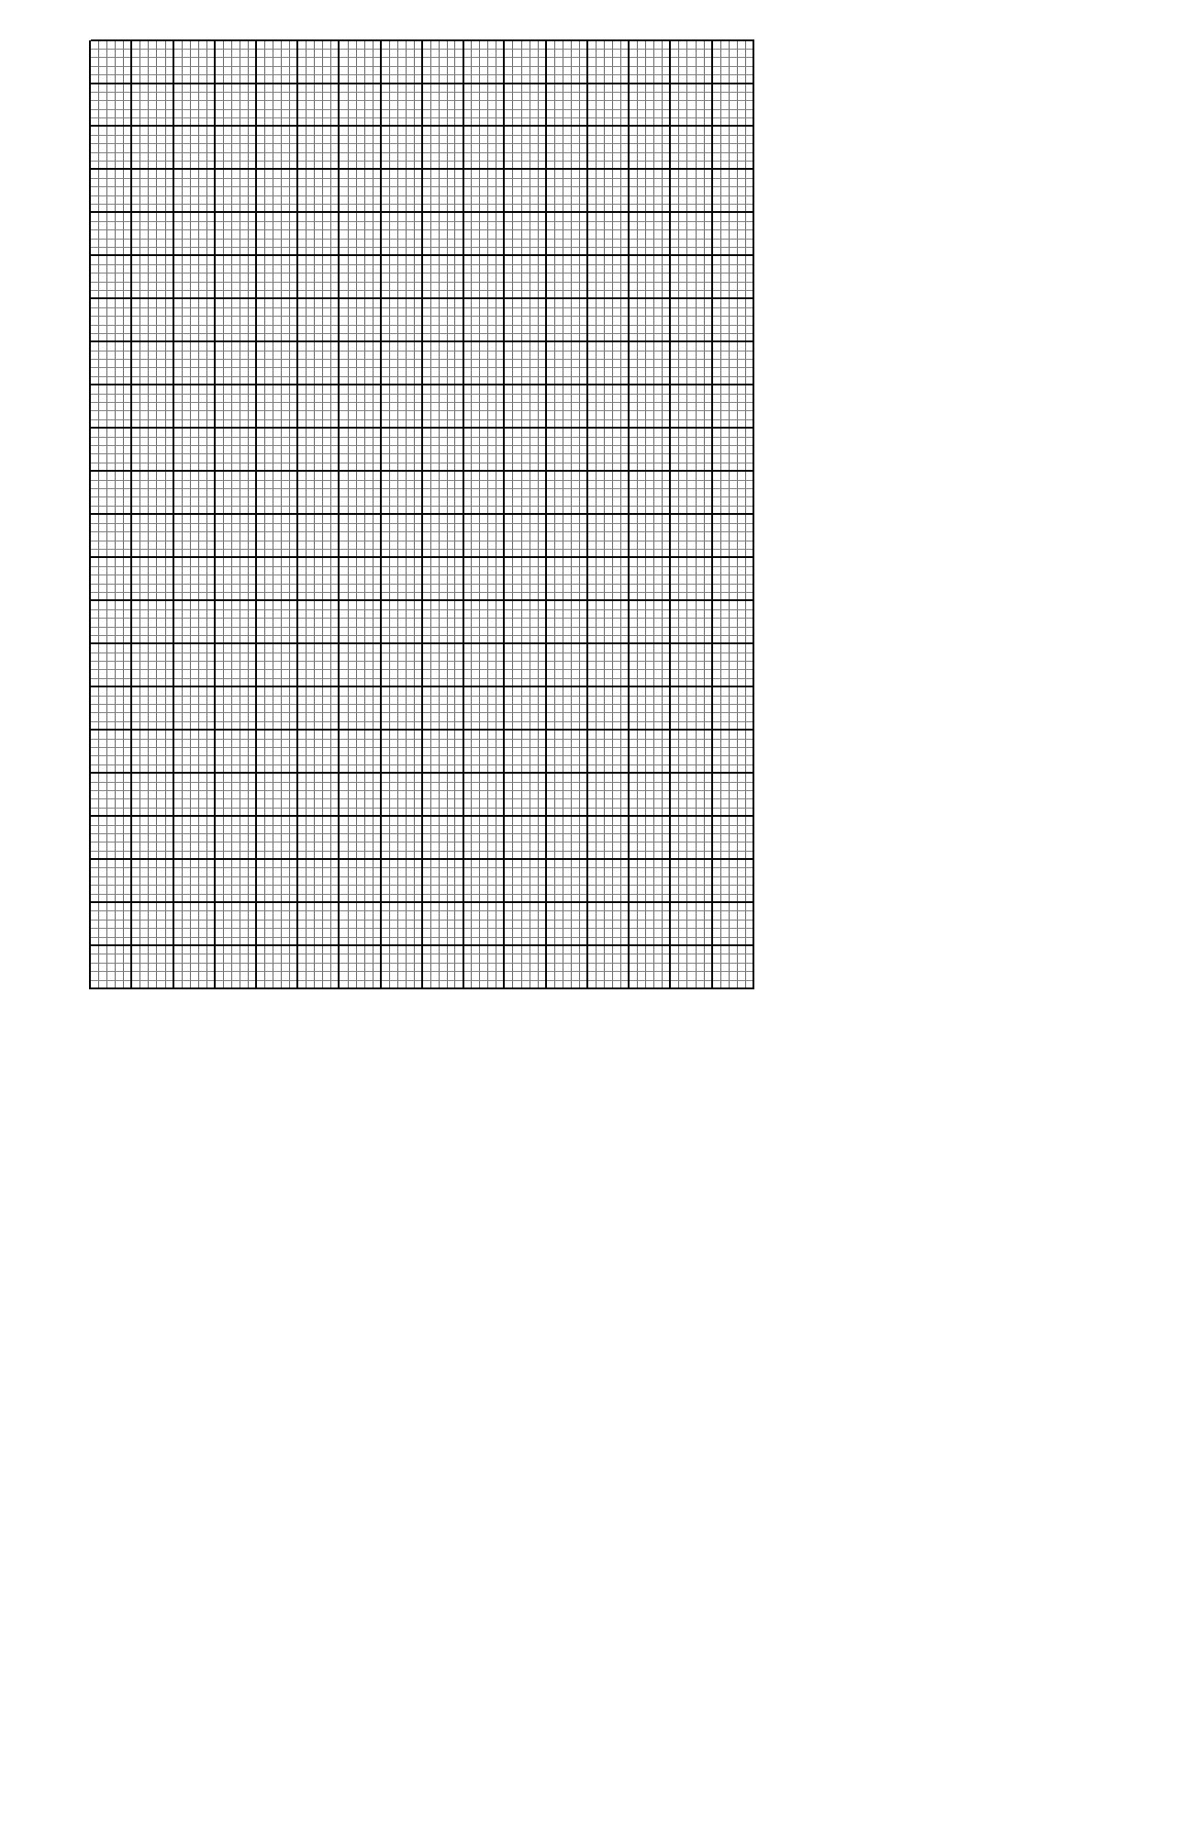

1. From your graph determine:
2. The slope (2mks)
3. The value of F when d=0 (2mks)
4. Using the information from your graph, determine the constant k and m in the equation below and state units, f represents the reading of the balance and d is as shown in the above. **F=2md +40k.** (4marks)

**Question 2**

**PART A**

**You are provided with the following:**

* Two new dry cells and two cell holders
* A resistor labeled Q
* Wire mounted on a millimeter scale
* 6 connecting wires with crocodile clips on one end of at least three
* A voltmeter
* An ammeter
* A switch

**Proceed as Follows:**

(a) Connect the apparatus provided as shown in the figure below.

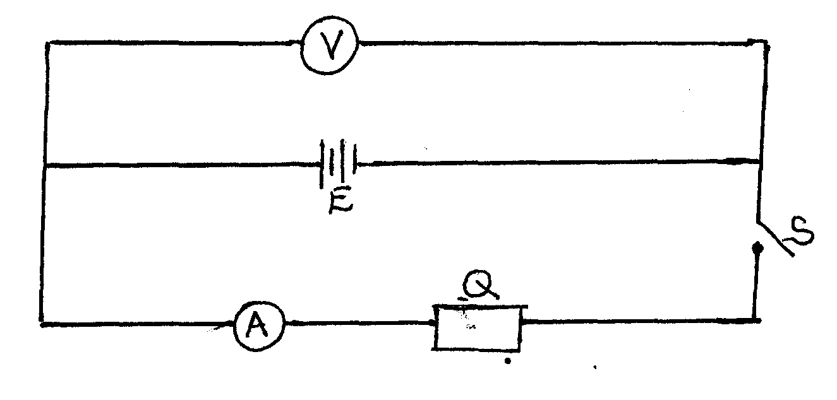

(i) Take the voltmeter reading when the switch S is open.

V1 = ……………………………… volts (1 mark)

(ii) Close the switch S, and take the voltmeter reading V2 and the ammeter reading I

V2 = ………………………………… volts (1 mark)

I1 = …………………………………... Amperes (1 mark)

(iii) Calculate the quantity P = ** (2 marks)

…………………………………………………………………………………………………………………………………………………………………………………………………………………………

(b) Set up the circuit as shown in the figure below

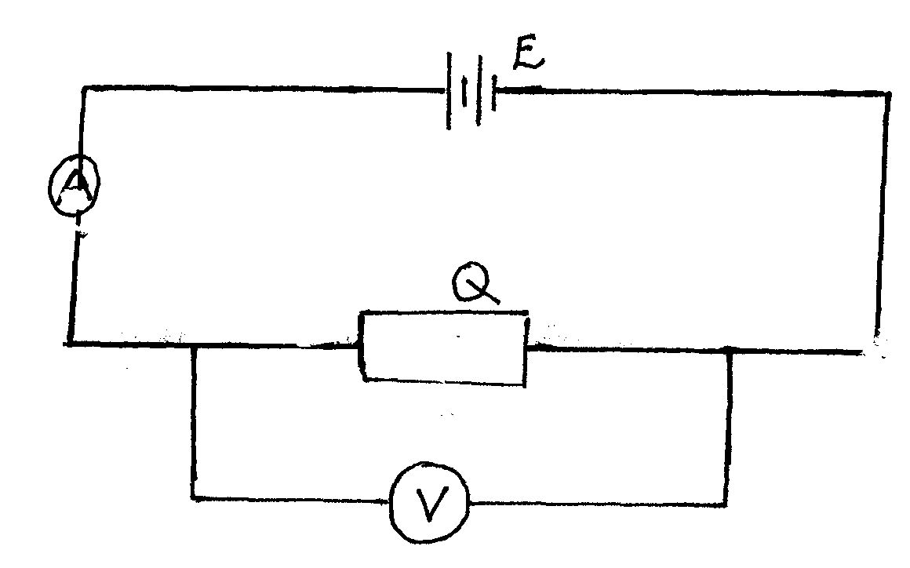

(i) Take the voltmeter reading V and the ammeter reading I. (2 marks)

V = ………………………….

I = ……………………………

(ii) Determine the resistance R of Q (2 mark)

……………………………………………………………………………………………………………………………………………………………………………………………………

(c) Set up the circuit shown in the figure below

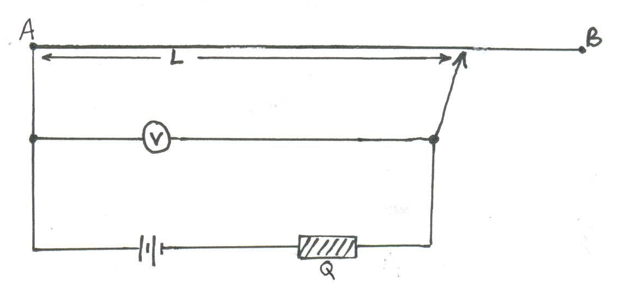

1. Move the crocodile clip along the wire AB to a point such that L = 100cm. Notethe voltmeter reading and record in table 2.
2. Repeat (d) above for values of L = 80cm, 60cm, 40cm, 20cm and 0 cm, tabulate your results. (5 marks)

**Table 2**

|  |  |  |  |  |
| --- | --- | --- | --- | --- |
| **Length L**  **(cm)** | **100** | **80** | **60** | **40** |
|  |  |  |  |  |
| **Voltmeter Reading**  **(V)** |  |  |  |  |
| **()** |  |  |  |  |
| **(V/cm)** |  |  |  |  |

1. Determine the average value of Z. (2 marks)

………………………………………………………………………………………………………………………………………………………………………………………………………………………………………………………………………………………………………………………………………

**PART B**

**You are provided with the following**

* A candle
* A lens and a lens holder
* A screen
* A metre rule

1. Determine the focal length, f by focusing a distant object.

f = …………………….cm (1mark)

1. Set up apparatus as shown in the figure below ensure that the candle flame and the lens are approximately the same height above the bench.

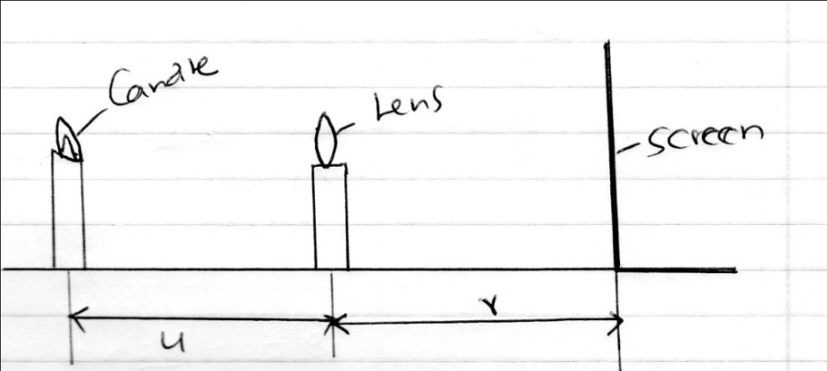

1. Set the position of the lens so that it is 40cm from the candle (u=40cm). Adjust the position of the screen until a sharp image of the candle flame is obtained. Measure the distance (v) between the lens and screen. Record the value of **v** in the table below.
2. Repeat the procedure in (i) above for the other values of u in the table 3 below. Complete the table (3marks)

Table 3

|  |  |  |
| --- | --- | --- |
| **U(cm)** | **40** | **50** |
| **V(cm)** |  |  |
| **Magnification *m=v/u*** |  |  |

THIS IS THE LAST PRINTED PAGE