**232/3/**

**PHYSICS**

**PAPER 3**

**MARKING SCHEME**

1. e)

|  |  |  |  |  |  |  |  |
| --- | --- | --- | --- | --- | --- | --- | --- |
| Distance (cm) | 10 | 20 | 30 | 40 | 50 | 60 | 70 |
| Force (N) | 0.8 | 1.0 | 1.3 | 1.6 | 1.8 | 2.0 | 2.4 |

±0.1 1mark for each correct value -max. 7marks

f)

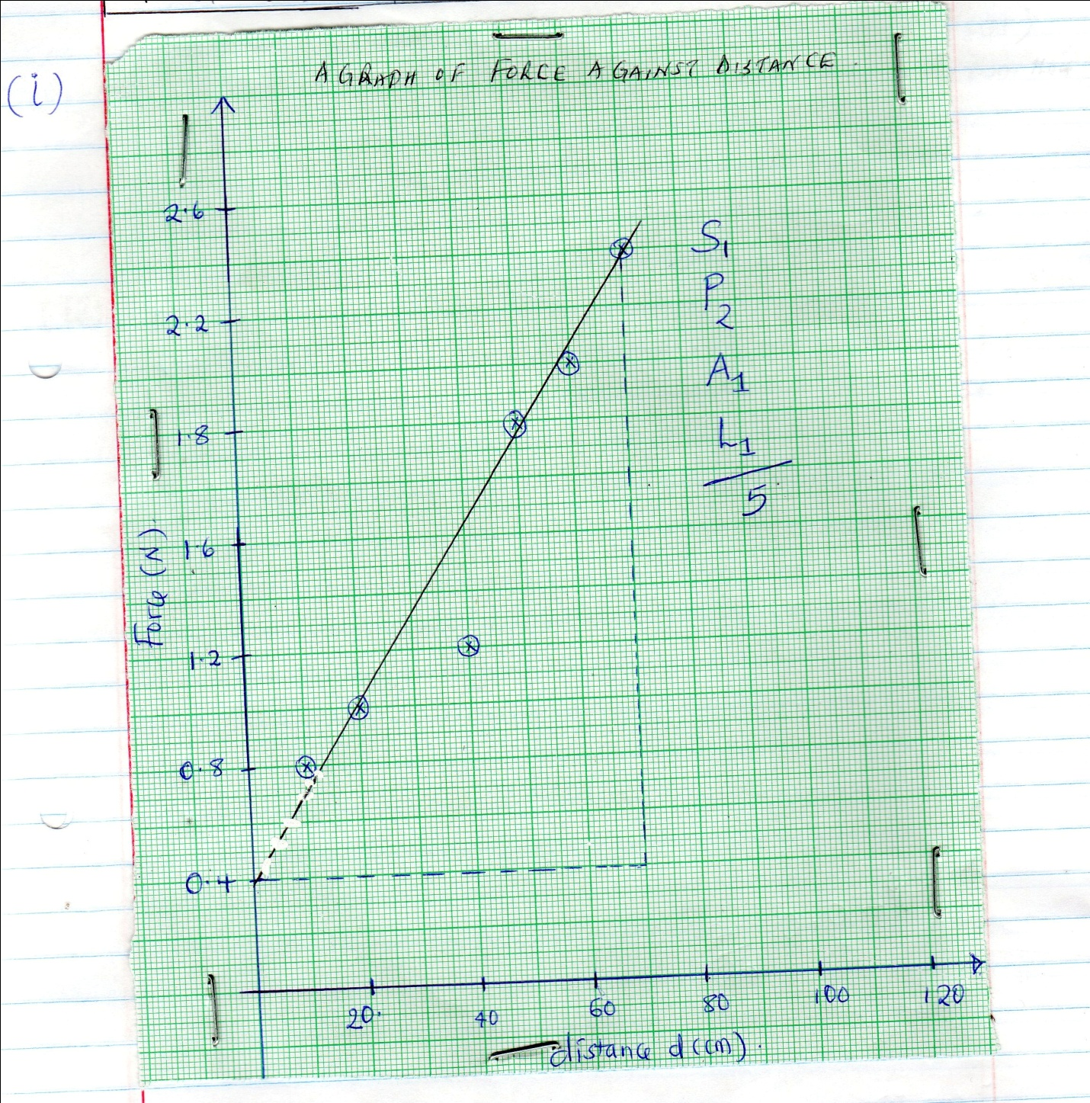

g) (i) The slope

(0, 0.4) (70, 2.4) ½ mk for each change

= 2.0

70

= 0.02857 N/cm 1mk for evaluation, with units ,4s.f or exact

Or 2.857 N/M

ii) When d = 0, Force = 0.4N i.e the y – intercept

(1mk for identify it’s a value for y – intercept)

(1mk for correct reading from the graph)

h) Comparing y = mx +c with F = 2md +40k

Then gradient = 2m

0.02857 = 2m

0.02857= m=0.014375 N/cm

2

Y= intercept = 40k

= 0.4 = 40k√1

40 40

= 0.04

40

0.001N√1

2. a) i) V1 = 3.1 0.1Volts ✓ (1mk) (at least 1 d.p)

ii) V2 = 2.6 0.1V ✓ (1mk) (at least 1 d.p)

I1 = 0.12 0.02A ✓ (1mk) (at least 2 dp)

iii) ✓ (1mk)

b) i) V = 2.2 $±$ 0.1V ✓ (1mk) (at least 1 d.p)

I = 0.22 $±0.02$ A ✓ (1mk) (at least 2 dp)

ii) ✓

1mk for ohms law/ substitution

1mk correct evaluation with correct unit

e)

|  |  |  |  |  |
| --- | --- | --- | --- | --- |
| Length, L (cm) | 100 | 80 | 60 | 40 |
| Length 1/L (1/cm) | 0.0100 | 0.01250 | 0.01667 | 0.0250 |
| Voltmeter  Reading (V)($±0.1$) | 1.5 | 1.3 | 1.1 | 0.9 |
| 1/V (1/V) | 0.6667 | 0.7692 | 0.9091 | 1.111 |
| **V/cm** | 0.01496 | 0.01625 | 0.01834 | 0.02250 |

Allow both rounding off and truncation

- Correct conversion of 1/L ✓ (1mk)

- Voltmeter Reading within range ✓ (1/2mk each) to a max of 2mks

- Correct evaluation of 1/V ✓ (1mk)

- Correct evaluation of Z ✓ (1mk)

(f) Averaging of Z must be shown (1 mark) correct answer (1 mark)

g) f = 20.0 $±$ 1.0 cm 1mk 1d.p a must

(j)

|  |  |  |
| --- | --- | --- |
| U (cm) | 40.0 | 50.0 |
| V (cm) | 41.0 | 34.0 |
| Magnification m=v/u | 1.025 | 0.68 |