Term 2 - 2022
PHYSICS (232/3)
FORM FOUR (4)
PAPER 3 (PRACTICAL)
Time: 2 ½ Hours
MARKING SCHEME

QUESTION ONE
PART A
You are provided with the following:
- Copper wire
- A retort-stand, boss and clamp
- An optical pin mounted on a cork
- A stop watch
- Wire cutters (to be shared)
- A metre-rule or half-metre rule

- Clamp the cork so that the optical pin is horizontal. Hang the copper wire from the pin by the loop as shown in figure 1. Ensure the wire is straight and the length X between the lower tip and the optical pin is 32 cm. If the length exceeds 32 cm reduce by cutting at the lower tip using the wire cutters provided.

table
Retort stand
Copper wire
cork
Optical pin
X
Figure 1
- Displace the lower tip of the wire slightly in a plane perpendicular to the optical pin and then release it. Measure the time t for 20 oscillations of the wire and record the value in table.

- Repeat the procedure in (b) above for other values of X shown in the table. (Note that each length X is obtained by cutting off an appropriate length from the lower tip of the wire. For example, to get X= 28cm cut off 4 cm from the lower end). Complete the table. (6 marks)

Table 1
Length X (cm) | 32 | 28 | 24 | 20 | 16 | 12
Time t for 20 oscillations (S) $±0.2$  @1 mark up to a max of 4  2 d.p a must | 18.56 | 17.37 | 15.87 | 14.94 | 13.09 | 11.21
Period (T = $\frac{t}{20}$(S)  1 mark for All correctly evaluated to 4 SF | 0.9280 | 0.8685 | 0.7935 | 0.7470 | 0.6545 | 0.5605
T² (S²)  1 mark for All correctly evaluated to 4 SF | 0.8612 | 0.7543 | 0.6296 | 0.5580 | 0.4284 | 0.3142
- Plot a graph of T² (y- axis) against X (5 marks)
Scale- 1 mark (simple and uniform); axes- 1 mark (for correctly labelled with units); plotting-@$\frac{1}{2}mark if$correctly plotted up to 2 max

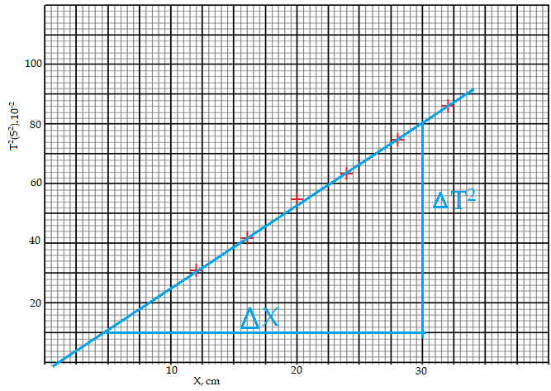
- (i) Determine the slope, S, of the graph (3 marks)
(if from graph, L = 0, then there is no slope)
$s=\frac{∆T^{2}}{∆X}=\frac{0.80-0.10}{30-5};=0.028$;s²/cm; = 2.8s²/m
$correct substitution$; correct evaluation; correct units in s²/cm or s²/m
(ii) Obtain the value of k in the equation: $S= \frac{8π}{3K}$ (2 marks)
$2.8=\frac{8×3.142}{3k};≡k=2.992$m/s²; correct substitution and correct answer with units
PART B
You are provided with the following:
- A cylindrical container
- Some water
- A stop watch
- A metre ruler or half metre rule
- A boiling tube
- Some sand
- A rubber band

Proceed as follows:
- Tie the rubber band round the boiling tube so that it is at a distance L= 12 cm from the bottom of the tube (see fig 2. a). Pour water into cylindrical container until the level is about 2.0 cm from the top of the beaker. Float the boiling tube in the water in the container. Add sand gradually into the boiling tube until the tube sinks to the 12 cm mark. See figure 2 (b).

L
(a) rubber-band

Rubber-band
12 cm

sand
(b) table
water
Boiling tube
Boiling tube

Figure 2

- Depress the boiling tube slightly and release so that is oscillates vertically without touching the sides of the container. Measure and record in table 2 the time t₁, for five oscillations of the boiling tube, Repeat the procedure two more times to obtain t₂, and t₃ and record the values in table 2. Complete the table. (3 marks)

Table 2
Any correct value of t ($±0.2$) ;
Correct averaging ;
Correct evaluation of T ;
t₁ (S) | t₂ (S) | t₃ (S) | Average, t (S)  t = $\frac{t_{1}+t_{2}+t_{3}}{3}$ | $$T=\frac{t}{5} (s)$$
2.90 | 2.53 | 3.00 | 2.81 | 0.562

(h) Evaluate PT = 40L given that L is the length of the tube up to the rubber band in (f) and T is the value obtained in (g) above. (1 mark)

$P×0.562=40×0.12$ $\frac{1}{2}mark for$correct substitution

P = 8.541m/s $\frac{1}{2}mark for$correct evaluation with units

QUESTION TWO

You are provided with the following apparatus:

PART A
- Constantan wire SWG 28 mounted on a mm scale
- Ammeter (0 – 1) A
- Voltmeter (0 –2.5) V
- A jockey
- 6 connecting wires with crocodile clips
- A switch
- A new dry cell and a cell holder
- Micrometer screw gauge to be shared

Proceed as follows:

- Connect the apparatus provided as shown in the circuit below. Measure the voltmeter reading, E when the switch is open.

E = 1.5V ; (1 mark)

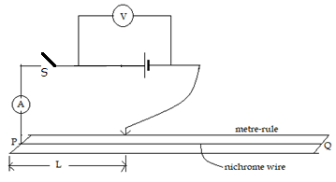
Figure 3
- With the crocodile clip at L = 10 cm, close the switch S and record the ammeter and voltmeter reading.

A = 0.38A ; (1 mark)

V = 1.1V ; (1 mark)

- Repeat the procedure in (b) for other values of l = 15cm, 20cm, 25cm, 30cm, 35cm and record the readings in the table below. (5 marks)

Table 3
Length. L. (cm) | 10 | 15 | 20 | 25 | 30 | 35
Voltmeter reading, V (volts)  ($\frac{1}{2}$ mark @ up to 2.5 maximum) $±0.01$ | 1.10 | 1.15 | 1.20 | 1.25 | 1.30 | 1.35
Ammeter reading, I(A)  ($\frac{1}{2} ,arks up to max. of 2.5$ | 0.38 | 0.26 | 0.24 | 0.23 | 0.20 | 0.18

- Given that V = X – 0.3.I, determine the value of X when L is 20cm (2 marks)
$1.20=X-0.3(0.24)$ ;

X = 1.272V ;

- Measure the diameter d of the wire x using the micrometer screw gauge.

0.33mm

d = 0.00033 m ; (range 0.00031-0.00034) (1mark)

- Dismantle the apparatus and set up the circuit as shown below
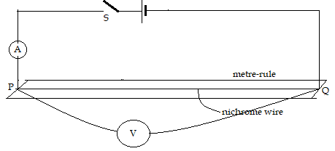
Figure 4
- Close the switch S and record the ammeter and the voltmeter readings

I = 0.10 A ; (1 mark)

V = 1.20 V ; (1mark)

Hence find R, the resistance of the wire.
$R=\frac{V}{I}=\frac{1.20}{0.10}=12$Ω (1mark)
- Given that: R = $\frac{4ρ}{πd^{2}} ,$ determine ρ (2 marks)
$12=\frac{4ρ}{3.142×({0.00033}^{2})};≡ρ=1.026×{10}^{-6}$Ωm²;
$correct substitution and correct answer with units$
PART B
You are provided with the following apparatus.
- Rectangular glass block
- 3 optical pins
- A soft board.
- A plane paper
- 4 paper pins.
- Four tuck pins
Proceed as follows:
- Using the tuck pins, fix the plane paper on the soft board.
Place the rectangular glass block in the middle of the plane paper and trace its outline (as shown in figure 5). Using a pencil. Remove the block.
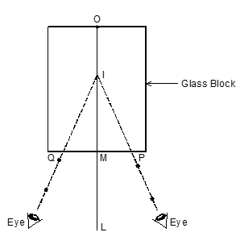
Figure 5

- Construct a perpendicular line LMO bisecting the shorter sides of M and O.
Mark points P and Q such that PM = MQ = 2cm.

Measure OM = 10.2 cm ; ($\frac{1}{2}$ mark)

- Place the plane paper on the soft board and carefully replace the glass block so that it fit the outline. Press the object pin on O such that it is upright and touching glass block and the second pin on P also upright and touching the block.
- Press the third pin P₁ a short distance from the block such that P₁, P and I lie on a straight line when viewed through the block with one eye. I is the image of the object pin O.
- Repeat the experiment with now on Q. Press the third pin P_{²} a short distance from the block such that when viewed P_{²}, Q and I lie in a straight line.

- Remove the pins and glass block; draw the lines P₁PI (PI dotted) and P₂ QI (QI) doted meeting OM at I.

IM = 6.6 cm ; ($\frac{1}{2}$ mark)

- Using the above information, determine, $k$, given that: $A=\frac{l}{k}$, where $l is the length OM$
and A is the length IM (1 mark)
$6.6=\frac{10.2}{k};≡k=1.545$;
$\frac{1}{2}mark for$correct substitution and $\frac{1}{2}mark for$correct answer

- State the significance of $k$ (1 mark)
Refractive index;

NB - Hand in your work on the plane paper as proof of having done the experiment.
($\frac{1}{2}mark for$out-line of glass block on paper and $\frac{1}{2}mark for$visible pin holes) on either side of line OL (1 mark)

This is the last printed page

