**NAME:……………………………..………………ADM NO………..…CLASS:………………….**

**SCHOOL:………….…….………………CANDIDATES SIGNATURE:…………..DATE:…………**

**FORM 4**

**232/2**

**PHYSICS**

**TIME: 2 HOURS**

**THE EAGLE JOINT EXAM-2021**

**TERM I-PREMOCK EXAM**

***INSTRUCTIONS TO THE CANDIDATES***

* *Write your* ***name****,* ***adm number, class and school*** *in the spaces provided.*
* ***Sign*** *and write the* ***date*** *of examination in the spaces provided*
* *Mathematical tables and silent non-programmable calculators may be used.*
* *This paper consists of* ***section A*** *and* ***section B****.*
* *Answer* ***all*** *the questions in* ***section A*** *and* ***section B*** *in the spaces provided.*
* *All working must be clearly shown.*

**For Examiners Use Only: -**

|  |  |  |  |
| --- | --- | --- | --- |
| **SECTION** | **QUESTION** | **MAXIMUM SCORE** | **CANDIDATE’S SCORE** |
| A | 1-10 | 25 |  |
| B | 11 | 13 |  |
| 12 | 10 |  |
| 13 | 12 |  |
| 14 | 12 |  |
| 15 | 8 |  |
| **TOTAL SCORE** |  | **80** |  |

***This paper consists of 13 printed pages. Candidates should check the question paper to ascertain that all pages are printed as indicated and that no question is missing.***

**SECTION A (25 MARKS)**

1. State and explain the effect of polarization in the performance of a simple cell. (2 marks).

………………………………………………………………………………………………………

………………………………………………………………………………………………………

………………………………………………………………………………………………………

………………………………………………………………………………………………………

………………………………………………………………………………………………………

2.Explain why eight dry cells in series cannot be used to start a car engine even though they   
 have the same e.m.f. as the lead acid accumulator (1 mark)

………………………………………………………………………………………………………

………………………………………………………………………………………………………

………………………………………………………………………………………………………

………………………………………………………………………………………………………

3. Figure 1.0 below shows a ray of light incident along the normal. The mirror is rotated at an   
 angle of 15o in a clockwise direction without changing the position of the incident ray.

**Fig. 1.0**

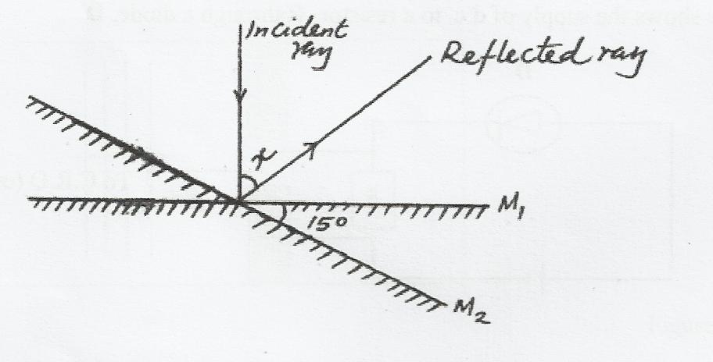

Determine the angle between the reflected ray and the incident ray. (2 marks)

……………………………………………………………………………………………………

………………………………………………………………………………………………………

4. A battery of e.m.f E drives a current of 0.25A when connected to a 5.5 Ω resistor. When the5.5 Ω resistor is replaced with 2.5 Ω resistor the current flowing becomes 0.5 A. Find the emf,   
 **E** and the internal resistance, **r**, of the battery. (4 marks)

………………………………………………………………………………………………………

………………………………………………………………………………………………………

………………………………………………………………………………………………………

………………………………………………………………………………………………………

………………………………………………………………………………………………………

5.a). Figure 2.0 shows a motor connected to a magnetic switch called a relay operated by an   
 ordinary switch S1. Use the information in the figure to answer questions that follow.



**Fig. 2.0**

i). Explain how the relay switches on the motor when S1 is closed. (3 marks)

………………………………………………………………………………………………………

………………………………………………………………………………………………………

………………………………………………………………………………………………………

………………………………………………………………………………………………………

ii). State with a reason the effect on the motor if the iron core is replaced with a steel core and

switch S1 is put on and then off. (2 marks)

………………………………………………………………………………………………………

………………………………………………………………………………………………………

………………………………………………………………………………………………………

………………………………………………………………………………………………………

6. A negatively charged rod is brought near the cap of a leaf electroscope. The electroscope is   
 then earthed momentarily by touching with the finger. Finally, the rod is withdrawn. State and   
 explain the observation made. (2 marks)

………………………………………………………………………………………………………

………………………………………………………………………………………………………

………………………………………………………………………………………………………

7. State any two ways of in increasing the size of an image formed by a fixed pinhole camera.

(2 marks)

………………………………………………………………………………………………………

………………………………………………………………………………………………………

………………………………………………………………………………………………………

………………………………………………………………………………………………………

8. The figure 3.0 below shows a circuit that can be used to verify Ohm’s law

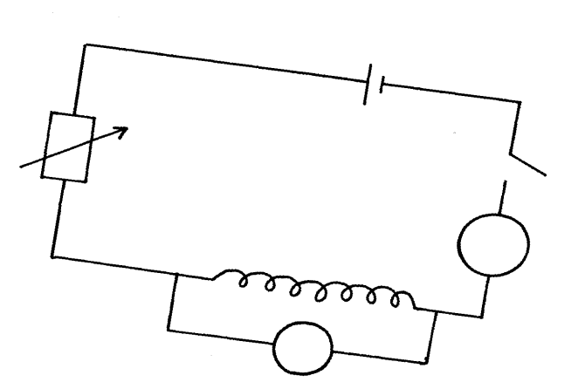

**Fig. 3.0**

**S**

**Rheostat**

**nichrome wire**

**A**

**V**

Explain briefly how the setup can be used to verify ohm’s law (3 marks)

………………………………………………………………………………………………………

………………………………………………………………………………………………………

………………………………………………………………………………………………………

………………………………………………………………………………………………………

9.Other than progressive waves travelling in opposite direction at the same speed, state any other

two conditions necessary for the formation of stationary wave (2 marks)

………………………………………………………………………………………………………

………………………………………………………………………………………………………

………………………………………………………………………………………………………

………………………………………………………………………………………………………

10.Arrange the following radiations in order of their wavelengths: infrared, blue light, ultraviolet,   
 radio waves, X-rays. (2 marks)

………………………………………………………………………………………………………

………………………………………………………………………………………………………

………………………………………………………………………………………………………

………………………………………………………………………………………………………

**SECTION B (55 MARKS)**

11. a) Distinguish between transverse waves and longitudinal waves. (2 marks)

………………………………………………………………………………………………………

………………………………………………………………………………………………………

………………………………………………………………………………………………………

………………………………………………………………………………………………………

………………………………………………………………………………………………………

b) Plane water waves travels from a deep end into a shallow end in a swimming pool at a

velocity of 4m/s. if the wavelength of these waves in deep end is 6cm and in the shallow end

is 1.5cm, determine the velocity of these waves in the shallow end. (3 marks)

………………………………………………………………………………………………………

………………………………………………………………………………………………………

………………………………………………………………………………………………………

………………………………………………………………………………………………………

c) State one factor that affects the velocity of sound in a solid. (1mark)

………………………………………………………………………………………………………

………………………………………………………………………………………………………

………………………………………………………………………………………………………

d) A disc siren with 200 holes is rotated at constant speed making 0.5 revolutions per second. If

air is blown towards the holes, calculate:

i) The frequency of sound produced. (3marks)

………………………………………………………………………………………………………

………………………………………………………………………………………………………

………………………………………………………………………………………………………………………………………………………………………………………………………………………………………………………………………………………………………………………

ii) The wavelength of the sound produced if velocity of sound in air is 340ms-1 (2 marks)

………………………………………………………………………………………………………………………………………………………………………………………………………………………………………………………………………………………………………………………………………………………………………………………………………………………………

c). State one way of reducing echoes in a room? (1 mark)

………………………………………………………………………………………………………………………………………………………………………………………………………………………………………………………………………………………………………………………

12). a) State one major reason why prisms are preferred over mirrors in periscopes. (1 mark)

………………………………………………………………………………………………………………………………………………………………………………………………………………………………………………………………………………………………………………………

b) Figure 4.0 below shows a ray of light incident on one side of a glass prism. Complete the   
 ray diagram to show how the ray is dispersed. (3 marks)

**Fig.4.0**

Screen

White light

c). Light travels from water at a velocity of 2.26x108 ms-1 and enter glass travelling at a velocity

of 2.0x108ms-1 Calculate the refractive index of glass with respect to water. (3 marks)

………………………………………………………………………………………………………

………………………………………………………………………………………………………

………………………………………………………………………………………………………

………………………………………………………………………………………………………

………………………………………………………………………………………………………

d). In a transparent liquid container, an air bubble appears to be 18cm when viewed from end A   
 and 12cm when viewed from end B as shown in figure 5.0 below. Where exactly is the air   
 bubble. If the length of the tank is 40cm? (3 marks)

**Fig. 5.0**



………………………………………………………………………………………………………

………………………………………………………………………………………………………

………………………………………………………………………………………………………

………………………………………………………………………………………………………

………………………………………………………………………………………………………

13.(a) State two factors that determine the capacitance of a parallel plate capacitor (2 marks)

………………………………………………………………………………………………………

………………………………………………………………………………………………………

………………………………………………………………………………………………………

………………………………………………………………………………………………………

(b). Figure 6.0 below shows four capacitors connected to a battery of 12 volts.

**Fig. 6.0**

**2**

**µF**

**5**

**µF**

**8**

**µF**

**12**

**V**

**3.2µF**

Calculate:

i) effective capacitance. (3 marks)

................................................................................................................................................

................................................................................................................................................

................................................................................................................................................

................................................................................................................................................

................................................................................................................................................

ii) charge on 3.2 $μ$ F (2 marks)

………………………………………………………………………………………………

………………………………………………………………………………………………

………………………………………………………………………………………………

………………………………………………………………………………………………

iii) p.d across 5 $μ$ F (2 marks)

………………………………………………………………………………………………

…………………………………………………………………………………………………

…………………………………………………………………………………………………

iv) the energy stored by 2 $μ$ F (2 marks)

………………………………………………………………………………………………………

………………………………………………………………………………………………………

………………………………………………………………………………………………………

………………………………………………………………………………………………………

c). Give one application of capacitors (1 mark)

………………………………………………………………………………………………………

………………………………………………………………………………………………………

14a). An object **O** stands on the principal axis of a concave mirror as shown in figure 7.0 below.

**Fig 7.0**

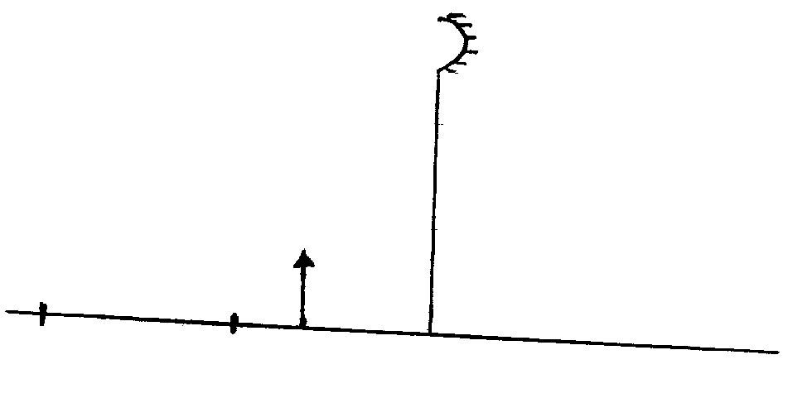

**C**

**F**

**O**

b) By drawing suitable rays, show the position of the image (3 marks)

c). Determine the magnification of the image formed (2 marks)

………………………………………………………………………………………………………

………………………………………………………………………………………………………

………………………………………………………………………………………………………………………………………………………………………………………………………………

d). In an experiment to determine the focal length of a converging lens, a group of form

four students collected some data and used the results to plot the graph shown in figure

8.0 below.

**Fig 8.0**

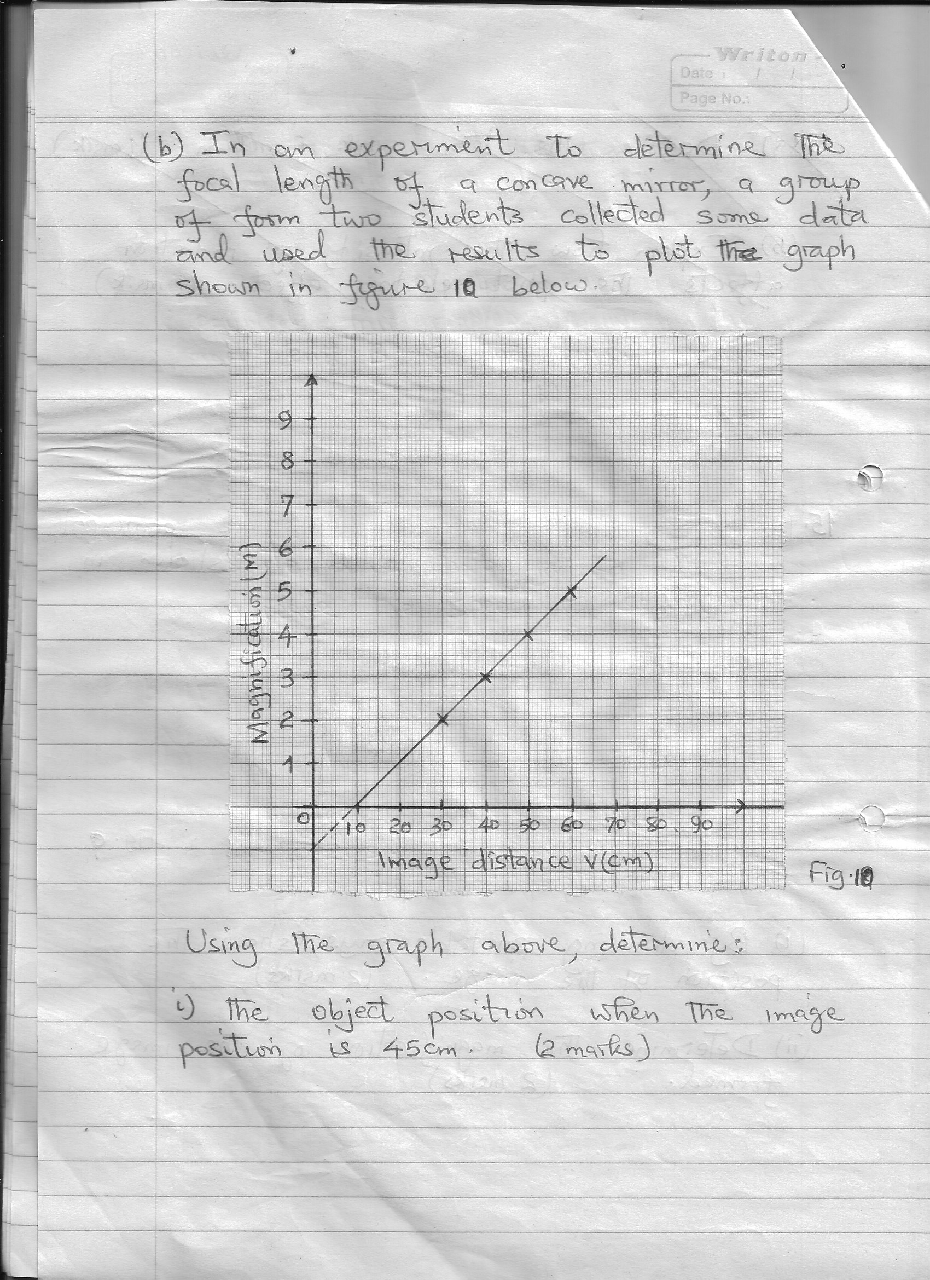

Using the graph above, determine:

(i) The object position when the image position is 45 cm (3 marks)

………………………………………………………………………………………………………………………………………………………………………………………………………………………………………………………………………………………………

………………………………………………………………………………………………

…………………………………………………………………………………………

(ii) Slope of the graph. (2 marks)

………………………………………………………………………………………………………………………………………………………………………………………………………………………………………………………………………………………………

(iii). The focal length of the lens given m = $\frac{v}{f}$- 1 (2 marks)

**………………………………………………………………………………………………………**

**………………………………………………………………………………………………………………………………………………………………………………………………………………**

**………………………………………………………………………………………………………**

15.) The figure 9.0 below shows a circuit with a coil used to warm oil in a beaker.

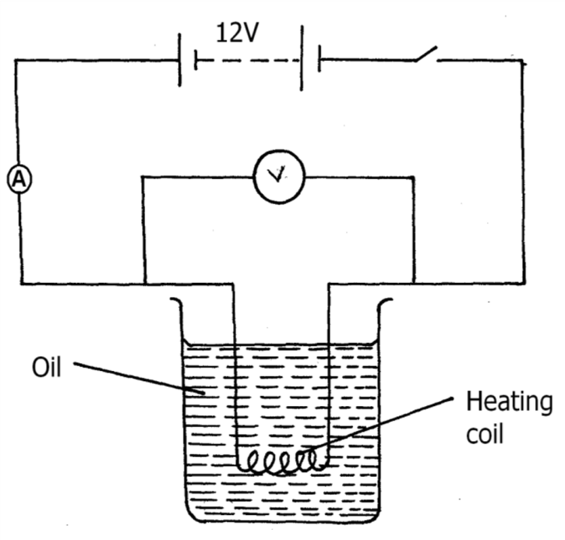

**Fig 9.0**

i). Explain how heat is produced in the coil (2 marks)

………………………………………………………………………………………………………

………………………………………………………………………………………………………

………………………………………………………………………………………………………

………………………………………………………………………………………………………

………………………………………………………………………………………………………

………………………………………………………………………………………………………

ii) Given that the reading of the ammeter is 2.4A determine the resistance of the coil. (3 marks)

………………………………………………………………………………………………………

………………………………………………………………………………………………………

………………………………………………………………………………………………………

………………………………………………………………………………………………………

iii). How much heat is produced in the coil in a minute? (3 marks)

………………………………………………………………………………………………………

………………………………………………………………………………………………………

………………………………………………………………………………………………………

………………………………………………………………………………………………………

**THIS IS THE LAST PRINTED PAGE**