**NAME……………………………………………………………… CLASS……………………ADM NO……………**

**SIGNATURE…………….. INDEX NO……………………… DATE………………**

**232/2**

**PHYSICS**

**PAPER 2**

**2022**

**TIME:2 Hours**

**FORM 4 END TERM 2 EXAMINATION**

***Kenya Certificate of Secondary Education***

***Physics Paper 2***

**INSTRUCTION TO CANDIDATES.**

. Write your ***name*** and ***admission number*** in the spaces provided above

. This paper contain ***two sections***; Section I and Section II.

. Answer all the questions in section **I** and II. In the spaces provided

. All workings and answers **must** be written on the question paper in the spaces provided below each question.

. Marks may be given for correct working even if the answer is wrong.

. Calculators and KNEC Mathematical tables may be used EXCEPT where stated otherwise.

. Show all the steps in your calculations, giving your answers at each stage in the spaces below each question.

***FOR EXAMINER’S USE ONLY***

|  |  |  |  |
| --- | --- | --- | --- |
| **SECTION** | **QUESTION** | **MAX MARKS** | **CANDIDATE’S SCORE** |
| **A** | **1-13** | **25** |  |
| **B** | **14** | **10** |  |
| **15** | **10** |  |
| **16** | **08** |  |
| **17** | **09** |  |
| **18** | **10** |  |
| **19** | **08** |  |
|  | **TOTAL** | **80** |  |

**SECTION A 25 MKS**

1. Give a reason when light strikes a mirror at 900, it is reflected along the same path (1 mark)

……………………….………………………………………………………………………………………………………… ………………………………….………………………………………………………………………………………………

1. The figure below shows an electroscope that is being charged.

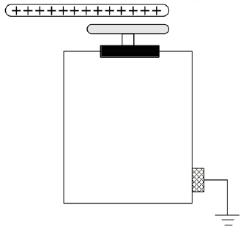

If the final charge on an electroscope is positive

a) State the method of charging that produces the above electroscope to be positively charged (1 mark)

………………………………………………………………………………………………………………

………………………………………………………………………………………………………………

b) Explain how the final charge was acquired (2 marks)

………………………………………………………………………………………………………………………………………………………………………………………………………………………………………………………………………………………………………………………………………………………………………………………………………………………………………………………………………………………………………………………………………………………………………………………………………………………………………………………………………………………

1. Give the formula relating to the Emf of a cell, the internal resistance, r, and the terminal voltage, V and the current, I in a closed circuit (1 mark)

…………………………………………………………………………………………………………………………………………………………………………………………………………………………………………………………………………

1. Give a reason why parabolic reflectors are used as car headlight lamps. (1 mark)

…………………………………………………………………………………………………………………………………………………………………………………………………………………………………………………………………………

1. A current of 2A flows through a conductor for 2.5minutes. If the electronic charge is 1.6 x 10-19 C, calculate the number of electrons involved. (3marks)

…………………………………………………………………………………………………………………………………………………………………………………………………………………………………………………………………………………………………………………………………………………………………………………………………………………………………………………………………………………………………………………………………………………………………………………………………………………………………………………………………………………………

1. Give one reason why Ultra sound is used in pulse echo techniques in determining the depth of the sea. (1 mark)

……………………………………………………………………………………………………………………………………………..…………………………………………………………………………………………………………………………………………………………………………………………………………………………………………………………………………………………………………………………………………………………………………………………………..

1. The figure below is drawn to scale. Use this information on the figure to answer the questions that follow;

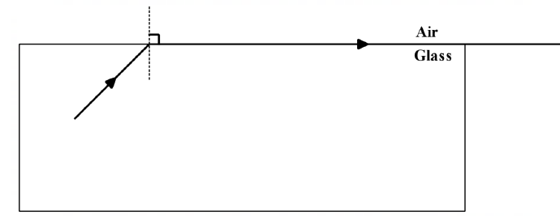

Determine the refractive index of the glass material. (2 marks)

…………………………………………………………………………………………………………………………………………………………………………………………………………………………………………………………………………………………………………………………………………………………………………………………………………………………………………………………………………………………………………………………………………………………………………………………………………………………………………………………………………………………

1. a) i) What is a virtual image? (1 mark)

…………………………………………………………………………………………………………………………………………………………………………………………………………………………………………………………………………………………………………………………………………………………………………………………………………….

ii) Complete the ray diagram in figure 3 below so as to form an image. (3 marks)

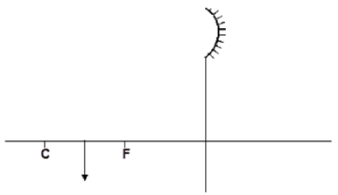

1. Three capacitors of capacitance 20μF are arranged as shown below. Find the Reading on the voltmeter across the 20μF shown in the following diagram. (3 marks)

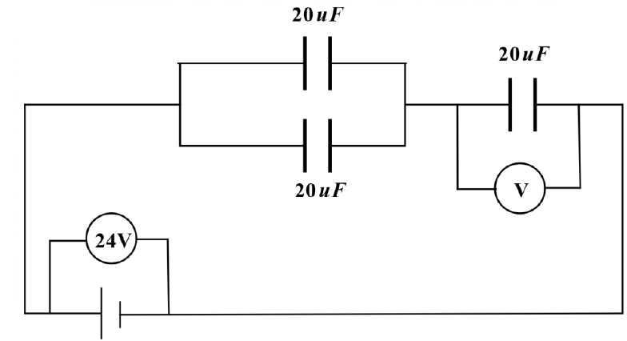

.…………………………………………………………………………………………………………………………………………………………………………………………………………………………………………………………………………………………………………………………………………………………………………………………………………………………………………………………………………………………………………………………………………………

1. In an experiment to magnetize two substances P and Q using electric current, two curves were obtained as shown below. State with a reason which substance will be used as an armature in an electric bell. (2 marks)

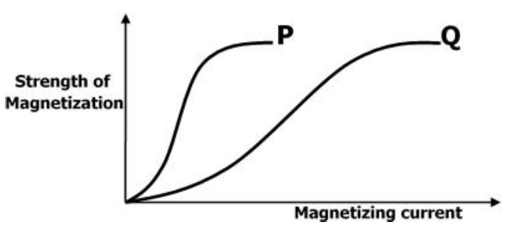

.…………………………………………………………………………………………………………………………………………………………………………………………………………………………………………………………………………………………………………………………………………………………………………………………………………………………………………………………………………………………………………………………………………………

1. State the function Argon and Nitrogen in a fluorescent lamp. (1 mark)

……………………………………………………………………………………………………………………………………

……………………………………………………………………………………………………………………………………

1. Distinguish between thermionic emission and photoelectric effect. (1mark)

……………………………………………………………………………………………………………………………………

……………………………………………………………………………………………………………………………………

……………………………………………………………………………………………………………………………………

1. The following is part of a radioactive decay series.

$${234 \atop 83}Bi\underset{→}{ β }{a \atop 84}X \underset{→}{ ∝ }{230 \atop b}Y$$

Determine the values of a and b (2mark)

……………………………………………………………………………………………………………………………………

…………………………………………………………………………………………………………………………………………………………………………………………………………………………………………………………………………

**SECTION B**

1. a) Explain in terms of flow of electric charges why a thin wire feels warmer than copper leads in the same current (1 mark)

……………………………………………………………………………………………………………………………………………………………………………………………………………………………………………………………………………………………………………………………………………………………………………………………………………………………………………………………………………………………………………………………………………………

b) i) State the main energy changes that take place in a filament lamp (1 mark)

…………………………………………………………………………………………………………………………………………………………………………………………………………………………………………………………………………

ii) Name any two factors affecting the heating effect of an electric current (2 marks)

…………………………………………………………………………………………………………………………………………..................……………………………………………………………………………………………………………

iii) Give a reason why tungsten wire is used in a filament bulb. (1 mark)

…………………………………………………………………………………………………………………………………………..................……………………………………………………………………………………………………………

c) A light bulb is found to have a resistance of 950Ω. When operating normally on a 240V mains.

Calculate

i) Power rating of the Bulb (2 marks)

……………………………………………………………………………………………………………………………………

……………………………………………………………………………………………………………………………………

……………………………………………………………………………………………………………………………………

…………………………………………………………………………………………………………………………………

ii) Electric energy converted to heat and light when the bulb operates for 2 hours (3 marks)

……………………………………………………………………………………………………………………………………

……………………………………………………………………………………………………………………………………

……………………………………………………………………………………………………………………………………

……………………………………………………………………………………………………………………………………

1. (a) The mirror AB and CD are at right angles to each other.

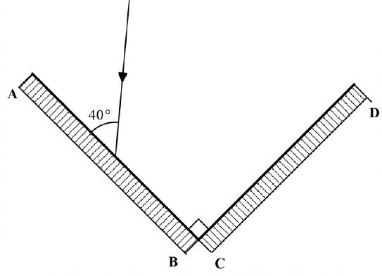

Complete the diagram to show the path taken by the ray PQ after reflection at both mirrors. (2 marks)

(b) The figure below shows two point sources of light with an opaque object placed between them and the screen.

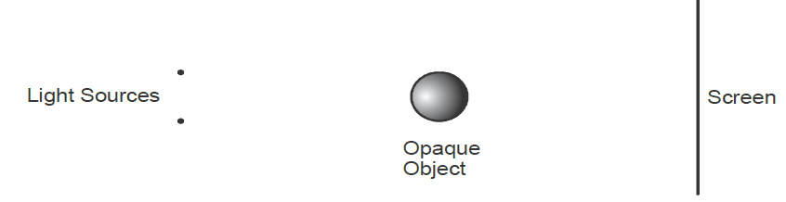

Complete the diagram to show the nature of the shadows formed. Label the shadows. (2 marks)

c) State the changes that would occur in the size and brightness of the image formed if:

i. The object distance is made large (1 mark)

……………………………………………………………………………………………………………………………………

……………………………………………………………………………………………………………………………………

……………………………………………………………………………………………………………………………………

ii. The length of the camera is made longer (1 mark)

……………………………………………………………………………………………………………………………………

……………………………………………………………………………………………………………………………………

iii. The single hole is replaced by four pinholes close together (1 mark)

……………………………………………………………………………………………………………………………………

……………………………………………………………………………………………………………………………………

……………………………………………………………………………………………………………………………………

d) The diagram below shows sound waves passing through air. Study it and answer the questions that follow.

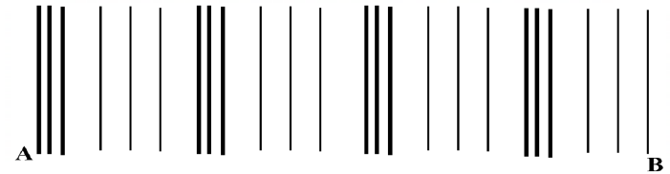

Label the following (3 marks)

i. Compression

ii. Rarefaction

iii. Wavelength

1. a) State the functions of carbon brushes in an electric motor. (1 mark)

……………………………………………………………………………………………………………………………………

……………………………………………………………………………………………………………………………………

b). Why are carbon brushes and commutators made of graphite in an electric motor? (1 mark)

……………………………………………………………………………………………………………………………………

……………………………………………………………………………………………………………………………………

c) The figure below shows a conductor carrying current placed in the magnetic field and moves in the direction shown

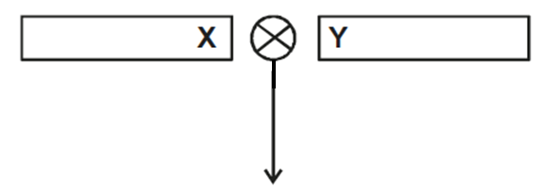

Identify the polarity of end X. (1 mark)

X – …………………………………………………………………

d) The figure below shows a simple electro magnet for lifting heavier container loads in the kilindini port in Mombasa city in Kenya.

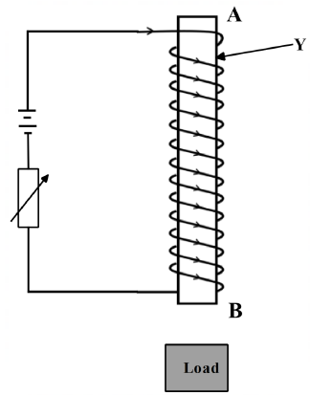

i) Which material is Y made from? Explain why it is a preferred choice for its use in the above diagram? (2 marks)

………………………………………………………………………………………………………………………………………………………………………………………………………………………………………………………………………………………………………………………………………………………………………………………………………………………………………………

ii) State the polarity of B (1 mark)

……………………………………………………………………………………………………………………………………

iii) Explain one way in which the electromagnet can be made more powerful (1 mark)

………………………………………………………………………………………………………………………………………………………………………………………………………………………………………………………………………………………………………………………………………………………………………………………………………………

(e) In an experiment on use of semiconductor diodes, it was noted that bulb X in figure below lights while bulb Y does not. Explain. (1mark)

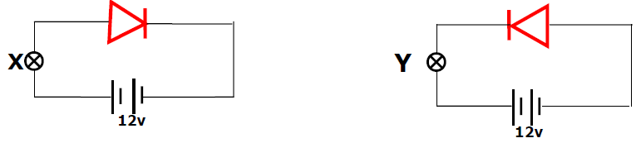

……………………………………………………………………………………………………………………………………………………………………………………………………………………………………………………………………………………

1. a) State the properties of X-rays, which makes it possible to detect cracks in bones. (1mark)

………………………………………………………………………………………………………………………………………………………………………………………………………………………………………………………………………………………………………………………………………………………………………………………………………………

1. Figure below shows the features of an X-ray tube.

**D**

**C**

**A**

**B**

**Oil in**

**Oil out**

i) Name the parts marked with letters A and B (1mark)

………………………………………………………………………………………………………………………………………………………………………………………………………………………………………………

ii) State and explain which material is suitable for part C. (1mark)

………………………………………………………………………………………………………………………………………………………………………………………………………………………………………………

iii) State the reason why the machine should be surrounded by D. (1mark)

………………………………………………………………………………………………………………………………………………………………………………………………………………………………………………

iv) State one way in which cooling is achieved in this X-ray machine. (1mark)

………………………………………………………………………………………………………………………………………………………………………………………………………………………………………………………………………………………………………………………………………………………………………

1. The figure below shows the trace on the screen of an a.c signal connected to the y-plates of C.R.O with time base on.

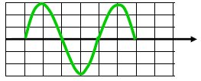

Given that the time control is 5ms/div, and the y-again is at 100V/div, determine:

i) The frequency of the a.c signal. (2marks)

…………………………………………………………………………………………………………………………………………………………………………………………………………………………………………………………………………………………………………………………………………………………………………………………………………………………………………………………………………………………………………………..

ii) The peak voltage of the input signal (2marks)

……………………………………………………………………………………………………………………………………………………………………………………………………………………………………………………………………………………………………………………………………………………………………………………………………………………………………………………………………………………………………………………

1. a) (i) Name one type of electromagnetic radiation whose frequency is greater than that of visible light but less than that of gamma rays. (1mark)

…………………………………………………………………………………………………………………………………………………………………………………………………………………………………………………………………………

(ii) Arrange the following in order of increasing frequencies: Red, Green, Yellow, Blue. (1mark)

…………………………………………………………………………………………………………………………………………………………………………………………………………………………………………………………………………

1. The figure below shows an object placed in front of a convex lens.

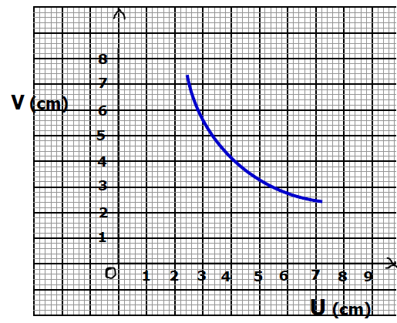

i) On the same figure indicate a point X where the object distance is equal to the image distance of the lens. (1 mark)

Use the point X in (a) above to determine;

ii) The radius of curvature (2 marks

………………………………………………………………………………………………………………………………………………………………………………………………………………………………………………………………………………………………………………………………………………………………………………………………………………………………………………

iii) Focal length of the lens (1 mark)

………………………………………………………………………………………………………………………………………………………………………………………………………………………………………………………………………………………………………………………………………………………………………………………………………………………………………………

iv) Calculate the magnification of the mirror at point X from the graph (1 mark)

…………………………………………………………………………………………………………………………………………………………………………………………………………………………………………………………………………………………………………………………………………………………………………………………………………………………………………….

c) The figure below shows the waves starting from two coherent sources S1 and S2

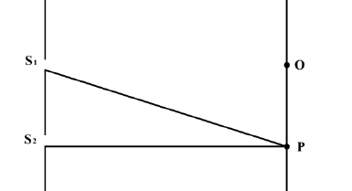

**K**

What would be observed at K if the waves are;

(i) light waves. (1 mark)

…………………………………………………………………………………………………………………………………………………………………………………………………………………………………………………………………………

(ii) Sound waves. (1 mark)

…………………………………………………………………………………………………………………………………………………………………………………………………………………………………………………………………………

c) Complete how the wave fronts emerge from the concave lens below. (1 mark)

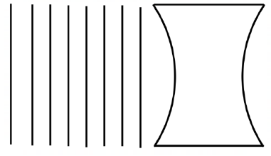

Deep shallow Deep

1. a) The figure below shows a circuit diagram for a photocell.

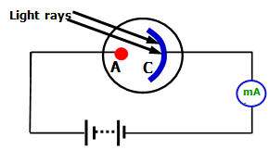

i) Name the part labeled A (1mark)

…………………………………………………………………………………………………………………………………………………………………………………………………………………………………………………………………………

ii) Why is the milliammeter showing a deflection when ultraviolet light is shown on the photocell? (1mark)

………………………………………………………………………………………………………………………………………………………………………………………………………………………………………………………………………………………………………………………………………………………………………………………………………………

iii) State how the milliameter reading is affected when the intensity of light is increased. (1mark) ………………………………………………………………………………………………………………………………………………………………………………………………………………………………………………………………………………………………………………………………………………………………………………………………………………

1. The graph below shows the relationship between the emf (E) and the current I flowing through a cell of internal resistance, r.

*2.00*

*1.75*

*1.50*

*1.25*

*1.00*

*0.75*

*0.50*

*0.25*

*0*

*Voltage (V)*

*Current (I)*

*0.5 1.0 1.5 2.0 2.5 3.0 3.5 4.0 4.5 5.0 5.5 6.0*



From the graph determine;

i) Emf of the cell (1 mark)

………………………………………………………………………………………………………………………………………………………………………………………………………………………………………………………………………………………………………………………………………………………………………………………………………………………………………………

ii) the internal resistance r of the cell (2 marks)

………………………………………………………………………………………………………………………………………………………………………………………………………………………………………………………………………………………………………………………………………………………………………………………………………………………………………………

(c) Two coils T and S are wound on a soft iron core as shown. T has 1000 turns while S has 600 turns and resistance of 100Ω

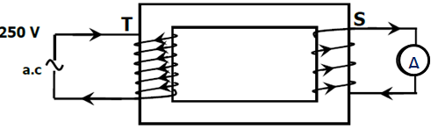

Calculate the maximum current measured by the ammeter. (2marks)

…………………………………………………………………………..…………………………………………………………………………………………………………………………………..…………………………………………………………………………………………………………………………………..………………………………………………………

**THIS IS THE LAST PRINTED PAGE**

