Term 2 - 2022
PHYSICS (232/2)
FORM FOUR (4)
PAPER 2
Time: 2 Hours

Name: …………………………………………………………. Adm No: ……………….
School: ……………………………………………………….. Class: …………………..
Signature: ……………………………………………………..Date: ……… …..

Instructions to candidates
(a) Write your name, index number in the spaces provided above.
(b) Sign and write the date of the examination in the spaces provided
(c) This paper consists of TWO Sections: A and B.
(d) Answer ALL the questions in section A and B in the spaces provided.
(e) All working MUST be clearly shown.
(f) KNEC mathematical tables and silent non-programmable electronic calculators may be used.
(g) This paper consists of 13 printed pages
(h) Candidates should check the question paper to ascertain that all the pages are printed as indicated and that no questions are missing
(i) Candidates should answer the questions in English

For examiners use only

Section | Question | Maximum score | Candidates score
A | 1-15 | 25
B | 16 | 11
 | 17 | 11
 | 18 | 10
 | 19 | 11
 | 20 | 12
TOTAL SCORE |  | 80

Section A (25 marks)

- The fig. 1 below shows a voltmeter before and after use to take the emf of a cell.
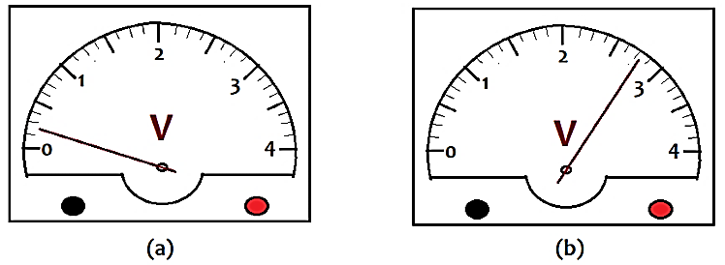
Record the value of emf of the cell. (2 marks)
………………………………………………………………………………………………………………………………………………………………………………………………………………………………………………………………………………………………………………………

- The chart below shows an arrangement of different parts of the electromagnetic spectrum.

Radio wave | A | B | Visible light | C | D | Gamma Rays

(i) Name the radiation represented by C. (1 mark)

……………………………………………………………………………………………..

(ii) Name a device that can be used to detect radiation A. (1 mark)

………………………………………………………………………………………………

- Figure 2 below shows a set-up of a simple cell.
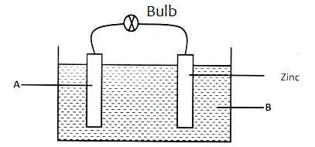

- Name the material used in part A (1 marks)
……………………………………………………………………………………………………
- Name the electrolyte B. (1 mark)
……………………………………………………………………………………………………

- The fig. 3 below shows a ray incident to a concave lens.
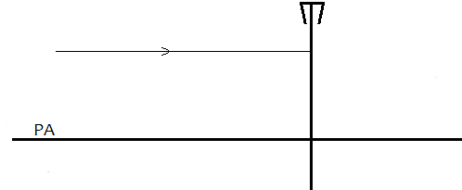
Draw on the diagram to show the resulting ray. (1mark)

- The figure 4 below shows a magnet and a solenoid in relative motion.

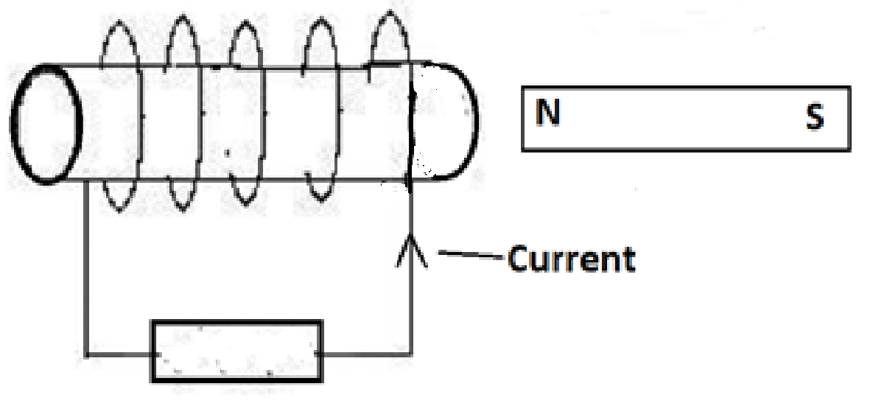
If the current shown was induced current indicate the motion of the magnet. (1mark)

- Figure 5 represents a displacement – time graph for a wave.
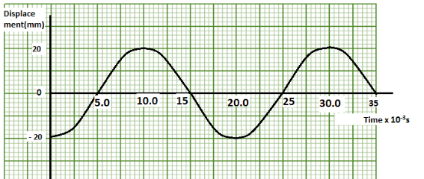

Determined the frequency of the wave. (2marks)

………………………………………………………………………………………………………………………………………………………………………………………………………………

- State the reasons for the following in the filament bulb:
- Inside is filled with inert gas at low pressure. (1 mark)

………………………………………………………………………………………………………
- The filament is coiled. (1 mark)

………………………………………………………………………………………………………

- A girl standing at a distance claps her hands and hears an echo from a tall building 2 seconds later. If the speed of sound in air is 340m/s, determine how far the building is. (3marks)

………………………………………………………………………………………………………………………………………………………………………………………………………………………………………………………………………………………………………………………
- In an experiment to magnetize an iron bar by single stroke method, the graph below was plotted.
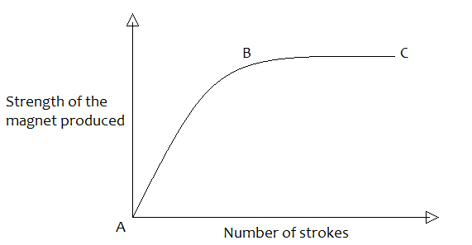

Explain what is happening between points AB and BC. (2marks)
AB ………………………………………………………………………………………………………

BC ………………………………………………………………………………………………………

- State two ways of confirming that an accumulator is fully charged. (2marks)

………………………………………………………………………………………………………………………………………………………………………………………………………………

- The fig. 6 below shows an electrical appliance with leads labelled Red, Black and Green.

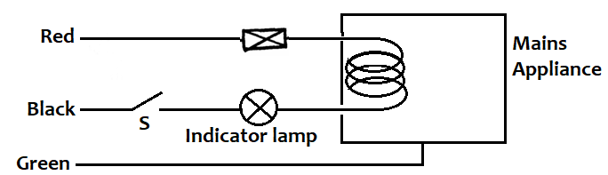

Identify one mistake in the connection. (1 mark)

………………………………………………………………………………………………………………………………………………………………………………………………………………

- Figure 7 below shows a perfectly efficient transformer. The number of turns in the secondary coil S is six times that of the primary coil P.
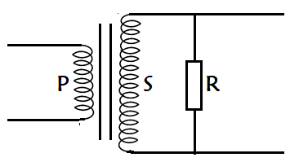

If a supply voltage of 4V d.c is connected across P, state with reason what happens to the voltage across R (2 marks).

………………………………………………………………………………………………………………………………………………………………………………………………………………

- Explain what is meant by radioactive decay. ( 1 mark)

……………………………………………………………………………………………………………………………………………………………………………………………………………………………………………………………………………………………………………………

- A part from the field, state two ways of increasing the magnitude of current generated. (2 marks)
………………………………………………………………………………………………………………………………………………………………………………………………………………

- State one structural difference between a.c and d.c generators. (1 mark)

………………………………………………………………………………………………………………………………………………………………………………………………………………

Section B (55 marks)

- a. State one application of each of the following. (2marks)
    - Convex mirror

……………………………………………………………………………………..

    - Parabolic mirror

……………………………………………………………………………………..

  - Fig. 9, which is drawn to a scale of 1:5, represents an object O and its image ‘I’ formed by a concave mirror.
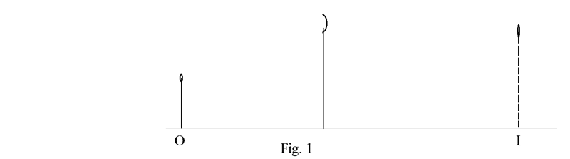

By drawing suitable rays, locate and mark on the figure the position of the principal focus ‘F’ of the mirror. Determine the focal length f. (3 marks)
………………………………………………………………………………………………………………………………………………………………………………………………………………
  - The graph in Fig. 10 shows the variation of magnification, M with image distance, V for a concave mirror.
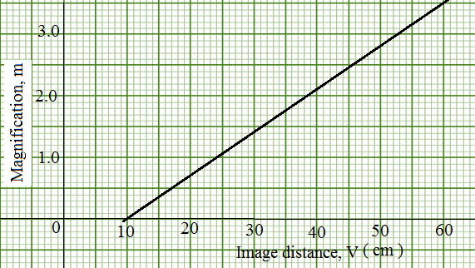
Determine:
- The object position when the image position is 45cm. (3marks)

………………………………………………………………………………………………………………………………………………………………………………………………………………………………………………………………………………………………………………………

- The focal length of the mirror. (1mark)

………………………………………………………………………………………………………………………………………………………………………………………………………………

d) state two reasons why a concave mirror is used as a doctor’s dental mirror. (2 marks)

………………………………………………………………………………………………………………………………………………………………………………………………………………………………………………………………………………………………………………………

- (a) State two factors that determine the capacitance of a parallel place capacitor. (2marks)

………………………………………………………………………………………………………………………………………………………………………………………………………………………………………………………………………………………………………………………

- A 5μF capacitor is charged to a potential difference of 200V and isolated. It is then connected to a 10μf capacitor.

Find ;
(i) The resultant potential difference across the combination (3marks)

………………………………………………………………………………………………………………………………………………………………………………………………………………………………………………………………………………………………………………………

(ii) Energy stored before connection (3marks)

………………………………………………………………………………………………………………………………………………………………………………………………………………………………………………………………………………………………………………………

(iii) Total energy in the capacitors after connection. (2marks)

………………………………………………………………………………………………………………………………………………………………………………………………………………………………………………………………………………………………………………………

(c) Give two applications of capacitors (2 marks)

………………………………………………………………………………………………………………………………………………………………………………………………………………………………………………………………………………………………………………………
- a) In an experiment to observe interference of light waves a double slit is placed close to the source. See figure 12
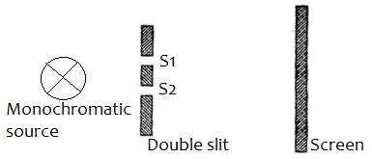

(i) What is a monochromatic source of light. (1 mark)

………………………………………………………………………………………………………………………………………………………………………………………………………………

(ii) State the function of the double slit ( 1 mark)

………………………………………………………………………………………………………………………………………………………………………………………………………………

(iii) Describe what is observed on the screen ( 1marks)

………………………………………………………………………………………………………………………………………………………………………………………………………………………………………………………………………………………………………………………

(iii) State what is observed on the screen when
I. The slit separation S₁S₂ is reduced ( 1 mark)

………………………………………………………………………………………………………………………………………………………………………………………………………………

II. White light source is used in place of monochromatic source ( 1 mark)

………………………………………………………………………………………………………………………………………………………………………………………………………………

b) During physics lesson, the teacher noticed that Joe had to sit behind in order to see the writings on the board clearly.
I. Name the eye defect experienced by Joe. (1 mark)

………………………………………………………………………………………………………

II. State one possible cause of the defect. (1 mark)

………………………………………………………………………………………………………………………………………………………………………………………………………………

- On the diagram in fig 11 below, draw to show how the defect can be corrected by use of a lens. (3 marks)

- (a) Distinguish between an ohmic and non-ohmic conductors. (1 mark)
………………………………………………………………………………………………………………………………………………………………………………………………………………………………………………………………………………………………………………………
(b) Figure 16 shows a circuit with resistors and voltmeter connected to a battery
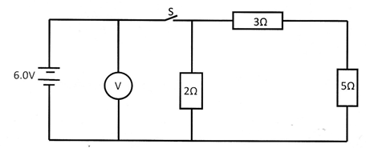

- If each cell has an internal resistance of 0.7Ω, determine the total resistance in the circuit. (3 marks)
………………………………………………………………………………………………………………………………………………………………………………………………………………………………………………………………………………………………………………………

- Calculate the value of current flowing through the 3Ω resistor when the switch is closed? (2 marks)
………………………………………………………………………………………………………………………………………………………………………………………………………………………………………………………………………………………………………………

- What is the reading of the voltmeter when the switch S is
- Open (1 mark)
………………………………………………………………………………………………………

- Closed (3 mark)
………………………………………………………………………………………………………………………………………………………………………………………………………………………………………………………………………………………………………………………

- Account for the difference between the answers in (I) and (II) above (1 mark)
………………………………………………………………………………………………………………………………………………………………………………………………………………………………………………………………………………………………………………………

- (a) The figure below shows a waveform on a CRO screen: Given that the Y-gain control is set at 20 V/cm and the time-base set to 10 ms/ cm,

Calculate the:
- Periodic time of the wave. ( 2 marks)
………………………………………………………………………………………………………………………………………………………………………………………………………………………………………………………………………………………………………………………

- Frequency of the wave. ( 2 marks )
………………………………………………………………………………………………………………………………………………………………………………………………………………………………………………………………………………………………………………………
- Peak voltage (2 marks)
………………………………………………………………………………………………………………………………………………………………………………………………………………………………………………………………………………………………………………………

(b) Calculate the frequency of X-rays produced by an X-ray tube operating at 20 kV, assuming that no energy is dissipated as heat. (Planck’s constant h = 6.63 x10⁻³⁴ Js, and the electronic charge is 1.6 x10⁻¹⁹ C) (3 marks)

………………………………………………………………………………………………………………………………………………………………………………………………………………………………………………………………………………………………………………………
(c) Calculate the energy of photons associated with radiation of frequency 4.8 × 10¹⁴ Hz, stating your answer in eV (3 marks)

………………………………………………………………………………………………………………………………………………………………………………………………………………………………………………………………………………………………………………………
THE LAST PRINTED PAGE

