232/1 - PHYSICS - Paper 1

2 Hours

Name ……………………………………………… Index Number ………………………... School .…………………………………………… Class ………………………................. Candidates Signature……………………………. Date ……………………………………
2022 TRIAL 3 MIDERM INTERNAL EXAMINATION
(Kenya Certificate of Secondary Education)

Kenya Certificate of Secondary Education

INSTRUCTIONS
Write your name and admission number in the space provided
Sign and write the date of the examination in the space provided above
This paper consists of two sections A and B.
Answer all the questions in the spaces provided.
All workings must be clearly shown.
Mathematical tables and silent electronic calculators may be used.

For examiner’s use only

SECTION | QUESTION | TOTAL MARKS | CANDIDATE’S SCORE
A | 1-13 | 25
B | 14 | 14
 | 15 | 10
 | 16 | 11
 | 17 | 10
 | 18 | 10
 |  | GRAND TOTAL | 80 MARKS

TOTAL CANDIDATE’S SCORE

Section A + section B =

This paper consists of 10printed pages
SECTION A (25 MARKS)
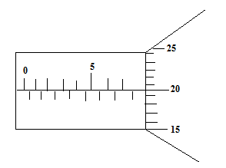
1. The figure below shows a micrometer screw gauge. What is the reading shown on the figure. (2 marks)

……………………………………………………………………………………………………………………………………………………………………………………………………………………………………………………………………………………………………………………………………………...
2. State pressure law. (1 mark)
……………………………………………………………………………………………………………………………………………………………………………………………………………………………………………………………………………………………………………………………………………...
3. State two factors that affect stability of a body. (2 marks)
i)

ii)
4. The diagram below shows a uniform wooden plank of length 4m and weight 10N. The plank is held at equilibrium by a weight of 40N placed at one end as shown below.
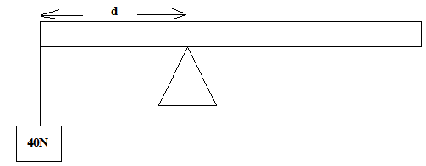

Determine the distance d. (3 marks)
……………………………………………………………………………………………………………………………………………………………………………………………………………………………………………………………………………………………………………………………………………...

5. Figure below shows a non-viscous fluid that is not compressible moving through a pipe of varied cross-sectional area.

If the area of the narrow region is 0.05m², calculate diameter of the wider region. (3 marks)

……………………………………………………………………………………………………………………………………………………………………………………………………………………………………………………………………………………………………………………………………………...

6. State one use of thermal expansion. (1 mark)

……………………………………………………………………………………………………………………………………………………………………………………………………………………………………………………………………………………………………………………………………………...
7. State two factors that affect melting point of a substance. (2 marks)

i)

ii)

8. A body is projected vertically upwards from the top of a building. If it lands on the base of the building. Sketch the velocity-time graph for motion. (2 marks)

9. State a reason why transfer by radiation is faster than by conduction. (1 mark)

……………………………………………………………………………………………………………………………………………………………………………………………………………………………...
10. The pulley system in the figure below supports a load of 50N.
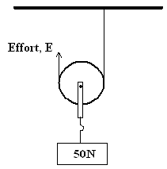

Given that the efficiency of the system is 80% calculate the effort, E. (3 marks)

……………………………………………………………………………………………………………………………………………………………………………………………………………………………………………………………………………………………………………………………………………...
11. The figure below shows a glass container with cross-section area of 50cm².
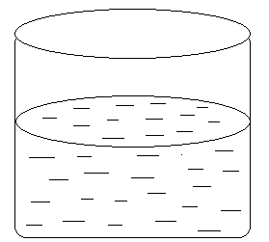

When a wooden block of mass 120g is immersed into the water it floats while fully submerged and the water level rises by 4cm, determine the density of the water. (3 marks)
……………………………………………………………………………………………………………………………………………………………………………………………………………………………………………………………………………………………………………………………………………...

12. Define the term momentum. (1 mark)

……………………………………………………………………………………………………………………………………………………………………………………………………………………………...

13. What is a pitch of a screw. (1 mark)

……………………………………………………………………………………………………………………………………………………………………………………………………………………………...

SECTION B
14. The figure below shows the motion of a trolley on ticker timer. The ticker has a frequency of 100Hz.

a) i) Calculate the initial velocity between A and B. (3 marks)

……………………………………………………………………………………………………………………………………………………………………………………………………………………………………………………………………………………………………………………………………………...
ii) Calculate the final velocity between C and D. (3 marks)

……………………………………………………………………………………………………………………………………………………………………………………………………………………………………………………………………………………………………………………………………………...

iii) Calculate the acceleration of the trolley during the motion. (3 marks)

……………………………………………………………………………………………………………………………………………………………………………………………………………………………………………………………………………………………………………………………………………...

b) Figure below shows a force-distance graph for a car being towed on a level ground.
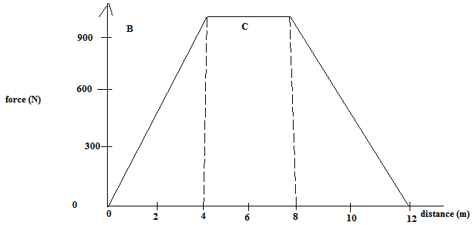

i) Calculate the total work done. (3 marks)

……………………………………………………………………………………………………………………………………………………………………………………………………………………………………………………………………………………………………………………………………………...

ii) If the velocity just before reaching point C is 0.6m/s. Calculate the power developed by the engine
at this point. (2 marks)

……………………………………………………………………………………………………………………………………………………………………………………………………………………………………………………………………………………………………………………………………………...
15. a) A metal ball of mass 100g is dipped into boiling water at 100⁰C and then placed in a calorimeter containing 80g of water at 20⁰C. After stirring, the temperature of the mixture stabilizes at 23.4⁰C. Ignoring the heat gained by the calorimeter, determine the specific heat capacity of the metal. (Specific heat capacity of water = 4200j/Kg K). (4 marks)

……………………………………………………………………………………………………………………………………………………………………………………………………………………………………………………………………………………………………………………………………………...

b) The cooling curve below is for a pure substance.
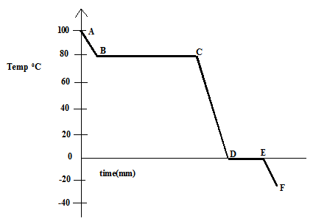

i) What is the melting point of the substance. (1 mark)

………………………………………………………………………………………………………………………………………………………………………………………………………………………………………………………………………………………………………………………………………

ii) State two factors that affect boiling point of a substance.

i)

ii)

iii) At what part of the curve is the substance.

Solid only?

Liquid only?

Solid and Liquid? (3 marks)

16. a) State Newton’s second law of linear motion. (1 mark)

………………………………………………………………………………………………………………………………………………………………………………………………………………………………………………………………………………………………………………………………………

b) The legal speed limit on motorways is approximately 30m/s. In an incident on a motorway, a car of mass 900kg leaves a skid mark 75m long when stopping. The maximum deceleration of the car when skidding is approximately 10m/s².

i) Show that before the incidence, the car must have been travelling above the legal speed limit.
(3 marks)

………………………………………………………………………………………………………………………………………………………………………………………………………………………………………………………………………………………………………………………………………

ii) Calculate for this skid, the maximum average braking force between each of the four tyres and the road. (3 marks)

………………………………………………………………………………………………………………………………………………………………………………………………………………………………………………………………………………………………………………………………………

iii) When the motorway is wet, the braking force provided by each wheel is reduced to 50% of the calculated in (ii) above. What is the effect of this reduced breaking force on stopping distance, explain your answer. Assume that the speed of the car before breaking is the same in both cases.
(2 marks)

………………………………………………………………………………………………………………………………………………………………………………………………………………………………………………………………………………………………………………………………………

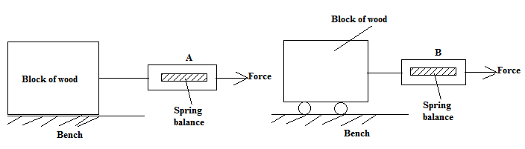
c) A student carried out an experiment to measure static friction using identical wooden blocks arranged as shown in the figure.

State and explain which spring balance will indicate a smaller reading when the block just starts to move. (2 marks)

………………………………………………………………………………………………………………………………………………………………………………………………………………………………………………………………………………………………………………………………………
17. a) Give a reason why people experience nose bleeding when they climb tall mountains. (1 mark)

………………………………………………………………………………………………………………………………………………………………………………………………………………………………………………………………………………………………………………………………………
b) The diagram shows a person raising a concrete block from a river bed by using two pulleys.

BLOCK

Water
6m
Pulley
Pulley

As shown in the diagram, the top of the block is 6.0m below the water surface. The density of water is 1000kg/m³ and the acceleration of free fall is 10m/s². Calculate the water pressure acting on the top of the block. (3 marks)

c) The block is raised through water. At one part, the water pressure acting on the top of the block 4.5 x 10⁴ pa. The area of the top of the block is 0.015m². Calculate the downward force exerted by the water on top of the block. (3 marks)

d) When the block is clear of the water, it is raised a further 4.0m. The weight of the block is 550N. Calculate the work on the block as it is raised the 4.0m through air. (3 marks)

18. The figure below shows part of an experiment set up to estimate the diameter of an oil molecule.
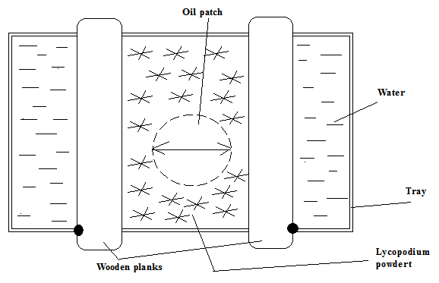

i) Describe how the oil patch is formed. (2 marks)

ii) What is the role of the Lycopodiumpowder. (1 mark)

b) An oil drop of average diameter 0.7mm spreads out into a roughly circular patch of diameter 73.5cm
on the surface of water in a trough.

i) Calculate volume of the drop in mm³. Take (π = ²²/₇) (3 marks)

ii) Calculate the area of the patch in mm³. (2 marks)

iii) Calculate the thickness of the oil molecule and express your answer in standard form. (2 marks)

