Term 2 - 2022
PHYICS (232/1)
FORM FOUR (4)
PAPER 1
Time: 2 Hours

Name: …………………………………………………………. Adm No: ……………….
School: ……………………………………………………….. Class: …………………..
Signature: ……………………………………………………..Date: ……… …..

Instruction to candidates
- This paper consists of two sections: A and B
- Answer all questions in section A and B in the spaces provided
- All workings must be clearly shown, and Use the CONSTANTS given.
- Gravitational acceleration, ‘g’ = 10m/s²
- Atmospheric pressure = 76mmHg
- density of water = 1000kg/m³
- density of mercury = 13600kg/m³
- Silent, non-programmable calculator may be used
FOR EXAMINER’S USE ONLY:
QUESTION | MARKS | CANDIDATES’ SCORE
1-12 | 25
13 | 13
14 | 14
15 | 15
16 | 13
TOTAL | 80

SECTION A (25 MARKS)
- Distinguish between density and relative density of a substance (1 mark)

- Figure 1, below shows a wire loop with a string that has been dipped into soap solution.

X
Y
Soap film
String
Wire-loop

Figure 1
- On the space alongside figure 1, Sketch a similar diagram to show the observed effect if the soap film is punctured at X (1 mark)

- Explain the observations made in (i) above (2 marks)

- State two reasons why gas particles diffuse faster than liquid particles (2 marks)

- A ball-bearing of mass 0.250 kg is held between the anvil and spindle of a micrometer screw gauge as shown in figure 2. The reading on the gauge when the jaws are closed without anything in between is 0.011cm. Use this information to answer the questions (a) and (b) below:

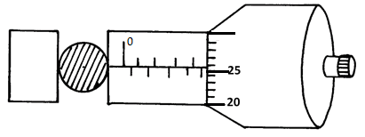
Figure 2
- What is the diameter of the ball bearing? (2 marks)

- Determine the density of the ball bearing (3 marks)

- The diagram in figure 3, shows a system in equilibrium and at room temperature.
Air
balloon
Small mass
Light material
Figure 3
State and explain what is observed when the temperature of the room is raised by 25⁰c.
(2 marks)

- Figure 4, shows two glass tubes of different diameters, dipped in a glass beaker half full of water
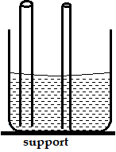
Figure 4
Complete the diagram to show how water will rise up in the two glass tubes (1 mark)

- State the conditions necessary for the law of conservation of linear momentum to hold
(1 mark)

- The diagram in figure 5, below shows a steel ball bearing gently falling down through a viscous liquid contained in a tall cylinder

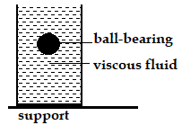
Figure 5
Label on the diagram (giving direction), the forces acting on the ball bearing as it moves down the cylinder (3 marks)

- A string vest keeps a person warm though it is a collection of holes bounded by strings. Explain (2marks)

- The figure 6, below represents a bimetallic strip of metals X and Y at room temperature (a) and when dipped into crushed ice (b) respectively. Sketch a diagram in the space alongside, to show the shape when the strip is heated to a temperature above the room temperature (1 mark)

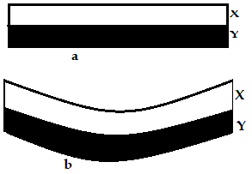
Figure 6
- Figure 7, below shows the cross-section of an aero-foil, with the aero-plane moving in the direction shown by the arrow.

Figure 7

Using a sketch of the streamlines showing how air flows past the wing as the aero-plane moves, explain how the aero-plane achieves the dynamic lift (3 marks)

- The diagram in figure 8, below shows a ball being whirled in a vertical plane at a uniform speed of 20m/s. If the maximum tension on the string is exceeded, suggest, by drawing on the diagram, the path which is likely to be taken by the ball. (1 mark)
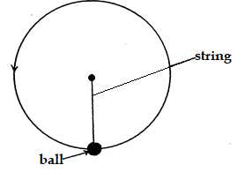
Figure 8
SECTION B (55 MARKS)
- The diagram below represents a u-shaped glass tube sealed at one end and containing mercury.

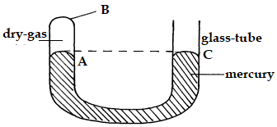
Figure 9
- Determine the pressure (in N/m²) of the dry gas as shown in the diagram above (2 marks)

- Explain why the gas should be dry if it is to be used to verify a gas law (1 mark)

- Describe how the arrangement can be used to verify Boyle’s law. (4 marks)

- Using the kinetic theory of gases, explain why the pressure of a gas increases with temperature increase (3 marks)

- Figure 10 below shows a measuring cylinder of height 30cm filled to a height of 20cm with water and the rest occupied by kerosene.

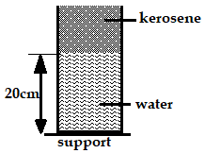
Figure 10
Given that density of water = 1000Kgm⁻³, density of kerosene = 800Kgm⁻³ and atmospheric pressure = 1.03x10⁵ Pascal, determine the total pressure acting on the base of the container (3 marks)

- Distinguish between uniform velocity and instantaneous velocity (1 mark)

- The velocity-time graph in the figure 11, below illustrates the motion of a ball which has been projected vertically upwards from the surface of the moon. The weight of the object on earth’s surface is 20N.
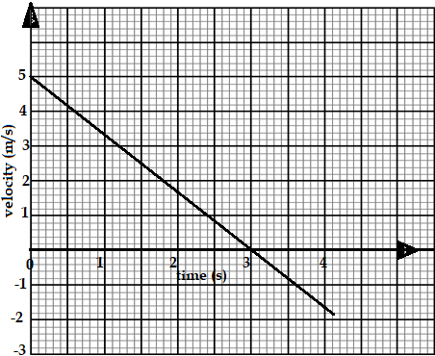
Figure 11
- State why the velocity becomes negative after 3seconds. (1 mark)

- Determine the acceleration of gravity on the moon showing clearly your work (3 marks)

- Determine the total distance travelled by the ball in 4.0seconds (3 marks)

- Find the weight of the ball on the moon (2 marks)

- A body starts from rest and attains a velocity of 10m/s after 4 seconds. Use the axes provided below to represent this motion (2 marks)
Velocity, m/s
Time, s
Figure 12
- Define angular velocity and state its SI unit (2 marks)

- Define the term “velocity ratio” as used in the working of machines (1 mark)
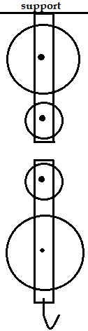
- A civil engineer wanted to raise sand from the ground to the third floor of a house he was working on. He began by assembling the following pulley system in figure 13.

- Complete the diagram in figure 13, by threading the pulley so that it can be used to raise the load L by applying an effort E from the third floor. (2 marks)

- The pulley system has a mechanical advantage of 3. Calculate the total work done when a load of 600N is raised through a height of 9m
(3 marks)

Figure 13

- On the axes provided, sketch a graph of mechanical advantage against load for the pulley system (2 mark)

- The graph below shows the potential energy against displacements for a body of mass 80g.
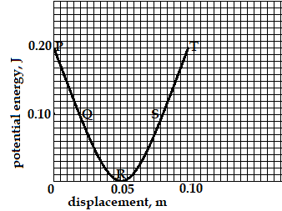
Figure 14
The body oscillates about point R. Calculate the velocity of the body at:
- P and T (3 marks)

- Q and S (2 marks)

- at R (2 marks)

- State Archimedes’ principle (1 mark)

- A rectangular brick of mass 10kg is suspended from the lower end of a spring balance and gradually lowered into water until its upper end is some distance below the surface.
- State and explain the changes observed in the reading of the spring balance during the process
(2 marks)

- If the spring reads 80N when the brick is totally immersed, determine the volume of the brick. (3 marks)

- The figure below shows a hydrometer.
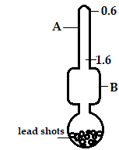
Figure 15
- Identify the parts labelled A and B (2 marks)

A …………………………………………………………………………………

B …………………………………………………………………………………

- Explain why the bulb should be made wide (2 marks)

- State the function of the lead-shots (1 mark)

- The diagram, figure 16, shows a block of wood floating on water in a beaker. The set-up is at room temperature before the Bunsen burner is lit. State and explain the changes that are likely to occur in depth X when the Bunsen burner is lit. (2 marks)

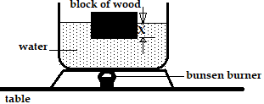
Figure 16

This is the last printed page

