Term 2 - 2022
PHYSICS (232/1)
FORM FOUR (4)
PAPER 1
Time: 2 Hours
MARKING SCHEME
SECTION A (25 MARKS)
- Distinguish between density and relative density of a substance (1 mark)

Density | Relative density
Mass per unit volume | The number of times a substance is denser than water

- Figure 1, below shows a wire loop with a string that has been dipped into soap solution.

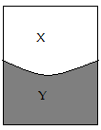
X
Y
Soap film
String
Wire-loop
Figure 1
- On the space alongside figure 1, Sketch a similar diagram to show the observed effect if the soap film is punctured at X (1 mark)

As shown above ;

- Explain the observations made in (i) above (2 marks)
before puncturing X, string is pulled equally by surface tension from both sides; after X is punctured, surface tension on side X is broken so the string is pulled only

- State two reasons why gas particles diffuse faster than liquids particles (2 marks)
- Gases have weaker cohesive forces than liquids ;
- Gases have larger intermolecular distance ;

- A ball-bearing of mass 0.250 kg is held between the anvil and spindle of a micrometer screw gauge as shown in figure 2. The reading on the gauge when the jaws are closed without anything in between is 0.011cm. Use this information to answer the questions (a) and (b) below:
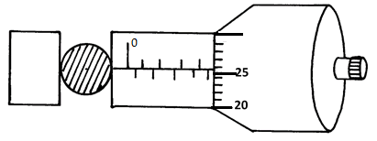
Figure 2
- What is the diameter of the ball bearing? (2 marks)
Reading = 5.5+ 0.26 = 5.76mm ;
Actual diameter = 5.76 – 0.11= 5.65mm ;
- Determine the density of the ball bearing (3 marks)
Volume = $\frac{4}{3}πR^{3}=\frac{4}{3}×3.142×({\frac{5.65}{2})}^{3}=$ 94.45cm³ ;

Density = $\frac{mass}{volume}=\frac{250}{94.45};=2.647$g/cm³ ;

- The diagram in figure 3, shows a system in equilibrium and at room temperature.
Air
balloon
Small mass
Light material
Figure 3
State and explain what is observed when the temperature of the room is raised by 25⁰c.
(2 marks)
The system tips to the right; higher temperature expands the volume of balloon increasing the up thrust acting on the balloon; This causes the light material to tip to the right.

- Figure 4, shows two glass tubes of different diameters, dipped in a glass beaker half full of water
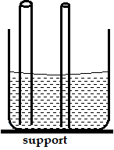

Figure 4
Complete the diagram to show how water will rise up in the two glass tubes (1 mark)
As shown (both correctly shown);
- State the conditions necessary for the law of conservation of linear momentum to hold
(1 mark)
No external force must act;

- The diagram in figure 5, below shows a steel ball bearing gently falling down through a viscous liquid contained in a tall cylinder

A B
A – UPTHRUST;
B – VISCOUS DRAG;
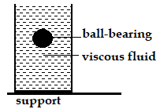
Weight;
Figure 5
Label on the diagram (giving direction), the forces acting on the ball bearing as it moves down the cylinder (3 marks)

- A string vest keeps a person warm though it is a collection of holes bounded by strings. Explain (2marks)
Combination of holes and strings traps air between them; air being a poor conductor of heat, it does not therefore allow the body to lose heat hence keeps him warm;

- The figure 6, below represents a bimetallic strip of metals X and Y at room temperature (a) and when dipped into crushed ice (b) respectively. Sketch a diagram in the space alongside, to show the shape when the strip is heated to a temperature above the room temperature (1 mark)

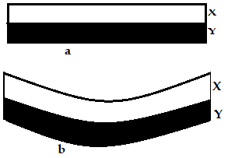
Heated above room temperature
Figure 6
- Figure 7, below shows the cross-section of an aero-foil, with the aero-plane moving in the direction shown by the arrow.

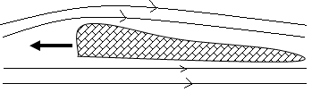
Figure 7
1 mark for the correct streamlines

Using a sketch of the streamlines showing how air flows past the wing as the aero-plane moves, explain how the aero-plane achieves the dynamic lift (3 marks)
Air moving above the aero-foil travels at a higher velocity than air below it hence reducing pressure above the aero-foil; the pressure difference provides an upward force (the dynamic lift);

- The diagram in figure 8, below shows a ball being whirled in a vertical plane at a uniform speed of 20m/s. If the maximum tension on the string is exceeded, suggest, by drawing on the diagram, the path which is likely to be taken by the ball. (1 mark)
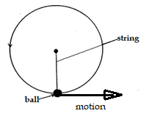
Figure 8

SECTION B (55 MARKS)
- The diagram below represents a u-shaped glass tube sealed at one end and containing mercury.

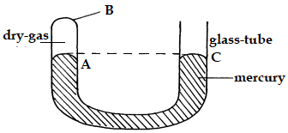
Figure 9
- Determine the pressure (in N/m²) of the dry gas as shown in the diagram above (2 marks)
Gas pressure = atmospheric pressure ;

$hρg=0.076×13600×10$ = 10,336 N/m² ;

- Explain why the gas should be dry if it is to be used to verify a gas law (1 mark)
Presence of moisture will exert undue pressure on mercury hence give erroneous readings of pressure;

- Describe how the arrangement can be used to verify Boyle’s law. (4 marks)
  - Connect end, C to a pressure gauge and pump air so that mercury in limb, A rises to some measurable margin.
  - Allow it to settle back to room temperature;
  - Record the pressure and length (volume) of the air column.
  - Repeat the above procedure at least three times, each time recording the pressure and corresponding length of the air column;
  - Plot a graph of pressure against length (volume) of the air column;
  - Note from the graph if volume decreases with increase in pressure, hence verifying the boyle’s law;

- Using the kinetic theory of gases, explain why the pressure of a gas increases with temperature increase (3 marks)
Higher temperature increases the kinetic energy of the gas molecules; this in turn increases the rate of bombardment of the gas molecules against the walls of the container; rate of change of momentum as the gas bombards the wall is higher hence the pressure is increased;
- Figure 10 below shows a measuring cylinder of height 30cm filled to a height of 20cm with water and the rest occupied by kerosene.

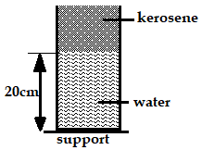
Figure 10
Given that the density of kerosene = 800Kgm⁻³ and atmospheric pressure = 1.03x10⁵ Pascal, determine the total pressure acting on the base of the container (3 marks)

Pressure due to water = $hρg=0.20×1000×10=2000$Pa ;
Pressure due to kerosene $=hρg=0.10×800×10=800$Pa ;
Atmospheric pressure $hρg=0.076×13600×10=10336Pa$
Total pressure = 13,136 Pa ;

- Distinguish between uniform velocity and instantaneous velocity (1 mark)
Uniform velocity | Instantaneous velocity
Constant change in displacement for equal time intervals. | Velocity of a body at a particular time

- The velocity-time graph in the figure 11, below illustrates the motion of a ball which has been projected vertically upwards from the surface of the moon. The weight of the object on earth’s surface is 20N.
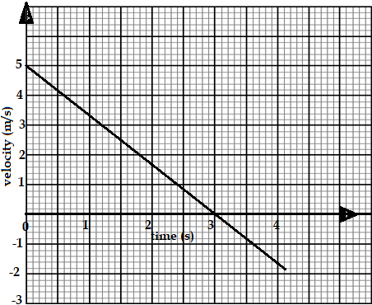
Figure 11
- State why the velocity becomes negative after 3seconds. (1 mark)
The ball reaches maximum height after 3 seconds and begins to fall back to the moons surface;

- Determine the acceleration of gravity on the moon showing clearly your work (3 marks)
$v=u-gt;≡0=5-g\left(3\right);$
therefore, g = $\frac{5}{3}=1.667$m/s²;
- Determine the total distance travelled by the ball in 4.0seconds (3 marks)
$s=ut-\frac{1}{2}gt^{2}=5\left(3\right)+\frac{1}{2}\left(1.667\right)\left(3^{2}\right)=22.5015m$ ;
$s=ut+\frac{1}{2}gt^{2}≡0\left(1\right)+\frac{1}{2}\left(1.667\right)\left(1^{2}\right)=0.8335m$ ;
$total distance=22.5015+0.8335=23.335m$ ;

- Find the weight of the ball on the moon (2 marks)
$w=mg≡20=m×10$ therefore, mass = 2kg;
$w=mg≡2×1.667=3.334N$ ;

- A body starts from rest and attains a velocity of 10m/s after 4 seconds. Use the axes provided below to represent this motion (2 marks)
Velocity, m/s
Time, s
10
4
0
Figure 12
- Define angular velocity and state its SI unit (2 marks)
Rate of change of angular displacement with time; SI unit is radian per second;

- Define the term “velocity ratio” as used in the working of machines (1 mark)
The ratio of load to effort ;

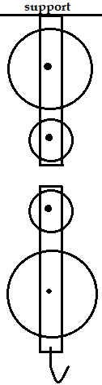
- A civil engineer wanted to raise sand from the ground to the third floor of a house he was working on. He began by assembling the following pulley system in figure 13.

- Complete the diagram in figure 13, by threading the pulley so that it can be used to raise the load L by applying an effort E from the third floor. (2 marks)
- The pulley system has a mechanical advantage of 3. Calculate the total work done when a load of 600N is raised through a height of 9m (4 marks)
effort

$MA=\frac{load}{effort}≡3=\frac{600}{E}, therefore, E=200N$ ;
$VR=\frac{effort distance}{load distance}≡5=\frac{E_{d}}{L_{d}}=\frac{E}{9}$ effort distance = 45m;
Work done on load = $L×L_{d}$ = $600×9=5400J$
Work done by effort = $E_{d}×E=45×200=9000J$;
Total work done = 5400+9000= 14,400 joules;

Figure 13

- On the axes provided, sketch a graph of mechanical advantage against load for the pulley system (2 mark)
MA
LOAD (N)

- The graph below shows the potential energy against displacements for a body of mass 80g.
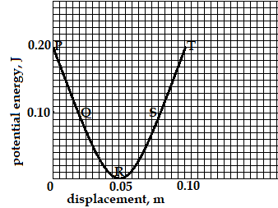
Figure 14
The body oscillates about point R. Calculate the velocity of the body at:
- P and T (2 marks)
At P and T, k.e = 0, ;
Therefore, velocity, V = 0 ;
- Q and S (2 marks)
k.e = (0.2 - 0.1) = 0.1J ;
$\frac{1}{2}×0.08×v^{2}=0.1$
$v^{2}=2.5$ , therefore, v = 1.581m/s ;

- at R (2 marks)
k.e = 0.2 joules
$\frac{1}{2}×0.080v^{2}=0.2$ ;

Therefore, v² = 5 hence, v = 2.236m/s ;

- State Archimedes’ principle (1 mark)
When a body is fully or partially immersed in a fluid, it experiences an upthrust which is equal to the weight of the fluid displaced;
- A rectangular brick of mass 10kg is suspended from the lower end of a spring balance and gradually lowered into water until its upper end is some distance below the surface.
- State and explain the changes observed in the reading of the spring balance during the process (2 marks)
The reading gradually reduces; upthrust force acts on the brick as it is being lowered into the water causing the reading to reduce;

- If the spring reads 80N when the brick is totally immersed, determine the volume of the brick. (3 marks)
$upthrust=wt in air-wt in water$
$U=100-80=20N$ ;
But upthrust, U = $vρg≡20=v×1000×10$ ;
Therefore, volume = $\frac{20}{10000}=0.002$m³ ;
- The figure below shows a hydrometer.
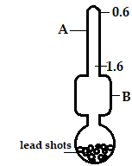
Figure 15
- Identify the parts labelled A and B (2 marks)

A stem ;
B bulb ;
Explain why the bulb should be made wide (2 marks)
Wide bulb displaces large volume of liquid; that provides sufficient upthrust to keep the hydrometer floating;
- State the function of the lead-shots (1 mark)
It makes the hydrometer float upright

- The diagram, figure 16, shows a block of wood floating on water in a beaker. The set-up is at room temperature before the Bunsen burner is lit. State and explain the changes that are likely to occur in depth X when the Bunsen burner is lit. (2 marks)

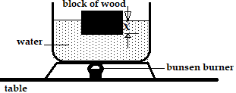
Figure 16
X increases; upthrust is lowered making the block of wood to sink more;

