COMPETENCY BASED CURRICULUM
GRADE 5 TERM 1 2023 – PHE ACTIVITIES

  - What is the name given to the place where athletes run? ( 2 mark)
................................................................................................................................................
................................................................................................................................................
....................................................................................................................................
  - State 3 safety measures that you consider when running 100m and 200m ( 3 marks)

  - List 3 importance’s of Team work during sports activity in school (3 marks)

  - Name 3 items you can use to improvise balls (3 marks)

  - What type of catching is shown in the picture below? (1 mark)

  - Identify the types of passes shown in the pictures below.
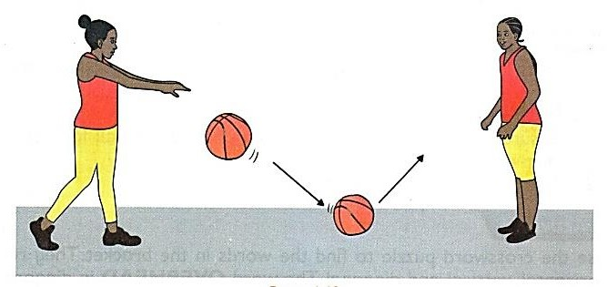 (1 marks) 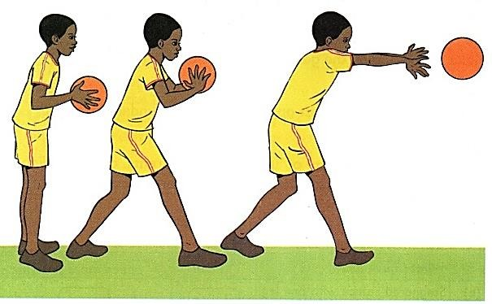 (2 marks)

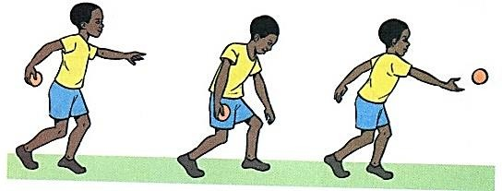
( 2 marks)
  - Give 1 reason why we should have commitment in sports. (1 mark)

  - Name the Name the type of game shown below.

