BUNAMFAN CLUSTER EXAMINATION – 2022
Kenya Certificate of Secondary Education
445/1 – METAL WORK – Paper 1
June 2022 - 2 ½ hours
Name…………………………………Adm No……

Class…………… Date……………………………

INSTRUCTIONS
- Write your name, admission number and class in spaces provided.
- Write the date of the examination in the spaces provided
- Answer all questions in section A ,Answer question 11 and any other three questions in section B in the space provided.
- ALL dimensions are in millimeters unless otherwise stated.
FOR EXAMINERS USE ONLY
Questions | Maximum score | Candidates score
1-10 | 40
11 | 15
12 | 15
13 | 15
14 | 15
15 | 15

1a)Define the terms metals and metalwork. (2marks)
................................................................................................................................................................................................................................................................................................
b) Name any four careers in the field of metalwork. (2marks)
...............................................................................................................................................................................................................................................................................................
2a) Name the three aspects of safety. (1 ½ marks)
...............................................................................................................................................................................................................................................................................................
b)List any five safety rules in a metal workshop. (2 ½ marks)
...............................................................................................................................................................................................................................................................................................................................................................................................................................................................................................................................................................................................................................................................................................................................................................................................................................................................................................
3a) Metal cutting tools should be made using hard materials.Explain why and name those two metals. (2marks)
...............................................................................................................................................................................................................................................................................................
b)Give two differences between Steel and aluminium. (2marks)
...............................................................................................................................................................................................................................................................................................

4a) The figure shows a tool used in measuring and checking.
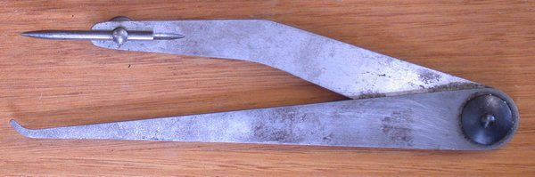
(i)Give the name of the tool and name the material used for making it. (2marks)
................................................................................................................................................................................................................................................................................................
(ii)Give two uses of the tool. (2marks)
...............................................................................................................................................................................................................................................................................................
5 a)Why is the cutting edge of a cold chisel hardened while the end struck by a hammer tempered. (2marks)
............................................................................................................................................................................................................................................................................................... ………….……………………………………………………………….….……………....
b) The figure below shows a tool used in cutting metals.
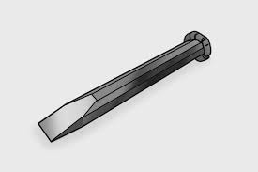
(i)Name the problem that the tool has ,state the cause of it and explain how to correct it.
(2marks)
...............................................................................................................................................................................................................................................................................................
6 The figure below shows a metal cutting tool.
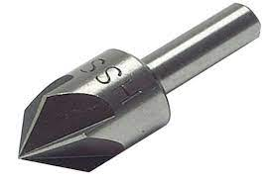
a)Give the name of the tool and its use. (2marks)
..............................................................................................................................................................................................................................................................................................
b) State two reasons for notching edges of sheet metal. (2marks)
...............................................................................................................................................................................................................................................................................................
7List all the steps followed in order to come up with a snap head on a rivet. (4marks)
..............................................................................................................................................................................................................................................................................................................................................................................................................................................................................................................................................................................................................................................................................................................................................................................................................................................................................................................................................................................................................................................................................................................................................................................................
8a)List four methods of applying paint. (4marks)
..............................................................................................................................................................................................................................................................................................................................................................................................................................................................................................................................................................................................
b)State two advantages of using a hacksaw over a cold chisel in cutting metals.(2marks)
..............................................................................................................................................................................................................................................................................................
9 Give four uses of templates in metalwork. (4marks)
............................................................................................................................................................................................................................................................................................ …...….....................................................................................................................................................................................................................................................................................
10 What care should be taken of the combination set? (4marks)
.....................................................................................................................................................................................................................................................................................................................................................................................................................................................................................................................................................…………………………...

Section B (60marks)
Answer question 11 and any other three questions in this section
11 Figure 2 shows orthographic views of a machined block drawn in third angle projection.
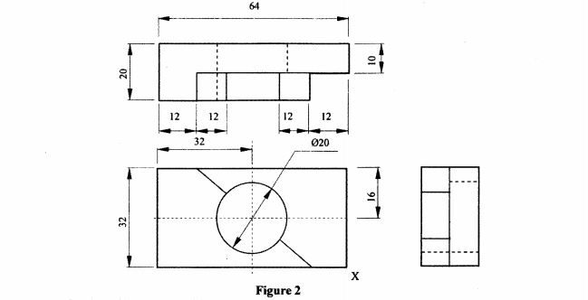
On the grid paper provided, draw the isometric view of the block taking X as the lowest point.
Show three main dimensions. (15 marks)

- Two mild steel plates of thickness 3mm are to be riveted using double riveted lap joint.
- Draw the sectional front elevation and plan of the riveted joint. (6marks)

- Calculate the rivet diameter (2marks)

- Calculate the rivet shank projection for a snap head ( 2marks)

- Calculate the distance between two rivets (2marks)

- Use sketches to show three rivet defects ( 3marks)

- Explain three inventories in the workshop (3marks)
….………………………………………………………………………………………………………………………………………………………………………………………………………………………………………………………………………………………………………………………………………………………………………………………………………………………………………………………………………………………………………………………………………………………………………………………………………………………………………………………………………………………………………………………………………………………………………………………………………………………………………………………………………………………………………………………………………………………………………………………………………………………………………………………………………………………………………………………………………………………………………………………………………………………………………………………………………………………………………………………………………………………………………………………………………………………………………………………….
(b) Explain the following documents as used in a workshop (3marks)
- Invoice
….…………………………………………………………………………………………………………………………………………………………………………………………………………………………………………………………………………………………………………………………………………………………..
- Catalogue
….………………………………………………………………………………………………………………………………………………………………………………………………………………………………………………………………………………………………………………………………………………………….
- Delivery note
….……………………………………………………………………………………………………………………………………………………………………………………………………………………………………………………………………
( c) Explain step by step the procedure of recruiting an employee in a company (6marks)
….…………………………………………………………………………………………………………………………………………………………………………………………………………………………………………………………………………………………………………………………………………………………………………………………………………………………………………………………………………………………………………………………………………………………………………………………………………………………………………………………………………………………………………………………………………………………………………………………………………………………………………………………………………………………………………………………………………………………………………………………………………………………………………………………………………………………………………………………………………………………………………………………………………………………………………………………………………………………………………………………………………………………………………………………………………………………………………………………………………………………………………………………………………………
( e) what do you understand by the term “break even” ( 1mark)
….……………………………………………………………………………………………………………………………………………………………………………………………………………………………………………………………………
- State two advantages of partnership business ( 2marks)
.

- (a) differentiate oil blacking from bluing (2marks)
….……………………………………………………………………………………………………………………………………………………………………………………………………………………………………………………………………………………………………………………………………………………………………………………………………………………………………………………………………………………………………………………………………………………………………………………………………………………………………………………………………………………………………………………………………………………………………………………………………………………
( b) Explain painting as a finishing process ( 2marks)
….……………………………………………………………………………………………………………………………………………………………………………………………………………………………………………………………………………………………………………………………………………………………………………………………………………………………………………………………………………………………………………………………………………………………………………………………………………………………………………………………………………………………………………………………
- Differentiate tears from runs ( 2marks)
….……………………………………………………………………………………………………………………………………………………………………………………………………………………………………………………………………

- Use sketch to describe a hand drill (4marks)

- State and explain four types of cold chisels ( 4marks)
….………………………………………………………………………………………………………………………………………………………………………………………………………………………………………………………………………………………………………………………………………………………………………………………………………………………………………………………………………………………………………………………………………………………………………………………………………………………………………………………………………………………………………………………………………………………………………………………………………………….
- Differentiate morse tapered twist drill from a parallel shank twist drill
( 1mark)

15 (a) Sketch a gas welding torch and:
- label ﬁve parts; (5marks)

- state four precautions to be observed when handling it. (3 marks)
….…………………………………………………………………………………………………………………………………………………………………………………………………………………………………………………………………………………………………………………………………………………………………………………………………………………………………………………………………………………………………………………………………………………………………………………………………………………………………………………………..
(b) (i) Use labelled sketches to show the three types of gas welding ﬂames.
(3marks)

- Explain how each of the ﬂames is obtained. (3marks)
….…………………………………………………………………………………………………………………………………………………………………………………………………………………………………………………………………………………………………………………………………………………………………………………………………………………………………………………………………………………………………………………………………………………………………………………………………………………………………………………………………………………………………………………………..

THIS IS THE LAST PRINTED PAGE

