METALWORK BUNAMFAN F4 PRE-MOCK 2022 SCHEME
1a)Define the terms metals and metalwork. (2mks)
Metals are hard solids mined from the ground.
Metalwork is the art of making articles from metal.
b) Name any four careers in the field of metalwork. (2mks)
Artisan,craftsmanship,technician,engineer,technologist.
2a) Name the three aspects of safety. (1 ½ mks)
Personal safety,tool and equipment safety and environmental safety.
b)List any five safety rules in a metal workshop. (2 ½ mks)
-Use proper personal protective equipment.
-Do not run in the workshop.
-Horse play should be avoided.
-Workshop floors should always be clean.
-Use gangways when walking in the workshop.
3a) Metal cutting tools should be made using hard materials.Explain why and name those two metals. (2mks)
So as to resist being cut,scratched or dented/So as to cut other metals without themselves being cut. HCS,HSS
b)Give two differences between Steel and aluminium. (2mks)
Steel | Aluminium
Strong | Weak
Rusts/can easily be corroded | Resistant to rust/corrosion

4a) The figure shows a tool used in measuring and checking.
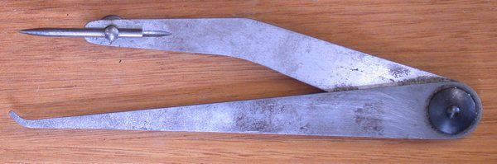
(i)Give the name of the tool and name the material used for making it. (2mks)
Odd-leg calipers-HCS
(ii)Give two uses of the tool. (2mks)
-Marking lines parallel to given datum edge.
-Finding the centre of a round bar.
5 a)Why is the cutting edge of a cold chisel hardened while the end struck by a hammer tempered. (2mks)
The cutting edge is hardened to prevent wearing,being cut and dented.
The end struck by a hammer is tempered to absorb the shock from the hammer blow.
b) The figure below shows a tool used in cutting metals.
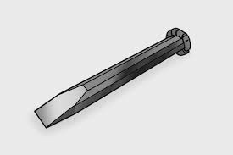

(i)Name the problem that the tool has ,state the cause of it and explain how to correct it. (2mks)
Mushroom head-Caused by repeated hammering making the material of the head to build up.Removed by grinding it off/dressing then chamfered.

6 The figure below shows a metal cutting tool.
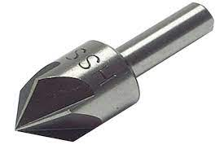
a)Give the name of the tool and its use. (2mks)
Countersink bit-Producing a conical hole at the mouth of a round hole.
b) State two reasons for notching edges of sheet metal. (2mks)
-To improve appearance
To prevent overlaps.
7List all the steps followed in order to come up with a snap head on a rivet. (4mks)
-Mark out the holes and other details on one of the plates.
-Clamp the plates together and drill one hole through both plates.
-Cut the rivet to length holding the waste shank in the vice.
-Using the dolly,close the plates together.
-Make the rivet expand in the hole using the flat face of the hammer.
-Form the head using pein end of the hammer.
-Finish forming the head using the snap.
-Remove the unwanted excess material using a file.

8a)List four methods of applying paint. (4mks)
-Using a brush
-Spraying using a spray gun.
-Dipping in paint.
-Using a piece of cloth.
b)State two advantages of using a hacksaw over a cold chisel in cutting metals.(2mks)
-It gives a good surface finish.
-It is more accurate.
9Give four uses of templates in metalwork. (4mks)
-Marking out repeated identical parts.
-Checking angles,curves and contours
-Marking out and guide for drill bit.
-Guide for oxy-acetylene cutting.
10 What care should be taken of the combination set?
-Should be cleaned well after use.
-Should be oiled lightly before being kept to prevent corrosion.
-Avoid dropping or knocking the tool against other hard objects.
-Excessive pressure should not be applied.
-The tool is best stored in a box or special bag.

Section B
11.
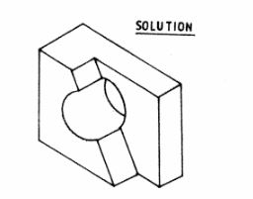

12 . (a)
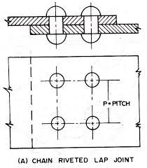

(b) d=11/2t
11/2 × 3=4.5 mm
( c) shank projection = 11/2 d
11/2×4.5=6.75 mm

(d) distance between rivets= 3D
3×4.5=13.5mm

( e)

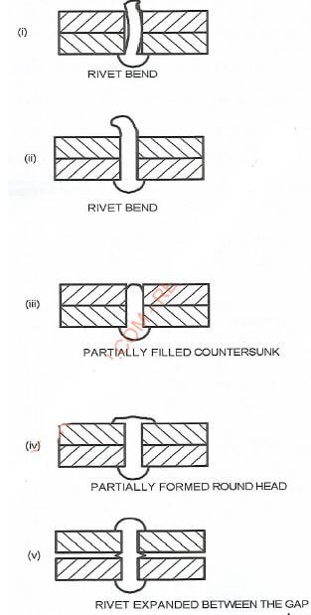

- (a)
- permanent inventories- record of all machines,equipment and furnaces that ate permanent in workshop
- expandable inventories- record of all tools and items that wear out with time
- Consumable inventories -record of materials that ate completely used up in workshop
(b) invoice- a document sent to the buyer listing all items and the prices that a buyer wishes to buy
Catalogue- a document sent by seller listing all items in stock and their prices
Delivery note - a document sent together with items bought listing all items packed and delivered
( c) identification of gap in the firm
Getting the required minimum qualifications
Advertising for the vacancy
Delimiting a pool of potential employees
Conducting an interview
Induction of the new employee
( d) a situation in the business where the business in not making any profit or loss.
( e) easy to raise capital
Labour is shared
Easy to expand
Provides variety of prepossession and abilities
- (a) oil blacking is carried out by heating metal to red hot and then wiped with a rag dipped in heavy lubricating oil while in bluing the metal is heated in clean flame and dipped in clean light oil
(b) clean the article to be painted with abrasive material
Apply primer and give it time to dry
Apply under coat and give it time to dry
Apply top coat and give it time to dry
( c ) tears are droplets of pain running down the article while rune ate the lines made by droplets of excess paint
( d)
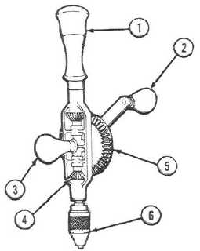

( e ) flat cold chisel- used for general purpose
Cross-cut cold chisel-used for making square grooves
Half round cold chisel- used for making circular grooves
Vee-shaped cold chisel-used for making vee shaped grooves

15. (a) Welding torch
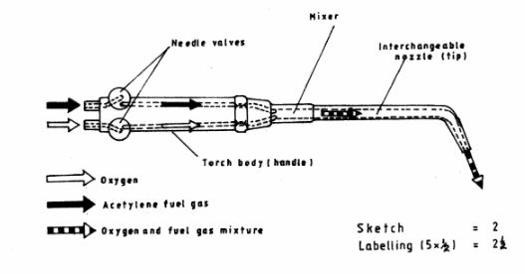
Safety precautions
- Ensure that the nozzle seat and threads are free from any foreign materials.
- Nozzle should only be cleaned with tip cleaner
- Never use nozzle to hold or push the Work piece
- Avoid knocking nozzle against hard surfaces
Any 3 x 1 = 3 marks
(b). Gas welding flames
(i)
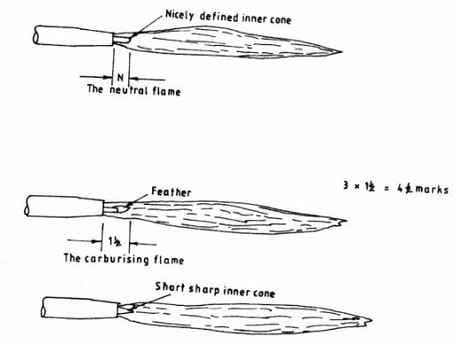
(ii) 1. Neutral Flame has equal quantities of oxygen and acetylene
2. Carburising ﬂame has more acetylene gas than oxygen
3. Oxiding flame has more as oxygen than acetylene gas
3 x 1

