NAME_________________________________________ADM.NO______________________

CLASS________________________________________ DATE________________________

SIGNATURE____________________________________

121/2
MATHEMATICS PAPER 2
Term 2, 2021
2 ½ HRS

ASUMBI GIRLS HIGH SCHOOL
TERM 2 – DECEMBER 2021
FORM 4 – MATHEMATICS PAPER 2

INSTRUCTIONS TO CANDIDATES
- Write your name and your class in spaces provide
- The paper contains two sections. Section I and Section II
- Answer all the questions in section I and any five questions from section II.
- Show all the steps in your calculations, giving your answers at each stage in the spaces below each question.
- Marks may be given for correct working even if the answer is wrong.
- Non-programmable silent electronic calculators and KNEC Mathematical tables may be used except where stated otherwise.
- This paper consists of 15 printed pages

FOR EXAMINERS USE ONLY.

Question | 1 | 2 | 3 | 4 | 5 | 6 | 7 | 8 | 9 | 10 | 11 | 12 | 13 | 14 | 15 | 16 | TOTAL
Marks

GRAND TOTAL
Question | 17 | 18 | 19 | 20 | 21 | 22 | 23 | 24 | TOTAL
Marks

SECTION 1 (50 MARKS)

Answer all questions in this section

1. Use logarithm tables to evaluate to 4 significant figures
90.35 + $\frac{1}{0.03506}$ ^{1/3} (4mks)

2. Simplify $\frac{3}{2+√2}$ + $\frac{4-√2}{2-√2}$ . Write your answer in the form a+ b$√C$ (3mks)

3. Expand (p - 3q )⁵ (1mks)
hence state
i. Coefficient of p⁴q (1mks)
ii. Fourth term in the expansion (1mk)

4. Make c the subject of the formula b = $\sqrt{k-ac}$ , hence find the value of c when k= 1, a=4 and b= 2 (3mk

5. Given that A= $\left[\begin{matrix}3x & x-36 \\ -6 & 2x-2\end{matrix}\right]$ Find value of x such that A is a singular matrix. (3mks)

6. The dimensions of a rectangle are 40cm and 45cm. If there is an error of 5 % in the dimensions find the percentage error in calculating area of the rectangle. (3 mks)

7. Solve the equation
Log ₂ (2 +3x) + 3log₂ 2 = 2+log₂ (2x+6) (3mks)

8. The cash price of a TV set is Ksh 13800. A customer opts to buy the set on hire purchase
terms by paying a deposit of Ksh. 2280. If the simple interest of 20% p.a is charged on the
balance and customer is required to pay 24 equal monthly instalments calculate the amount of
each instalment. (2mks)

9. Chords PQ and RS intersect internally at point T. Given that PT = 3.2 cm, TQ= 4.7cm and TS = 5.2cm, find the length of chord RS. (3mks

10. On the line AB below show by shading the region R above the line such that
i. R is nearer A than B
ii. R is not more than 3.0 cm from A (4mks)
iii. $<$ ARB $≥$90⁰

11. Determine the radius and centre of a circle whose equation is
3x² +3y²-18x+12y-9=0 (3mks)

12. Grade A coffee costs sh.100 per kg while grade B costs sh150 per kg. Find the ratio in
which the two grades should be mixed so that by selling the mixture at sh.147 per kg a 5% profit is realised. (3mks)

13. The following table shows income tax rates
Income Ksh per month | Rate in ksh per every sh.20
1-8400 | 2
8401-18000 | 3
18001-30000 | 4
Above 30000 | 5
Mr Ngondu is a non-director of a company, he is housed freely therefore for purpose of taxation 15 % of his basic salary is added to his income to obtain a taxable income. He is also entitled to a family relief of sh. 1162 and his P.AY.E is sh. 3038. Determine his income. (3 mks)

14. In a transformation, an object A of area 4cm² is mapped into B of area 48cm² by a transformation whose matrix is $\left(\begin{matrix}y & 1 \\ 4 & 2\end{matrix}\right)$ determine possible values of y. (3mks)

15. The figure below shows a triangle ABC not drawn to scale. Calculate the length marked b given that AB= 240cm <BAC = 30⁰ and <ACB =45⁰ (3mks)

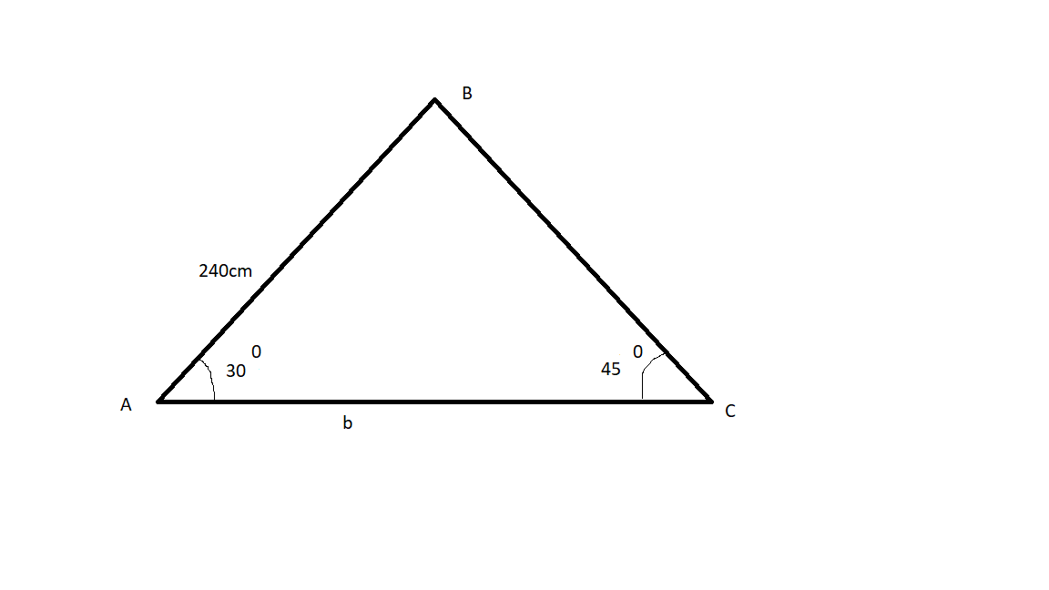

16. Two variables R and V are such that R= kv^{n} where k and n are constants. The table below
shows values of logR and logV to 2d.p.
Log V | 0.48 | 0.60 | 0.70 | 0.78 | 0.85 | 0.90
Log R | 1.43 | 1.68 | 1.88 | 2.03 | 2.16 | 2.28

On the grid provided draw a graph of Log R against log V hence find value of n (4 mks)

SECTION II (50 MARKS)

ANSWER ONLY FIVE QUESTIONS IN THIS SECTION
17. (a) Complete the table below for values of y for the curve
Y= x³-5x²+2x+9 for -2≤ x ≤5 (2mks)

X | -2 | -1.5 | -1 | 0 | 1 | 2 | 3 | 4 | 5
y
(b) Draw a graph of y= x³-5x²+2x+9 for -2 ≤ x ≤ 5 (3mk

(c) Use your graph to solve the equations
- X³-5x²+2x+9 =0 (2mks)

- X³-5x²+6x = -5 (3 mks)

18. The cost Y of producing a number of items varies partly as X and partly inversely as X. To produce 2 items it costs sh. 135 and to produce 3 items it costs sh.140.

a) find Law connecting Y and X. (5mks)

b) Cost of producing 10 items. (2mks)

c) Number of items produced at a cost of sh.180 (3mks)

19. The first, fourth and thirteenth terms of an AP correspond to the first three consecutive terms
of an increasing Geometric progression.
Given that the first term of the AP is a and common difference is d

(a) Write down the first three terms of the GP in terms of a and d. (1mk)

(b) The sum of the third and eleventh terms of the AP is 30.
Calculate;

- The first term and common difference of the AP (5mks)

- Common ratio of the GP (2mks)

- Sum of the first 10 terms of the GP (2mks)

20. (a) Two towns on latitude 30⁰ N are 3000km apart. Find the longitude difference of the two
towns. (Take $π$ = $\frac{22}{7}$ and radius of earth to be 6370km) (2mks)

(b) The position of the airport P and Q are P (60⁰N, 45⁰W) and Q (60⁰N, K⁰E)
It takes a plane 5 hrs to travel due East from P to Q at an average speed of 600 knots.

- Calculate the value of K (3mks)

- The local time at P is 10.45 am when is the local time at Q when the plane reached there? (3mks)

(c) Calculate the shortest distance between A(30⁰S, 36⁰E) and B (30⁰S, 144⁰W) (2mks)

21. The probability that Andrew goes to bed on time is $2/3$. If he goes to bed on time the
probability that he wakes up early is $3/5$ otherwise it is $1/7$. If Andrew wakes up late, the
probability that he will be punctual for class is$1/4$ otherwise its is${ 2}/7$.

(a) Draw a tree diagram to represent above the information. (2mks)

(b) Determine the probability that;
- He will wake up late (2mks)

- He will wake up early and arrive in class late (2mks)

- He will go to bed late but arrive class early (2mks)

- He will be late for class. (2mks)

22. A shear parallel to x-axis (x-axis invariant) maps point (3,1) onto ( 5,1). If S is the
transformation find the matrix that defines S (3mks)

(b) A transformation X maps points (1,3) and -2,3) onto (2,4) and (-3, -1) respectively.
Determine the matrix of transformation ` (4mks)

(c) Transformations R and T are represented by matrices $\left(\begin{matrix}2 & 1 \\ 0 & 2\end{matrix}\right)$ and $\left(\begin{matrix}3 & 0 \\ 1 & 3\end{matrix}\right)$ respectively, point P has coordinates ( 3,-2)
- Find coordinates of RT(P) (3mks)

23. A transport company runs a fleet of two types of buses operating between Meru and Nairobi.
Coach buses and Minibuses. A coach bus carries 52 passengers and 200kg of luggage while a minibus carries 32 passengers and 300kg of luggage. On one Saturday, there were 500 passengers with 3500 kg of luggage to be transported, the company could only use a maximum of 15 buses all together.
(a) if the company uses x coach buses and y minibuses write down all inequalities that satisfy
the given conditions. (4mks)

(b) Represent the inequalities graphically in the grid provide
(use a scale of 1cm to represent 1 unit) (3mks)

(c) if the cost of running one coach bus is sh.7200 and that of running one minibus is sh. 6000
use the graph above to determine the minimum cost of running the vehicles (3 mks)

24. The velocity of a particle after t seconds is given by V= t² – 4t+4.

(a) Find displacement of the particles during the third second (4mks)

(b) Determine the time when the particle is momentarily at rest (3mks)

(c) The acceleration of the particle after 2 seconds (3mks)

THE END

