Name……………………………………………………Adm.No……………………….

Class…………………………………Signature……………………Date………………

121/1
MATHEMATICS PAPER 1
Term 2 , 2021
2 ½ HRS

ASUMBI GIRLS HIGH SCHOOL
TERM 2 – DECEMBER 2021
FORM 4 – MATHEMATICS PAPER 1

INSTRUCTIONS TO CANDIDATES
- Write your name and your class in spaces provide
- The paper contains two sections. Section I and Section II
- Answer all the questions in section I and any five questions from section II.
- Show all the steps in your calculations, giving your answers at each stage in the spaces below each question.
- Marks may be given for correct working even if the answer is wrong.
- Non-programmable silent electronic calculators and KNEC Mathematical tables may be used except where stated otherwise.
- This paper consists of 16 printed pages

FOR EXAMINERS USE ONLY.

Question | 1 | 2 | 3 | 4 | 5 | 6 | 7 | 8 | 9 | 10 | 11 | 12 | 13 | 14 | 15 | 16 | TOTAL
Marks

GRAND TOTAL
Question | 17 | 18 | 19 | 20 | 21 | 22 | 23 | 24 | TOTAL
Marks

SECTION A (50 marks)

Answer all questions in this section in the spaces provided.

1. Without using a calculator evaluate
5x6 + (-76)$÷$4+27$÷$3
(-5)$÷$3 x (-4) (3mks)

2. ( a) Express 2268 in terms of its prime factors (1mk)

(b) Hence determine the smallest positive number x such that 2268x is a perfect square. (2mks)

3. Elvis arrived in Kenya with 5000 sterling pound, he exchanged it to Kenya Shilling and spent sh. 267 100. Before jetting out of the country, he exchanged the balance into Euros. Using the exchange rates below, calculate the amount he obtained in Euros in Kenya shillings. (3mks)
Currency Buying Selling
1 Sterling pound 114.20 114.50
1Euro 101.20 101.30

4. Simplify the expression (3mks)
2x²+3x-2
x³- 4x

5. When two wires of length 179m and 234m are divided into pieces of equal lengths a
remainder of 3m is left in each case. Find the least number of pieces that can be obtained.
(3mks)

6. Without using calculator, solve for n in the equation 1 - ${\left(\frac{1}{3}\right)}^{n}$ =$\frac{242}{243}$ (3mks)

7. Solve for y in the equation $\frac{7-y}{4}$ - $\frac{9-2y}{3}$ = $\frac{1}{2}$ (3mks)

8. Two similar solids have surface area of 48cm² and 108cm² respectively. Find the volume of the smaller solid if the bigger solid has a volume of 162 cm³ (3 mks)

9. Use reciprocal table only to evaluate $\frac{1}{0.325}$ (3mks)
Hence, evaluate $\frac{√0.25}{0.325}$ to 1.d.p

10. A plot measuring 1.2m by 19.1 m is surrounded by a path 0.5m wide. Find the area of the
path in square metres. (3mks)

11. The interior angle of a regular polygon is 60⁰ more than its exterior angle, find the number of sides of the polygon. (3mks)

12. Complete the following solid given that ABC is its cross-section (3mks)

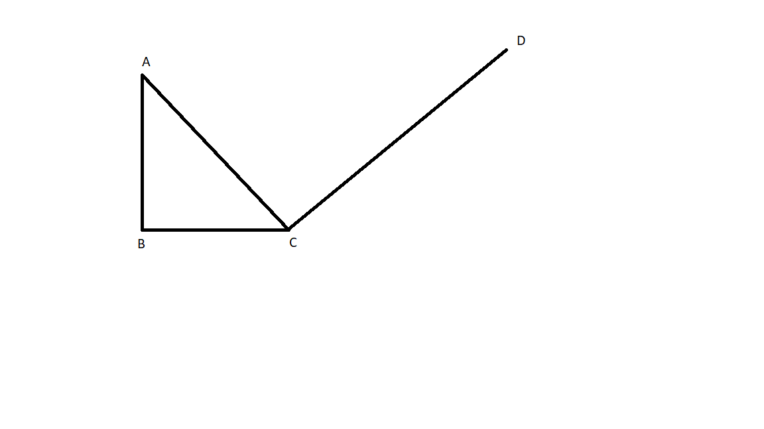
13. If tan x = $\frac{1}{√3}$ find without using tables or calculator the value of
Sin (90-x)+ cos (90-x) leaving your answer in simplified surd form (3mks)

14. A line perpendicular to the line 3y-2x=2 passes through the point (-3,2). Determine the
equation of the line and write it in the form ax +by = c where a, b, and c are constant.
(3mks)

15. Given that A = $\left(\begin{matrix}4 & 3 \\ -1 & -2\end{matrix}\right)$ and C = $\left(\begin{matrix}3 & 7 \\ -1 & -2\end{matrix}\right)$ (4mks)
Find B such that A² + B = C⁻¹

16. Ali travelled a distance of 5km from village A to village B in direction of N60⁰E. He then
changed direction and travelled a distance of 4km in the direction of 135⁰ to village C.
- Using a scale of 1cm to represent 1.0 km represent the information on an accurate diagram.
(2mks)

\

- Using scale drawing (a) above determine
- distance between A and C (1mk)

- bearing of A from C (1mk)

SECTION B (50mks)
Answer only five questions in this section, in the spaces provided below each question.

17. The table below shows marks obtained by 100 candidates at Highway secondary school in a Biology examination

Marks | 15-24 | 25-34 | 35-44 | 45-54 | 55-64 | 65-74 | 75-84 | 85-94
Frequency | 6 | 14 | 24 | 14 | x | 10 | 6 | 4

- Determine the value of x (2mk)

- State the modal class (1mk)

- Calculate the median mark to 4 significant figures (3mks)

- Using an assumed mean of 59.5 calculate the mean mark (4mks)

18. the diagram below represents a frustum of a right pyramid with a rectangular base ABCD measuring 24cm by 18cm. the frustum was made by cutting off a small pyramid exactly 2/3 up the vertical height

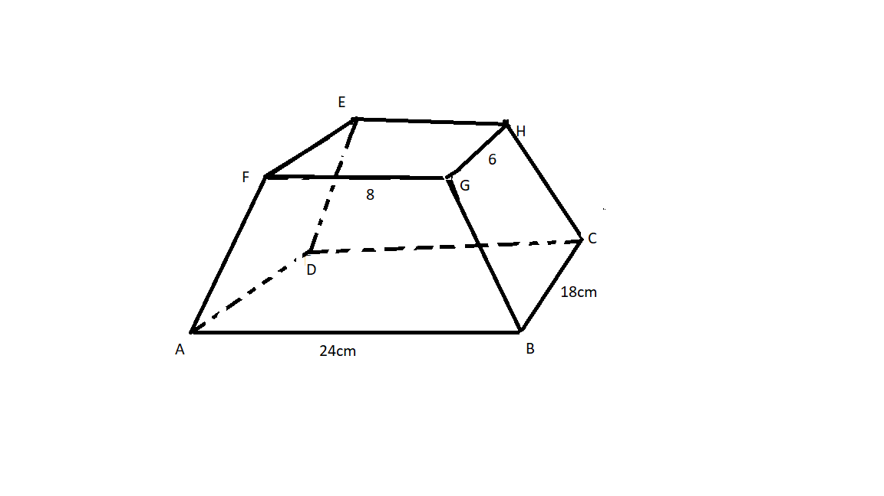
The slant height of the original pyramid is 36cm. Calculate to 1 decimal place;
- Vertical height of the original pyramid. (3mks)

- Volume of the frustum. (4mks)

- Surface area of the original pyramid. (3mks)

19. The figure below shows a cube of side 10cm. M is the midpoint of AF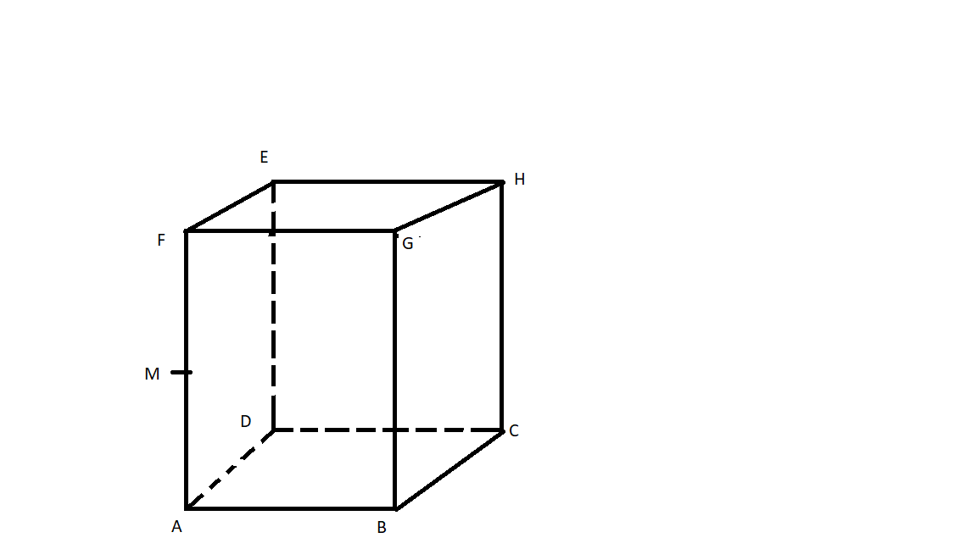

Find;
- Length HM (4mks)

- The angle between HM and ABCD (2 mks)

- Angle between HM and MC (4mks)

20. (a) Complete the table below for y= 3x²+4x+6 (2mks)

X | 1.0 | 1.5 | 2.0 | 2.5 | 3.0 | 3.5 | 4.0 | 4.5 | 5.0 | 5.5 | 6.0
y

(b) Using a trapezium rule with 5 strips determine the area enclosed by the curve y= 3x² +4x+6.
The lines x= 1 and x= 6 and the x-axis. (2mks)

(c) Use mid-ordinate rule with 5 strips to determine the area under the curve y= 3x²+4x+6 the
lines x= 1, x=6 and x- axis. (2mks)

(d) Find the exact area enclosed by the curve y= 3x²+4x+6 the
lines x= 1, x=6 and x- axis. (2mks)

(e) Find percentage error in using trapezium rule. (2mks)

21. a) Given that A = $\begin{matrix}3 & 4 \\ 2 & 3\end{matrix}$ find inverse of A (1mk)

- Two universities, TECK and KCT purchased beans and rice . TECK bought 90 bags of beans and 120 bags of rice for a total of sh 360 000 . KCT bought 200 bags of beans and 300 bags of rice for a total of sh 850 000. Use matrix method to find the price of one bag of each item . (6marks)

C) The price of beans later decreased in the ratio 4: 5 while that of rice increased by 20 %. A businessman bought 20 bags of beans and 30 bags 0f rice. How much did he pay? (3mks)

22. A commuter train moves from station A to D via B and C in that order, the distance from A
to C via B is 70km and that of B to D via C is 88km. Between stations A and B the train
travels at an average speed of 48km/h and it takes 15minutes. The average
speed of the train between C and D is 45km/h. Find;
- Distance between B and C (2mks)

- Time taken between C and D (2mks)

- If the train halts at B for 3 minutes and at C for 4 minutes and average speed for the whole journey is 50km/h. Find its average speed between B and C. (4mks)

- If the return journey was 54km/h how long did it take for the whole journey? (2mks)

23. In a triangle OPQ, OP =P and OQ= q and that N is a point on PQ such that PN = $\frac{2 }{3}$ PQ, M is
the midpoint of OQ.

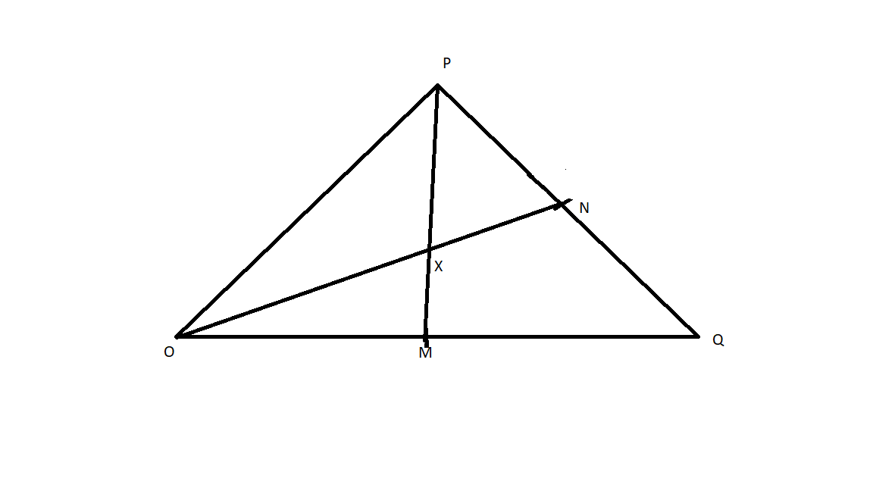

- Find in terms of p and q the vecors

- PQ (1mk)

- PM (1mk)

(iii ) PN (1mk)

(b) Given further that PX= nPM and OX -= mON where m and n are scalars and that x is a point
of intersection of PM and ON.
Express OX in terms of;
- P, q and m (1mk)

- P, q and n (1mk)

(c)Determine the values of m and n. (5mks)

(d) find ratio OX= ON (1mk )

24. The floor of a rectangular room can be covered completely by a carpet costing sh. 200 per
square metre. The total cost of the carpet would be sh. 5600. Taking the length of the room
to be x m;
- Express width of the room in terms of x (2mks)

- If a uniform width of $\frac{1}{2}$ m is left uncovered all round. The cost is sh. 2000 less. Form and solve an equation to determine the value of x. (5mks)

- Later it was decided that the floor left uncovered in (b) above should also be covered. However the cost of the carpet had then gone up by sh. 150 per square metre. Determine the cost in covering the previously uncovered region. (3mks)

THE END

