121/2
MATHEMATICS PAPER 2MARKING SCHEME
1. | No. Log  −  0.7214 2.8582  20.37 0.3090  −  1.1672 x $\frac{1}{3}$  69.8 1.7224  1.8439  −  3.8785  7.560 x 10⁻³ | M1  M1  A1 | Logs  x, -
2. | Co-ordinates of mid-point M:  OM = $\frac{1}{2}$(OP + OQ)  ˜  ˜  = $\frac{1}{2}\left[\left(\begin{matrix}-2 \\ 8\end{matrix}+ \left(\begin{matrix}4 \\ 7\end{matrix}\right)\right)\right]$ = $\frac{1}{2}\left(\begin{matrix}2 \\ 15\end{matrix}\right)$ = $\left(\begin{matrix}1 \\ 7.5\end{matrix}\right)$  Hence M $\left(1,7.5\right)$  Gradient of PQ = $\left(\frac{7-8}{4--2}\right)$ = $\frac{-1}{6}$  Equation of bisector of PQ at  $\frac{y-7.5}{x-1}$ = 6  y – 7.5 = 6x -6  y = 6x + $\frac{3}{2}$ | M1  M1  A1 | Co-ordinate M  Equating to ||⊥ gradient  eqn
3. | A.S.F = $\frac{36}{49}$, L.S.F = $\frac{6}{9}$ = $\frac{2}{3}$  V.S.F = $\frac{2^{3}}{3^{3}}$ = $\frac{8}{27}$  $\frac{8}{27}$ = $\frac{20.2}{V}$ , v = 68.175cm3 | M1  A1 | VSF  Vol accept to 4 sf
4. | $\frac{87}{100}$ x 800 = 696 (selling point)  B.P x $\frac{120}{100}$ = 696, B.P = KSh. 580 | B1  B1 | S.P  B.P
5. | 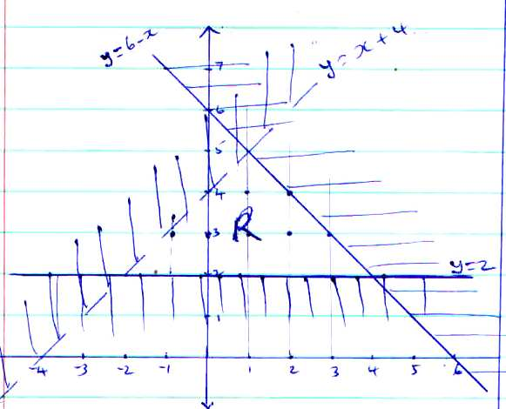 | L1  L1  L1  B1 | For y < x + 4 plotting & shading  For Plotting & shading y ≤ 6 – x  For plotting y ≥ 2  For identification of R
6. | $\left(\frac{\frac{1}{3}π{\left(\frac{4}{3}r\right)}^{2}}{\frac{1}{3}πr^{2}h}x\left(\frac{3}{4}h\right)\right)$ - $\left(\frac{1}{3}πr^{2}h\right)$ x 100  $\left(\frac{\frac{1}{3}πr^{2}\left(\frac{4}{3}-1\right)}{\frac{1}{3}πr^{2}h}\right)$ x 100  = $\frac{1}{3}$x 100 = 33$\frac{1}{3}$% increase | M1  M1  A1 | $\frac{NV-OV}{OV}$  FactorisingOv

7. | Log (5x + 75) – Log (2x – 9) = Log3²  Log$\left(\frac{5x+75}{2x+9}\right)$ = Log3²  $\frac{5x+75}{2x+9}$ = 9  5x + 75 = 9(2x – 9)  156 = 13x  x = 12 | M1  M1  A1 | eqn in logs  Logs removed (all)  Value of x
8. | 2a = 2(3i – 2j + 3k  ˜  ˜  ˜  ˜  ˜  = 6i – 4j + 6k  3b = 3(2i – 4j – 3k)  ˜  ˜  ˜  = 6i – 12i – 9k  ˜  ˜  ˜  2a – 3b = 8j + 15k  ˜  ˜  ˜  ˜  |2a – 3b) = $\sqrt{64+225}$  ˜  ˜  = 17 | M1  M1  A1 | 2a and 2b values  calculation of magnitude  Ans
9. | A³ = $\frac{bx}{b+x}$  A³b + A³x = bx  x(b – A³) = A³b  x = $\frac{A^{3}b}{{b-A}^{3}}$  Substituting for A = 2 and b = 6,  $\frac{2^{3}x6}{6-2^{3}}$ = $\frac{48}{-2}$  = -24 | M1  M1  A1 | Removal of $\sqrt[3]{}$  Simplification  Eqn
10. | (a) 6(XC) = 5 x 4.8  XC = $\frac{5 x 4.8}{6}$ = 4cm  (b) 8 x (8 + 4 + 6) = BT²  BT = $\sqrt{144}$ = 12cm | M1  A1  A1 | Eqn  XC  Eqn  BT
11. | Adding: $\frac{3\sqrt{5}+\sqrt{5}-2}{\sqrt{5}\left(\sqrt{5}-2\right)}$ = $\frac{2\sqrt{5}-2}{5-2\sqrt{5}}$  Multiply by conjugate:-  $\frac{2\sqrt{5}-2}{5-2\sqrt{5}}$•$\frac{5+2\sqrt{5}}{5+2\sqrt{5}}$  = $\frac{10\sqrt{5}+20-10-4\sqrt{5}}{25-20}$  = 6$\frac{\sqrt{5}}{5}$ +10  2 + $\frac{6}{5}\sqrt{5}$
12. | (a) y = kx + cx²  45 = 20k + 400c  60 = 24k + 576c  270 = 120k + 2400c  300 = 120k + 2880c  c = $\frac{30}{480}$ = $\frac{1}{16}$  45 = 20k + $\frac{400}{16}$, k = 1  hence  y = x + $\frac{1}{16}x^{2}$  (b) 75 = x + $\frac{x^{2}}{16}$  $x^{2}$ + 16x – 1200 = 0  x = $\frac{-16\sqrt{256+4x1200}}{2 x 1}$  x = -43.56 or 27.56 | M1  M1  A1 | Substitution  c, k  eqn
13. | ${\left(a-x\right)}^{6}$ = a6 + 6a⁵(-x)1 + 15a4(-x)2 + 20a³)-x)³  a⁶ – 6a⁵x + 15a⁴x² – 20a³x³  (a – x)⁶ = 2.996 = (3-0.01)⁶  a = 3, x = 0.01  hence  36 – 6 x 3⁵x (0.01) + 15 x 3⁴ (0.01)2 – 20 x 3³ x (0.01)³  729 – 14.58 + 0.1215 – 0.00054  = 714.54096  = 714.541 | M1  A1 | Expansion  Simplification in a, x  CAO
14. | Third piece  Max length: 3.05 – (1.25 + 0.935)  = 0.865m  Min length: 2.95 (1.35 + 0.945)  = 0.655m  Hence  0.655 to 0.865m | B1  B1  B1 | Expression for max length  Exp. For min length  Identify of upper & lower limit. (Accept given as range
15. | 1kg of Tamu mixed with x kg of Chungu  (70 x 1) + (64 x x) = 68 x (1 + x)  70 + 64x = 68 + 68x  x = $\frac{1}{2}$  Tamu: Chungu = 1: x = 1:$\frac{1}{2}$  = 2:1 | M1  A1 | Alternative Formula  eqn to find x Tamu Chungu  70 64  68  4 2
16. | $x^{2}$ + 8x + ${\left(\frac{8}{1}\right)}^{2}$ + $y^{2}- 2y$ + ${\left(\frac{-2}{2}\right)}^{2}$  = 1 + ${\left(\frac{8}{2}\right)}^{2}$ + $\left(\frac{-2}{2}\right)$  (x + 4)² + (y – 1)² = 18  Centre of circle (-4, 1)  Radius of circle = $\sqrt{18}$  or 4.243 | M1  M1  A1 | eqn  Eqn of circle expressed  Centre & Radius
17. | 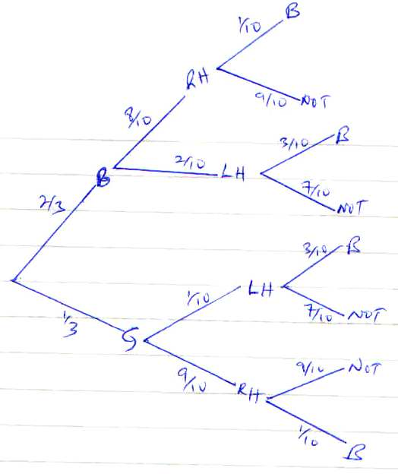  (b) (i) = $\frac{2}{3}$ x $\frac{2}{10}$ + $\frac{1}{3}$ x $\frac{1}{10}$  = $\frac{4}{30}$ + $\frac{1}{30}$ = $\frac{5}{30}$ = $\frac{1}{6}$  (ii) $\frac{2}{3}$ x $\frac{2}{10}$ x $\frac{3}{10}$ + $\frac{1}{3}$ x $\frac{3}{10}$  = $\frac{12}{300}$ + $\frac{3}{300}$  = $\frac{15}{300}$  = $\frac{1}{20}$ | B2  M1  A1  M1 | All (B1 one arm
18. | (a) Det = 32 – 35  = - 3  P-1 = -$\frac{1}{3}\left(\begin{matrix}8 & -7 \\ -5 & 4\end{matrix}\right)$  (b) (i) 8b + 14m = 47600  10b + 16m = 57400  $\left(\begin{matrix}8 & 14 \\ 10 & 16\end{matrix}\right)\left(\begin{matrix}b \\ m,\end{matrix}\right)$ = $\left(\begin{matrix}47600 \\ 57400\end{matrix}\right)$  or  $\left(\begin{matrix}4 & 7 \\ 5 & 8\end{matrix}\right)\left(\begin{matrix}b \\ m\end{matrix}\right)$ = $\left(\begin{matrix}23800 \\ 28700\end{matrix}\right)$  (ii) $\left(\begin{matrix}b \\ m\end{matrix}\right)$ = $\left(\begin{matrix}\frac{-8}{2} & \frac{7}{3} \\ \frac{5}{3} & -\frac{4}{3}\end{matrix}\right)\left(\begin{matrix}23800 \\ 28700\end{matrix}\right)$  $\left(\begin{matrix}b \\ m\end{matrix}\right)$ = $\left(\begin{matrix}-\frac{8}{3}x23800+28700x\frac{7}{3} \\ \frac{5}{3}x23800+-\frac{4}{3} x 28700\end{matrix}\right)$  $\left(\begin{matrix}b \\ m\end{matrix}\right)$ = $\left(\begin{matrix}3500 \\ 1400\end{matrix}\right)$  Bag of beans cost Sh. 3500  Bag of maie cost Sh. 1400  (c) $\frac{115}{100}$ x 3500 = 4025  8 x 4025 = 32400  47600 – 32400 = 15400  ∴1400m = 15400  m = 11 bags  Ratio 8:11 | B1  B1  M1  A1  M1  M1  A1  B1  B1  B1 | Accept $\left(\begin{matrix}-\frac{8}{3} & \frac{7}{3} \\ \frac{5}{3} & -\frac{4}{3}\end{matrix}\right)$  Both
19.  20. | (a) = 38000 + 14000 + 8500 + 3300  = 62800  $$\frac{62800 x 12}{20}$$  K£ 37680 p.a.  (b) 1st K£ 600 6000 x 2 = 12000  Next £6000 6000 x 3 = 18000  Next £6000 6000 x4 = 24000  Next £6000 6000 x 5 = 30000  Next £6000 6000 x 6 = 36000  Next £6000 6000 x 7 = 42000  Rem. £ 1680 1680 x 8 = 13440  Tax due p.a. = Sh. 175440  Less relief Sh. 18000  Tax paid = Sh. 157440  (c) (i) Tax paid per month = $\frac{157440}{12}$  = 13,120  Total deductions  = 13120 + 320 + 1000 + 2000 + 500  = 23940  (ii) Net salary = 62800  - 23900  38,900  - $\frac{9^{x}}{3^{2x+1}}$ = $\frac{81}{9^{x}}$  $\frac{3^{2x}}{3^{2x+1}}$ = $\frac{3^{4}}{3^{2x}}$  $3^{-1}$ = $3^{4-2x}$  -1 = 4 – 2x  $$2x=5$$  x = 2.5  - Common ratio = $\frac{81}{9^{\frac{5}{2}}}$  = $\frac{81}{3^{5}}$  = $\frac{81}{243}$  = $\frac{1}{3}$  - a = $3^{2\left(2.5\right)+1}$  = $3^{6}$  = 729  S₄ = 729 $\left(\frac{{1-\left(\frac{1}{3}\right)}^{4}}{1-\frac{1}{3}}\right)$  = 729 $\left(\frac{1-\frac{1}{81}}{1-\frac{1}{3}}\right)$  = 729 $\left(\frac{\frac{80}{81}}{\frac{2}{3}}\right)$  = 729 x $\frac{80}{81}$ x $\frac{3}{2}$  = 1080 | M1  A1  M1  M1  M1  A1  M1  A1  M1 | Taxable income in Sh/m  (can be implied in accuracy mark)  Values in just 4 slabs  Subtracting relief  Addition  Ans
21. | (a) (i) Fraction filled in 1 hr by PtQ  = $\frac{2}{9}$ + $\frac{1}{3}$ = $\frac{5}{9}$  Time taken to fill tank = $\frac{9}{5}$ = 1$\frac{4}{5}$ hrs  (ii) Fraction filled in 1 hr by P, Q & r  = $\frac{5}{9}$ - $\frac{1}{2}$ = $\frac{1}{18}$  Time taken to fill = $\frac{18}{1}$ = 18 hours  (b) (i) Fraction filled by 9.00 a.m  P $\frac{2}{9}$ x 1 hr = $\frac{2}{9}$  Q $\frac{1}{3}$ x $\frac{1}{4}$hrs = $\frac{1}{12}$  Both P and Q $\frac{2}{9}$ + $\frac{1}{12}$  = $\frac{11}{36}$  (ii) Fraction to be filled = $\frac{25}{36}$  Time taken = $\frac{25}{36}$ x 18  = 12$\frac{1}{2}$ hrs  Time taken for taken to fill up  = 0900  1230  2130 hrs  or 9.30 p.m | M1  A1  M1  A1  M1  M1  A1  M1  A1

22. | (a) (i) ON = OP + PN  = P + $\frac{1}{3}$PQ  = p + $\frac{1}{3}$q - $\frac{1}{3}$p  ˜  ˜  ˜  = $\frac{2}{3}$p + $\frac{1}{3}$q  ˜  ˜  (ii) PM = PO + OM  =-p + $\frac{2}{3}$q  (b) (i) OX = hON  = h$\left(\frac{2}{3}p+\frac{1}{3}q\right)$  = $\frac{2}{3}$hp + $\frac{1}{3}$hq  ˜  ˜  OX = OP + PX  = P + kPM  = P + k (-p + $\frac{2}{3}q$)  = p – kP + $\frac{2}{5}$q  = (1 – k)p + $\frac{2}{5}$kq  ˜  $\frac{2}{3}$hp + $\frac{1}{3}$hq = (1 – k)p + $\frac{2}{5}$kq  ˜  $\frac{2}{3}h$ = 1 – k………. (i)  $\frac{1}{3}$h = $\frac{2}{5}$k …………...(ii)  From (ii) h = $\frac{6}{5}$k  Subt in (i)  $\frac{2}{3}$ x $\frac{6}{5}$k = 1 – k  k = $\frac{5}{9}$  h = $\frac{1}{3}$  (ii) PX : XM = $\frac{5}{9}$ : $\frac{4}{9}$  = 5 : 4 | M1  A1  M1A1  B1  B1  M1  M1 | Equating eqns  For extracting coefficients
23. | (a) ∠QRS = 90⁰ (Subst. by the remainder)  ∠ PRS = 90 – 70 = 20⁰  (b) ∠POQ = 2 x 70⁰ = 140⁰  ∠at centre is twice ∠ at circumference  (c) ∠RQP = $\frac{180-70}{2}$ = 55⁰( Base angles of a Δ)  ∠RQP and ∠PSE are supplementary (cyclic  quadrilateral)  ∴∠PSR = 180 – 55 = 125⁰  ∠ QSR = 125 – 70  = 55⁰  (d)∠PSQ = ∠PRQ = 700 (Subst. by same arc)  ∠QSP = ∠SPO = 700 (base angles of isoscles Δ)  Reflex ∠POS = 360 – 40  = 320⁰ |  | B1  B1  B1  B1  B1

24. | x -5 -4 -3 -2 -1 0 1 2  y -5 15 19 13 3 -5 -5 9
(c) (i) x = -4.85
x = -0.7
x = 1.5
(ii) x³ + 4x² – 5x – 5 = -4x – 1
x³ + 4x² – x – 4 = 0
y = x³ – 4x² – 5x = 5
0 = x³ – 4x² – x – 4
y = -4x – 1

x 0 1
y -1 -5
x = -4
x = 1
 | 