Mathematics Activities - CBC Grade 2 Term 1 Exams 2023
QUESTIONS
- Work out
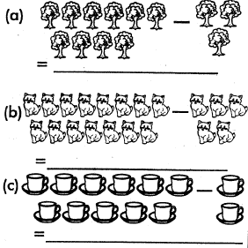
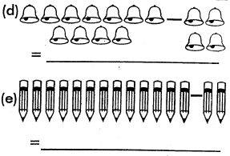
- Write in words
  - 200
  - 43
  - 104
  - 16
- What fraction is shaded?
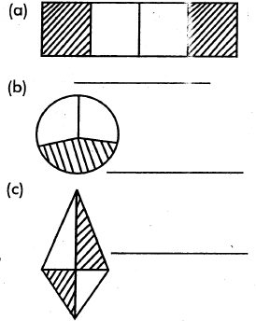
- Work out
  - 124
+26
  - 624
+123
  - 414
+ 565
  - 506
+603

  - 730= _____hundreds_____ tens_____ones
  - 934= _____hundreds_____tens _____ones
  - 20= _____hundreds_____tens_____ones
- Which is heavier
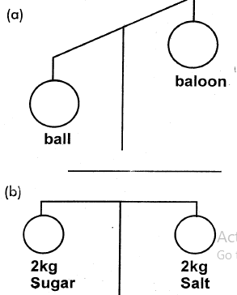
- Work out
  - 97
- 68
  - 178
-16
  - 965
-569
  - 888
-624
- Arrange the numbers from smallest to the largest
  - 97,111,56,105
  - 28, 18, 8, 38
  - 74, 24, 14, 99
- Three sheep have_____legs.
- There are_____ days in a week.
- Divide
  - 8 ÷ 2 =
  - 9 ÷ 3 =
  - 6 ÷ 1 =
  - 4 ÷ 2 =

- Multiply
  - 3 x 2 =
  - 4 x 4 =
  - 2 x 2 =

MARKING SCHEME

  - 7
  - 10
  - 9
  - 7
  - 11

  - two hundred
  - fourty three
  - a hundred and four
  - sixteen

  - ²/₄ or ½
  - ¹/₃
  - ²/₄ or ½

  - 150
  - 747
  - 979
  - 1109

  - 7, 3, 0
  - 9, 3, 4
  - 0, 2, 0

  - ball
  - they are the same

  - 29
  - 162
  - 396
  - 264

  - 56,97,105,111
  - 8,18,28,38
  - 14,24,74,99
- 12
- 7

  - 4
  - 3
  - 6
  - 2

  - 6
  - 16
  - 4

