Mathematics - Grade 5 Term 1 Exams 2023
QUESTIONS
- What is the place value of digit 3 in the numbers below? (3mks)
  - 430 4
  - 2653 2
  - 58 23
- A member of county assembly donated 5486 books to a certain school. What is the figure in words.
- What is the perimeter of the figures
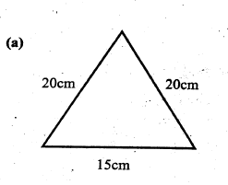
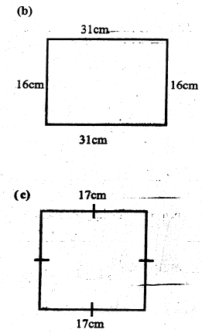
- In a farm there are 4678 animals 2626 are female animals. How many male animals were in the farm
- Workout
  - 672
+726
  - 987
+249
  - 3561
+9269
  - 4623
+ 288
- Write the following numbers in words
  - 343
  - 999
  - 606
- What is the next number in the series
  - 2000,2200,_____,2600, 2800
  - 900, 1000, 1100,_____,1300
  - 3, 5,____,9, 11
- Arrange the fraction from the smallest to the largest
  - ¹/₈, ¹/₂, ¹/₄, ¹/₃,____
  - ¹/₉, ¹/₃, ¹/₆, ¹/_{8,} ¹/_{10,}____
- Multiply
241
x 3
- A carton had 5 packets of pens, each packet had 12 pens. How many pens were there in the carton altogether

MARKING SCHEME

  - hundreds
  - tens
  - ones
- five thousand four hundred and eighty six

  - 35 cm
  - 93 cm
  - 68 cm
- 2052

  - 1398
  - 1236
  - 12830
  - 4911

  - Three hundred and forty three
  - Nine hundred and ninety nine
  - Six hundred and six

  - 2400
  - 1200
  - 7

  - ¹/₈, ¹/₄, ¹/₃, ¹/₂
  - ¹/₁₀, ¹/₉, ¹/₆, ¹/₃
- 723
- 60 pens

