Mathematical activities - Grade 2 Term 1 Exam 2023

Write the next number
- 2, 4, 6, ___10
- 7, 9, 11, ___
- 20, 18, 16, ___
Write in words
- 3 ______________
- 7 ______________
- 5 ______________
Add
- 14 + 3 = _____
- 21 + 7 = _____
- 1 5
+ 5
____
- 6 2
+ 3
____
- 63 + 2 = ______
- 6 + 1 + 2 = ______
- 27 + 12 = ______
- 2 2
+1 4
_____
Take away
- 7 − 6 = ______
- 35 − 9 = ______
- 9
−4
____
- 3 9
− 6
____
- Which one is heavier?
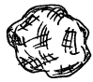 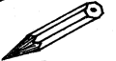
Stone Pencil
- Which one holds less?
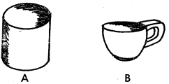

Circle where a half (½) is shaded

