MATHEMATICS
PAPER 1 2023

MARKING SCHEME

1. | 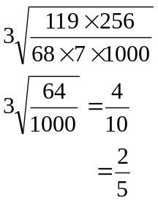 | M1  M1  A1 | ✓ removal of decimal and simplification  ✓cube root  C.A.O.
 |  | 3
2. | Share of elder boy =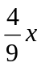  Share of younger boy=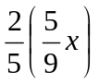  =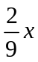  Girls share =  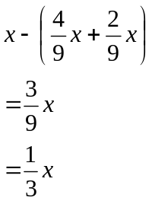  % share of younger boy to girls share  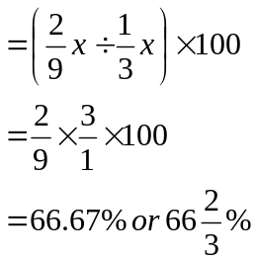 | B1  B1  M1  A1
 |  | 4

3. | 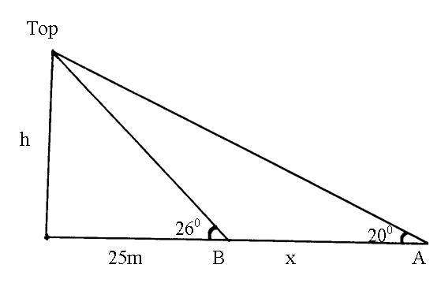  h = 25 tan 26⁰  = 12.1933  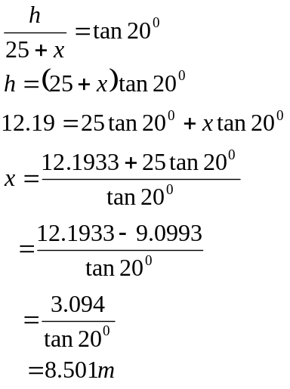 | B1  M1  A1 | ✓ height  for equation in x  ✓ solution
 |  | 3
4. | 5<2x²<35  2.5<x²<17.5  1.581<x<4.183  2,3,4 | B1  B1  B1 | Removal of fraction or equivalent  ✓Square roots  ✓ integral values
5. | Overtaking speed (Relative speed)  =80km/h-40km/h=40km/h  Distance= 60m+20m  =80m  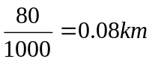  Time take = 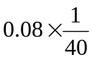  =0.002hrs  =7.2seconds | M1  M1  A1 | ✓ distance  Expression for time
 |  | 3

6. | Let no. be XY  product XY =20---------------(i)  Reversed no YX  (10y+x)-(10x+y)=9-----------(ii)  9y-9x=9  y-x=1  y=1+x  Substitution in (i) we’ve  x(1+x)=20  x+x²=20  x²+x-20=0  x²+5x-4x-20=0  x(x+5)-4(x+5)=0  (x+5)(x-4)=0  x=-5 or x=4 | M1  M1 | ✓ Formation of the two equation  ✓solving of any unknown
7. | (a) (x-5)²+(y-5)²=5²  x²-10x+25+y²-10y+25=25  x²-10x+y²-10y+25=0  (b) Grad PQ=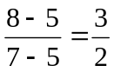  (c) grad of the tangent at Q =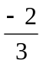  Let (x,y) be any other point on it  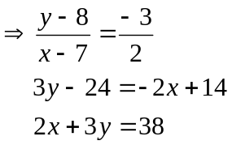 | B1  B1  M1  A1
 |  | 4
8. | Area of A = ½ ×4×15=30cm²  Area of B = ½ QR×15  ½ QR×15=30  QR=4cm  Area of C= ½ ST×PR  = ½ ST×8=30  ST=7.5cm  PT²+PR²=TR²  22.5²+8²=X²  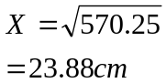 | B1  B1  M1  A1
 |  | 4
9. | (2500×5)+270(480-30×5)  =SH. 101,600 | M1  A1
 |  | 2

10. | I=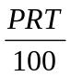  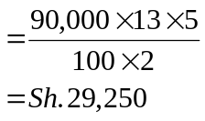  A =(90,000+29,250)  =SH. 119,250 | M1  A1  B1
 |  | 3
11. | 3^{2(t+1)}+3^{2t}=30  3^{2t} . 3²+3^{2t} =30  3^{2t}(3²+1)=30  3^{2t}×10=30  3^{2t}=3¹  2t=1  t= ½ | M1  M1  A1
 |  | 3
12. | 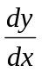=2x-2  2x-2=4  x=3  y=3²-2(3)+6  = 9-6+6  =9  point is (3,9) | M1  A1
 |  | 2
13. | Let 50 shilling notes = x  And 20 shilling coins = y  x=3y--------------------------------(i)  50x+20y=3400--------------------(ii)  Substitute (i) in (ii)  50(3y)+20y=3400  150y+20y=3400  170y=3400  y=20  x=3(20)  x=60 | M1  M1  A1 | Formation of both equations  ✓elimination of one unknown  Both ✓
 |  | 3
14. | 45×10=450  45×4=180  Remaining day =270  No. of days =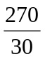=9 days | M1  M1  A1
 |  | 3

15. | 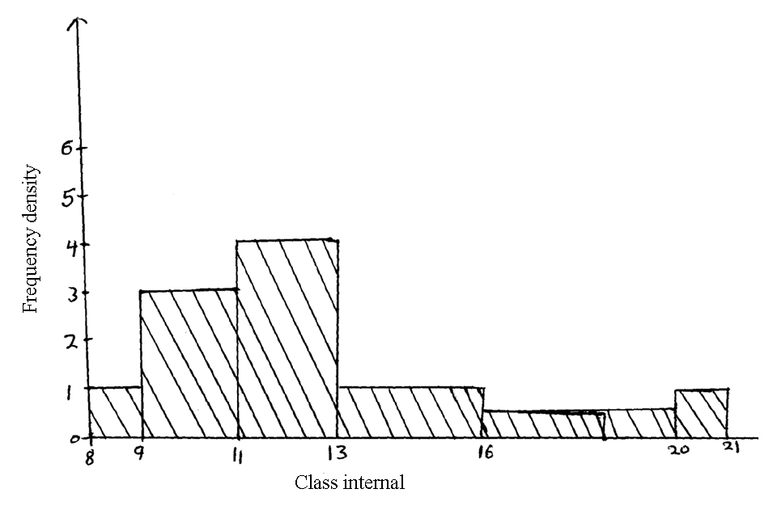 | B1  B1  B1 | ✓Frequency density  ✓bars
 |  | 3
16. | 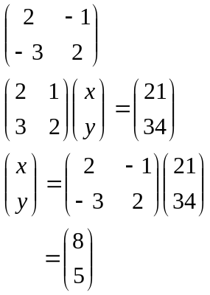 | B1  M1  M1  A1
 |  | 4

17. | 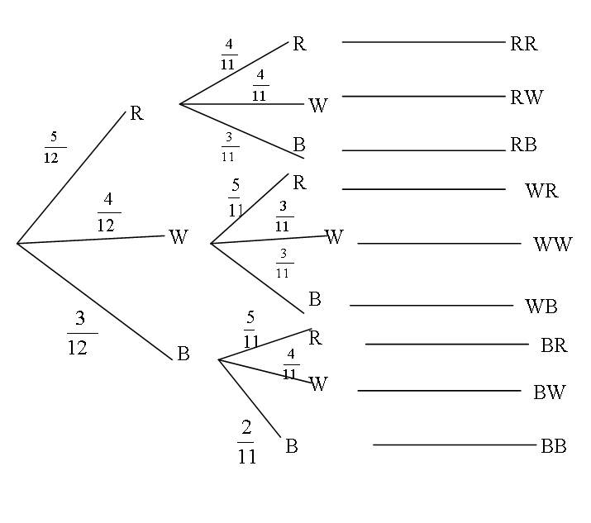  (b) (i) P(RR) or P(WR) or P(BR)  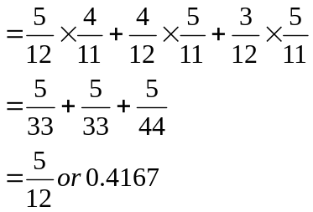  (ii) P(RR) or P(WW) or P(BB)  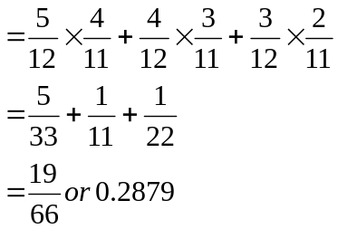  (iii) P(RB) or P(WB) or P(BR) or B(BW) or P(BB)  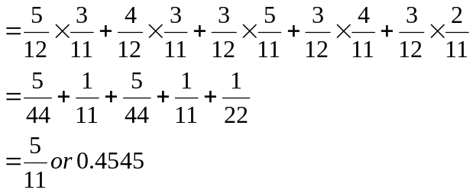 | B2  B1  M1  A1  M1  A1  M1  M1  A1
 |  | 10

18. | (a) < STQ= < PQS = 28⁰(angle in alternate segment)  (b) < TQU = 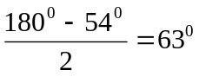(base angles of isosceles triangles)  (c) < TQS =63⁰-28⁰=35⁰(< TUQ is alternate to <PQT=63⁰)  (d) < UOQ =54⁰×2=108⁰(angle subtended at centre is twice that at  circumference by same chord UQ)  Reflect < UOQ=360⁰-108⁰=252⁰  (e) < TQR=< TSQ  = 180⁰-(28⁰+35⁰)  = 117⁰  (angle in alternate segment are equal) | B1  B1  B1  B1  B1  B1  B1  B1  B1  B1 | Angle  Reason  Angle  Reason  Reason  Angle  Angle  Reason  NB:Accept  Alternative reasons which are correct.
 |  | 10
19. | 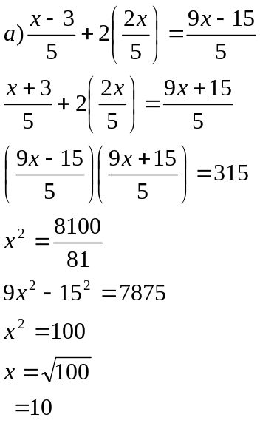  b) Dancing floor area  = (10-3)(10+3)  = 91  Total floor area =15×21=315  Carpeted margin Area =315-91=224m²  c) 750×224=sh 168,000 | M1  M1  M1  M1  A1  M1  M1  A1 M1A1 | For the two expressions  For equality the two expressions  Removal of fractions and forming quadratic equation
 |  | 10

20. | 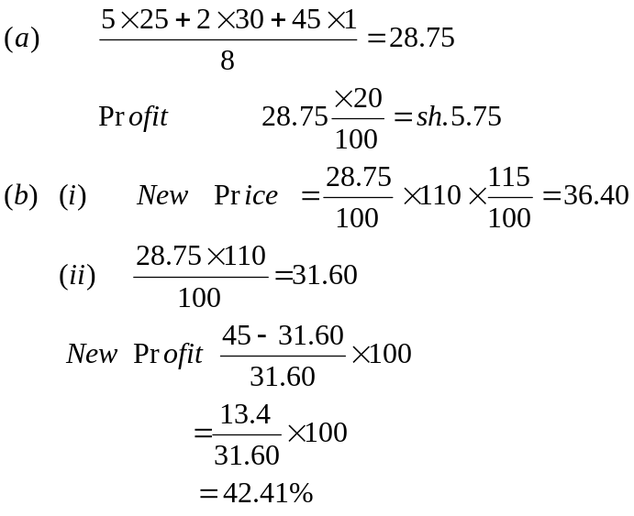 | Ml  A1  Ml  Al  M1  M1  A1  M1  M1  A1
21. | 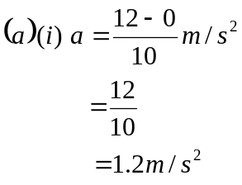  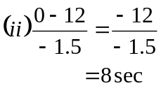 | M1  A1  M1  A1

 | (b)  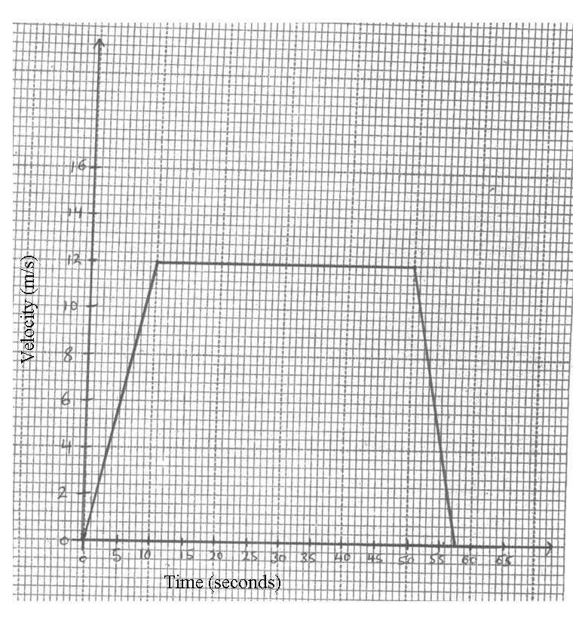  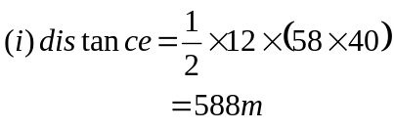  (ii) 1st 15 seconds  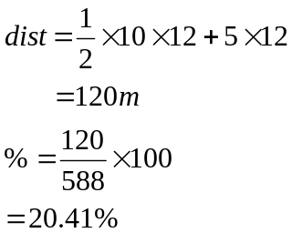 | B2  M1  A1  M1  A1
 |  | 10

22. | (a)  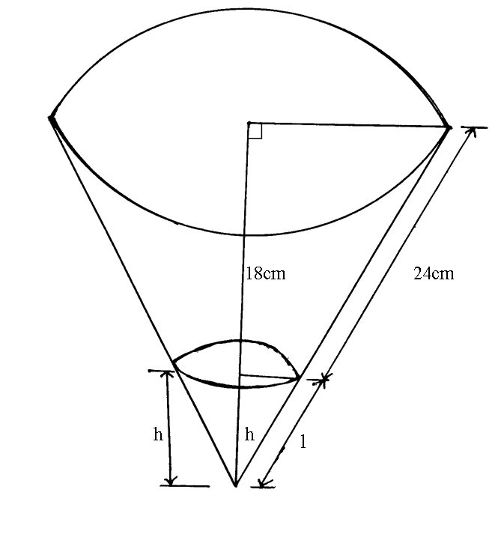  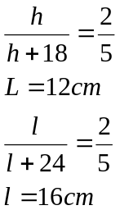  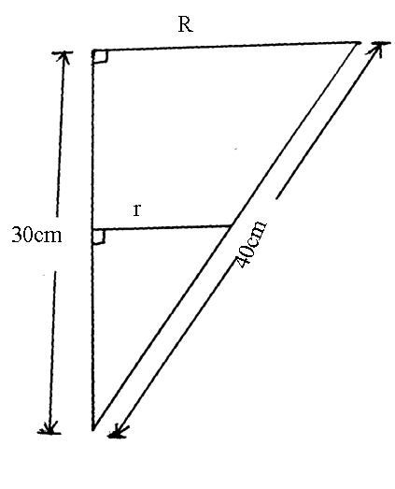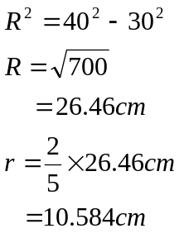  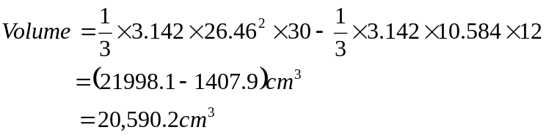 | B1  B1  B1  M1  A1  M1  A1

 | (b) Curved surface area  = 3.142×26.46×40-3.142×10.584×16  =(3325.5-532.08)cm²  = 2793.42cm² | M1M1  A1
 |  | 10
23. | (a) -(x²-2xy+y²)  -(x²-xy-xy+y²)  -x(x-y)-y(x-y)  -(x-y)(x-y)  -(x-y)²  = -(3)²  = -9  (b) 9x²+3xy+3xy+y²  3x(3x+y)+y(3x+y)  (3x+y)(3x+y)  = (3x+y)²  = 17²  = 289  (c) 3x²-3xy+xy-y²  3x(x-y)+y(x-y)  (x-y)(3x+y)  = 3(17)  =51  (d) numerator  3x²-3xy-xy+y²  3x(x-y)-y(x-y)  (x-y)(3x-y)  Denominator :  (3x+y)(3x-y)  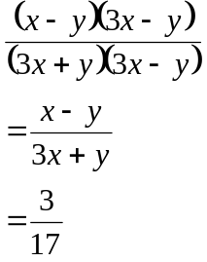 | M1  A1  M1  A1  M1  M1  A1  M1  M1  A1
 |  | 10

24. | (a)  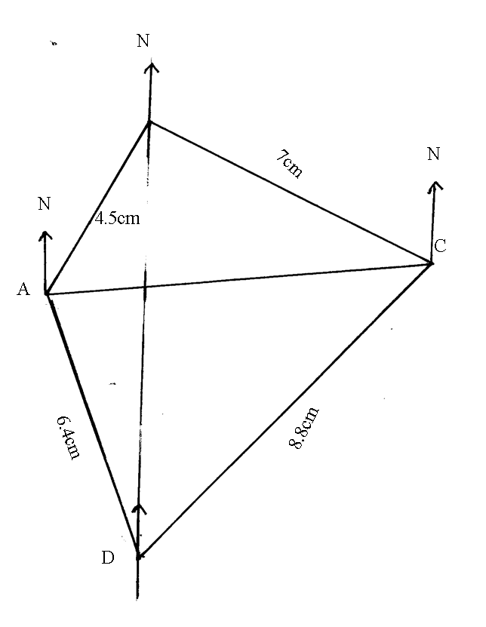  B  (b) (i) N20⁰W  (ii) 542⁰W  (c) (i) 6.4×100km=640km  (ii) 8.8×100km=880km  (d) (i) 300⁰  (ii) 268⁰ | B1  B1  B1  B1  B1  B1  B1  B1  B1  B1
 |  | 10

