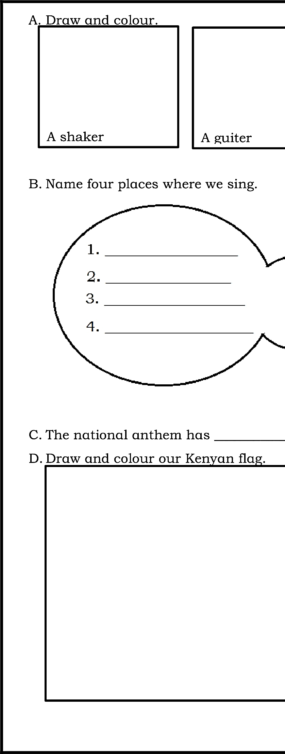

COMPETENCY BASED CURRICULUM

GRADE 3 - TERM 1 EXAM 2023 – MUSIC ACTIVITIES
NAME: SCHOOL

