NAME …………………………………………………………. ADM NO……………………………

SCHOOL ………………………………………………… CLASS ……………………………………

DATE …………………………………….
511/1
MUSIC
PAPER 1
FORM FOUR
(SEPTEMBER - 2022)
TIME. 15 MINS PER STUDENT
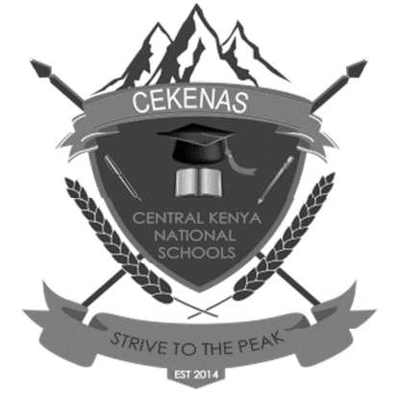
CEKENAS END OF TERM TWO EXAMS-2022
Kenya Certificate Of Secondary Education. (K.C.S.E)
511/1
MUSIC
PAPER 1
FORM FOUR
(AUGUST/SEPTEMBER - 2022)
TIME. 15 MINS PER STUDENT

Instructions to candidates
(a) Each candidate is required to sight read only one of the exercises in this test.
(b) The test should be read through once.
( c) This paper consists of 4 printed pages.

Voice
1.
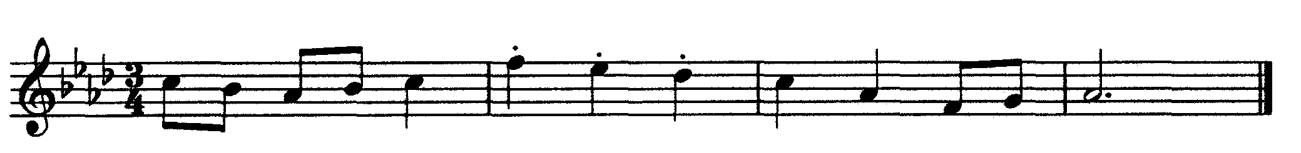

2.

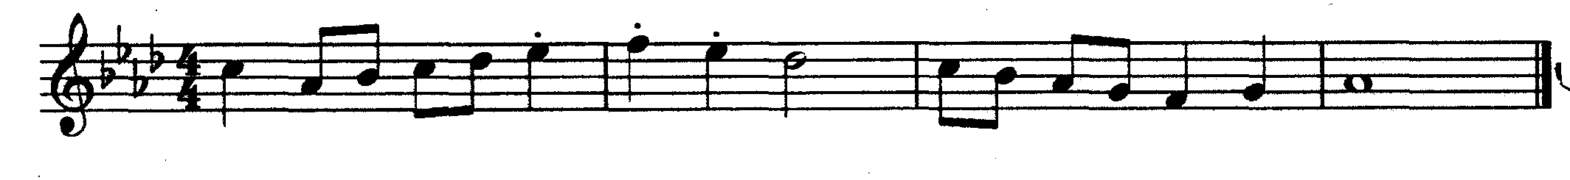
Recorder
3.
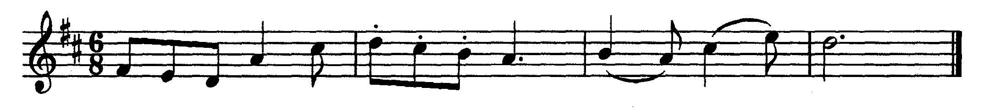
4.
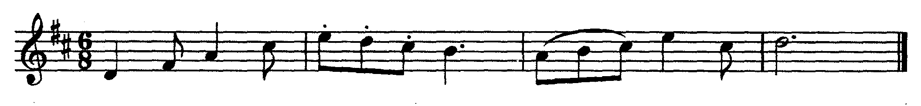
Violin
5.
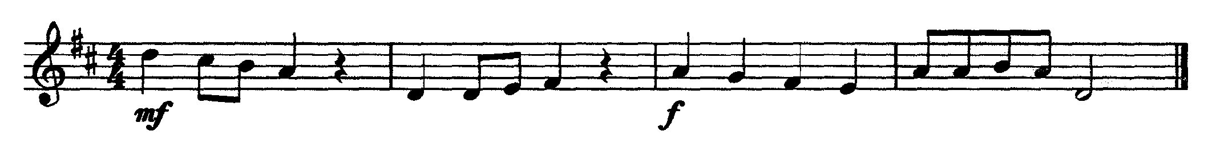
Viola
6.

Cello/Double Bass
7.
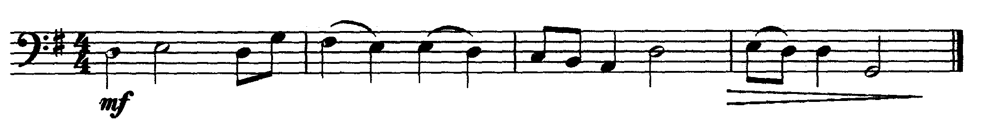
Trumpet/Cornet
8.
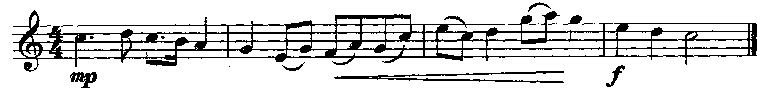
Trombone/ Tuba/Euphonium
9.
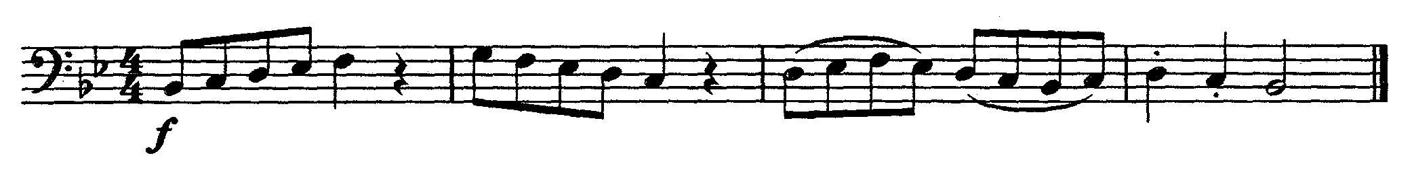
Flute
10.
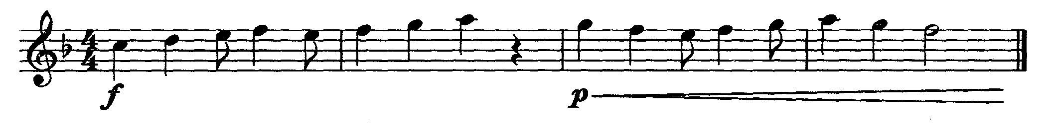
Clarinet
11.
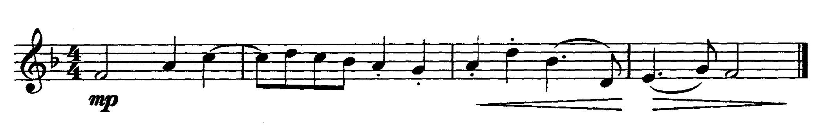
Saxophone
12.
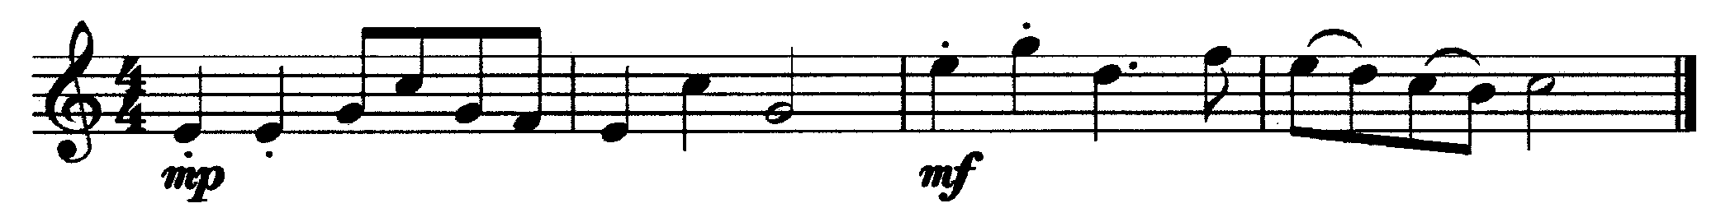
Horn
13.
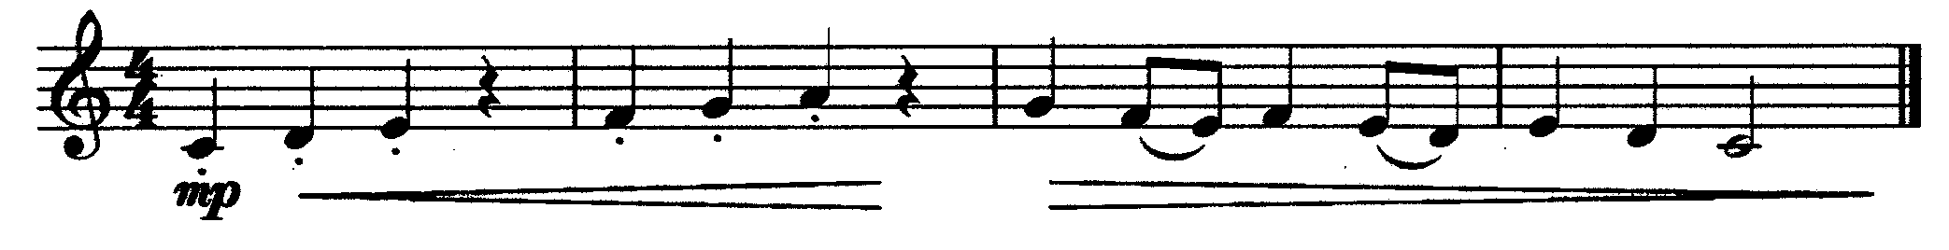
Guitar

14.
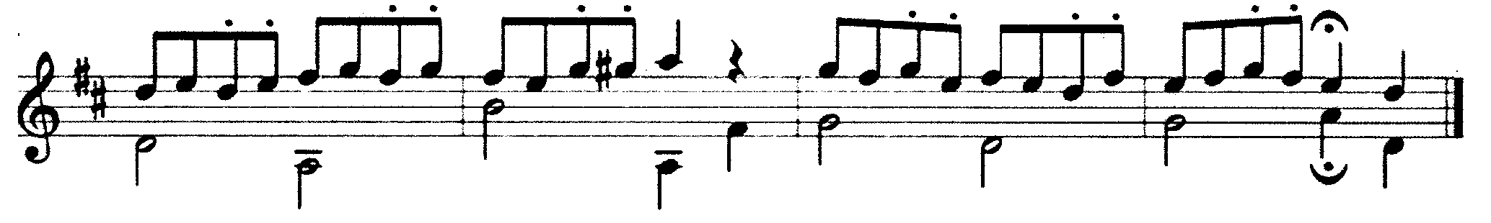
Piano
15.
