**NAME: …………………………………………………….. SCHOOL……………............**

**ADM NO:………………………… DATE:……………….. SIGNATURE………….……**

**511/3**

**MUSIC**

**THEORY**

**PAPER 3**

**FORM FOUR**

**TIME: 2 Hours 30mins**

**CATHOLIC DIOCESE OF KAKAMEGA EVALUATION TEST.**

**AUG/SEPT EXAM 2022,**

*INSTRUCTIONS TO CANDIDATES*

**Answer all questions in this paper in the spaces provided.**

**In question 4,choose any two of the questions numbered (a),(b),(c) or (d)**

**The paper consists of 12 printed pages.**

FOR EXAMINER’S USE :

|  |  |  |  |
| --- | --- | --- | --- |
| SECTION | QUESTION | MAXIMUM SCORE | CANDIDATE’S SCORE |
| A | 1a | 08 |  |
|  | 1b | 07 |  |
|  | 2. | 15 |  |
| B | 3. | 14 |  |
|  | 4. | 14 |  |
|  | 5. | 10 |  |
|  | 6. | 10 |  |
|  | 7. | 06 |  |
| C | 8. | 16 |  |
| TOTAL |  | **100** |  |

**SECTION A:BASIC SKILLS(30 MARKS)**

1a)Continue the following opening to make a **sixteen-bar** melody. Modulate to the **relative minor** before returning to the tonic. Introduce a **sequence** and a **triplet**.(8 mks)









1b)Using staff notation, fit a tune to the lyrics below.(7 marks)

*Janga hili la korona,limekuwa donda ndugu,*

*Tunasema kwa pamoja,tutashinda kwa hakika.*





2.Add Alto,Tenor and Bass to the melody given below. Choose appropriate chords from the following; I,IV,V,ii and vi. Introduce a cadential six four. (15 Marks)







**SECTION B:HISTORY AND ANALYSIS(48 marks)**

**3.African music**

a) (i)Outline **three** factors that determine the choice of costumes and décor used in a traditional dance.

(3 marks)

………………………………………………………………………………………………………………

………………………………………………………………………………………………………………

………………………………………………………………………………………………………………

ii)Outline **two** roles of artefacts as a visual display in the performance of African traditional music performance.

(2 mks)

………………………………………………………………………………………………………………

………………………………………………………………………………………………………………

b)Discuss **three** ways in which formal education has negatively affected traditional African music. (3 mks)

………………………………………………………………………………………………………………

………………………………………………………………………………………………………………

………………………………………………………………………………………………………………

……………………………………………………………………………………………………………

c)(i)What is an **aerophone?** (1 mk)

………………………………………………………………………………………………………………

………………………………………………………………………………………………………………..

ii)Identify **flutes** fromthe list below . (3 mks)

*auleru*

*bung’o*

*ekerongwe*

*enko*

*ekhombi*

*chivoti*

d)Ornaments are decorative items in a performance. Give two **instrumental** ornaments used in African music performance. (2 mks)

………………………………………………………………………………………………………………

………………………………………………………………………………………………………………

4.**WESTERN MUSIC**

**Answer any two questions from (a),(b)(c) and (d)**

a)**Antonio Vivaldi**

i)Outline **two** ways in which Vivaldi acquired his musical training. (2 marks)

……………………………………………………………………………………………………………

……………………………………………………………………………………………………………

ii)Outline **two musical** duties which Vivaldi performed while at **Ospedalle Dela Pieta.** (2 marks)

………………………………………………………………………………………………………………

………………………………………………………………………………………………………………

iii)The **1730s** saw a decline in Vivaldi’s musical career. Explain **three** ways in which this decline came about.

(3 marks)

………………………………………………………………………………………………………………

………………………………………………………………………………………………………………

………………………………………………………………………………………………………………

b)**W.A. Mozart**

i)In which period did Mozart live? (1 mark)

…………………………………………………………………………………………………………….

ii) Ouline **three** characteristic features evident in Mozart’s music. (3 marks)

………………………………………………………………………………………………………………

………………………………………………………………………………………………………………

………………………………………………………………………………………………………………

……………………………………………………………………………………………………………..

iii)Name Mozart’s **three** masterpieces of Italian comic opera. (3 marks)

………………………………………………………………………………………………………………

……………………………………………………………………………………………………………….

……………………………………………………………………………………………………………

c) **Johannes Brahms**

i) Outline **three** features that characterize Brahms music. ( 3 marks)

………………………………………………………………………………………………………………

………………………………………………………………………………………………………………

………………………………………………………………………………………………………………

ii)A part from composing, give **two** other duties that Brahms carried out during his lifetime.(2 marks)

…………………………………………………………………………………………………………………………………………………………………………………………………………………………………………………………

iii)Which **type** of works are each of the following; (2 marks)

***academic festival -***

***Gavotte in A Major -***

d) **Benjamin Britten**

i)What is Britten’s **nationality**? (1 mark)

………………………………………………………………………………………………………………

ii)Give titles of **three** **large scale** operas by Britten. (3 marks)

………………………………………………………………………………………………………………

……………………………………………………………………………………………………………….

………………………………………………………………………………………………………………

iii)State any **three** events that influenced Britten’s music education background. (3 marks)

………………………………………………………………………………………………………………

………………………………………………………………………………………………………………

………………………………………………………………………………………………………………

5.**PRESCRIBED AFRICAN MUSIC**

**POKOT folksong by Ortum Boys’ High School(PPMC Recording)**

a)Outline the sequence of events at the **opening section** of the performance. (3 mks)

…………………………………………………………………………………………………………………

…………………………………………………………………………………………………………………

…………………………………………………………………………………………………………………

………………………………………………………………………………………………………………… b) State **two** roles of the text in the recording. (2 mks)

…………………………………………………………………………………………………………………

…………………………………………………………………………………………………………………

c)State **two** ways in which voice has been used in the recording. (2 mks)

…………………………………………………………………………………………………………………

…………………………………………………………………………………………………………………

d)Explain **three** styles of call and response that are evident in the performance. (3 marks)

……………………………………………………………………………………………………………………………

…………………………………………………………………………………………………………………………….

…………………………………………………………………………………………………………………………….

6. **PRESCRIBED WESTERN MUSIC**

**Choral Fantasy in c minor,op.80,Finale (Allegretto ma non troppo by L.V Beethoven**

a)Identify one area each where the following have been used. Cite the bar numbers. (2 mks)

i) Arppegiated chords

……………………………………………………………………………………………………………………………………………………………………………………………………………………………………

ii)Antiphonal singing

……………………………………………………………………………………………………………………………………………………………………………………………………………………………………

b)Identify two articulation marks that have been used in the music. (2 marks)

…………………………………………………………………………………………………………………..

c)Describe the entry of voices between bar134 and 147. (3 marks)

…………………………………………………………………………………………………………………..

…………………………………………………………………………………………………………………..

d)In which bar does the meter of the music change? (1 mark)

…………………………………………………………………………………………………………………..

e)Which cadence appears between bar 58 and 59? (1 mark)

………………………………………………………………………………………………………………..

f)Give the meaning of the following as used in the score; (1 mark)

*piu*

*poco marcato*

7.**Unprepared analysis(6 marks)**

Study the excerpt given then answer the questions that follow.

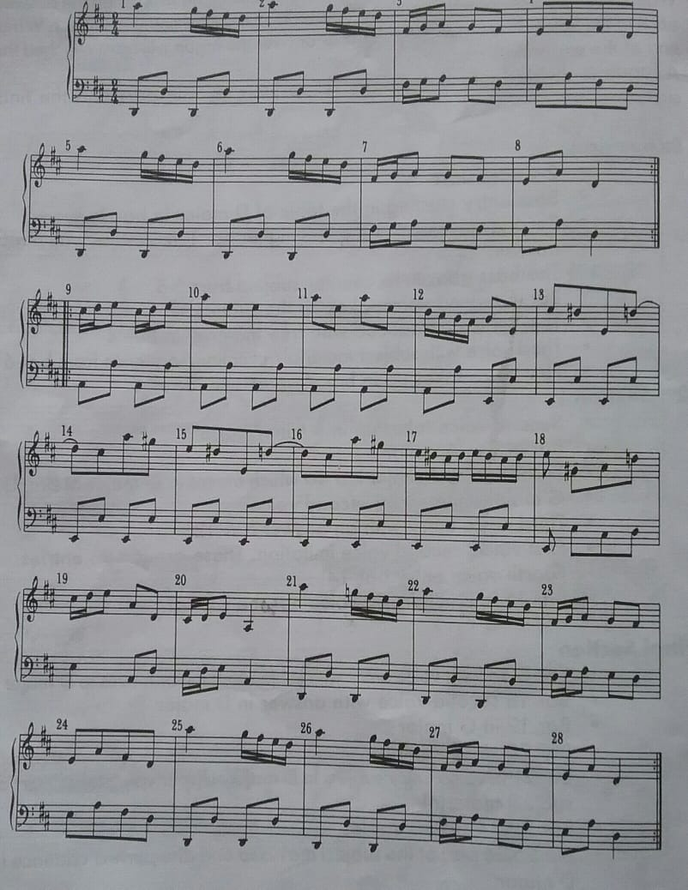

i)In which key is the music between bar 13 and 18? (1 mk)

………………………………………………………………………………………………………………

ii)By use of bar numbers, identify the form of the music. (1 mk)

………………………………………………………………………………………………………………

iii)Identify the cadence at bar 8,figuring the chords that make up the cadence. (2 mks)

………………………………………………………………………………………………………………

iv)For which instrument is the music well suited? (1 mk)

………………………………………………………………………………………………………………

v)Identify an area where syncopation has been used in the score. (1 mark)

……………………………………………………………………………………………………………

**8. GENERAL MUSIC KNOWLEDGE (16 MKS)**

a)Outline **three** ways through which a traditional musician can earn a living from music. (3 mks)

………………………………………………………………………………………………………………

………………………………………………………………………………………………………………..

………………………………………………………………………………………………………………..

………………………………………………………………………………………………………………..

b)The music below is written for a clarinet in B Flat. Write it in concert pitch.(5 mks)





c)Write the following melody in **staff notation**. (5 mks)

**Key=D minor**

Time 2

4

{|l:-.t|d:d.,l|r.d:t.se|l:-||



d)State the meaning of each of the following in relation to music . (3 mks)

*etude*

*Libretto*

*strophic*