CEKENAS END OF TERM TWO EXAMS-2022
FORM FOUR
Kenya Certificate Of Secondary Education (K.C.S.E)

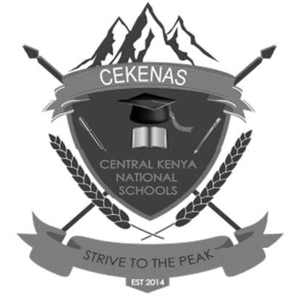
511/2
MUSIC
PAPER 2
(AUGUST/SEPTEMBER)
FORM FOUR
MARKING SCHEME

1. a)
3marks
b)

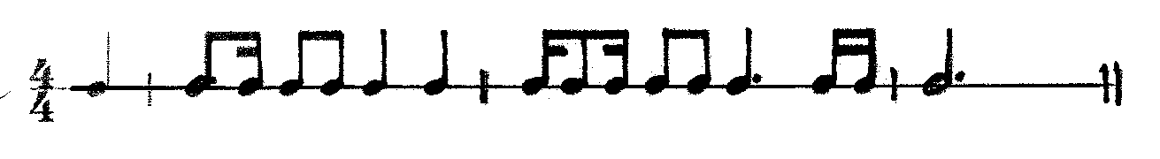8marks
c)
8marks

2. a)
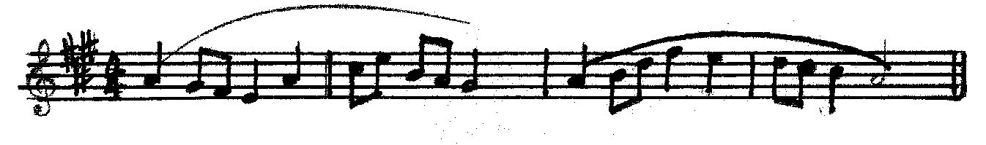10 marks

b)
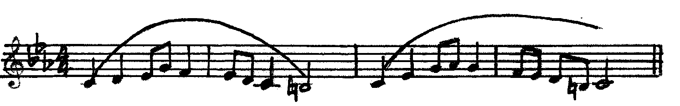10marks

3. i). Minor third (1 ½ marks) ii). Major sixth (1/2 marks)
4.
i). imperfect ii). interrupted iii). Plagal iv). Perfect
5. a). D minor ( 1 ½ marks) b). E major ( 1 ½ marks.)

