MOVEMENT ACTIVITIES (MUSIC AND ART) - CBC GRADE 2 TERM 1 EXAM 2023

QUESTIONS
- When do we sing the National Anthem?
- Complete this statement: Oh God of all
(creation, nation, heavens)
Name 2 types of songs
- ....................................
- ....................................
- Clothes worn during music performance are called .........................
(sisal skirts, costumes, shorts)
- Name these musical instruments
(Trumpet, brass guitar band drum)
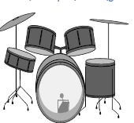
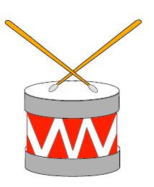
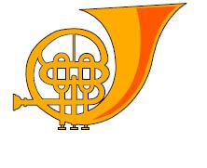
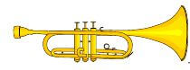
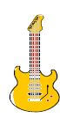
- Sing a singing game with your friend.
- Make a rhythm by clapping ta-ta, tata
- Dance to a melody and mention the body parts used for dancing
ART.
- Make number pattens.
Draw the following line
- Straight line
- Curved line
- Zigzag line
- Wavy line

Marking Scheme
- When raising /hoisting the national flag.
During nation heads of state meeting.
When commemorating public/national holidays.
- Creation

- For questions 3 and 4 mark any of the following:
  - love songs
  - sacred songs
  - lullaby
  - dirge/funeral songs
(Any other relevant type of songs)
- costumes
- band
drum
brass(French horn - not in list)
trumpet
guitar
- any singing game correct marks
- single clap,(pause) single clap,(pause) double clap (ta-ta,tata)
- Child should dance to a melody put on by the teacher and mention the body parts that he/she is using to dance example head, shoulders, knees etc.
- pattern 1: 2,4,6,8,10
pattern 2: 3, 6, 9, 12, 15
pattern 3: 5, 10,15, 20, 25, 30
mark any pattern that makes sense
- 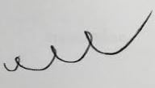
(any variation)
- 
 