METALWORK 445/1 BUNAMFAN MOCK DEC. 2021 SCHEME

1(a) methods of applying paint
- By use of painting brushes
- By dip painting
b)Reasons for painting
- To prevent rust
- To decorate 1×2=2marks
2 (a) uses of drift in forging
- Opening up a punched hole
- Enlarging holes in forging 1×2=2marks
( c) precautions to be observed when twisting
- Ensure you use a two handle wrench when twisting.
- Ensure once complete twist is done in uniform heat.
- Ensure the work-piece is always straight. 1×2=2marks
3 (a) reasons for using hollow metals when making furniture.
- To ensure items made are light in weight
- For strength and durability 1×2=2marks
(b) safety when grinding
- Use the face for grinding and not the sides
- Always wear safety goggles
- Ensure the gap between tool rest and grinding wheel is as small as possible
- Ensure the wheel is even and balance
- Avoid loose clothing 1×2=2marks
- Switch off the machine and the power supply after use
4( a) specifications of twist drill
- Shank diameter
- Length of the shank
- Material of the rivet
- Shape of the head 1×4=4mrks
(b) factors to consider when selecting a spelter
- The material to be joined
- The thickness of the material to be joined
- The position of the joint 1×3=3mrks
5 (a) methods of holding a work piece in a lathe
- By use of a 3 jaw chuck
- By use of 4 jaw chuck
- By use of face plate
- By use of face plate and dog 1×4=4mrks
(b) reasons for knurling
- To enhance grip
- to decorate the article 1×2=2marks
6 (a) sources information related to career
- News letters
- Career booklets
- Career subjects 1/2×4=2mrks
(b) types of inventories
- Permanent inventories -used for recording equipment tools and machines that are permanent
- Expendable inventories- used for recording items that wear out with time
- Consumable inventories- used for recording materials that are to be used 1×3=3mrks
( c ) reasons for carrying out annealing
- To relief stress and strain caused by work hardening
- To soften metal that has been hardened by working on it 1×2=2marks
(d) procedure of annealing
- Heat the metal to temperatures above critical temperate, then let it cool slowly in a closed furnace 1×1=1mrk
7 (a) forging tools
- Leg vice- used for holding hot work piece
- Anvil -provide a platform for hammering
- Hot set- used for cutting and necking metals
- Flatters- used for finishing work piece to flatness
- Fullers -used for finishing round work piece
- Swage block -used for forming various shaped 1×3=3mrks
(b) state two disadvantages of cooling a brazed joint rapidly
- The joint may develop cracks
- It makes the joint brittle
- Makes the joint weak
- Causes scaling of the joint 1×2=2marks
8 (a) state two advantages of forging over machining
- Forms strong items
- Grain structures are not cut or removed 1×2=2marks

- types of tin snips
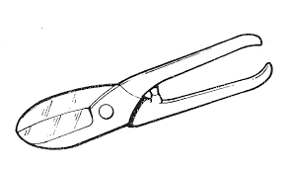
Straight tin snips

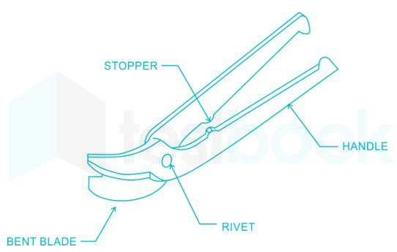
Curved tin snips

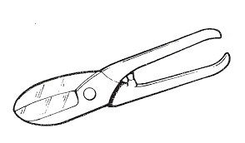
Universal tin snips
1×3= 3mrks
- disgusting gross-pay and net-pay
- Gross pay -this is the amount of money paid before deductions are made 1×2=2marks
- Net pay -payment received after deductions 1×2=2marks

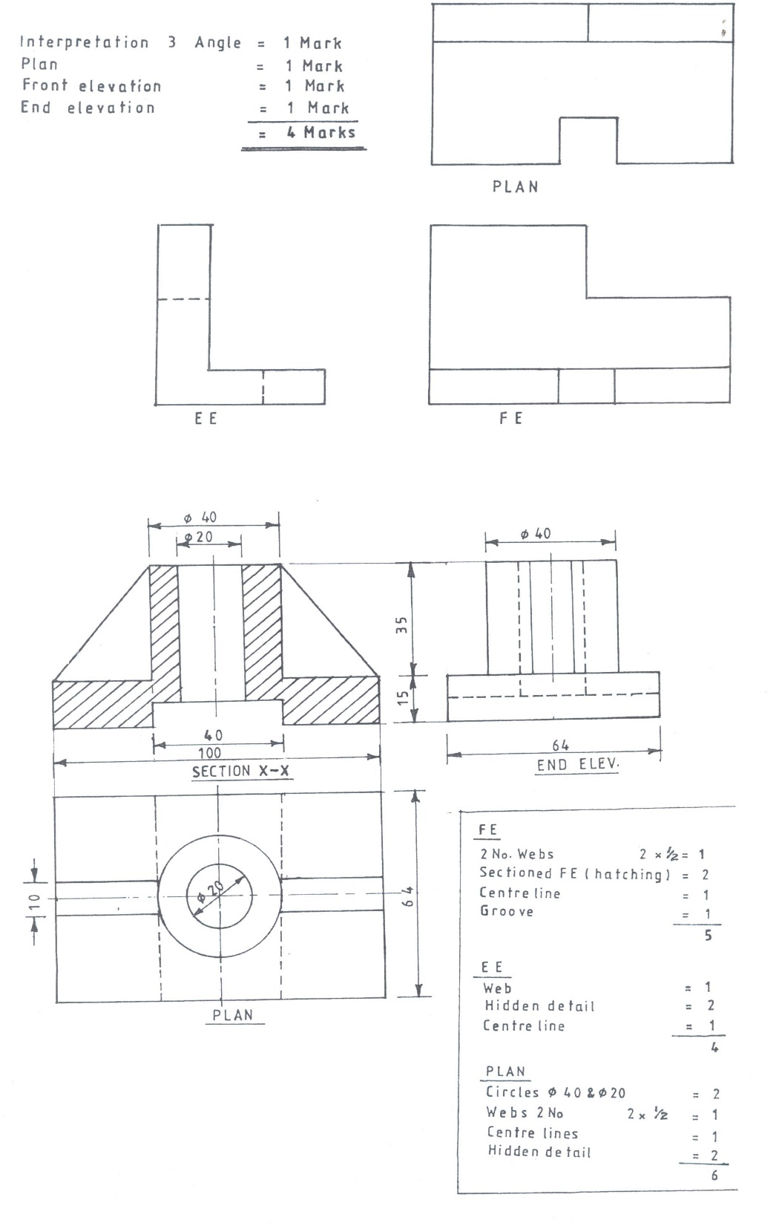

12a) Name three methods of testing the quality of gas welded joints. [1 ½ marks]
Visual inspection -Bending
Penetrate fluid -Tensile
Application of load. -Impact

b)Sketch the correct flame for welding brass and outline the procedure of setting the flame. [5 ½ marks]
-Open the acetylene cylinder valve half turn and oxygen valve a full turn.
-Open acetylene needle valve,set to the working pressure and close the needle valve.Open oxygen needle valve,set to the working pressure and close the needle valve.
-Open acetylene needle valve slightly and light the torch.Increase the volume of gas until the flame is clear of soot.
-Open the oxygen needle valve and set a neutral flame.

c) Use a labeled sketch to show an appropriate technique for gas welding thick plates and give three reasons for using the technique. [8marks]

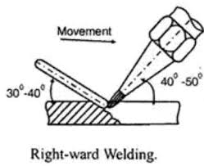
-It is faster than the leftward
-Less gas is used
-The cooling rate is lower so the weld is more ductile
-No bevel is required for steels upto8.0mm.
13a)The figure below shows a very important equipment used in forgework.

(i)Give the name of the equipment. [ 1 mark]
Forge
(ii)Name parts labeled c, e and f. [1 ½ marks]
c-Water bosh
e-Hood
f--Flue

(iii)State the uses of parts a,b and d. [1 ½ marks]
a-Hearth-For heating the workpiece
b-Tuyere-Protecting the blast fan
f-Blast fan-Blowing air for the fuel to burn.
b)List four factors that would contribute to a poorly brazed joint. [4marks]
-Wrong size of filler rod
-Not cleaning the area of the seam.
-Wrong type of flux
-Not arranging the parent metals well.

c)State three differences between gas welding and brazing. [3marks]
Gas welding Brazing
-Filler metal same material as parent metal -Filler metal is brass
-Parent metals meld or fuse -Parent metals do not melt.
-Joint colour same as parent metal -Joint colour different from
Parent metals.
-High temperatures -Low temperatures
-Neutral flame -Oxidising flame

d)Give four safety precautions to be observed when tapping a through hole. [4marks]
-The taps should not be given undue pressure.
-Lubricate the taps when in use.
-Use the correct size of tap wrench.
-Do not subject the taps to high temperatures.
14a)Using sketches explain the following terms as applied in limits and fits. [4marks]
i)Nominal size
Is the actual or exact size.Size before tolerance is included.
ii) Tolerance
Is the difference between the upper limit and the lower limit.
iii) Allowance
Is the difference between the low limit of hole and the upper limit of hole.

iv)Lower limit.
Is the smallest permissible size.
b) The figure shows a precision tool used in metalwork.

i)Show how to find its accuracy. [1mark)
0.5/50=0.01mm.
ii)Name the parts labeled A,B,C and D and give the function of each. [4marks]
A-Anvil-Measuring face
B-Sleeve-Has measuring graduations for the main scale
C-Thimble-Carries the thimble scale
D-Ratchet-Ensures correct feel when adjusting.

c)Give two applications of each of the three types of fits. [3marks]
Clearance-Latches,pivots,piston machines,machine tool spindles,sliding rods.
Interference-Wheel belts,tyres,coupling under certain conditions.
Transition-Electric motors in shafts,gear rims,fixed plugs,driven bushings,flushed bolts
d)State three safety precautions to be observed when using the vernier calipers.
[3marks]
-They should not be dropped.
-Always clean and close the jaws into their position and place the calipers in its case after use.
-They should be oiled to prevent rusting.
-Ensure that all the screws are in position at all times.
15a)Illustrate five operations that can be performed on a drilling machine. [5marks]

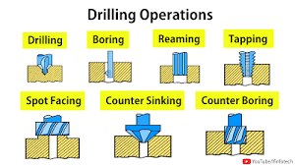

b)State three reasons for twisting metal bars. [3marks]
-For strength,decoration,rigidity
c)With reference to cutting external threads:
(i)Name two types of dies used. [2marks]
Round adjustable split die
-Adjustable two piece die
-Solid rethreading die.
(ii)State two reasons for using cutting oil. [2marks]
-Cooling the workpiece and the tool.
-Lubricating the work.
d)An M10 internal thread is to be cut in a mild steel.Given that the thread pitch is 1.5mm,determine the size of the drill to be used. [1mark]

10-1.5=8.5mm

e)Give five reasons why we finish metal articles. [5marks]
-To improve the physical appearance.
-To prevent rusting or tarnishing.
-To cover surface of a less expensive metal with a thin coat of a more expensive one.
-To improve the surface of an article in order to reduce or minimise wear.
-To improve safety by removing sharp burrs.

