COMPETENCY BASED CURRICULUM GRADE 3 - TERM 1 EXAM 2023 – MATHS ACTIVITIES
NAME: SCHOOL

- Write the next numbers 30,40, , , 80
- Circle the greater number 58 85
- Order from the least to the greatest 15,8,18,24
4. 16-13 =
Write the missing number
5. 13= tens ones
6. 24= tens 4 ones
7. . 30
+ 30

8. 26+3 =

9. 6+10 =
10. 4 + = 9

11. +6 = 10

12. 45-3 =

13. 12 – 6 =

14. 8 - = 5

15. 50 – 30 =

Complete

- One week has how many days

- Which one holds more
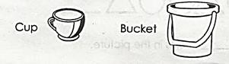
- Which one is heavier?

- We come to school in the (evening, morning, night)
- Which one is a coin?

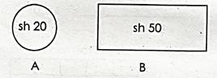

- 16 = + 4

- A triangle has how many corners

- Write the next pattern

