Term 1 – 2023 OPENER EXAM
MATHEMATICS (121/1)
PAPER 1
FORM FOUR (4)
Time: 2 ½ Hours
Name: …………………………………………………………. Adm No: ……………….
School: ……………………………………………………….. Class: …………………..
Signature: …………………………………………………….. Date: ……………………
INSTRUCTIONS TO CANDIDATES
- Write your name and index number in the spaces provided at the top of this page.
- Write your school name, sign and write the date of the examination in the spaces provided above.
- This paper consists of Two sections: Section I and Section II
- Answer ALL questions in Section I and any five questions from Section II
- Show all the steps in your calculations, giving your answers at each stage in the spaces provided below each question.
- Marks may be given for correct working even if the answer is wrong.
- Non-Programmable silent electronic calculators and KNEC Mathematical Tables may be used.
- This paper consists of 14 printed pages.
- Candidates should check the question paper to ensure that all the pages are printed as indicated and no questions are missing.
- Candidates should answer the questions in English.

For Examiners’ Use Only
SECTION I
1 | 2 | 3 | 4 | 5 | 6 | 7 | 8 | 9 | 10 | 11 | 12 | 13 | 14 | 15 | 16 | Total

SECTION II
17 | 18 | 19 | 20 | 21 | 22 | 23 | 24 | Total |  | Grand Total

SECTION I (50 Marks)
Answer all the questions in this section
- Use logarithms only to evaluate to 4 decimal places: (4 marks)
$${\left(\frac{0.7089×124.5}{{\left(86.73\right)}^{2}}\right)}^{\frac{1}{3}}$$

- Evaluate without using tables or calculators. (3 marks)
$$\sqrt[3]{\frac{{\left(\sqrt[3]{27}\right)}^{2}×{\left(\sqrt[4]{16}\right)}^{3}}{243}}$$

- Three tellers in a bank can each serve a customer in 42 seconds, 56 seconds and 84 seconds respectively. Determine the shortest time, in minutes they can take to serve a total of 117 customers. (4marks)

- A tourist exchange X US dollar for Kenya shillings on arrival in Kenya. She spent in Kenya for some days and paid Ksh 45 600 for her expenses. She later left the country and exchanged the remainder back to US dollars. She went back with 1200 US dollars.
Given that the dollar buys and sells as shown in the table below.

Currency | Buying | Selling
1 US dollar | Kshs 98.36 | Kshs 98.54

Find the value of X to the nearest dollar (3 marks)

- Mr. Abdiaziz who deals in electronics sells a radio to a customer at Kshs. 1,440 after giving him a discount of 10% but finds that he still makes a 20% profit. Find the profit Mr. Abdiaziz would make if he does not give a discount. (3marks)

- In the figure given below (not drawn to scale), O is the centre of circle. If $∠BCA={80}^{0}$ and $∠CB0={10}^{0}.$
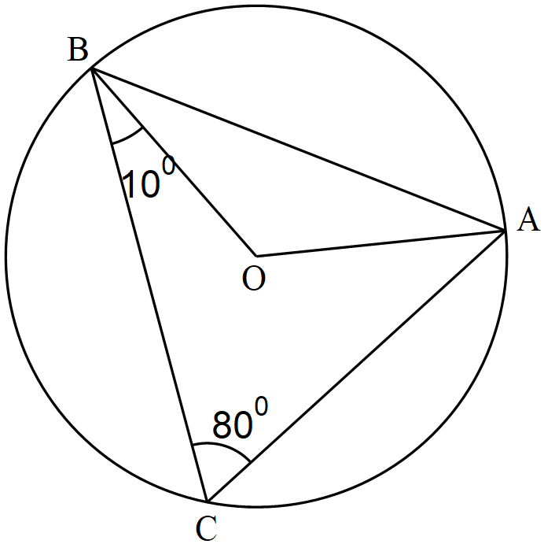

Determine the size of ∠$CAB.$ (3 marks)

- Solve the inequality below and represent the solution on a number line. (3 marks)
$$5-2x<\frac{1}{2}x≤\frac{x+2}{3}$$

- The heights of two similar pails are 12 cm and 8 cm. The larger pail can hold 2 litres. What is the volume of the smaller pail? Give your answer to 2 decimal places. (3 marks)

- Simplify the expression: (3 marks)
$$\frac{{3a}^{3}-{27ab}^{2}}{a^{3}+a^{2}b-6ab^{2}}$$

- Determine the value of $\tan{(θ+{14}^{0})}$ given that (2 marks)
$$\cos{\frac{1}{2}θ^{0}=\sin\left(3θ-{36}^{0}\right) for 0^{0}≤θ≤{90}^{0}}$$

- The figure below shows a pyramid whose base is a regular hexagon of side 4 cm.
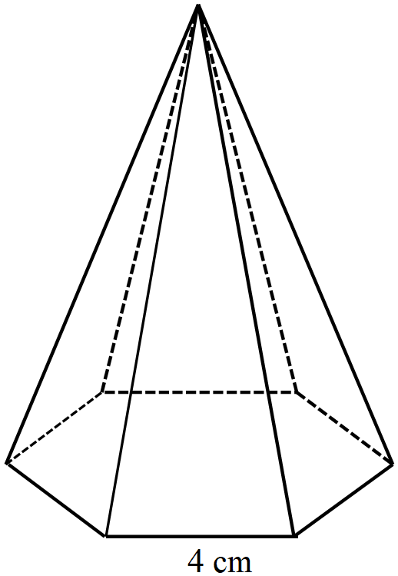

Calculate the volume of the pyramid correct to 3 decimal places, given its height is 10 cm. (4 marks)

- Using a ruler and pair of compasses only,
- construct a rhombus KLMN whose base is the line KL provided below and angle KLM=120⁰ (2 marks)

- Use KM and NL to calculate the area of the rhombus. (2 marks)

- Given that $OT=-3i+6j-2k$ and $OS=4i+5k$, find $\left|ST\right|$ (3 marks)

- Solve the following pair of simultaneous equations by substitution method. (3 marks)
$$5x-8y=2$$
$$7x+3y=17$$

- A sales lady earns a basic salary of Ksh 24 800 per month. In addition, she gets a 4% commission on the first Ksh 80 000 worth of goods and a further 5% commission on goods worth over Ksh 80 000. In a certain month, she sold goods worth Ksh. 200,000 Calculate her total income in that month. (3 marks)

- In the figure below ABFG is a uniform cross-section of a prism. BC is one of the visible edges of the prism.

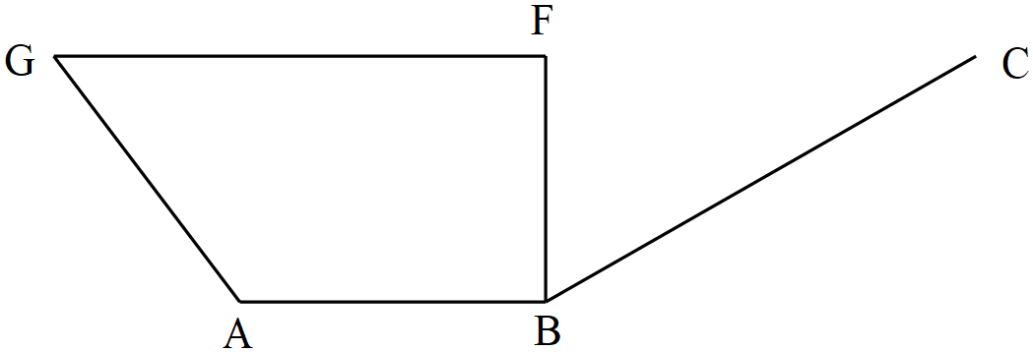

Complete the sketch of the solid showing the hidden edges with broken lines. (2 marks)
SECTION II (50 Marks)
Answer any five questions in this section
- The diagram below shows a garden in the shape of a quadrilateral PQRS in which PQ=SR=120 m, QR=45 m, ∠PQR=∠SPQ=90⁰ and ∠135⁰
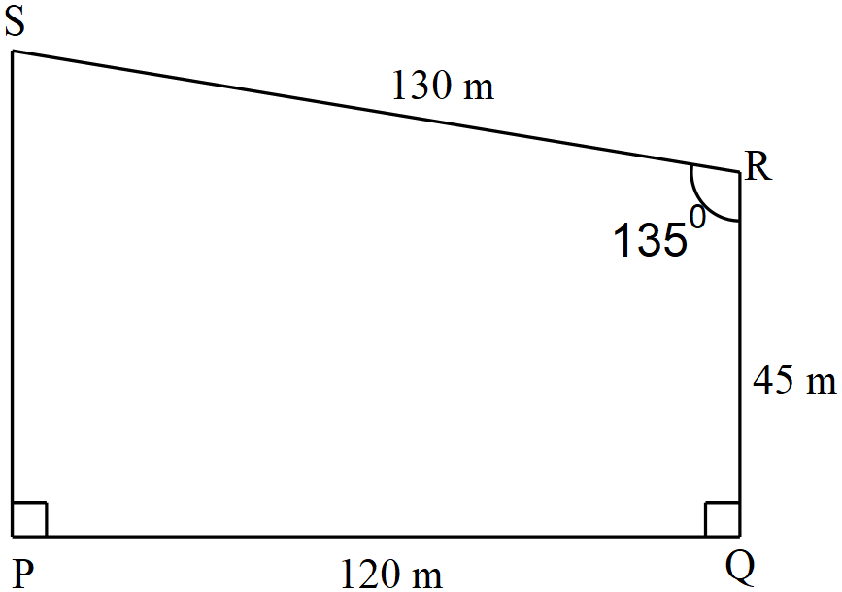

- Calculate to 1 decimal place:
- The size of angle QPR. (2 marks)

- The length PS (5 marks)

- Calculate the area of the garden in hectares, correct to 3 decimal places. (3 marks)

- The equation of line L₁ is$2x+3y+ 6= 0$.
- Find the gradient of line L₁ (1 mark)

- The line L₂ is perpendicular to L₁ and passes through the point P with coordinates (7, 2), find the equation of L₂ , giving the answer in the form $y= mx+ c$ where m and c are constants. (3 marks)

- The line L₁ and L₂ intersect at point Q. Find the coordinates of Q. (3 marks)

- The line L₃ is parallel to l₁ and passes through point P. Find the equation of L₃ giving the answer in the form $ax+ by = c$ , where a , b and c are constants. (2 marks)

- Determine the coordinates of the $x$ intercept of the line L₃. (1 mark)

- Three towns P, Q and R are such that Q is 120km on a bearing of 060⁰ from P. R lies on a bearing of 120⁰ from P. The bearing of R is 165⁰ from Q.
- Using the scale of 1 cm to represent 20 km, show the relative positions of P, Q and R. (3 marks)

- Use the scale drawing in (a) above to determine:
- The distance of R from P. (2 marks)

- The bearing of P from R. (1 mark)

- Two police patrol cars leave P and Q such that the one from P travels due east while the one from Q travels due south. The two cars meet at S.
- On the scale diagram, locate S (2 marks)

- Measure the distance of S from R . (2 marks)

- The height of a number of students was recorded in the table below. Each measurement is given to the nearest cm.

Height(cm) | Mid-point ($x$) | Frequency ($f$) | $$fx$$
138 – 142 | 140 | 3 | 420
143 – 147 |  | 8
148 – 152 |  | 12
153 – 157 |  | 20
158 – 162 | 160 | 30 | 4800
163 – 167 |  | 14
168 – 172 |  | 7
173 – 177 |  | 4
178 – 182 | 180 | 2 | 360
 |  | Ʃ$f=$ | Ʃ$fx=$

- Complete the table. ` (3 marks)

- Use the completed table to calculate the mean height of the students. (2 marks)

- Draw a histogram to represent the information. (2 marks)

- Use the histogram above to estimate the median height. (3 marks)

- The distance between two towns Athi River town and Busia town is 750 km. A minibus left town Athi River at 8.15 a.m. and traveled towards Busia at an average speed of 90 km/h. A matatu left Busia at 10.35 a.m. on the same day and traveled towards Athi River at an average speed of 110 km/h.
- (i) How far from Athi River did the two vehicles meet? (5 marks)

(ii) At what time of the day did the two vehicles meet? (1 mark)

- A motorist starts from his home at 10.30 a.m. on the same day and traveled at an average speed of 120 km/h. He arrived at the same time as the minibus. Calculate the distance from Busia to his home. (4 marks)

- The cartesian coordinate plane below shows Δ$ABC$ and its image Δ$A'B'C'$ under a transformation T.
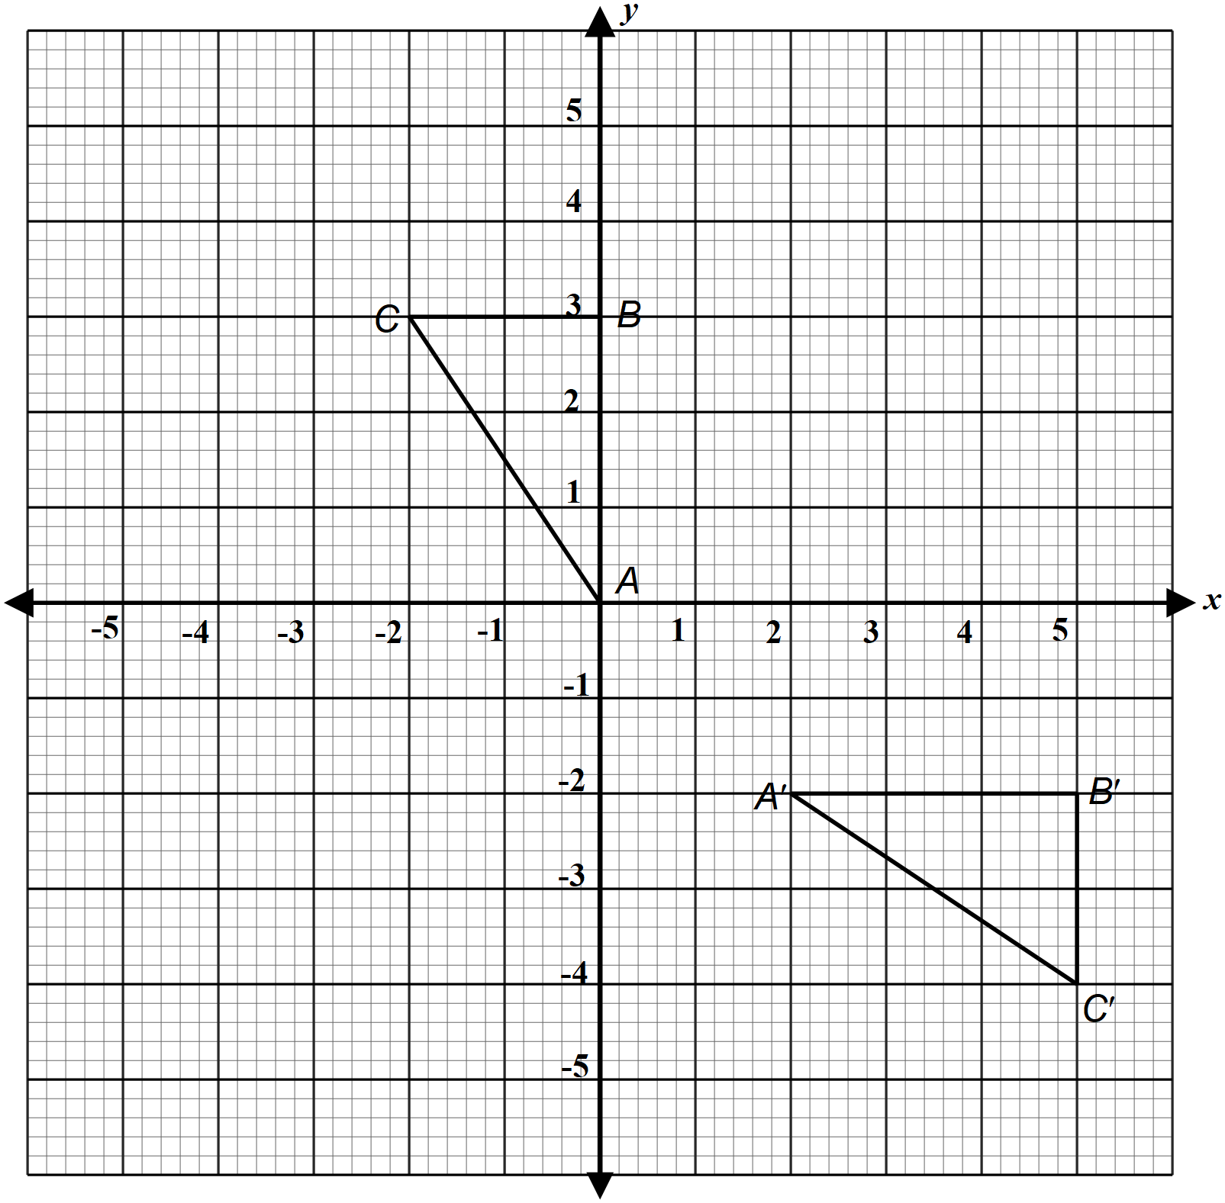

- Describe fully the transformation T fully. (3 marks)

- Δ$A''B''C''$ is the image of Δ$A'B'C'$ under a rotation +90⁰ about (0, 0). On the same axes, draw Δ$A''B''C''$ and state its coordinates (3 marks)

- Δ$A'''B'''C'''$ is the image of Δ$A''B''C''$ under an enlargement of scale factor $-1$ about (0, 0) Draw Δ$A'''B'''C'''$. (2 marks)

- Name two pairs of triangles that are oppositely congruent. (2 marks)

- (a) Find the quadratic equation whose roots are $\frac{-3}{4}$ and $\frac{2}{3}$ and write it in the form ${ax}^{2}+bx+c=0$ where $a$, $b$ and $c$ are integral values. (3 marks)

(b) The length of a floor of a rectangular hall is 9 m longer than its width. The area of the floor is 136 m². Calculate the perimeter of the floor. (4 marks)

(c) Solve the quadratic equation below by completing the square, correct to 3 decimal places. (3 marks)
$$\frac{1}{2}x^{2}-\frac{7}{3}x+\frac{3}{4}=0$$

- In the figure below, O is the centre of the circle, ∠$ADO={39}^{0}$, ∠$OBC={33}^{0}$ and ∠$ECD={45}^{0}$. EC is a tangent to the circle at C.
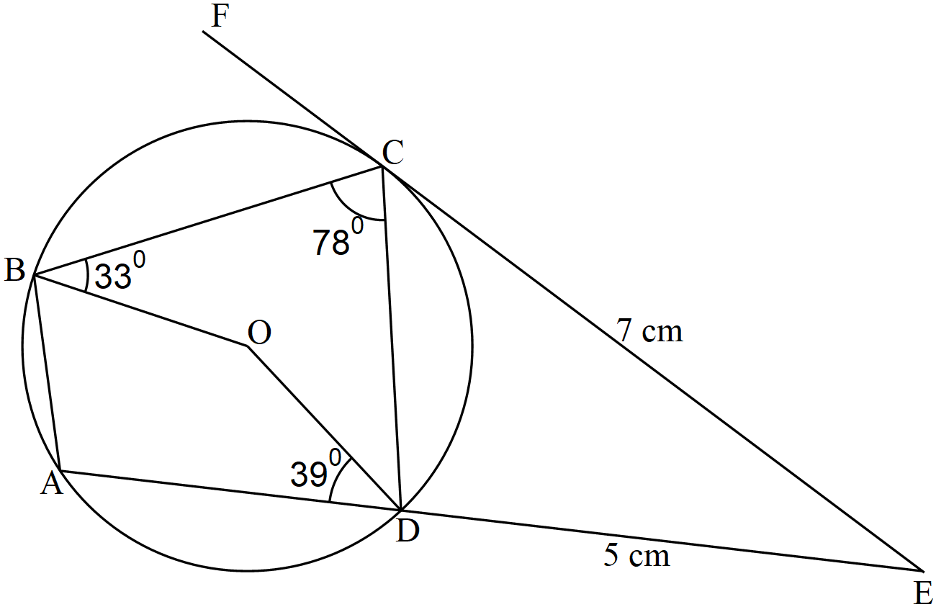

- Calculate, giving reasons
- ∠CDE (3 marks)

- Reflex ∠BOD (3 marks)

- ∠BDC (2 marks)

- Given that EC=7 cm and DE = 5 cm, calculate the length of AD (2 marks)

