**NAME …………………… …………………………………ADM NO ………………………….…….**

**SCHOOL.……………………………………………………CANDIDATE’S SIGN……...……………**

**CLASS............................... DATE……………………………………..**

**121/2  
MATHEMATICS ALT. A  
Paper 2  
SEPT-2022**

**Time: 2 ½ Hours**



**CEKENAS END OF TERM TWO EXAM-2022**

**FORM FOUR EXAM**

*Kenya Certificate of Secondary Education.(K.C.S.E)*

**INSTRUCTION TO CANDIDATES**

*a) Write your name and Admission number in the spaces provided above.   
b) Sign and write the date of examination in the spaces provided above.   
c) The paper consists of* ***two*** *sections.* ***Section I*** *and* ***Section II.*** *d) Answer* ***ALL*** *the questions in Section I and any* ***FIVE*** *questions in Section II.   
e) Show all the steps in your calculations, giving your answer at each stage in the spaces provided*

*below each question.   
f) Marks may be given for correct working even if the answer is wrong.   
g) Non-programmable silent electronic calculators and KNEC Mathematical tables may be used*

*except where stated otherwise.   
h) Candidates should answer the questions in English.*

***i) This paper consists of 16 printed pages.***

***j) Candidates must check the question paper to ascertain that all pages are printed as indicated***

***and that no question(s) is/are missing***

**FOR EXAMINER’S USE**

**SECTION I**

|  |  |  |  |  |  |  |  |  |  |  |  |  |  |  |  |  |
| --- | --- | --- | --- | --- | --- | --- | --- | --- | --- | --- | --- | --- | --- | --- | --- | --- |
| 1 | 2 | 3 | 4 | 5 | 6 | 7 | 8 | 9 | 10 | 11 | 12 | 13 | 14 | 15 | 16 | **Total** |
|  |  |  |  |  |  |  |  |  |  |  |  |  |  |  |  |  |

**SECTION II**

|  |  |  |  |  |  |  |  |  |
| --- | --- | --- | --- | --- | --- | --- | --- | --- |
| 17 | 18 | 19 | 20 | 21 | 22 | 23 | 24 | **Total** |
|  |  |  |  |  |  |  |  |  |

**Grand Total**

**SECTION I: (50MKS)**

**ATTEMPT ALL THE QUESTIONS FROM THIS SECTION**

1. Find the percentage error in the area of a circle whose radius is 3.5cm measured to 1decimal place. (3mks)

2. Make h the subject of the formula. (3mks)



3. Simplify and express your answer in the form . State the values of a and b. (Express a and b in the simplest form) (3mks)

4. Given that a2x2+6ax+k is a perfect square find K. (3mks)

5. Vector q has a magnitude of 7 and is parallel to vector P. Given that  , Express vector q in terms of I, j and k. (3mks)

6. Given that three number x, y and z are in the ratio 6:4:5. Find the value of (3mks)



7. Determine the equation of the normal to the curve y=x2 -3x+1 at a point (-2, 3) giving your answer in the form ax+by=c. (3mks)

8. (a) Expand and simplify (1-3x)5 upto the term in x3. (1 mks)

(b) Hence use your expansion to estimate (0.97)5 correct to 4 decimal places. (2mks)

9. Two lines x+2y=1 and 2x+3y=3 intersect at T. Find the equation of circle centre T and radius 5 units giving your answer in form of x2 + y2 +ax+by+c=0 (4 mks)

\

10. A quantity P varies jointly as the square of Q and inversely as S. P=3 when Q=5 and S=2. Find the value of P when Q=2 and S=3. (3mks)

11. Solve for x if sin  for the range  (3mks)

12. A rectangle ABCD is such that AB=6 and BC=5cm. A variable point P moves inside the rectangle such that APPB and AP>2.5cm. Show the region where P lies. (3mks)

13. Chords AB and CD intersects externally at Q. If AB=5cm, BQ=6cm and DQ =4cm. Find the length CQ. (3mks)

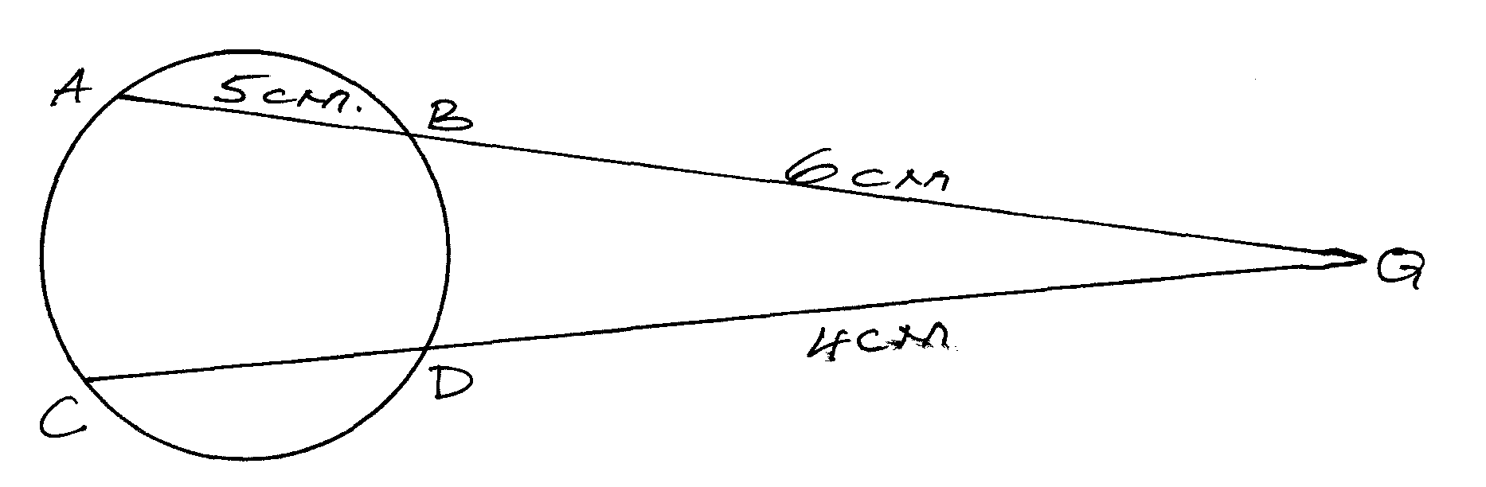

14. Find the value of k for which the matrix below is singular . (3mks)



15. Solve for x in the equation (3mks)



16. The graph below is part of the straight line graph obtained from the initial equation V= apn.

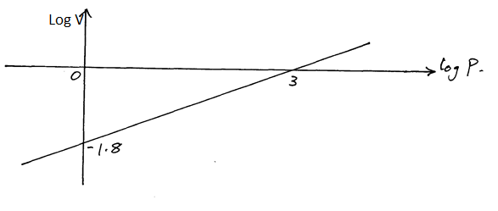

(a) Write down the equation of the straight line in form y=mx+c. (1mk)

(b) Use the graph to calculate the values of a and n. (3 mks)

**SECTION II**

**ANSWER ONLY FIVE QUESTIONS FROM THIS SECTION**

17. The table below shows income tax rates.

|  |  |
| --- | --- |
| **Monthly taxable pay in K£** | **Rate of tax Ksh in 1 K£** |
| 1-435  436-870  871-1305  1306-1740  Excess over 1740 | 2  3  4  5  6 |

A company employee earn a monthly basic salary of Ksh 30,000 and is also given allowances amounting to Ksh 10 480.

(a) Calculate the total income tax. (5mks)

(b) The employee is entitled to a personal tax relief of Ksh 800 per month. Determine the net tax. (1mk)

(c) If the employee received a 50% increase in his total income, calculate the corresponding percentage increase on the income tax. (4 mks)

18. John and James were employed together in a certain year. Their annual salaries in shillings progressed as follows.

|  |  |  |  |
| --- | --- | --- | --- |
|  | 1st year | 2nd year | 3rd year |
| JOHN | 480,000 | 528,000 | 576000 |
| JAMES | 480,000 | 528,000 | 580800 |

(a) Calculate John’s annual salary increment and hence write down an expression for his annual salary in his nth year of employment. (2mks)

(b) Calculate James’ annual percentage rate of salary increment and hence write down an expression for his annual salary in his nth year of employment. (3 mks)

(c) Calculate their total earnings after 10 years of employment to the nearest Kshs. (5mks)

19. The number x is chosen at random from the set (0,3,6,9) and the number y is chosen at random from set (0,2,4,6,8). Calculate the probability of each of the following separate events.

(i) x> 6 (1mk)

(ii) x+y=11 (2mks)

(iii) x>y (2mks)

(iv) xy=0 (2mks)

(v) 10x+y<34 (2mks)

20. On the surface of the earth A(500N, 800E) and B(500N, 1200 E) are two separate places that seem to enjoy trade connected by airlines, taking the radius of the earth as 6370km.

(a) If the local time at B is 12.15pm. Find the time at A. (2mks)

(b) Calculate the shortest distance between A and B along

(i) Parallel of latitude in nm. (3mks)

(ii) A great circle in nm. (3mks)

(c) There is a third place C(0,800E) that is also enjoying some relationship with town A. Calculate the distance between A and C in km. (2mks)

21. The diagram shows a sketch of the graph of y=x2+6 and y=22, intersecting at point P and Q.

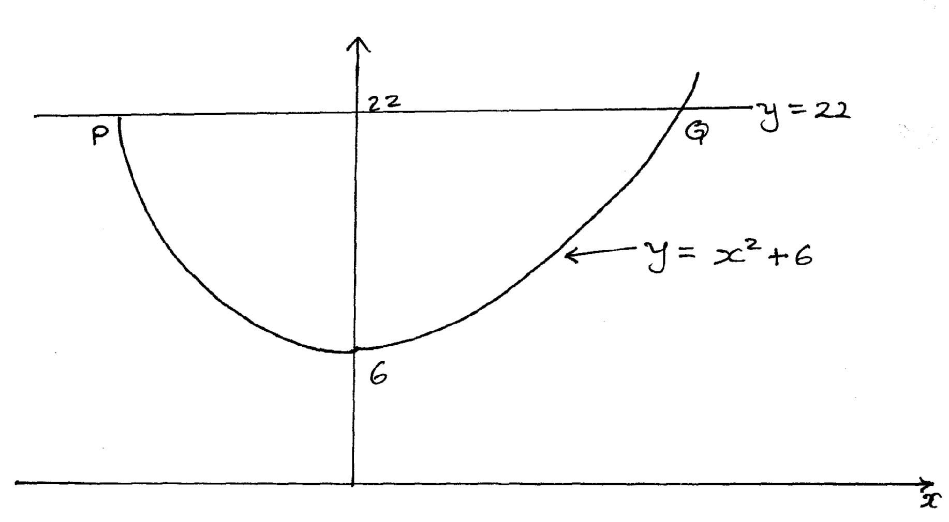

(a) Find the co-ordinates of P and Q. (2mks)

(b) Estimate the area bounded by line PQ and the curve using the trapezium rule with 8 intervals. (3mks)

(c) Calculate the actual area of the enclosed region. (3mks)

(d) Calculate the percentage error introduced. (Give your answer to 4 d.p) (2mks)

22. Mr Mark Opito wishes to take students from wonderful mixed secondary school for a tour. The total number of pupils to be taken should not exceed 60. Each girl must contribute sh 10,000 and each boy shs 15000 and money to be contributed must not exceed sh 120,000. If the trip is to be successful the number of boys must conditionally be greater than girls.

(a) Write down inequalities to represent this information taking the number of boys and girls to be x and y respectively. (3mks)

(b) Represent the above information on the graph paper provided (4 mks)

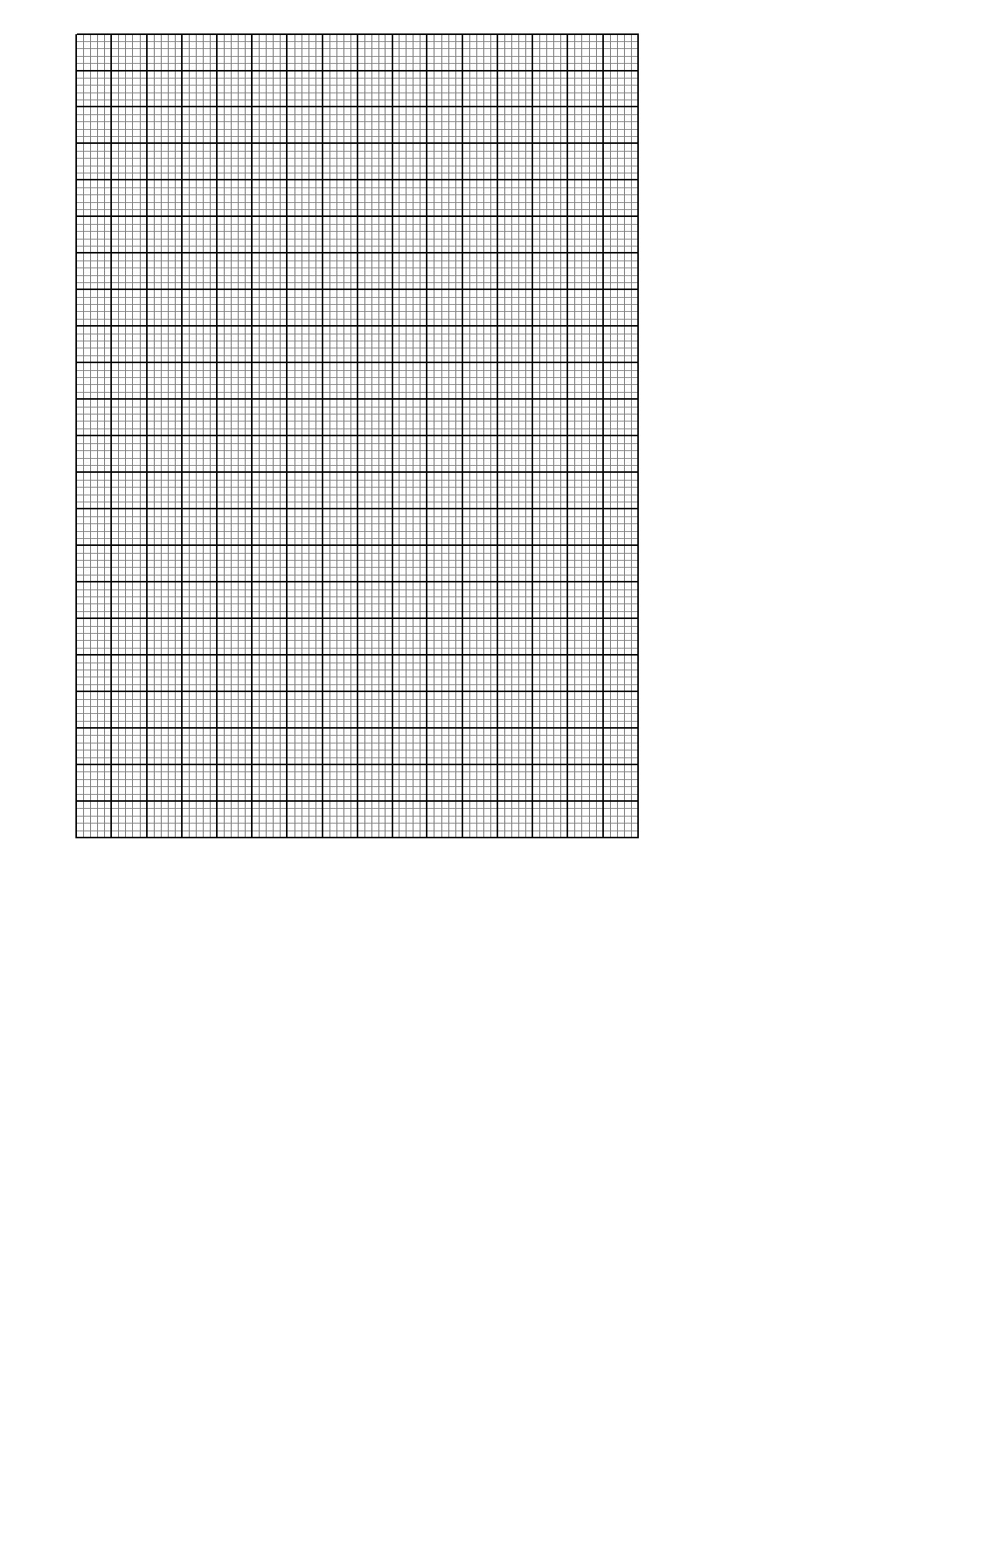

(c) What is the optimum number of boys and girls to be taken in order to minimize cost and hence determine the cost. (3mks)

23. Complete the table below. (2mks)

|  |  |  |  |  |  |  |  |  |  |  |  |  |  |
| --- | --- | --- | --- | --- | --- | --- | --- | --- | --- | --- | --- | --- | --- |
| x | 0 | 15 | 30 | 45 | 60 | 75 | 90 | 105 | 120 | 135 | 150 | 165 | 180 |
| sinx | 0.00 | 0.26 |  | 0.71 |  |  | 1.00 | 0.97 |  | 0.71 |  |  | 0.00 |
| 2cos x | 2.00 | 1.93 |  | 1.41 |  |  | 0.00 | -0.52 |  | -1.41 |  |  | -2.00 |
| y=sinx+2cosx | 2.00 | 2.19 |  | 2.23 |  |  | 1.00 | 0.45 |  | -0.70 |  |  | -2.00 |

(b) Draw the graph of y=sin x+2 cos x for  on the grid provided. (3mks)



(c) Use the graph to solve

(i) sin x+2cosx=0 (1mk)

(ii) 2(sinx +2cos x) =3 (2mks)

(iii) tan x+2= (2mks)

24. The following Distribution shows the marks obtained by 72 students in a mathematical test.

|  |  |  |  |  |  |  |  |
| --- | --- | --- | --- | --- | --- | --- | --- |
| Marks | 20-29 | 30-39 | 40-49 | 50-59 | 60-69 | 70-79 | 80-89 |
| Frequency | 3 | 13 | 13 | 13 | 14 | 12 | 4 |

(a) Use the information above to draw a cumulative frequency (Ogive) curve on the grid provided.



(b) Use your graph to estimate

(i) Median (1mk)

(ii) Lower quartile and upper quartile (3mks)

(iii) Quartile deviation. (1mk)

(c) The percentage of candidates passing if the pass mark is 42 marks. (3mks)