Term 2 - 2022
MATHEMATICS (121/1) –PAPER 1
FORM FOUR (4)
Time: 2 ½ Hours (MARKING SCHEME)

NO. | WORKING | MARKS | REMARKS
 | $$\sqrt[3]{\frac{0.4×1.28×{10}^{3}}{0.064×{10}^{3}}}=\sqrt[3]{\frac{4×128}{64}}$$  $$\sqrt[3]{\frac{2^{2}×2^{7}}{2^{6}}}$$  $${\left(\frac{2^{9}}{2^{6}}\right)}^{\frac{1}{3}}={\left(2^{3}\right)}^{\frac{1}{3}}=2$$ | M1  M1  A1 | Removal of decimal places  Expressing as product of prime factors
 | Total | 3
 | $$2.\dot{3}\dot{4}=2.3434343…=r$$  $$100r=234.3434343…$$  $$r=2.343434…$$  $$99r=232$$  $$r=\frac{232}{99}$$  Also $1.\dot{9}\dot{1}=1.919191…q$  $$100q=191.919191…$$  $$q=1.919191…$$  $$99q=190$$  $$q=\frac{190}{99}$$  Hence  $$\frac{232}{99}-\frac{190}{99}$$  $$=\frac{42}{99}=\frac{14}{33}$$ | M1  M1  M1  A1 | Expressing $2.\dot{3}\dot{4}$ as a fraction  Expressing $1.\dot{9}\dot{1}$ as a fraction  Difference between the 2 fractions
 | Total | 4
 | $$HCF→7920=2^{4}×3^{2}×5×11$$  $$GCD→12=2^{2}×3$$  $$48=2^{4}×3$$  $$264=2^{3}×3×11$$  Other number$→2^{2}×3^{2}×5=180$ | M1  M1, A1 | Expressing HCF, GCD and the 2 given numbers in power form
 | Total | 3
 | From the graph,  $x=-3→x+3=0$ and $x=2→x-2=0$  $$\left(x+3\right)\left(x-2\right)=0$$  $$x\left(x-2\right)+3\left(x-2\right)=0$$  $$x^{2}-2x+3x-6$$  $$x^{2}+x-6=0$$  Hence  $a=1, b=1$ and $k=-6$ | M1  A1  B1 | Factorization by grouping
 | Total | 3

NO. | WORKING | MARKS | REMARKS
 | $$P:Q=2:3… ×4=8:12$$  $$R:Q=5:4…×3=15:12$$  Hence $P:Q:R=8:12:15$  $$Q→\frac{12}{8+12+15}×875$$  $$Q→\frac{12}{35}×875=300 bags$$ | B1  M1  A1
 | Total | 3
 | Curved Surface Area of cylinder  $$C.S.A=\frac{22}{7}×1.02×1.3$$  Number of revolutions  $$=\frac{291.72}{\frac{22}{7}×1.02×1.3}$$  $$=70$$ | M1  M1  A1
 | Total | 3
 | $$Cost→\frac{120}{100}×5000=USD 6000$$  $$Shipping→\frac{80325}{135}=JPY USD$$  $$Total→6000+595=6,595$$  Total cost $→6,595×120$  $$=Ksh. 791, 400$$ | M1  M1  A1 | Total cost in USD  Conversion of USD to Ksh
 | Total | 3
 | Let $BC=x$  $$\tan{{40}^{0}=\frac{AB}{x}→AB=x\tan{{40}^{0}}}$$  Also  $$\tan{{32}^{0}=\frac{AB}{x+50}→AB=\left(x+50\right)\tan{{32}^{0}}}$$  $$x\tan{{40}^{0}}=\left(x+50\right)\tan{{32}^{0}}$$  $$0.8391x=\left(x+50\right)0.6249$$  $$0.8391x-0.6249x=31.245$$  $$0.2142x=31.245$$  $$x=\frac{31.245}{0.2142}=145.9 m$$ | M1  M1  A1 | Expressing AB in terms of  tan 32⁰ and tan 40⁰  Equating AB to AB  145.9 seen
 | Total | 3
$$V=\left\{\frac{1}{2}×8\left(13+20\right)\right\}×12$$
$$V=1 584$$
$$Mass=\frac{3.5×1 584}{1000}$$
$$=5.544 kg$$
 | Total | 3

NO. | WORKING | MARKS | REMARKS
 | $$3^{2x+2}+3^{2x}=810$$  $$3^{2}×3^{2x}+3^{2x}=810$$  $$9\left(3^{2x}\right)+3^{2x}=810$$  $$10\left(3^{2x}\right)=810→3^{2x}=81$$  $$3^{2x}=3^{4}$$  $$2x=4→x=2$$ | M1  M1  A1 | Expressing right hand side in terms of base 3
 | Total | 3
 | Let the slant length of the smaller cone be $l$  $$\frac{l}{l+30}=\frac{10}{17.5}$$  $$17.5l=10l+300$$  $$l=\frac{300}{7.5}=40$$  $$C.S.A=3.142\left\{\left(17.5×70\right)-\left(10×40\right)\right\}$$  $$C.S.A=2 592.15 {cm}^{2}$$ | M1  M1, M1  A1
 | Total | 4
 | $$4x-x≤6+9$$  $$3x≤15→x≤5$$  $$x+3x≥8-4$$  $$4x≥4→x≥1$$  $$1≤x≤5$$  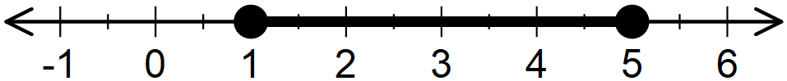 | B1  B1  B1 | For $x≤5$ and $x≥1$  Compound inequality shown  Number line drawn
 | Total | 3
 | Frequency distribution table  Marks $$f$$  10 – 14 2  15 – 19 5  20 – 24 7  25 – 29 12  30 – 34 4  Ʃ$f=2+5+7+12+4=30$ | B1  B1  B1 | All classes/class boundaries  All frequencies  Total frequency30 seen
 | Total | 3
 | Logarithms  Number Std Form Logarithm  $$7.089$$ $$124.5$$ $$7.089×{10}^{0}$$ $$1.245×{10}^{2}$$ $$0.8506$$ $$2.0952$$  $$2.9458$$  $$86.73$$ $$8.673×10$$ $$1.9382$$  $$1.0076÷3$$  $$2.167$$ $$2.167×{10}^{0}$$ $$0.3359$$ | M1  M1  M1  M1 | All logs  Correct +/- of logs  Correct multiplication by 2 and division by 3  Accuracy
 | Total | 4

NO. | WORKING | MARKS | REMARKS
 | Commission $→$ $20 000-12 400=7 600$  $$\frac{2}{100}×80 000=1 600$$  $$7 600-1 600=6 000$$  $$6 000=\frac{3}{100}×A$$  $$A=6 000×\frac{100}{3}=200 000$$  Total value  $$200 000+80 000=280 000$$ | M1  M1  A1 | Amount from commission  Expression for excess of 80 000
 | Total | 3
 | - Lines of symmetry  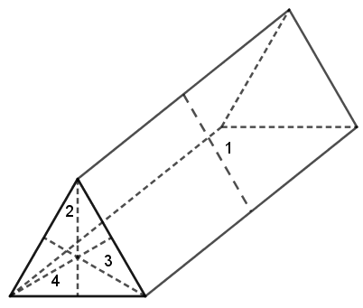  - Net  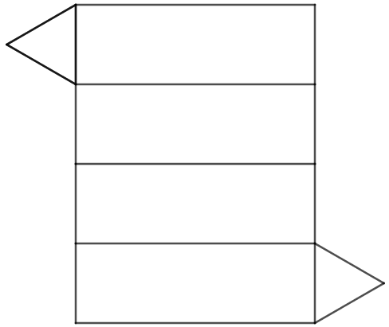 | B1  B1  B1 | For all the 4 lines of symmetry drawn  Correct net drawn  Correct measurements transferred from the solid
 | Total | 2

NO. | WORKING | MARKS | REMARKS
 | - (i) Equation of $l_{1}$  $$3=-\frac{1}{2}\left(-1\right)+c$$  $$6=1+2c$$  $$2c=5→c=\frac{5}{2}$$  $$l_{1}→y=-\frac{1}{2}x+\frac{5}{2}$$  (ii) If $S(0,k)→S$ – $y$-intercept  $$k=\frac{5}{2}=2.5$$  - (i) Gradient of $l_{2}$  $$m_{2}=\frac{5-(-3)}{4-1}=\frac{5+3}{3}=\frac{8}{3}$$  (ii) Equation of $l_{2}$  $$\frac{8}{3}=\frac{y-5}{x-4}$$  $$8x-32=3y-15$$  $$8x-3y=17$$  - Equation of $l_{3}$  $$m_{3}×\frac{8}{3}=-1→m_{3}=-\frac{3}{8}$$  $$\frac{-3}{8}=\frac{y-5}{x}$$  $$-3x=8y-40$$  $$3x+8y=40$$  - Acute angle of $l_{3}$ and $x$-axis  $$\tan{θ=\frac{3}{8}}$$  $$θ=\tan^{-1}\left(\frac{3}{8}\right)$$  $$θ=20.{56}^{0}$$ | M1  A1  B1  B1  M1  A1  B1  M1  A1 | Substituting $(-1, 3)$ in $y=mx+c$  $y=-\frac{1}{2}x+\frac{5}{2}$ seen  2.5 or equivalent seen  $\frac{8}{3}$ seen
 | Total | 10

NO. | WORKING | MARKS | REMARKS
 | - Amount of water delivered in 1 minute  $$V=\frac{22}{7}×3.5×3.5×15×100$$  $$V=57 750$$  Capacity  $$\frac{57 750}{1 000}=57.75 litres$$  - Area of base of tank  Time difference  $$1310 hrs$$  $$0630 hrs$$  $$6 hrs 40 minutes→6×60+40=400 minutes$$  $$1 minute→57.75 litres$$  $$400 minutes=400×57.75$$  $$=23 100 litres$$  $$1 litres=1 000 {cm}^{3}$$  $$23 100 litres=23 100×1 000$$  $$23 100×1 000=Base Area×12$$  $$Base Area=\frac{23 100×1 000}{12×10 000}$$  $$= 192.5{ m}^{2}$$  - Monthly water bill  $$1 000 litres→Ksh 100$$  $$23 100 litres=\frac{23 100×100}{1 000}$$  $$=Ksh 2 310$$  Bill  $$2 310+1 950=Ksh 4 260$$ | M1  A1  B1  M1  M1  M1  A1  M1  M1, A1 | Time difference  Capacity in 400 minutes  Expression for base area
 | Total | 10

NO. | WORKING | MARKS | REMARKS
 | - $A^{-1}$  $$\det{A=15}×8-9×12=12$$  $$A^{-1}=\frac{1}{12}\left(\begin{matrix}15 & -12 \\ -9 & 8\end{matrix}\right)=\left(\begin{matrix}1.25 & -1 \\ -.075 & \frac{2}{3}\end{matrix}\right)$$  - (i) Equations  $$8p+12c=294 000$$  $$\left(8+1\right)p+\left(12+3\right)c=294 000+43 500$$  $$9p+12c=337 500$$  (ii) Cost of each item  $\left(\begin{matrix}8 & 12 \\ 9 & 15\end{matrix}\right)\left(\begin{matrix}p \\ c\end{matrix}\right)=\left(\begin{matrix}294 000 \\ 337 500\end{matrix}\right)$  $$\left(\begin{matrix}1.25 & -1 \\ -.075 & \frac{2}{3}\end{matrix}\right)\left(\begin{matrix}8 & 12 \\ 9 & 15\end{matrix}\right)\left(\begin{matrix}p \\ c\end{matrix}\right)=\left(\begin{matrix}1.25 & -1 \\ -.075 & \frac{2}{3}\end{matrix}\right)\left(\begin{matrix}294 000 \\ 337 500\end{matrix}\right)$$  $$\left(\begin{matrix}1 & 0 \\ 0 & 1\end{matrix}\right)\left(\begin{matrix}p \\ c\end{matrix}\right)=\left(\begin{matrix}30 000 \\ 4 500\end{matrix}\right)$$  $$\left(\begin{matrix}p \\ c\end{matrix}\right)=\left(\begin{matrix}30 000 \\ 4 500\end{matrix}\right)$$  $$p=Ksh 30 000$$  $$c=Ksh 4 500$$  - Let the number be $ab$  $$a-b=1$$  $$\left(10a+b\right)+\left(10b+a\right)=165$$  $$11a+11b=165→a+b=15$$  $$a-b=1$$  $$a+b=15$$  $$2a=16→a=8$$  $$8-b=1→b=8-1=7$$  Hence the number is $87$ | B1  B1  B1  M1  M1  M1  A1  M1  M1  A1 | Accept if all elements as fractions  Matrix equation  Premultiplying by $A^{-1}$  Both values  Forming 2 equations in $a$ and $b$  Solution for $a$ and $b$ using any method
 | Total | 10

NO. | WORKING | MARKS | REMARKS
 | 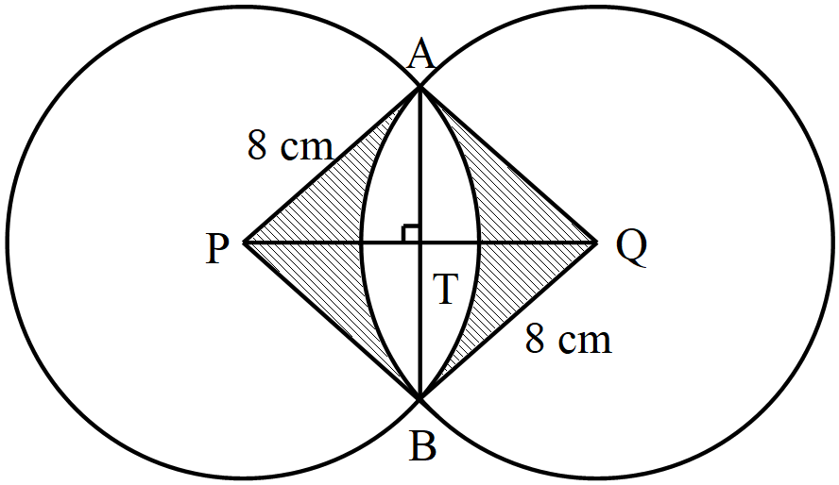  - Consider ΔAPT  $$PT=\frac{1}{2}PQ=6 cm$$  $$AT=\sqrt{8^{2}-6^{2}}=5.291 cm$$  $$AB=2×5.291=10.58 cm$$  - Shaded area  Let ∠$APT=θ$ in ΔAPT  $$\cos{θ=\frac{6}{8}→θ=\cos^{-1}\left(\frac{6}{8}\right)={41.41}^{0}}$$  $$APB=2×{41.41}^{0}={82.82}^{0}$$  Area of segment  $$A=\frac{82.82}{360}×3.142×8^{2}-\frac{1}{2}×8×8×\sin{{82.82}^{0}}$$  $$A=46.261-31.749$$  $$A=14.512$$  Both segments  $$14.512×2=29.024$$  Area of APBQ  $$A=2×31.749=63.498$$  Shaded area$=63.498-29.024$  $=34.74$ ${cm}^{2}$ | M1  A1  B1  M1, M1  A1  M1  M1  M1  A1 | Angle APT  Area of sector, area of ΔAPB  Area of both segments  Area of APBQ  Shaded Area
 | Total | 10

NO. | WORKING | MARKS | REMARKS
 | - (i) ∠RTP  ∠RQT$={180}^{0}-{100}^{0}={80}^{0}$ – opposite angles of cyclic quadrilateral QRST are supplementary  ∠TQP$=$∠UPT$={28}^{0}$ – angle between a chord and a tangent is equal to the angle subtended by the same chord on the circumference of the alternate segment.  ∠RQP$={80}^{0}+{28}^{0}={108}^{0}$  Hence  ∠RTP$={180}^{0}-{108}^{0}={72}^{0}$ – opposite angles of cyclic quadrilateral QRTP are supplementary  (ii) Join O to Q and consider ΔRQO  ∠RQO$={50}^{0}$ – base angles of isosceles ΔRQO  ∠ROQ$={180}^{0}-2×{50}^{0}={80}^{0}$ – sum of angles in ΔRQO is 180⁰  ∠RTQ$=\frac{1}{2}×{80}^{0}={40}^{0}$ – angle at the centre is twice angle at the circumference  Hence  ∠QTP$={72}^{0}-{40}^{0}={32}^{0}$  - Consider  ∠QPT$={180}^{0}-\left({28}^{0}+{32}^{0}\right)={120}^{0}$  ∠TQO$={80}^{0}-{50}^{0}={30}^{0}$  In ΔQPT  $$\frac{6}{\sin{{32}^{0}}}=\frac{QT}{\sin{{120}^{0}}}$$  $$QT=\frac{6\sin{{120}^{0}}}{\sin{{32}^{0}}}=9.806$$  Let M be the midpoint of QT  $$MQ=\frac{1}{2}×9.806=4.903$$  Consider ΔOQM  $$\cos{{30}^{0}=}\frac{OQ}{4.903}$$  $$OQ \left(radius\right)=\frac{4.903}{\cos{{30}^{0}}}=5.7 cm$$ | B1  B1  B1  B1  B1  B1  M1  M1  M1  A1 | ∠RQT  ∠RQP  ∠RTP  ∠ROQ  ∠RTQ  ∠QTP  Sine Rule applied  Half of QT  Attempt to get radius
 | Total | 10

NO. | WORKING | MARKS | REMARKS
 | - Time  Total length $= 40+100+160=300 m$  Relative speed$=60-40=20 km/h$  $$Time=\frac{0.3}{20}×3600$$  $=54 seconds$  - (i) Value of m  $$180=\frac{1}{2}×15(4+m)$$  $$180×2=15\left(4+m\right)$$  $$\frac{180×2}{15}=4+m$$  $$4+m=24→m=20 m/s$$  (ii) No acceleration  (iii) Deceleration  $$a=\frac{0-20}{60-45}$$  $$a=\frac{-20}{15}=-1\frac{1}{3} m/s^{2}$$  Hence, a deceleration of $1\frac{1}{3}$ $m/s^{2}$ | M1  M1  M1  A1  M1  M1  A1  B1  M1  A1 | Total length  Relative speed  Equation distance to area of trapezium  Collecting like terms
 | Total | 10

NO. | WORKING | MARKS | REMARKS
 | - Sketch  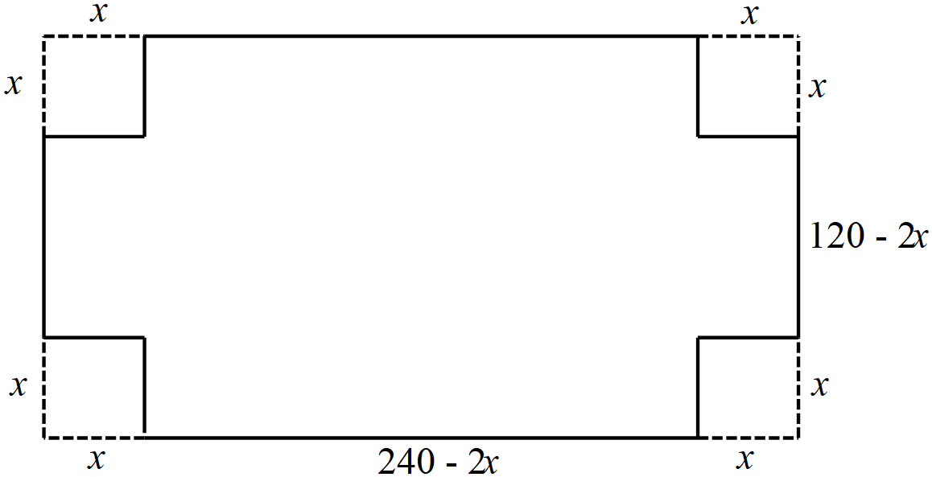  - Value of $x$ for maximum volume  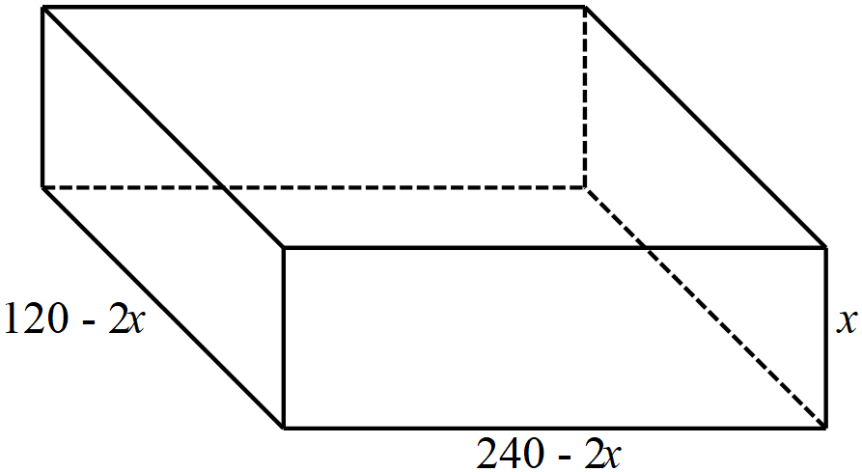  $$V=\left(240-2x\right)\left(120-2x\right)x$$  $$V=\left\{240\left(120-2x\right)-2x\left(120-2x\right)\right\}x$$  $$V=\left({4x}^{2}-720x+28800\right)x$$  $$V={4x}^{3}-720x^{2}+28800x$$  $$\frac{dV}{dx}=12x^{2}-1440x+28800$$  For maximum volume  $$12x^{2}-1440x+28800=0→x^{2}-120x+2400=0$$  $$x=\frac{-(-120)±\sqrt{{\left(-120\right)}^{2}-4×2400}}{2}$$  $$x=\frac{120±\sqrt{4800}}{2}$$  $$x=\frac{120±69.28}{2}$$  Either  $$x=\frac{120+69.28}{2}=94.64≅95$$  And  $$x=\frac{120-69.28}{2}=25.36≈25$$  Hence $x=25$  - Mass of empty box  External dimensions  $\left(240-2×25\right)$ cm by $\left(120-2×25\right)$ cm by $25 cm$  $$190 cm by 70 cm by 25 cm$$  Internal dimensions  188 cm by 68 cm by 24 cm  $$V=\left(190×70×25\right)-\left(188×68×24\right)$$  $$V=332500-306816=25684$$  $$Mass=25684$$ | B1  B1  M1  M1  A1  B1  M1  M1  A1 | Correct sketch  Dimensions shown on the sketch  Expression for volume  Equating volume to 0 at maximum volume  Both values of $x$  Value of $x$  Internal and external dimensions
 | Total | 10
NO. | WORKING | MARKS | REMARKS
 | - Table  $$x$$ $$-2$$ $$-1$$ $$0$$ $$1$$ $$2$$ $$3$$ $$4$$ $$5$$  $$y$$ $$-23$$ $$1$$ $$9$$ $$7$$ $$1$$ $$-3$$ $$1$$ $$19$$  - Graph  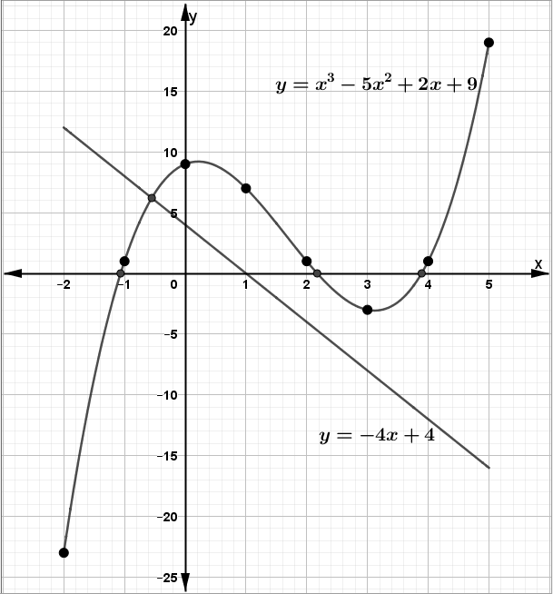  - Roots  - $x^{3}-5x^{2}+2x+9=0$  $$y=x^{3}-5x^{2}+2x+9$$  $$0=x^{3}-5x^{2}+2x+9-$$  $$y=0$$  $x=-1.2 or x=2.2 or x=3.8$ – all $±0.2$  - $x^{3}-5x^{2}+6x=-5$  $$y=x^{3}-5x^{2}+2x+9$$  $$0=x^{3}-5x^{2}+6x+5-$$  $$y=-4x+4$$  $$x=-0.6±0.2$$ | B2  S1  P1  C1  B1  B1  M1  L1  B1 | All the $y$ values (B1 for at least 5 $y$ values )  Linear scales used on both axes – accommodates all table values  All points plotted within the graph paper  Smooth curve drawn  $y=0$ shown or implied in the roots  All the values of $x$  attempt to get $$y=-4x+4$$  Line $y=-4x+4$ drawn  value of $x$
 | Total | 10

