ACK DIOCESE OF MUMIAS SECONDARY SCHOOLS

Kenya Certificate of Secondary Education
SEPTEMBER 2022

121/1

Mathematics Alt. A

Paper 1

Marking Scheme

SECTION I
No | Workings |  |  | Marks | Comments
1. | $\frac{38}{5}$- $\frac{1}{3}$ X $\frac{55}{12}$ X $\frac{12}{5}$  $\frac{38}{5}$ - $\frac{11}{3}$ =$\frac{114-55}{15}$  =3$\frac{14}{15}$ |  |  | M1  M1  A1 | Removing brackets.  C.A.O
 | Total Marks |  |  | 3
2. | L.C.M (30,40)=120minutes (2 hours)  Number of times = $\frac{1500hrs-0750hrs}{2hrs}$  = 3 $\frac{7}{12}$ = 3 times |  |  | B1  M1  A1 | For L.C.M.  For the integer 3
 | Total Marks |  |  | 3
3. | (0.0472₎² =(4.72 x 10⁻²₎²  = 22.278 x 10⁻⁴ = 0.0022278  (0.1236₎² = (1.236 x 10⁻¹₎²  =1.528 x 10⁻² = 0.01528  =$\sqrt{0.0022278+0.01528}$  =$\sqrt{1.751X10}$⁻²  =0.13233 |  |  | M1  M1  A1 | For any one correct squaring from.  Correct square root.  to at least four significant  figures
 | Total Marks |  |  | 3
4. | 3(0)−2x=−2  x=1  ⸫R(1,0) |  |  | M1  A1 | Substituting y with 0  Coordinates of point R
 | Total Marks |  |  | 2
5. |  | Hypotenuse = $\sqrt{4^{2}+3^{2}}$ = 5  ⸫ Cos (90-α) =$\frac{3}{5}$ |  |  | 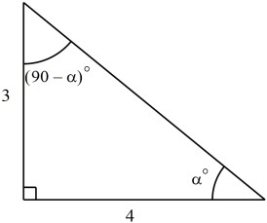
 | Total Marks |  |  | 2

No | Workings | Marks | Comments
6. | - M=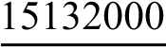  75.66  = 200 000 US Dollars  - 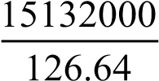  =119488 | M1  A1  M1  A1
 | Total Marks | 3
7. | <ABC = 42 Opposite angles in a cyclic quadrilateral add up to 180  <BAC = 42 Base angles of an isosceles triangle are equal  <ACB = 96 Sum of interior angles of a triangle add up to 180 | B1  B1  B1
 | Total Marks | 3
8. | 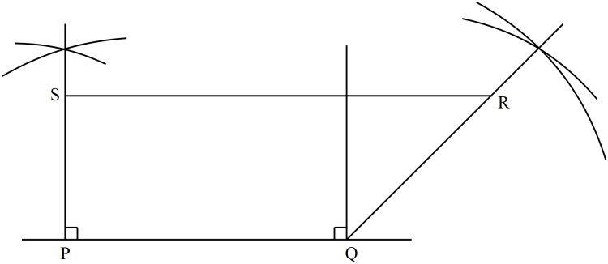  $$\frac{7.8cm x 40m}{1}$$  =312 ± 4m | B1  B1  M1  A1 | - Constructing 135º  - Completed PQRS
 | Total Marks | 3
9. | a : b : c  2 : 5  2 : 3 ,  ` 4: 10: 15  a:c= 4:15 | M1  A1
 | Total Marks | 2
10. | 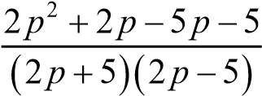  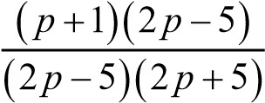  P+1 .  2p+ 5 | M1  M1  A1 | - Numerator  -  Denominator  - CAO
 | Total Marks | 3

No | Workings |  |  | Marks | Comments
11. | 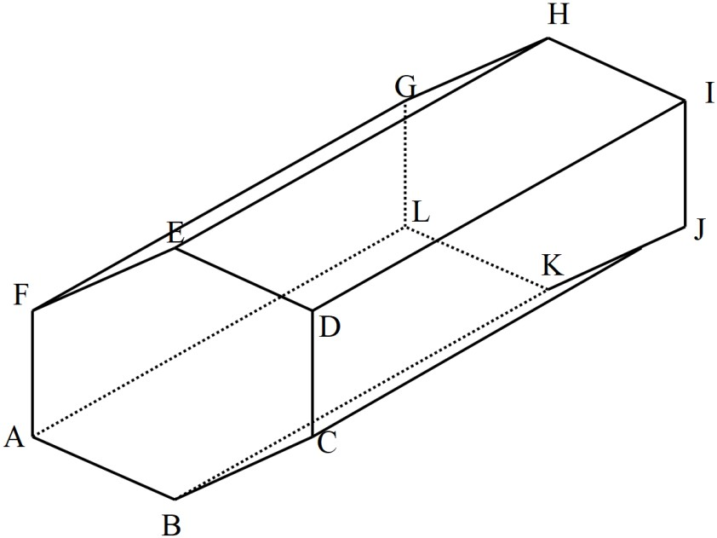 |  |  | B1  B1  B1 | Construction  - Hidden  - Completed  - solid
 | Total Marks |  |  | 4
12. | 2x−3≤ 4x+7 4x+7 <x+3  −2x≤10 3x< 6  x≥−5 x<2  -5≤ x<2 |  |  | B1  B1  B1 | - x ≥−5  - x<2.  - No. line
 | Total Marks |  |  | 3
13 | AB= |  |  | M1  M1  A1 | - Vector AB  - magnitude  - CAO
 | Total Marks |  |  | 3
14. | p³×q =135  p³×q = 3³×5  p = 3 q = 5 |  |  | B1  B1  B1 | - Factoring  - Value of p  - Value of q
 | Total Marks |  |  | 3
No | Workings | Marks | Comments
15. | x 0 0.4 0.8 1.2 1.6 2.0  y 2.00 1.96 1.83 1.60 1.20 0.00  a)  b)Area = ×0.04[(2.00+0.00)+2(1.96 +1.83+ 1.60+1.20)]  = 0.2(2.00+13.18)  =3.036cm² | B1  M1  M1  A1
 | Total Marks | 3
16 | (4x155)+160(n−4)=180(n−2)  620+160n−640 =180n−360  20n = 340 n =17sides | M1  M1  A1

SECTION II
No | Workings | Marks | Comments
17. | - S.A= 2X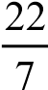X35²  =7700cm² x  x+60 = x  35 14  14(x+60)= 35x  14x−35x =−840  −21x =−840  x = 40  ⸫ Slant height = 40 + 60 = 100cm  - Total Surface Area of the model:  = 2πr² +(πRL−πrl)+πr²  Curved S.A = 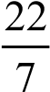(35x100−14x40r)  = 92400cm²  Base area: 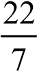x14²  = 616cm²  Total Surface area of the model:  = 7700 + 9240 + 616  =17 556cm² | M1  A1  M1  A1  B1  M1  A1  M1  M1  A1 | - Applying similarity  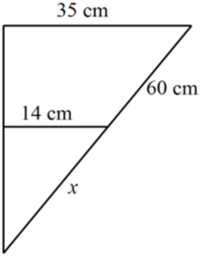  - Curved S.A  - Base area  - Addition including hemisphere  - CAO
 | Total Marks | 10

No | Workings | Marks | Comments
18. | - Matatu distance = 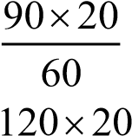= 30km  Nissan distance = 120x30 = 40km  60  After 30 mins = 90x30  60  =45 km  Relative distance = (120 −90)= 30 km/hr Relative speed = 75−40 = 35 km  Time taken to overtake = 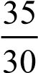 = 1 hour 10 mins time = 8 : 50 + 1: 10 = 10:00 a.m.  - Overtaking time = 10:00 - 8:00 = 2 hours  Distance = 90 x 2  = 180 km  - Time = distance = 240  speed 90  = 2 hours 40 minutes Arrival time = 8:00 + 2:40  = 10 : 40 a.m. | M1  M1  M1  M1  A1  M1  A1  M1  M1  A1 | ✓Distance after 30 mins  - Relative distance.  - .
 | Total Marks | 10

No | Workings | Marks | Comments
19. | - x =100−87 x =13  - Modal class : 19.0 – 19.4  Length(cm) x f fx c.f  18.0−18.4 18.2 5 91 5  18.5−18.9 18.7 8 149.6 13  19.0−19.4 19.2 30 576 43  19.5−19.9 19.7 x =13 256.1 56  20.0−20.4 20.2 10 202 66  20.5−20.9 20.7 20 414 86  21.0−21.4 21.2 10 212 96  21.5−21.9 21.7 4 86.8 100  $\sum{f}$=100 $\sum{f}x$=1987.5  - Mean = $\sum{fx}$ = 1987.5  $\sum{f}$ 100  =19.875  - L+ $\left(\frac{N}{2}-c.f\right)$i  f  19.45+ (50-43) x 0.5  13  =19.45+10.26923 =19.72 | B1  B1  B1  B1  B1  B1  M1  A1  M1  A1 | - x  - fx  - C.f  -  f
 | Total Marks | 10
20. | - Diagram (Next page)  - 16.5x300=4950 ±30km  - 16x300=4800 ±30km  - 316⁰ ± 1⁰ | B1  B1  B2  B1  B2  B2  B1 | Point B ✓  - Point C  - Point D ✓  Complete diagram  - Plotting  - Curve  - both values
 | Total Marks | 10

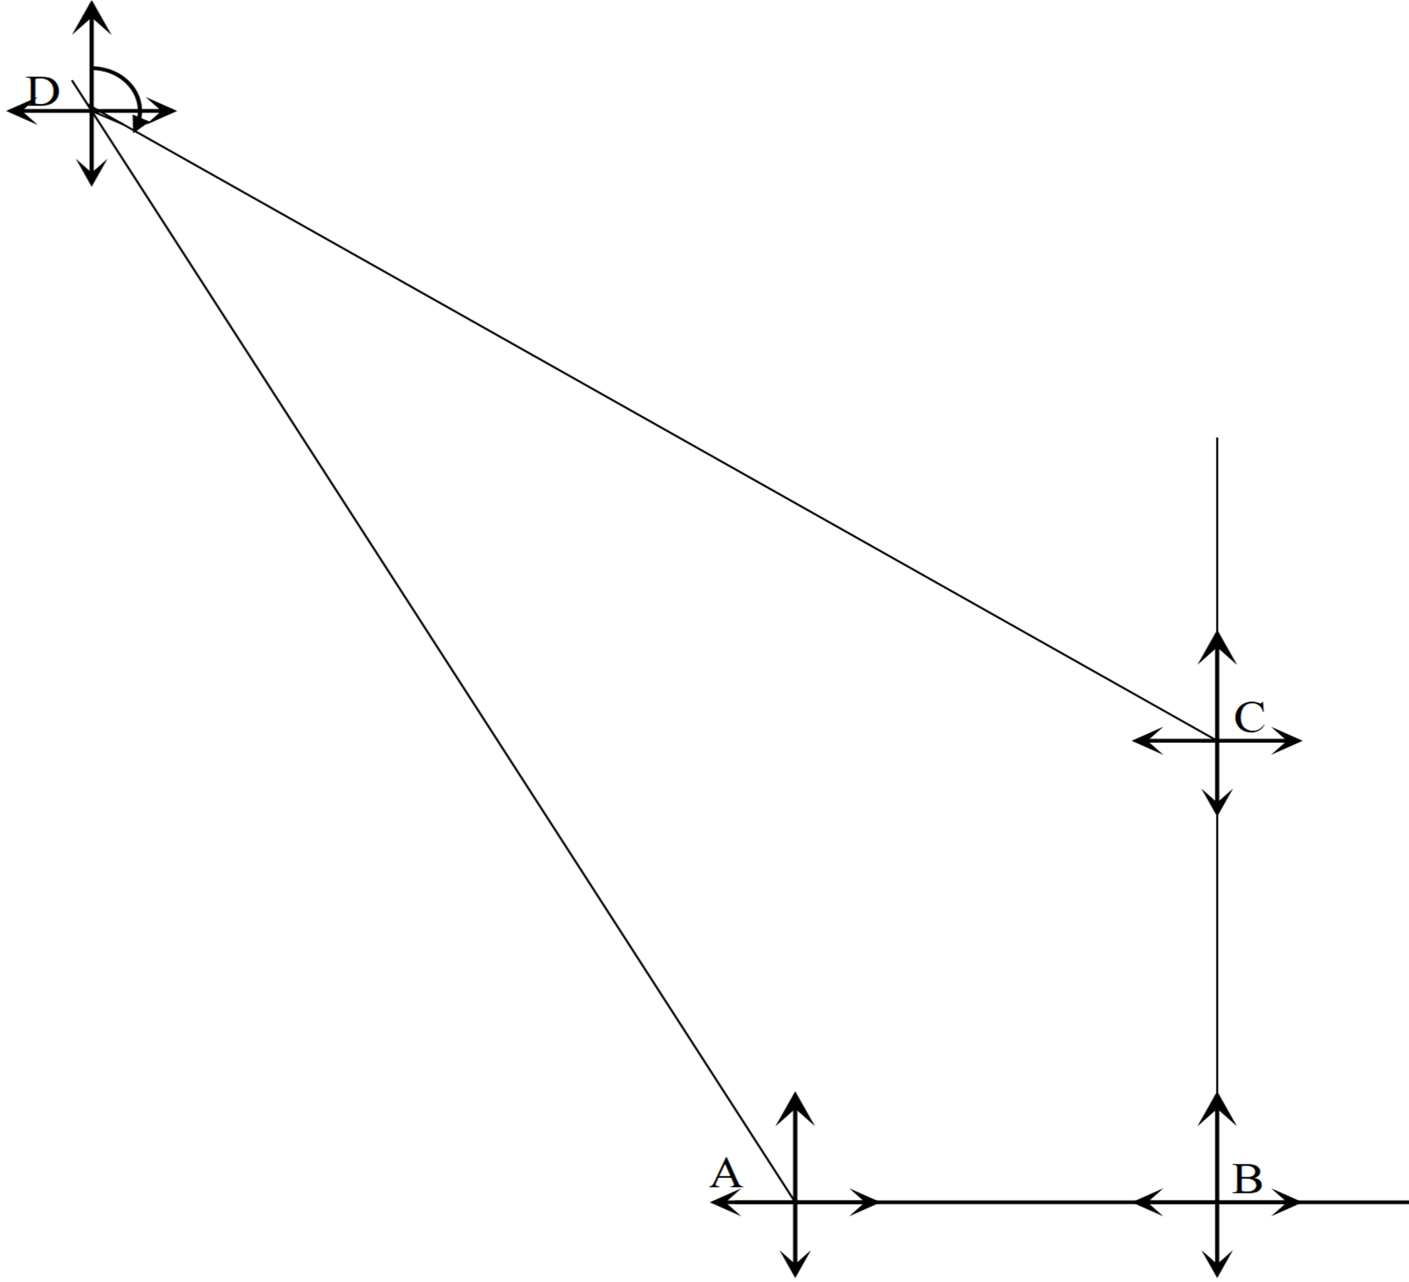

No | Workings | Marks | Comments
21. | - Plotting PQR  - On grid (Triangle P'Q'R'under  enlargement S.F = about(2,2) )  P'(1,1) Q'(4,1) R'(2,3)  - On the grid (TriangleP''Q''R'' under positive quarter turn about(1,1) )  - On grid (Triangle P'''Q'''R''' under reflection in the line y=1 )  - Reflection in the line y=−x+ 2 | B1  B1  B1  B1  B1  B1  B1  B1  B1  B1 | ✓Triangle PQR  - Enlargement process  - Triangle P'Q'R'  - Coordinates of P'Q'R'.  - Rotation process.  - triangle P''Q''R''drawn.  - Line y=1.  - Triangle P'''Q'''R''' drawn  - Identifying reflection  - Equation. y=−x+ 2
 | Total Marks | 10
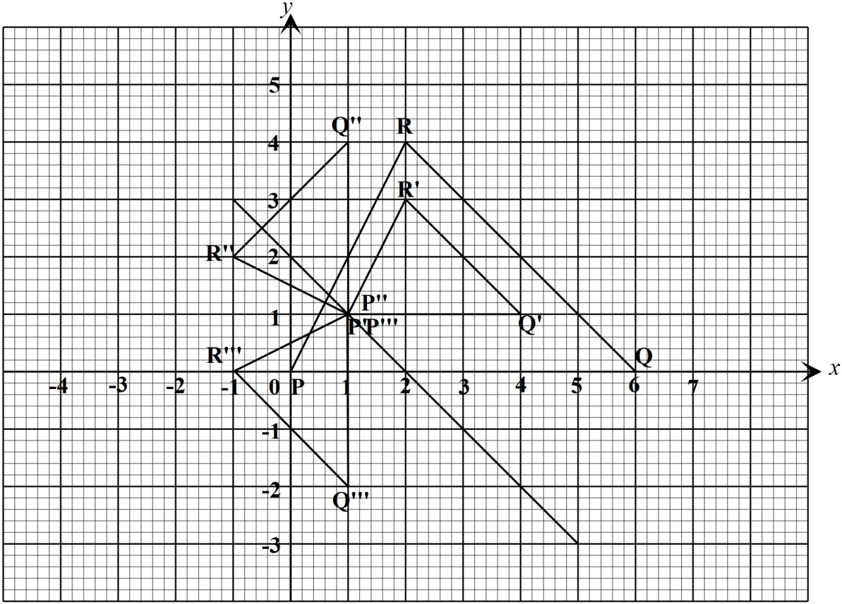

NO | Working | Marks | Comments
22. | - Determinant = 8−9=−1  A⁻¹ = $\frac{1}{-1}$ $\left(\begin{matrix}2 & -3 \\ -3 & 4\end{matrix}\right)$ = $\left(\begin{matrix}-2 & 3 \\ 3 & -4\end{matrix}\right)$  - (i) Equations:  20x+15y = 9500  15x+10y = 6750  (ii) Solving the equations:  20x+15y= 9500  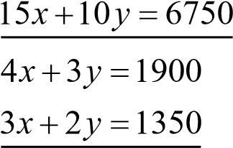  $\left(\begin{matrix}4 & 3 \\ 3 & 2\end{matrix}\right)\left(\begin{matrix}x \\ y\end{matrix}\right)$ = $\left(\begin{matrix}1900 \\ 1350\end{matrix}\right)$  $\left(\begin{matrix}-2 & 3 \\ 3 & -4\end{matrix}\right)$ $\left(\begin{matrix}4 & 3 \\ 3 & 2\end{matrix}\right)\left(\begin{matrix}x \\ y\end{matrix}\right)$=$\left(\begin{matrix}-2 & 3 \\ 3 & -4\end{matrix}\right)\left(\begin{matrix}1900 \\ 1350\end{matrix}\right)$  $\left(\begin{matrix}x \\ y\end{matrix}\right)$ = $\left(\begin{matrix}250 \\ 300\end{matrix}\right)$  ⸫ x = Kshs 250 y = Kshs 300  (c) Oranges new price = 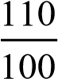 x250 = Kshs.275  Mangoes new price = 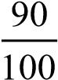 x300 = Kshs.270  $\left(\begin{matrix}20 & 15 \\ 15 & 10\end{matrix}\right)\left(\begin{matrix}275 \\ 270\end{matrix}\right)$ = $\left(\begin{matrix}9550 \\ 6825\end{matrix}\right)$  total cost = 9550 + 6825 = Kshs.16 375 | B1  B1  B1  B1  M1  M1  A1  M1  M1  A1 | - Determinant  - Inverse  - Each value  ✓Pre – multiplying with  inverse  - Correct multiplication.  ✓Both values  - New costs.  - Using matrix to find total cost. (Follow through) ✓ Total value.
 | Total Marks | 10

NO | Working | Marks |  | Comments
(a)
x | -1 | 0 | 1 | 2 | 3 | 4 | 5
y | 7 | 2 | -1 | -2 | -1 | 2 | 7
(b) Curve
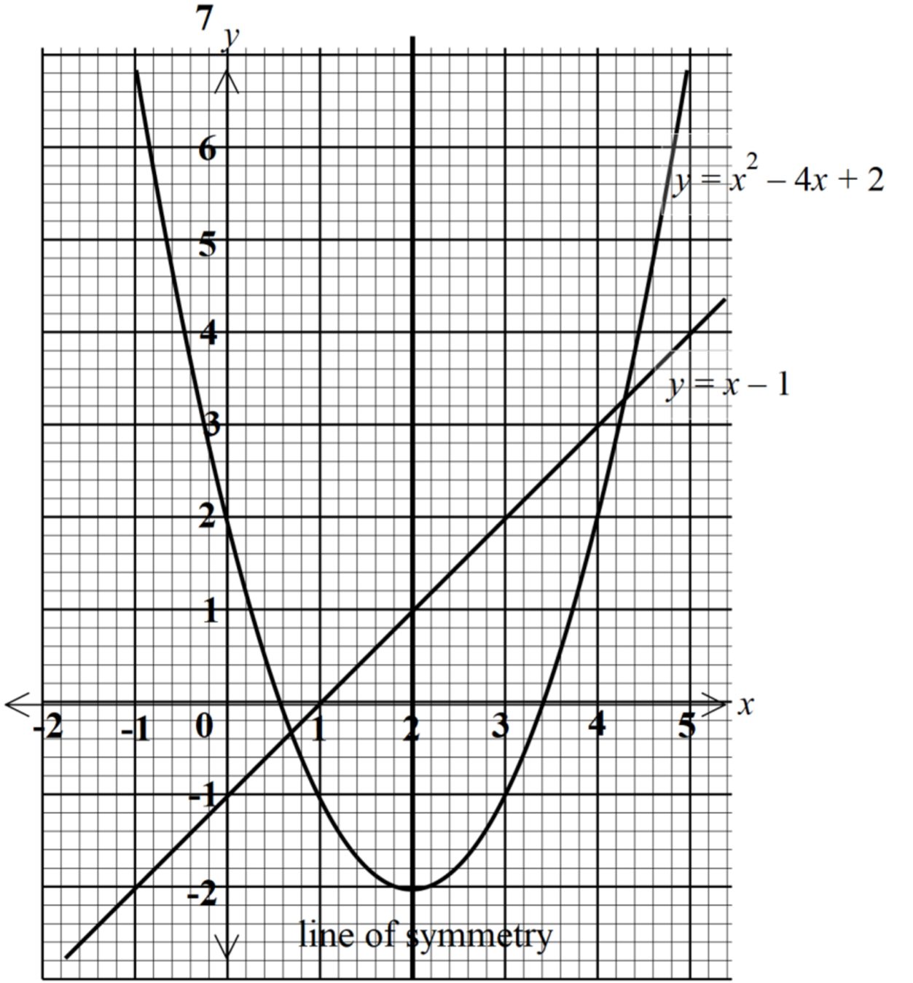
II. Line drawn
(c)x = 0.7 or 4.3 ± 0.1
(d) x = 2

 | Total Marks | 10

No | Workings | Marks | Comments
24. | ds  - =12t² −5t −3  dt  v =12t² −5t −3 v =12(3)² −5(3)−3 v = 90m/s  - 12t² −5t −3=0  12t² −9t + 4t −3 = 0  3t(4t −3)+1(4t −3)= 0  (4t −3)(3t +1)= 0  t = $\frac{3}{4}$ or $\frac{1}{3}$  t = $\frac{3}{4}$ seconds  - Displacement at t =  s = 4t³ −$\frac{5}{2}$ t² −3t+3 s =  s = 4 $\left(\frac{3}{4}\right)$ ³ - $\left(\frac{3}{4}\right)$² - 3$\left(\frac{3}{4}\right)$ + 3  s =$\frac{33}{32}$ = 1$\frac{1}{32}$ or 1.03125  - a= $\frac{dv}{dy}$ =24t – 5  a =$\frac{dv}{dy}$ =24(2)-5  a = 43 m/s² | M1  M1  A1  M1  M1  A1  M1  A1  M1  A1
 | Total Marks | 10

