END TERM 1-2023
MATHEMATICS PAPER 2 (121/2)
FORM FOUR
TIME: 2 ½ HOURS

NO. | WORKING | MARKS | REMARKS
 | Capacity of container  $$\frac{22}{7}×7^{2}×10×\frac{1}{1000}$$  $$=1.54 litres$$  $$No of times=\frac{18.48}{1.54}$$  $=12$ | M1  M1  A1 | Volume of container
 | Total | 3
 | Last term$→T_{n}=3+\left(n-1\right)2=1+2n$  $$T_{41}=3+\left(41-1\right)2=83$$  $$1+2n-83=48$$  $$1+2n=48+83$$  $$2n=131-1$$  $$2n=130$$  $$n=65$$ | M1  M1  A1 | Expressions for $T_{n}$ and $T_{41}$
 | Total | 3
 | $$p^{2}=\frac{x^{2}-q}{r+x^{2}}$$  $$p^{2}\left(r+x^{2}\right)=x^{2}-q$$  $${rp}^{2}+p^{2}x^{2}=x^{2}-q$$  $${rp}^{2}+q=x^{2}-p^{2}x^{2}$$  $${rp}^{2}+q=x^{2}\left(1-p^{2}\right)$$  $$x^{2}=\frac{{rp}^{2}+q}{1-p^{2}}$$  $$x=±\sqrt{\frac{{rp}^{2}+q}{1-p^{2}}}$$ | M1  M1  A1 | Removal of square root  Collection of terms in x  A0 if ± missing
 | Total | 3
 | $$px^{2}-\frac{3}{2}x+\frac{1}{16}={\left(ax-b\right)}^{2}$$  $$px^{2}-\frac{3}{2}x+\frac{1}{16}=a^{2}x^{2}-2abx+b^{2}$$  $$b^{2}={\left(\frac{1}{4}\right)}^{2}→b=\frac{1}{4}$$  $$\frac{3}{2}=2ab→\frac{3}{2}=2×a×\frac{1}{4}$$  $$\frac{1}{2}a=\frac{3}{2}→a=3$$  $$p=a^{2}→p=3^{2}→p=9$$ | M1  A1
 | Total | 2

NO. | WORKING | MARKS | REMARKS
 | $$r=\sqrt{{25}^{2}-{24}^{2}}=7 cm$$  $$\sin{θ=\frac{24}{25}}$$  $$θ=\sin^{-1}\left(\frac{24}{25}\right)→θ={73.74}^{0}$$  $$A=\frac{1}{2}×7×24-\frac{{73.74}^{0}}{360}×\frac{22}{7}×7^{2}$$  $$A=84-31.54=52.46$$ | B1  B1  M1  A1 | $r=7$cm  ∠TOP
 | Total | 4
 | $$k+100m=45,000$$  $$k+60m=40,000$$  $$40m=5,000$$  $$m=\frac{5,000}{40}=125$$  $$k=40,000-60×125$$  $$k=32,500$$  $$C=32,500+125n$$  $$63,000=32,500+125n$$  $$125n=63,000-32,500$$  $$125n=30,500$$  $$n=\frac{30,500}{125}=244$$ | M1  A1  M1  A1
 | Total | 4
 | $${\left(1+2x\right)}^{6}=1+6\left(2x\right)+15{\left(2x\right)}^{2}+20{\left(2x\right)}^{3}+15{(2x)}^{4}+…$$  $${\left(1+2x\right)}^{6}=1+12x+{60x}^{2}+{160x}^{3}+{240x}^{4}+…$$  $$1+2x=0.98→0.98-1=2x→-0.02=2x→x=-0.01$$  $${\left(0.98\right)}^{6}=1+12\left(-0.01\right)+60{\left(-0.01\right)}^{2}+160{\left(-0.01\right)}^{3}+240{\left(-0.01\right)}^{4}$$  $${\left(0.98\right)}^{6}=0.8858424$$  $$=0.88584$$ | M1  M1  A1
 | Total | 3

NO. | WORKING | MARKS | REMARKS
 | Amount borrowed$=50,000-25,000=25,000$  Total instalments$=24×2,250=54,000$  Let the rate of interest be $r\%$ per month  $$54,000=25,000{\left(1+\frac{r}{100}\right)}^{2}$$  $$\frac{54,000}{25,000}={\left(1+\frac{r}{100}\right)}^{24}$$  $$2.16={\left(1+\frac{r}{100}\right)}^{24}$$  $$\sqrt[24]{\sqrt{2.16}}=1+\frac{r}{100}$$  $$1.03261=1+\frac{r}{100}$$  $$103.261=100+r$$  $$r=103.261-100=3.261\%$$ | M1  M1  M1  A1
 | Total | 3
 | - Phase angle  $${60}^{0}$$  - Period  $$\frac{{360}^{0}}{a}={720}^{0}$$  $$a=\frac{{360}^{0}}{{720}^{0}}=\frac{1}{2}$$ | B1  B1
 | Total | 3
 | $$60×θ=4320$$  $$θ=\frac{4320}{60}={72}^{0}$$  $${72}^{0}-{45}^{0}={27}^{0}$$  Hence $R→\left({27}^{0}N, {108}^{0}E\right)$ | B1  B1  B1
 | Total | 3
P1

C1

M1

A1
 | Total | 4

NO. | WORKING | MARKS | REMARKS
 | $$P(either H or S)=P(HS') or P(H'S)$$  $$P\left({HS}^{'}\right)or P\left(H^{'}S\right)=P\left({HS}^{'}\right)+P\left(H^{'}S\right)$$  $$P\left({HS}^{'}\right)or P\left(H^{'}S\right)=\frac{7}{8}×\frac{1}{3}+\frac{1}{8}×\frac{3}{4}$$  $$P\left({HS}^{'}\right)or P\left(H^{'}S\right)=\frac{7}{24}+\frac{3}{32}$$  $$P\left({HS}^{'}\right)or P\left(H^{'}S\right)=\frac{37}{96}$$ | M1  M1  A1
 | Total | 3
 |  | B1  B1  B1  B1 | Bisecting line AB  Arc radius 2 cm and centre C  Bisecting angle CDA  Locating and shading the region
 | Total | 4
 | $$A.E=\frac{1}{2}\left\{2×π×3.55-2×π×3.45\right\}$$  $$A.E=\frac{1}{10}π$$  $$\% age Error=\frac{\frac{1}{10}π}{2×π×3.5}×100$$  $$\% age Error=\frac{0.1π}{7π}×100$$  $$\% age Error=1\frac{3}{7}\%$$ | M1  M1  A1 | Absolute error in the perimeter  Expression for percentage error  Accept $1.4286\%$
 | Total | 3

NO. | WORKING | MARKS | REMARKS
 | $$Number$$ $Logarithm$  $$14.7$$ $$1.1673$$  $$\tan{{35}^{0}24'}$$ $$-0.1484$$  $$1.0189$$  $$69.85$$ $$1.8442×2$$ $$3.6844$$  $$-2.6655×\frac{1}{3}$$  $$0.1302$$ $$-0.8855$$ | M1  M1  M1  A1 | All logarithms  addition and subtraction of logarithms  multiplication of logarithms by 2 and division by 3  A0 if < 4 decimal places
 | Total | 4
 | $$\log\left(\frac{5x+75}{2x-9}\right)=\log{3^{2}}$$  $$\frac{5x+75}{2x-9}=9$$  $$9\left(2x-9\right)=5x+75$$  $$18x-81=5x+75$$  $$18x-5x=75+81$$  $$13x=156$$  $$x=\frac{156}{13}=12$$ | M1  M1  A1
 | Total | 3

NO. | WORKING | MARKS | REMARKS
 | - Table  Height $$f$$ $$x$$ $$d=x-5.45$$ $$fd$$ $${fd}^{2}$$  3.0 – 3.9 3 3.45 $$-2$$ $$-6$$ $$12$$  4.0 – 4.9 5 4.45 $$-1$$ $$-5$$ $$5$$  5.0 – 5.9 7 5.45 $$0$$ $$0$$ $$0$$  6.0 – 6.9 8 6.45 $$1$$ $$8$$ $$8$$  7.0 – 7.9 5 7.45 $$2$$ $$10$$ $$20$$  8.0 – 8.9 2 8.45 $$3$$ $$6$$ $$18$$  30 $$13$$ $$63$$  - Standard deviation  $$s=\sqrt{\frac{63}{30}-{\left(\frac{13}{30}\right)}^{2}}$$  $$s=1.3828$$  - (i) Ogive  (ii) Range of height between the 20th and 80th percentiles  $$P_{20}=\frac{20}{100}×30=6^{th}=4.65 cm$$  $$P_{80}=\frac{80}{100}×30={24}^{th}=7.15 cm$$  Range$= 4.65 to 7.15$ | B1  B1  B1  B1  M1  A1  B1  B1  B1  B1 | All $x$  All $d$  All $fd$  All ${fd}^{2}$  Axes  Curve  Identification of the percentiles from ogive
 | Total | 10

NO. | WORKING | MARKS | REMARKS
 | - Taxable income  $$38,780+10,000+3,850$$  $$=52,630$$  - PAYE  $$12,000×\frac{2}{20}=1,200$$  $$\left(22,500-12,000\right)×\frac{3}{20}=1,575$$  $$\left(33,000-22,500\right)×\frac{4}{20}=2,100$$  $$\left(43,500-33,000\right)×\frac{5}{20}=2,625$$  $$\left(52,630-43,550\right)×\frac{6}{20}=2,739$$  $$PAYE=\left(1,200+1,575+2,100+2,625+2,739\right)-1,054$$  $$PAYE=9,185$$  - Net Salary  $$Gross salary=52,630+5200=57,830$$  $$Net Salary=57,830-(9,185+3,000+7,568+780)$$  $$Net salary=37,297$$ | M1  A1  M1  M1  M1  M1  A1  M1  M1  A1 | First 2 bands  Second 2 bands  Last band
 | Total | 10
 | - (i) $Area=\left(60+2x\right)\left(48+2x\right)=2880+216x+{4x}^{2}$  (ii) $Area=\left\{2880+216x+{4x}^{2}\right\}-(60×48)$  $=216x+{4x}^{2}$  - (i) Value of $x$  $\left\{\left(60+2x\right)\left(48+2x\right)\right\}-\left(60×48\right)=220$  ${4x}^{2}+54x-55=0$  $\left(x+55\right)\left(x-1\right)=0$  Either $x+55=0→x=-55$ (discriminate)  Or $x-1=0→x=1 metre$  (ii) Perimeter  Dimension $60+2$ metres by $48+2$ metres  $P=2\left(62+50\right)$  $P=224 metres$ | M1  M1  A1  M1  M1  A1  B1  M1
 | Total | 10

NO. | WORKING | MARKS | REMARKS
 | - Coordinates of triangle $ABC$  $$\left(\begin{matrix}1 & -2 \\ 0 & 1\end{matrix}\right)\left(\begin{matrix}a & c & e \\ b & d & f\end{matrix}\right)=\left(\begin{matrix}-6 & -2 & -2 \\ 0 & -3 & 0\end{matrix}\right)$$  $$\left(\begin{matrix}a-2b & c-2d & e-2f \\ b & d & f\end{matrix}\right)=\left(\begin{matrix}-6 & -2 & -2 \\ 0 & -3 & 0\end{matrix}\right)$$  $b=0, a-$2b=6$→a=-6$  $$d=-3→c-2×-3→c+6=-2→c=-8$$  $$f=0→e=-2$$  Hence  $$\left(\begin{matrix}-6 & -8 & -2 \\ 0 & -3 & 0\end{matrix}\right)→A\left(-6, 0\right), B\left(-8, -3\right) and C(-2, 0)$$  - (i) Triangles  (ii) Shear, $y=0$ invariant  - (i) triangle $A''B''C''$ drawn  (ii) Matrix  $$\left(\begin{matrix}p & q \\ r & s\end{matrix}\right)\left(\begin{matrix}0 & 6 & 0 \\ 6 & 2 & 2\end{matrix}\right)=\left(\begin{matrix}-6 & -8 & -2 \\ 0 & -3 & 0\end{matrix}\right)$$  $$\left(\begin{matrix}6q & 6p+2q & 2q \\ 6s & 6r+2s & 2s\end{matrix}\right)=\left(\begin{matrix}-6 & -8 & -2 \\ 0 & -3 & 0\end{matrix}\right)$$  $6q=-6→q=-1$, $6p-2=-8→6p=-6→p=-1$  $$6s=0→s=0, 6r+2s=-3→6r=-3→r=-\frac{1}{2}$$  Matrix=$\left(\begin{matrix}-1 & -1 \\ 0 & -\frac{1}{2}\end{matrix}\right)$ | M1  A1, B1  B1, B1  B1  B1  M1  M1  A1
 | Total | 10

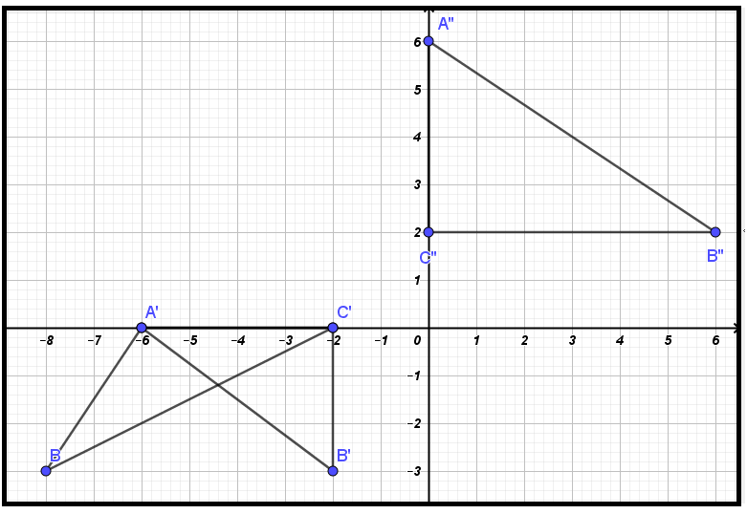
$$x^{0}$$ | $$0$$ | $$30$$ | $$60$$ | $$90$$ | $$120$$ | $$150$$ | $$180$$ | $$210$$ | $$240$$ | $$270$$ | $$300$$ | $$330$$ | $$360$$
$$y=2\sin\left(\frac{3}{4}x\right)-2\cos\left(\frac{3}{4}x\right)$$ | $$-2.0$$ | $$-1.1$$ | $$0.0$$ | $$1.1$$ | $$2.0$$ | $$2.6$$ | $$2.8$$ | $$2.6$$ | $$2.0$$ | $$1.1$$ | $$0.0$$ | $$-1.1$$ | $$-2.0$$
$$y=1+2\cos{x }$$ | $$3.0$$ | $$2.7$$ | $$2.0$$ | $$1.0$$ | $$0.0$$ | $$-0.7$$ | $$-1.0$$ | $$-0.7$$ | $$0.0$$ | $$1.0$$ | $$2.0$$ | $$2.7$$ | $$3.0$$

NO. | WORKING | MARKS | REMARKS
 | - Table  - Graphs  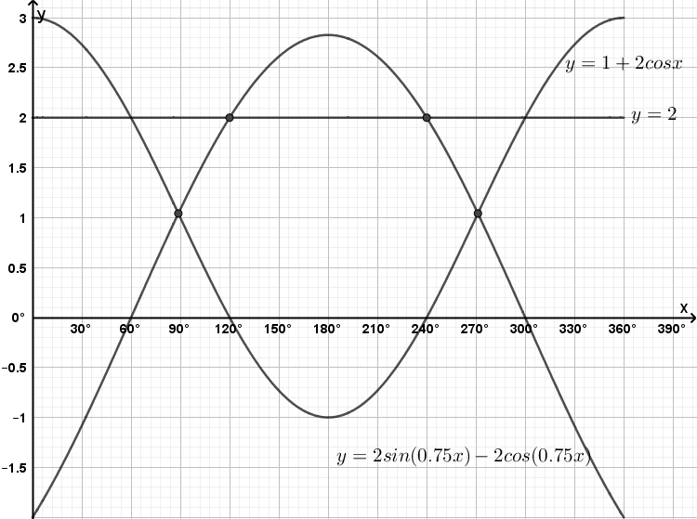  - Using graphs to  - find the values of $x$ for which:  $$1+\cos\left(\frac{3}{4}x\right)=\sin\left(\frac{3}{4}x\right)$$  $$2+2cos\left(\frac{3}{4}x\right)=2sin\left(\frac{3}{4}x\right)$$  $$2=2sin\left(\frac{3}{4}x\right)-2cos\left(\frac{3}{4}x\right)$$  $$x={120}^{0}, {240}^{0}$$  - determine the values of $x$ for which:  $$2\sin\left(\frac{3}{4}x\right)-2\cos\left(\frac{3}{4}x\right)=1+2\cos{x}$$  $x={84}^{0}$and ${276}^{0}$ | B2  P1  C1  P1  C1  L1  B1  B1  B1 | All values correct (B1 at least 5 values correct)  Line $y=2$ drawn  All values
 | Total | 10

NO. | WORKING | MARKS | REMARKS
 | - Awuor  - Annual increment  $$T_{11}=180,000+10d=288,000$$  $$288,00-180,000=10d$$  $$10d=108,000$$  $$d=10,800$$  - Sum after 11 years  $$S_{11}=\frac{11}{2}\left\{2×150,000+\left(11-1\right)×\frac{10}{100}×150,000\right\}$$  $$S_{11}=\frac{11}{2}\left\{300,000+10×15,000\right\}$$  $$S_{11}=2,475,000$$  - Wasonga  $$T_{11}=150,000+10×15,000$$  $$T_{11}=300,000$$  $$\frac{300,000}{11}$$  $$27,270$$ | M1  M1  A1  M1  M1  A1  M1  A1  M1  A1
 | Total | 10

NO. | WORKING | MARKS | REMARKS
 | - DG and ABCD  $$KD=\sqrt{8^{2}+6^{2}}=10 cm$$  Consider ΔGKD  $$\tan{D=\frac{4}{10}}$$  $$D=\tan^{-1}\left(\frac{4}{10}\right)={21.8}^{0}$$  - ABGH and ABCD  Consider ΔGKB  $$\sin{B=\frac{4}{5}}$$  $$B=\sin^{-1}\left(\frac{4}{5}\right)$$  $$B={53.1}^{0}$$  - Volume  $$A=\frac{1}{2}×4\left(8+11\right)$$  $$A=38$$  $$V=38×6=228$$ | M1  M1  A1  M1  M1  A1  M1  A1  M1, A1
 | Total | 10

NO. | WORKING | MARKS | REMARKS
 | - $x=5x-x^{2}$  $$0=5x-x-x^{2}$$  $$0=4x-x^{2}$$  $$x\left(4-x\right)=0$$  Either $x=0$ or $4-x=0→x=4$  $$a=4$$  - Area by trapezium rule  $$h=\frac{4-0}{4}=1$$  $$x$$ $$0$$ $$1$$ $$2$$ $$3$$ $$4$$  $$y$$ $$0$$ $$4$$ $$6$$ $$6$$ $$4$$  $$A=\frac{1}{2}×1\left\{\left(0+4\right)+2\left(4+6+6\right)\right\}$$  $$A=18$$  $$A=\frac{1}{2}×4×4=8$$  Shaded area $=18-8=10$  - Area by integration  $$A=\int_{0}^{4}{\left(5x-x^{2}\right)dx-\int_{0}^{4}{x dx}}$$  $$A={\left[\frac{5}{2}x^{2}-\frac{1}{3}x^{3}\right]}_{0}^{4}-{\left[\frac{1}{2}x^{2}\right]}_{0}^{4}$$  $$A=\left(\frac{5}{2}{×4}^{2}-\frac{1}{3}{×4}^{3}\right)-\left(\frac{1}{2}{×4}^{2}\right)$$  $$A=\frac{56}{3}-8$$  $$A=10\frac{2}{3}$$ | M1  A1  M1  M1  M1, A1  M1  M1  M1  A1
 | Total | 10

