MATHEMATICS - CBC GRADE 2 TERM 1 2023
QUESTIONS
- Count and write how many (4mks)
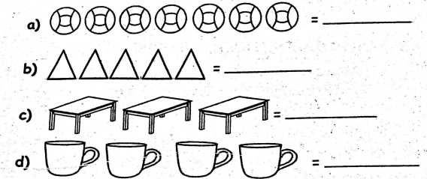
- Write the missing numbers (3mks)
  - 66, 67, __, __, 70
  - 19,__, __, __, 23, 24
  - 27,__, 29, __, 31
- Write the numbers in figures (4mks)
  - Twenty one
  - Seven
  - Thirteen
  - Fifty six
- Complete the following (4mks)
  - 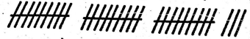
__Tens, __ones = ___
  - 32 = __tens and __ones.
  - 21 = __tens and __ones.
  - 4 = __tens and __ones.
- Work out (4mks)
  - 3 + 4 + 4=
  - 8 +1 =
  - 6 + 0 =
  - 2 + 3 + 4 =
- Add (4mks)
  - 40 + 30 =
  - 50 + 10 =
  - 3 + 3 + 6 =
  - 12 + 14 =
- Fill in the boxes (2mks)
  - 8 +__= 12
  - __+ 8 = 10
- Take away (5mks)
  - 42 - 31 =
  - 13 - 5 =
  - 18 - 8 =
  - 15 - 3 =
  - 12 - 6 =
- What is 16 take away 9?
- Subtract 8 from 20
- Mark had 6 mangoes. He ate two mangoes. How many mangoes remained?(1mk)
- How much money? (3mks)
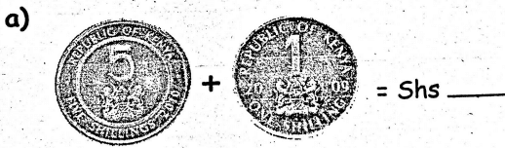
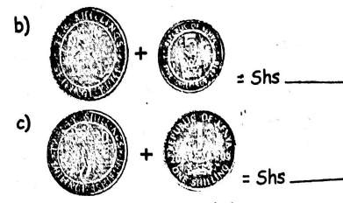
- Which line is shorter (1 mks)
A____________
B______
- A week has__days. (1 mk)
- Which one is heavier? (1mk)
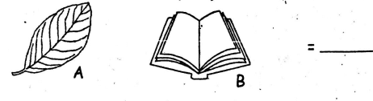
- Name the shapes below (6mks)
