Name……………………………………………….Adm No………..Class……
Index No……………………….. Signature…………………………

121/1
Mathematics Paper 2
Form 4
2 ½ Hours
Term 2, 2022
MOKASA TWO EXAMINATIONS
Kenya Certificate of Secondary Education (K.C.S.E)
INSTRUCTIONS TO CANDIDATES
- Write your name and Admission number in the spaces provided at the top of this page.
  - This paper consists of two sections: Section I and Section II.
  - Answer ALL questions from section I and ANY FIVE from section II
  - All answers and workings must be written on the question paper in the spaces provided
below each question.
  - Show all the steps in your calculation, giving your answer at each stage in the spaces
below each question.
  - Non – Programmable silent electronic calculators and KNEC mathematical tables may be
used, except where stated otherwise.

FOR EXAMINERS USE ONLY

SECTION I
1 | 2 | 3 | 4 | 5 | 6 | 7 | 8 | 9 | 10 | 11 | 12 | 13 | 14 | 15 | 16 | TOTAL

SECTION II
17 | 18 | 19 | 20 | 21 | 22 | 23 | 24 | TOTAL

GRAND TOTAL
SECTION I (50 MARKS)
Answer all questions in this section
1. Use logarithms to evaluate (4marks) $\sqrt[3]{\frac{log6.32}{0.7214×10.47}}$

2. Solve the simultaneous equation (3marks)

3. The measurements of aright angled triangle is given to the nearest milimetres as 8.4 and 3.7 base and height respectively. Calculate the maximum relative error in the area of the triangle to 4 decimal places (3marks)

4. Solve the equation $4\cos^{2}θ=7-7sinθ,$ where $0^{o}≤θ≤{360}^{0}$ (3 marks)

5. Express in surds form and rationalize the denominator. ( 3 marks)

6. Without using mathematical tables or calculator evaluate the expression;
2+¹/₂Log₁₀1600 - Log₁₀4 (3marks)

7. The table below shows monthly income tax rates in a certain year.
Monthly taxable in Ksh. | Tax rate percentage (%) in each shilling
Under ksh.12299 | 10%
From ksh.12299 but under ksh.23886 | 15%
From ksh.23886 but under ksh.35473 | 20%
In that year, the net tax on Moraa’s monthly income was ksh.4182.85.If a monthly personal relief of ksh.1408 was allowed, calculate Moraa’s monthly income. (4 marks)

8. Triangle A B C with vertices A(2,2), B(4,1) and C(6,4) undergoes a shear with x-axis invariant and point C is mapped onto C’ (2,4). Find the matrix of transformation. (3marks)

9. Three quantities x, y and z are such that x varies partly as y and partly as the inverse of the square of z. When x = 6, y = 3 and z= 2. When x = 8, y = 5 and z= 2. Find the value of x when
y = 10 and z= 8 (3marks)

10. The first, the third and the ninth term of an increasing arithmetic progression are three consecutive terms of a geometric progression, if the first term of the arithmetic progression is 3, find the common difference of the arithmetic progression. (3marks)

11. Expand${\left(a-x\right)}^{5}$. (1 mark)

Use your expansion to estimate the value of ${\left(2.99\right)}^{5}$to 3 decimal places. (2marks)

12. Find the centre and the radius of a circle whose equation is;
$4x^{2}+4y^{2}-16x+24y+16=0$ (3 marks)

13. Construct triangle ABC such that $AB=8cm$, $<BAC= {55}^{0} and BC=7.2cm$. On the same side as C, construct locus K such that $<AKB={50}^{0}$, hence determine the area between line AB and the locus K. (4 marks)

14. The breadth of a room must not be more than 44m and the floor area must be at least 100m2.The length should be at least two metres more than the breadth. Taking X and Y to represent length and breadth respectively, write down three inequalities other than X>0 and Y>0 to describe these conditions (3marks)

15. The gradient function of a curve is given by the expression 2x+1. If the curve passes through the point (-4, 6), find the equation of the curve. (3 marks)

16. Tap A can fill a tank in 2hours and tap B can fill the same tank in 5hours.Tap C can empty the tank in 4hours.Calculate how long it would take to fill the tank when the three taps A,B and C are left running? (2marks)

SECTION II ( 50 MARKS)
ANSWER ANY FIVE QUESTIONS.
17. In the figure below AD is the diameter of a circle with the centre O.TCS is a tangent to the
Circle at C .Chords AB= BC=10 and <CAD=48⁰

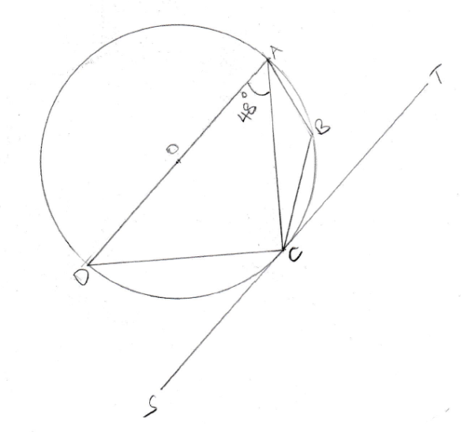
(a) Giving reasons find the size of
(i) <DCS (2marks)

(ii) <ABC (2marks)

(iii) <BCA (2marks)

(b) Calculate the length of line to 1d.p
i).AC (2marks)

ii) CN the perpendicular bisector of AD from C (2marks)
18. In the figure below OA = a, OB = b, AC=3CB and X is the mid –point of OC.

O
A
B
C
X
M
- Express in terms of a and b
- BC ( 1mark)

- OC ( 2 marks)

- AX ( 2 marks)

- Given that AX is produced to M so that AX =7XM.Show that O,M and B are collinear. (4 marks)

- Find the ratio in which m divides OB. (1 mark)

19. Two towns A and B lie on the same latitude in the northern hemisphere. When it is 8am at A, the time at B is 11.00 am.
a) Given that the longitude of A is 150 E find the longitude of B. (3marks)

b) A plane leaves A for B and takes 31/2 hours to arrive at B traveling along a parallel of latitude 850km/h. Find:
(i)The latitude of the two towns (take radius of the earth to be 6371km) (4marks)

(ii) The radius of the circle of latitude on which towns A and B lie. (3marks)

20. The figure alongside shows a right pyramid VPQRS which stands on a rectangular base PQRS. Side PQ = 12 cm, QR = 9 cm and each slant height of the pyramid is 20 cm long.
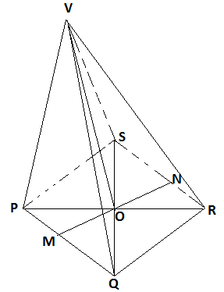
(a) Calculate to 4 significant figures
i) The length of PR (1 mark)

ii)The vertical height of the pyramid (2marks)

iii)The volume of the pyramid (2marks)

(b) M and N are the mid-points of PQ and RS respectively. Calculate to 2 decimal places
- The length of the line VM (2 marks)

- The size of the angle between the planes VPQ and PQRS (3 marks)

21. The table below shows the masses measured to the nearest Kg of 100 people.
Mass kg | 40-49 | 50-59 | 60-69 | 70-79 | 80-89 | 90-99 | 100-109
No of people | 9 | 19 | 22 | 18 | 13 | 11 | 8
- Draw a cumulative frequency curve for the data above. (4 marks)

Use your graph to estimate
- The median mass. (1 mark)
- The number of people whose mass is above 70.5kg (1 mark)
- The range of mass that are in the middle 80% of the people. ( 3 marks)
22. A cupboard has 7 white cups and 5brown cups all identical in size and shape.
There is a blackout in the town and Mrs. Bett has to select three cups one after another
without replacing the previous ones.
- Draw a tree diagram to represent the information. (2 marks)

(b) Calculate the probability that she chooses;
(i) Two white cups and one brown cup. (2 marks)

(ii) Two brown cups and one white cup. (2 marks)

(iii) At least one white cup. (2 marks)

(iv) three cups of the same color. (2 marks)

23. The velocity of a particle moving in a straight line after t seconds is given by v=3+5t-2t²
Calculate;
(a)The acceleration of the particle after 4 seconds (3marks)

(b)The distance covered between t=2seconds and t=4 seconds (4marks)

(c)The time the particle is at rest (3marks)

24. The equation of a curve is given by $y=1+2Sin x$.
a) Complete the table below for $y=1+2Sin x$ ( 2 marks)
$$x$$ | 0 | 30 | 60 | 90 | 120 | 150 | 180 | 210 | 240 | 270 | 300 | 330 | 360
$$y=1+2Sin x$$ | 1.0 |  |  |  | 2.7 |  |  | 0 |  | -0.7 |  |  | 1.0
b.i) On the grid provided, draw the curve of $y=1+2Sin x$,for $0^{0}≤x ≤{360}^{0}$ ( 3 marks)

ii) State the amplitude of the curve. (1 mark)
c) On the same grid, draw the graph of $y=\tan{x}$ for ${90}^{0}≤x≤{270}^{0}$ (3 marks)

d) Use the graphs to solve the equation $\tan{x-2\sin{x=1}}$ (1 Mark)

