MUMIAS WEST JET
TERM 1 – JUNE 2022
FORM 4 - MATHEMATICS PAPER 1

MARKING SCHEME

NO. | WORKING | MARKS | COMMENTS
1 | 5 x6 +(-76) $÷$ 4 +27$÷3$  -15$÷ 3$x (-4)  = 30 + (-19) + 9  -5 x-4  = $\frac{20}{20}$= 1 | M1  M1  A1 3 | For numerator  For denominator
2 | 2268= 2² x 3⁴ x 7  X = 2² x3⁴ x 7² = 7  2² x3⁴ x7 | B1  M1 A1  3
3 | Amt in Ksh = 5000 x 114.2  = 571000  Remainder = 571000-276100  = 303900  Amt in Euros = 303900  101.30  = 3000 Euros | M1  M1  A1  3
4 | 2x² + 3x -2 = (2x -1)( x+ 2)  X³-4x x( x² -4)  = (2x -1)( x+ 2)  x( x -2)( x + 2)  = 2x - 1  X( x- 2) | M1  M1  A1  3 | Factorizing numerator  Factorizing denominator  Simplified expression
5 | 179 - 3 = 176  234 – 3 = 231  176 = 2⁴ x 11  234 = 3 x 7 x 11  GCD = 11  Number of pieces = $\frac{176}{11}$ + $\frac{231}{11}$  = 16 + 21  = 37 | B1  M1  A1  3 | For GCD
6 | - - $\left(\frac{1}{3}\right)$^{n} = $\frac{242}{243}$  $\left(\frac{1}{3}\right)$^{n} = 1 - $\frac{242}{243}$  = $\frac{1}{243}$  $\left(\frac{1}{3}\right)$^{n} = $\left(\frac{1}{3}\right)$⁵  $∴$ n =5 | M1  M1  A1  3
7 | $\frac{4-y}{4}$ - $\frac{9-2y}{3}= \frac{1}{2}$  3(4-y) – 4(9-2y) =6  12-3y -36 +8y = 6  5y =30  Y=6 | M1  M1  A1 3 | For removal of denom.  - Opening of brackets  c.a.o.
8 |  | B1  B1  B1  B1 4 | For locus (i)  For locus (ii)  For locus (iii)  For the region
9 | $\frac{1}{0.325}$ = $\frac{1}{3.25×{10}^{-1}}$  = 0.3077$×{10}^{1}$  = 3.077  $\frac{\sqrt{0.25}}{0.325}$ = 0.5$×3.077$  = 1.5385  = 1.5 | B1  M1  A1 3 | For reciprocal with evidence of working
10 | External area = 20.1 × 2.2 = 44.22  Internal area = 19.1 × 1.2 = 22.92  Area of path = 44.22 – 22.92  = 21.3 $m^{2}$ | M1  A1  2 | 0.5  0.5
11 | $× + ×$ +60 = 180$°$  2X = 120˚  X = 60˚  Exterior =60  No. of sides = $\frac{360}{60}$  = 6 sides | M1  M1  A1 3
12 |  | B1  B1  B1  3 | Sides  Broken lines  Shape of solid
13 | Total = 42×24 = 1008  Total with abs = 1008-65  = 943  Average = $\frac{943}{23}$ =41 | M1  M1 A1  3
14 | $γ$= $\frac{2x}{3}$ + $\frac{2}{3}$  Gradient = $\frac{-3}{2}$  $\frac{γ-2 }{x--3}$ = $\frac{-3}{2}$  2($γ$-2) = -3(x+3)  2$γ$ – 4 = -3x – 9  3x + 2$γ$ = -5 | B1  M1  A1 3
15 | B = $A^{2}$ + $C^{-1}$  = $\left(\begin{matrix}4 & 3 \\ -1 & 2\end{matrix}\right)$ $\left(\begin{matrix}4 & 3 \\ -1 & 2\end{matrix}\right)$ + $\left(\begin{matrix}-2 & -7 \\ 1 & 3\end{matrix}\right)$  = $\left(\begin{matrix}13 & 18 \\ -6 & 1\end{matrix}\right)$ + $\left(\begin{matrix}-2 & -7 \\ 1 & 3\end{matrix}\right)$  = $\left(\begin{matrix}11 & 11 \\ -5 & 4\end{matrix}\right)$ | B1  M1 M1  A1  4 | For $c^{-1}$  - Squaring A  - Addition
16 | - AC = 7.2km  - Bearing 273˚ | B1  B1  B1  B1  4 | For B  For C
17a  b  c  d | X = 100-78  = 22  Modal class 35-44  x $$f$$ $$cf$$ $$d$$ $$fd$$  15-24 19.5 6 6 -40 -240  25-34 29.5 14 20 -30 -420  35-44 39.5 24 44 -20 -480  45-54 49.5 14 58 -10 -140  55-64 59.5 22 80 0 0  65-74 69.5 10 90 10 100  75-84 79.5 6 96 20 120  85-94 89.5 4 100 30 120  100 -940  Median = 44.5 + $\frac{50-44}{14}$ × 10  = 44.5 + $\frac{6}{14}$ × 10  = 44.5 + 4.29  = 48.79  Mean = $\frac{∑fd}{Σ_{f}}$ + A  = 59.5 - $\frac{940}{100}$  = 50.1 | M1  A1  B1  B1  B1  B1  M1  A1  M1  A1  10 | For vcf  For $fd$  For $\sum{fd}$ = -940

17 | a)  x = 5  x + 12 10  10x = 5x + 60  5x = 60  X = 12  L = 24² + 10² = 26  1/26 = 5/10  L = 13  Slant height 26 – 13  = 13  b) Curved area of the frustum  S.A = RL - rl  =  (260 – 65)  = 612.6  c) Volume of the frustrum  1/3  (R²H – r²h)  = 1/3  (2400 – 300)  = 1/3  (2100)  = 2200 cm² | M1  M1  A1  M1  M1  A1  M1M1M1  A1 | When 13 is seen  Both reas correct  -
 | Total marks | 10
18 | - 1 1/2 x 80  = 120km  - 120 – 50  = 40  - Time taken  $\frac{120}{40}$  = 3hrs  8.300 + 3  11.30A.m  - 3 x 120  = 360km  - 600 – 360 = 240km | M1  A1  M1  A1  M1  A1  B1  M1  A1  B1 | For 11.30am  For 240
 | Total marks | 10
19 | Class Tally Frequency Mid point Fx Cf  145 – 149 150 – 154 155 – 159 160 – 164 165 – 169 170 – 174 175 - 179 11 1 1 11 11 111 2 1 11 5 7 7 3 147 152 157 162 167 172 177 294 152 1727 810 1169 1204 531 2 3 14 19 26 33 36  Fx²  5887  b) i) 5887  36  = 163.53  ii) 159.5+$\left(\frac{\frac{36}{2}-14}{11}\right)$5  = 159.5 + 1. 8182  = 161 . 32  - Graph | B1  B1  B1  B1  A1  M1  A1  B1  B1 | classes  frequencies  (all Tallies)  Fx (frequency)  X midpoints  Cumulative  Frequency (c.f)  Plotting  curve  (No hanging curve. Not drawn by use of free hand)
 | Total marks | 10

20 |  | . a) i) 16200  Y  ii) 16 200 or 16 200 – 60  y + 3 y  b) i) 16 200 – 16 200 = 60  y y + 3  60y² + 180y – 48 600 = 0  Y² + 3y – 810 = 0  (y + 30) ( y – 27) = 0  = 27 or -30  = y = 27  ii) 16200 = Ksh 540  30  iii) 15 x 16 200  100 27  = Ksh 90 |  | B1  B1  M1  M1  M1  A1  M1A1  M1  A1 |  |  | Simplifying and removing brackets  Factors equated to zero  Evidence of discrimation of -30 seen
21 |  | c)$1/2×8×8.2=32.8Cm^{2}$ |  | B1  B1  B1  B1  B1  B1  B1  M1A1 |  |  | 600 constructed locating point A  Dropping a  Length the  8.2 + 0.1  For a line at an angle to BC  For joining C to the last point  For locating point D  ( following through)
 |  | Total marks |  | 10
22 |  | - I) BN = BA + AN  = -a + 5/6 b  = 5/6b – a  ii) CM = -b + 2/5a  = b + r ( ²_{/5}a - b)  - AX = b + rCM  = b – rb + ²/₅ra  = ( 1 – r) b + ²_{/5}ar  Ax = a + k ( ⁵/₆b – a)  ( 1 – k)a + ⁵/⁶kb  ii) ( 1 – r) b + ²/₅ar = ( 1 -k) a + ⁵/6kb  ⁵/₆K = 1 – r – ( i)  ²/₅r = 1 – k -- (11)  K = ⁶/₅ – ⁶/₅r  2/5 = 1- ( ⁶/₅ – ⁶/₅r) = 1 – ⁶/₅ + ⁶/₅r  -4r = -1 = 7 r = ¼  ⁵/₆K = ¾  K = ⁹/₁₀ |  | B1  B1  M1  M1  M1  M1  Al |  |  | Equating two values of AX.  Two equations extracted
 |  |  |  | 10marks
23 |  |  | 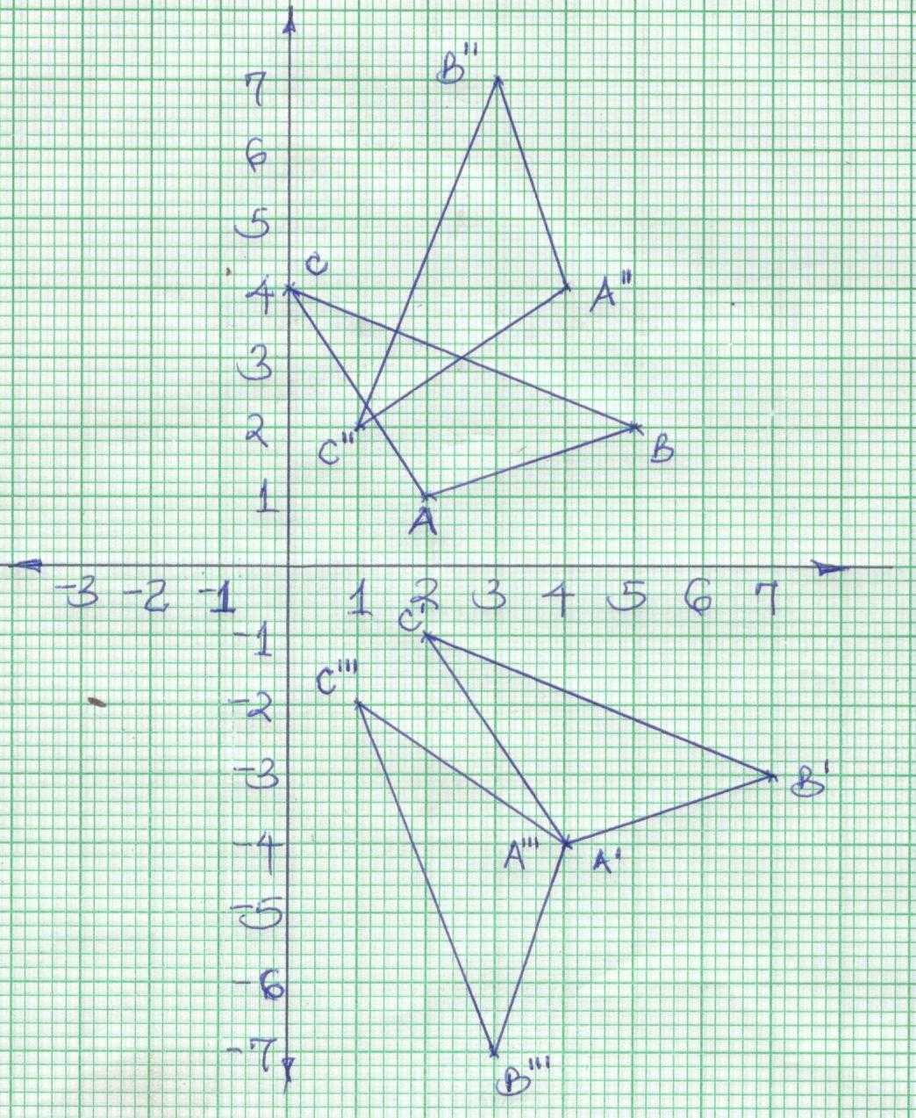  (b) A¹(4,-4) B¹(7,-3) C¹(2,-1)  (c) A¹¹(4,4) B¹¹(3,7) C¹¹(1,2)  (d) A¹¹¹(4,-4) B¹¹¹(3,-7) C¹¹¹(1,-2) |  | B1  B1  B1  B1  B1  B1  B1  B1  B1  B1 | For plotting  For ∆ABC  For ∆A¹B¹C¹  For construction or otherwise  For ∆A¹¹B¹¹C¹¹  For construction or otherwise  For ∆A¹¹¹B¹¹¹C¹¹¹
24a)  b)  c)  d) | S = t (t² – t – 2t + 2)  = t³ – 3t² + 2t  ds = 3t² – 6 (2) + 2  dt  V = 3 ( 4) - 6 ( 2) + 2  V = 2m/s  dv = 0  dt  dv = 6t – 6  dt  6t – 6 = 0  t = 1  = 3( 1)² – 6(1) + 2  = -1m/s  3t2 – 6t + 2 = 0  T = 6 + (-6)² – 4 ( 3) ( 2)  T = 6 + 3.464  T = 1.577 or 0.4227  a = 6 ( 3) – 6 = 12m/s² |  |  |  |  |  | B1  M`  A1  M1  M1  A1  M1  A1  B1
 | Total marks |  |  | 10

This is the last printed page

