121/2 MATHEMATICS PAPER 2 MARKING SCHEME DECEMBER EXAM 2021

Qn | Workings | Marks | Comments
1. | b² = 4ac  5² = c + 2  25 = c + 2  c = 23 | M1  A1 | Correct expression in C
 |  | 02
2. | Truncated = 0.777  Rounded off = 0.778  A.E = 0.778 – 0.777 = 0.001  % E = x 100  = 0.12870012870012870012870012870013 | B1  M1  A1 | For both values correct  Expression for % Error  Allow 0.1287
 |  | 03
3. | 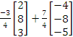 =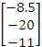  P(-8.5, -20, -11) | M1  A1  B1 | Expression  Correct matrix  Co-ordinate form
 |  | 03
4. | 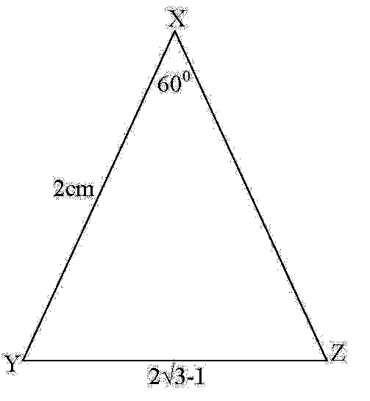  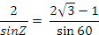  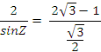  x | M1  M1  M1  A1 | Correct substitution in sine rule  Surd form for sin 60⁰  Correct attempt to rationalize  CAO
 |  | 04
5. | (x³)⁶ -6 (x³)⁵ + 15 (x³)⁴² - 20 (x³)^{33 . . .}  - 20 (x³)³³  - 20 x 8 =  - 160 | M1  M1  A1 | Expansion up to the 4th term  Correct attempt to simplify  Constant term stated
 |  | 03
6. | Let log₃x = y  2y² – y – 3 = 0  (2y – 3)(y + 1) = 0  y = -1 or y = 1 ½  if log₃x = -1, x = 3⁻¹ = ¹/₃  if log₃x = 1 ½ , x = 3^{1.5} = 5.196 | M1  A1  B1 | Quadratic equation formed  For both correct  For both correct
 |  | 03
7. | P = cp – d = 13800 – 2280 = 11520  I = 11520 x 20 x 2/100= 4608  A = P + I = 11520 + 4608 = 16128  MI= 16128 ÷ 24  = 672 | M1  M1 A1 | Expression for simple interest  Expression for MI
 |  | 03
8. | 2ax + x² = 3v  x² + 2ax – 3v = 0  x2 + 2ax +a² = 3v + a²  √(x + a)² = √(3v +a²)  x + a = ±√(3v +a²)  x = -a ± √(3v +a²) | M1  M1  A1 | Formation of quadratic equation  Completing the square  Correct attempt to solve
 |  | 03
9. | A= 1(14.75 +26.75+77.75+68.75+98.75)  = 253.75 square units | B1  M1  A1 | Correct values of mid-ordinates  Expression for area
  x | 1.5 | 2.5 | 3.5 | 4.5 | 5.5
  y | 14.75 | 26.75 | 77.75 | 68.75 | 98.75
 |  | 03
10. | 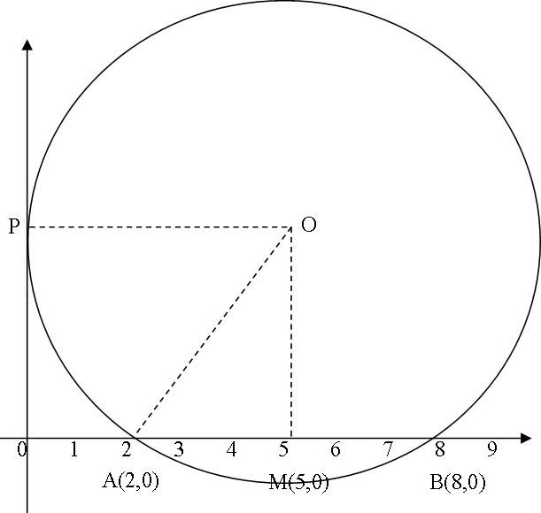  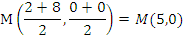  OA = OP = 5 units  AM = 5 – 2 = 3 units  OM = √(5² – 3²) = 4 units  C(5,4) , r = 5  (x – 5)² + (y – 4)² = 5²  x² – 10x + 25 + y² – 8y + 16 = 25  x² + y² -10x - 8y + 16 = 0 | M1  M1  M1  A1 | Expression for midpoint  Radius, r  Expression for OM  Correct substitution  Correct expanded form
 |  | 04
11. | 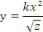  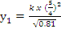 = 1.736k  % change = | M1  M1  A1 | Correct substitution  Expression for percentage change
 |  | 03
12. | 3sin²x – sin x – 2 = 0  Let sin x = y  3y² - y -2 = 0  (3y + 2)(y – 1 ) = 0  y = 1 or y = ⁻²/₃  sin⁻¹(1) = 90⁰  sin⁻¹(⁻²/₃) = 221.8⁰, 317.8⁰  x = 90⁰, 221.8⁰, 317.8⁰ | M1  M1  A1  B1 | Quadratic equation formed  Correct attempt to solve  For both  All values correct
 |  | 04
13. | i) k + 2k + 3k + 4k + 5k + 6k = 1  21k = 1  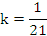  ii) P(5&6) 0r P(6&5)  ( | B1  M1  A1 | Addition of probabilities (allow for any correct)  Allow
 |  | 03
14. | (a) Let VU = x  8(8 + x) = 12²  8x = 144 – 64 =80  x = 10  b) VX =  XU =  XT = 6 + 8 = 14  SX = √(14² – 12²) = 7.211 | B1  M1  A1 | x = 10  Expression for XT
 |  | 03
15. | Q₁ =  Q₃ =  Quartile deviation = | B1  M1  M1  A1 | Cf  Q1 and Q3  Expression for quartile deviation  Allow 16.47
  h | 10-19 | 20-29 | 30-39 | 40-49 | 50-59 | 60-69 | 70-79
  f | 9 | 16 | 19 | 26 | 20 | 10 | 4
  cf | 9 | 25 | 44 | 70 | 90 | 100 | 104
 |  | 04
16. | 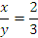  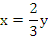  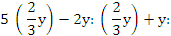  = 4:5 | M1  A1 | Correct substitution
 |  | 02
17. | (a) (i) x-intercept  x²(2x + 3) = 0  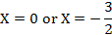  (ii) y-intercept  When x =0, y = 0  (b) (i) Stationary points of curve  = 0  6x(x + 1) = 0  x = 0 or x = -1  stationary points (0,0) and (-1,1)  (ii)  maximum point (-1, 1), minimum point (0,0)  iii)  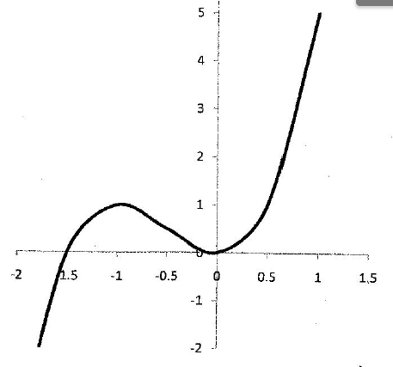 | M1  A1  B1  M1  A1  B1  B1  B1  B1  B1  B1 | Factorized form  Both correct  Both correct  Derivative equated to zero  Attempt to solve  For both  Checking points  For both  Points plotted (-1.5,0), (-1,1), (0,0)  Smooth curve
  x | -2 | -1 | -0.5 | 0 | 1
   | 12 | 0 | -1.5 | 0 | 12
  sketch
18. | a) (i)  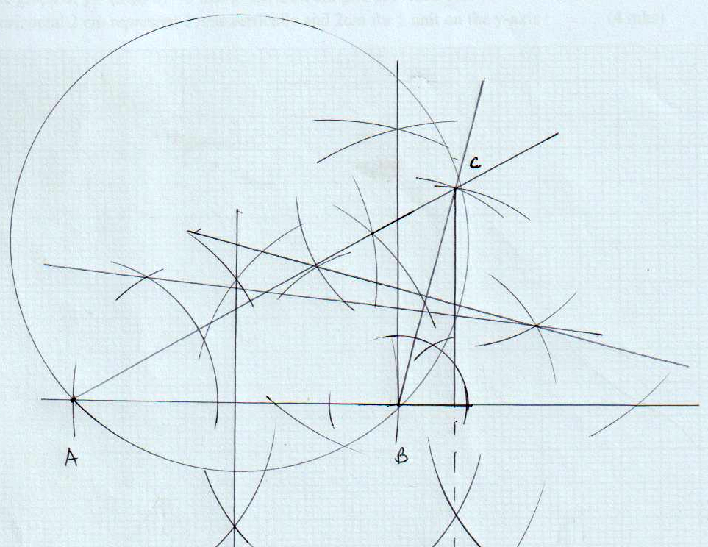  ii)  r = 5.2cm ± 0.1  iii)  h = 5cm ± 0.1  b) area of circle – area of triangle  = 84.98 – 21.25  = 63.73cm² | B1  B1  B1  B1  B1  B1  B1  B1  M1  A1 | Construction of 30⁰  Construction of 105⁰  Complete triangle, well labeled  Line bisectors  Complete Circle drawn  radius  height dropped  follow through for r and h ± 0.1
 |  | 10

19 | 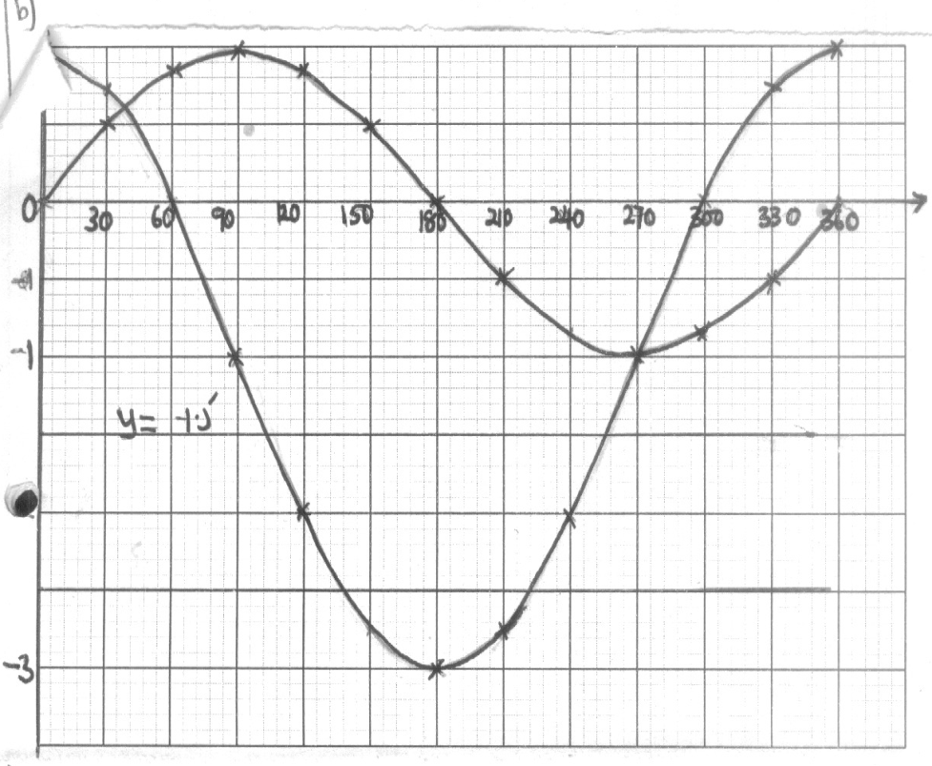  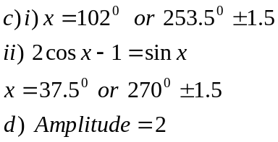 | B1  B1  S1  P1  C1  C1  B1  B1  B1  B1 | Scale  Plotting for both  Smooth curve
  x | 0 | 30 | 60 | 90 | 120 | 150 | 180 | 210 | 240 | 270 | 300 | 330 | 360
  2cosx-1 | 1 | 1.73 |  | -1 |  | -2.73 |  | -2.73 |  |  |  | 0.73 | 1
  sinx |  | 0.50 | 0.87 |  | 0.87 |  |  | -0.50 | -0.87 |  | -.087 | 0.50 | 0
20. | a) i) 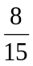  ii) 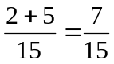  b)i)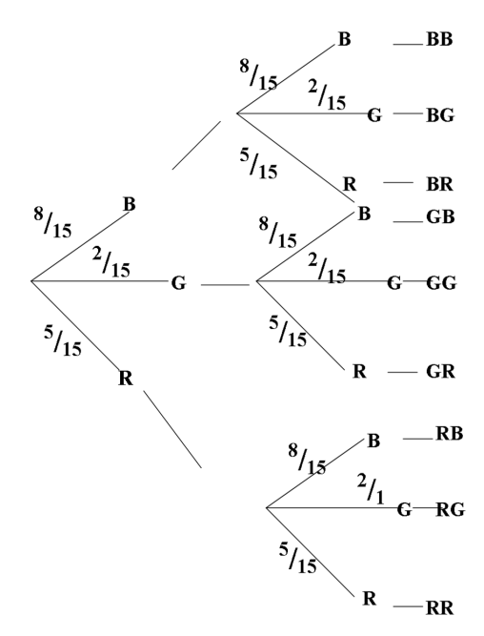  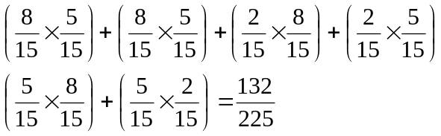  ii)  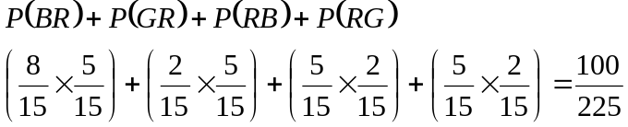 | B1  M1  A1  B1  M1  M1  M1  A1  M1  M1  A1 | Tree diagram draw with probabilities indicates  ✓1 probability  Addition of the probability  ✓ probability  Addition
 |  | 10
21. | (a)(i)  Distance =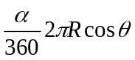  =longitude difference  =40+140=180⁰  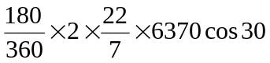  =17,337.8Km  b) =602  =1200  Distance =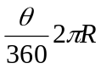  =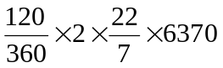  =13,346.7km  (c) A(30⁰N,40⁰N)  B(30⁰W,140⁰E)  Difference in longitude=140+40  =180⁰  1⁰=4min  180=?  1804=720minutes  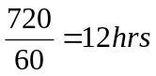  8.00+12.00=20.00  =12.00hrs/8.00pm | 10  B1  M1  A1  M1  A1  M1  A1  M1  M1  A1 | For 180º
 |  | 10
22. | c) i) Q₃ = 19.25, Q₁ = 17.15  ½ (Q₃ – Q₁) = ½ (19.25 – 17.15)  = 1.05  ii) 13cm - - 15.2, 17cm - - 15.8  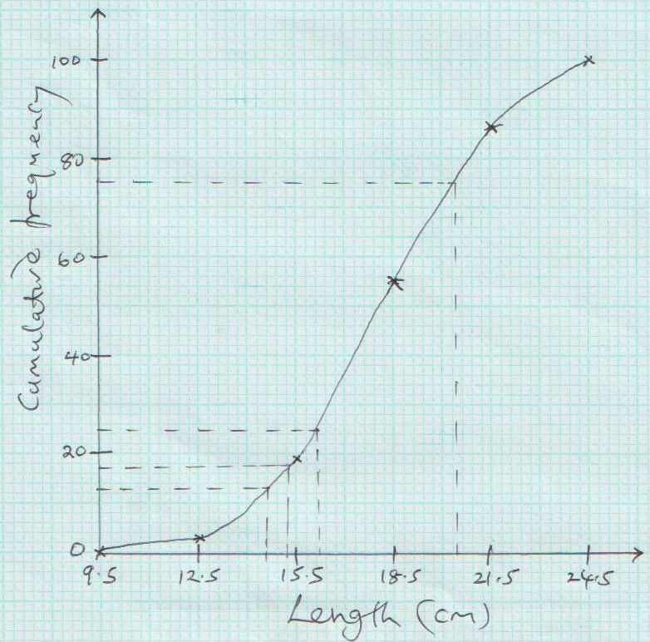  15.8 – 15.2 = 0.3 | B2  B1  S1  P1  C1  B1  M1  A1  B1  B1 | All values correct  At least 4 values correct  Q₃ & Q₁ correct  Correct cf values
  Length in cm | 9.5-12.5 | 12.5-15.5 | 15.5-18.5 | 18.5-21.5 | 21.5-24.5
  No. of leaves | 3 | 16 | 36 | 31 | 14
  cf | 3 | 19 | 55 | 86 | 100
 |  | 10
23. | 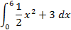  Error: 54.5-54=0.5  = | B2  M1  A1  M1  M1  A1  B1  M1  A1
  x | 0 | 1 | 2 | 3 | 4 | 5 | 6
  y | 3 | 3.5 | 5 | 7.5 | 11 | 15.5 | 21
 |  | 10
24. | a)  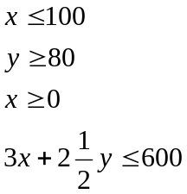  b)  300  250  200  150  100  50  50  100  150  200  250  300  0  - Objective function 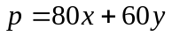  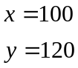 | B1  B1  B1  B1  B1  B1  B1  B1  B1  B1 | For each correct inequality  For each correct line drawn
 |  | 10

