**NAME: ……………………………………………… ADM: ………….. CLS: ………**

**FORM FOUR END OF TERM 1 YR 2021 EXAM**

**MATHEMATICS**

**Paper 2**

**121/2**

**Time 2 ½ Hours**

**Instructions to candidates**

1. Write your name and admission number in the spaces provided above.
2. This paper consists of two sections: **Section I** and **Section II**.
3. Answer all the questions in **Section I** and only ***ﬁve*** questions from **Section II**.
4. **Show all the steps in your calculations, giving your answers at each stage in the spaces provided below each question.**
5. Marks may be given for correct working even if the answer is wrong.
6. **Non-programmable** silent electronic calculators **and** KNEC Mathematical tables may be used, except where stated otherwise.

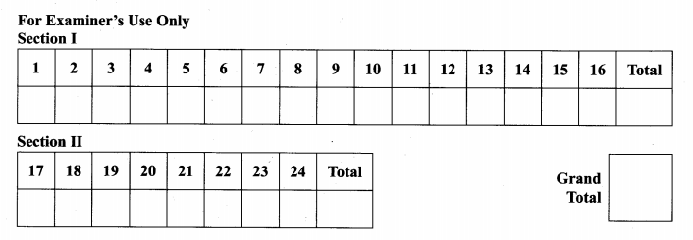

**SECTION 1 (50 marks) Answer all questions in this section**

1. Use logarithms to evaluate , (4marks)

2. Make d the subject of the formula (3marks)

$a^{2}=\sqrt{\frac{1-d^{2}}{b^{2}}-\frac{b}{3}}$

1. Simplify the following surds leaving your answer in the form a+ b $\sqrt{c}$

(3marks)

4. (a) Expand the binomial expression 4 up to the third term. (1mark)

(b) Use the expansion above (where x > 1) to estimate the value of (99)4 to 3 s.f.

(2marks)

5. A(3,2) and B(7,4) are points on the circumference of a circle. Given that chord

AB passes through the centre of the circle determine the equation of the circle.

(4marks)

6. Without using logarithms tables of calculator: Evaluate. (3marks)

+ –

7. Solve for x given that the following is a singular matrix. (3mks)

8. The sides of a triangle were measured and recorded as 8.4 cm, 10.5 cm and

15.32 cm . Calculate the percentage error in it’s perimeter 2d.p. (3marks)

9. Given that 64, b, 4…. are in continued proportion, find the value of b. (3marks)

10. The figure below shows a circle centre O. AB and PQ are chords intersecting

externally at a point C. AB=9cm, PQ=5cm and Qc =4cm, find the length BC.

(3marks)

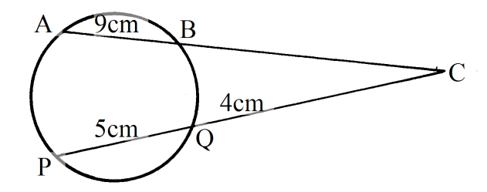

11. Two variables x and y are such that y varies directly as xn where n is a

constant. Given that y=320 when x=16 and y = 2560 when x = 64. Find the value

of n. (3marks)

12. A man sold a motor cycle at 84000. The rate of depreciation was 5% per

annum. Calculate the value of the motor cycle after 3 years to 1d.p. (3marks)

13. Vector **r** has a magnitude of 14 and is parallel to vector **s**. Given that

**s** = 6**i** – 2**j** +3**k**, express vector **r** in terms of **i, j** and **k**. (3marks)

14. Solve for x in the range 0 ≤ x ≤ 3600

If 2sin2x + sin x – 1=0 (4marks)

15. The prefects body of a certain school consists of 7 boys and 5 girls. Three

prefects are to be chosen at random to represent the school at a certain function

at Nairobi. Find the probability that the chosen prefects are boys. (2mks)

16. A trigonometric function is given as (4mks)

y = 0.5 cos (2x – 40)0

Determine (a) Amplitude

(b) Period

(c) Phase angle

***SECTION B(50 MARKS)***

***Answer any five questions from this section in the spaces provided.***

17. (a) (i) Taking the radius of the earth, R=6370km and $π=\frac{22}{7}$, calculate the

shortest distance between two cities P(600N, 290W) and Q(600N, 310E) along

the parallel of latitude. (3marks)

(ii) If it is 1200hrs at **P**, what is the local time at **Q** (3marks)

(b) An aeroplane flew due south from a point A(600N, 450E) to a point B, the

distance covered by the aeroplane was 8000km, determine the position of B.

(4marks)

18. The diagram below shows a square based pyramid **V** vertically above the

middle of the base. PQ=10cm and **VR**=13cm. **M** is the midpoint of **VR.**

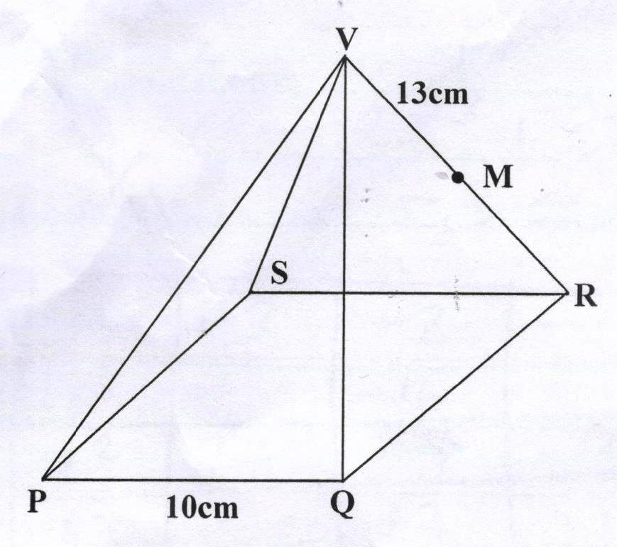

Find

(a) (i) the length **PR.** (2marks)

(ii) the height of the pyramid (2marks)

(b) (i) the angle between **VR** and the base **PQRS** (2marks)

(ii) the angle between **MR** and the base **PQRS**  (2marks)

(iii) the angle between the planes **QVR** and **PQRS**. (2marks)

19. Complete the following table for the equation

y = 2x3 + 3x2 –6x –4 for the values –3≤ x ≤ 2 (2marks)

|  |  |  |  |  |  |  |
| --- | --- | --- | --- | --- | --- | --- |
| x | -3 | -2 | -1 | 0 | 1 | 2 |
| 2x3 |  | -16 |  | 0 | 2 | 16 |
| 3x2 | 27 |  | 3 | 0 |  | 12 |
| -6x |  | 12 |  | 0 |  | -12 |
| -4 | -4 | -4 | -4 | -4 | -4 | -4 |
| y |  | 4 |  | -4 |  | 12 |

On the grid provided draw the graph of y=2x3 + 3x2 – 6x – 4 (3marks)



c)By drawing a suitable straight lines use your graph to solve the equations

(i) 2x3 + 3x2 – 4x – 2 =0 (2marks)

(ii) 2x3 + 3x2 – 6x – 4 =0 (3marks)

20. The diagram below shows a triangle **OPQ** in which **M** and **N** are points on **OQ**

and**PQ** respectively such that **OM**= $\frac{2}{3}$**OQ** and **PN** = $\frac{1 }{4}$**PQ**. Lines **PM** and **ON**

meets at **X.**

P

N

Q

O

M

X

(a) Given that **OP** = **p** and **OQ**= **q** express in term of **p** and **q** the vectors.

(i) **PQ** (1mark)

(ii) **PM** (1marks)

(iii) **ON** (1marks)

(b) You are further given that **OX**=**KON** and **PX**=**hPM**.

(i) Express **OX** in terms of P and q in two different ways. (2marks)

(ii) Find the value of h and **K**. (4marks)

(iii) Find the ratio **PX**:**XM** (1mark)

21. In the figure below , O is the centre of the circle.PQR is a tangent to the circle

at Q. Angle PQS=280, angle UTQ=540 and UT=TQ

P

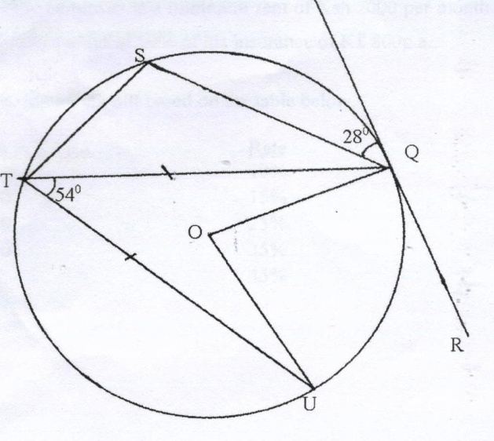

Giving reasons, determine the size of

(a) Angle STQ (2mks)

(b) Angle TQU (2mks)

(c) Angle TQS (2mks)

(d) Reflex angle UOQ (2mks)

22. Mr. Kimutai a teacher from Tuiyotich Secondary School earns K£12000 per

annum and lives in a house provided by the employer at a minimum rent of

Ksh2000 per month. He gets a family relief of K£1320p.a and is entitled to a

relief of 10% of his insurance of K£800p.a.

(a) Calculate his annual tax bill based on the table below. (6mks)

Income slab in k£p.aRate

1 – 2100 10%

2101 – 4200 15%

4201 – 6300 25%

6301 – 8400 35%

Over 8400 45%

(b) Kimutai other deductions include.

* W.C.P.S = sh600.00pm
* NHIF = sh500.00pm

Calculate Kimutai’s net salary monthly. (4mks)

23. (a) Use the mid-ordinate rule with five strips to estimate the area bounded by the curve y = x2 +1, the x–axis, lines x=1 and x=6 (4mks)

(b) Find the exact area of the region in (a) above (3mks)

(c) Calculate the percentage error in area when mid-ordinate rule is used.

(3mks)

24. An arithmetic progression AP has the first term a and the common difference d.

(a) Write down the third, ninth and twenty fifth terms of the AP in terms of

a and d. (2mks)

(b) The AP above is increasing and the third, ninth and twenty fifth terms

form the first three consecutive terms of a geometric progression (G.P).

The sum of the seventh and twice the sixth term of AP is 78. Calculate

(i) The first term and common difference of the A.P (5mks)

(ii) The sum of the first 5 terms of the G.P (3mks)