**NAME: ……………………………………………… ADM: ………….. CLS: ………**

**FORM FOUR END OF TERM 1 YR 2021 EXAM**

**MATHEMATICS**

**Paper 1**

**121/1**

**Time 2 ½ Hours**

**Instructions to candidates**

1. Write your name and admission number in the spaces provided above.
2. This paper consists of two sections: **Section I** and **Section II**.
3. Answer all the questions in **Section I** and only ***ﬁve*** questions from **Section II**.
4. **Show all the steps in your calculations, giving your answers at each stage in the spaces provided below each question.**
5. Marks may be given for correct working even if the answer is wrong.
6. **Non-programmable** silent electronic calculators **and** KNEC Mathematical tables may be used, except where stated otherwise.

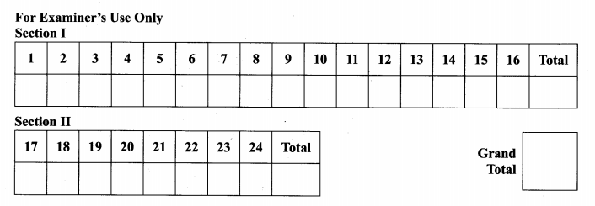

**SECTION 1 (50 marks) Answer all questions in this section**

1. Simplify without using a calculator. (3marks)

1 $\frac{4}{5}$ of $\frac{25}{18}$ ÷ 1 $\frac{2}{3}$ x 24

2 – of 12 ÷

2. Find the size of each interior angle of a regular pentagon. (3marks)

3. Find all the integral values of x which satisfy the inequalities. (3marks)

x + 8 > 4x –6 ≥ 3(4 –x)

4. Three types of tea A, B and C are mixed in the ratio 2:3:5 by mass. Type A, B

and C tea cost Ksh210, Ksh160 and Ksh120 respectively per kilogram. The

blend is to be sold at a 30% profit. Determine the selling price of the blend per

kilogram. (3marks)

5. Determine the radius of a uniform cylindrical block 1.4m long and of density of

2.2g/cm3 if the mass is 47432g (=) (3marks)

6. A boy whose height is 1.5 stands on the horizontal ground and observes that the

top of flag pole, 10m away, makes angle of elevation of 400. Calculate the height

of the flag post. (3marks)

7. Two similar cylinders have total surface areas of 45cm2and 20cm2. If the larger

has a mass of 81g . Find the mass of the smaller one. (3marks)

8. Find the values of x and y in (4marks)

23x +y x 34x–y = 648

9. Simplify the following expression. (3marks)

3x2 – 14xy – 5y2

3x2 – 75y2

10. Use tables of reciprocals and cubes to evaluate to four significant figures.

(3marks)

-

11. On Saturday October 15, 2017 the following were the buying and selling prices

of foreign currencies in a certain bank.

|  |  |  |
| --- | --- | --- |
|  | Buying(Ksh) | Selling(Ksh) |
| 1 Euro | 111.53 | 112.01 |
| 100 Japanese Yen | 97.32 | 97.70 |

A Japanese travelling from Sweden arrived in Kenya with X Euros. He

converted all the X Euros to Kenya shillings at the bank while in Kenya he

spent a total of kenya shillings 350000 and then converted the remaining

Kenya shillings to Japanese Yen at the same bank at the same rates. If the

Japanese received 32669396 Yen. Calculate the value of X. (3marks)

12. The GCD is 1620, 1800 and a third number is 180. The LCM of the three

numbers is 8100. Find the difference between greatest and smallest possible

third number. (3marks)

13. The position vectors of points A and B are $\left({6 \atop \begin{aligned}-2 \\ 9\end{aligned}}\right)$ and $\left({-9 \atop \begin{aligned}4 \\ 3\end{aligned}}\right)$ respectively, point C

divides AB externally in the ratio 5:2. Find the position vector of C. (3marks)

14. The average mark scored by the first 27 students in a mathematics test is 52.

The average mark scored by the remaining 37 is 58. Calculate the mean mark

for the whole class. (3marks)

15. Five years ago, a mother’s age was four times that of the daughter. In four

years to come, she will be 2 ½ times the age of her daughter . Calculate the sum

of their present ages. (3marks)

16. (a) Using a pair of compasses and a ruler only construct a triangle ABC and

such that AB=4cm, BC=6cm and angle ABC=1350. (2marks)

(b) Construct the height of triangle ABC in (a) above taking AB as the base,

hence calculate the area of triangle ABC. (2marks)

***SECTION II(50 MARKS) ATTEMPT FIVE QUESTIONS ONLY***

17. (a) In a safari rally drivers are to follow a route ABCD. B is 250km from A on a

bearing of 0750, C is on a bearing of 1100 from A and 280km from B. The

bearing C from D is 2200 and at a distance of 300km. By scale drawing,

show the relative position of ABC and D. (5marks)

(b) Determine

(i) the distance of A from C (1mark)

(ii) the compass bearing of B from C. (2marks)

(iii) The distance and the true bearing of A from D. (2marks)

18. The vertices of triangle PQR are P(2,4) Q(4,6) and R(5,1). The vertices of its

image under a rotation are P1(-3,-1) Q1(-5,1) and R1(0,2)

(a) (i) On the grid provided, draw PQR and P1Q1R1  (2marks)

(ii) By construction, determine the centre and the angle of rotation.

(3marks)

(b) On the same grid as in a (i) above, draw.

(i) TriangleP11Q11R11 the image of PQR under a reflection in the line

y=0 and state its coordinates. (2mks)

(ii) Triangle P111Q111R111 is the image of P11 Q11 R11 under an enlargement scale factor -1, centre(0,-4) and state its coordinates. (3marks)



19. A modern coast bus left Nairobi at 10.45 am and travelled towards Mombasa at

an average speed of 60km/h. A Nissan matatu left Nairobi at 1.15pm on the

same day and travelled towards Mombasa along the same road at an average

speed of 100km/h. The distance between Nairobi and Mombasa is 500km.

(a) Determine the time of the day when the Nissan matatu overtook the bus

(5marks)

(b) Both vehicles continued towards Mombasa at their original speeds. Find

how long the matatu had to wait in Mombasa before the bus arrived. (5marks)

20. Jane bought 3 bags of sugar and 5 bags of rice for a total of sh29, 750. Had she

bought 4 bags of sugar and 2 bags of rice she could have spent sh5250 less.

(a) Form two equations that represent the information above. (2mks)

(b) Calculate the cost of a bag of sugar and that of rice using the matrix

method. (4marks)

(c) Jane’s profit per bag of sugar was 18% while her profit per bag of rice was

30%

(i) Find the total amount that she received from her sales. (2marks)

(ii) Calculate her percentage profit from the sale of all the sugar and

rice. (2marks)

21. The following figure represents a dancing floor with a carpeted margin all

around of $\frac{2}{5}$ x wide leaving a dancing space of (x–3) cm by (x–3) cm.

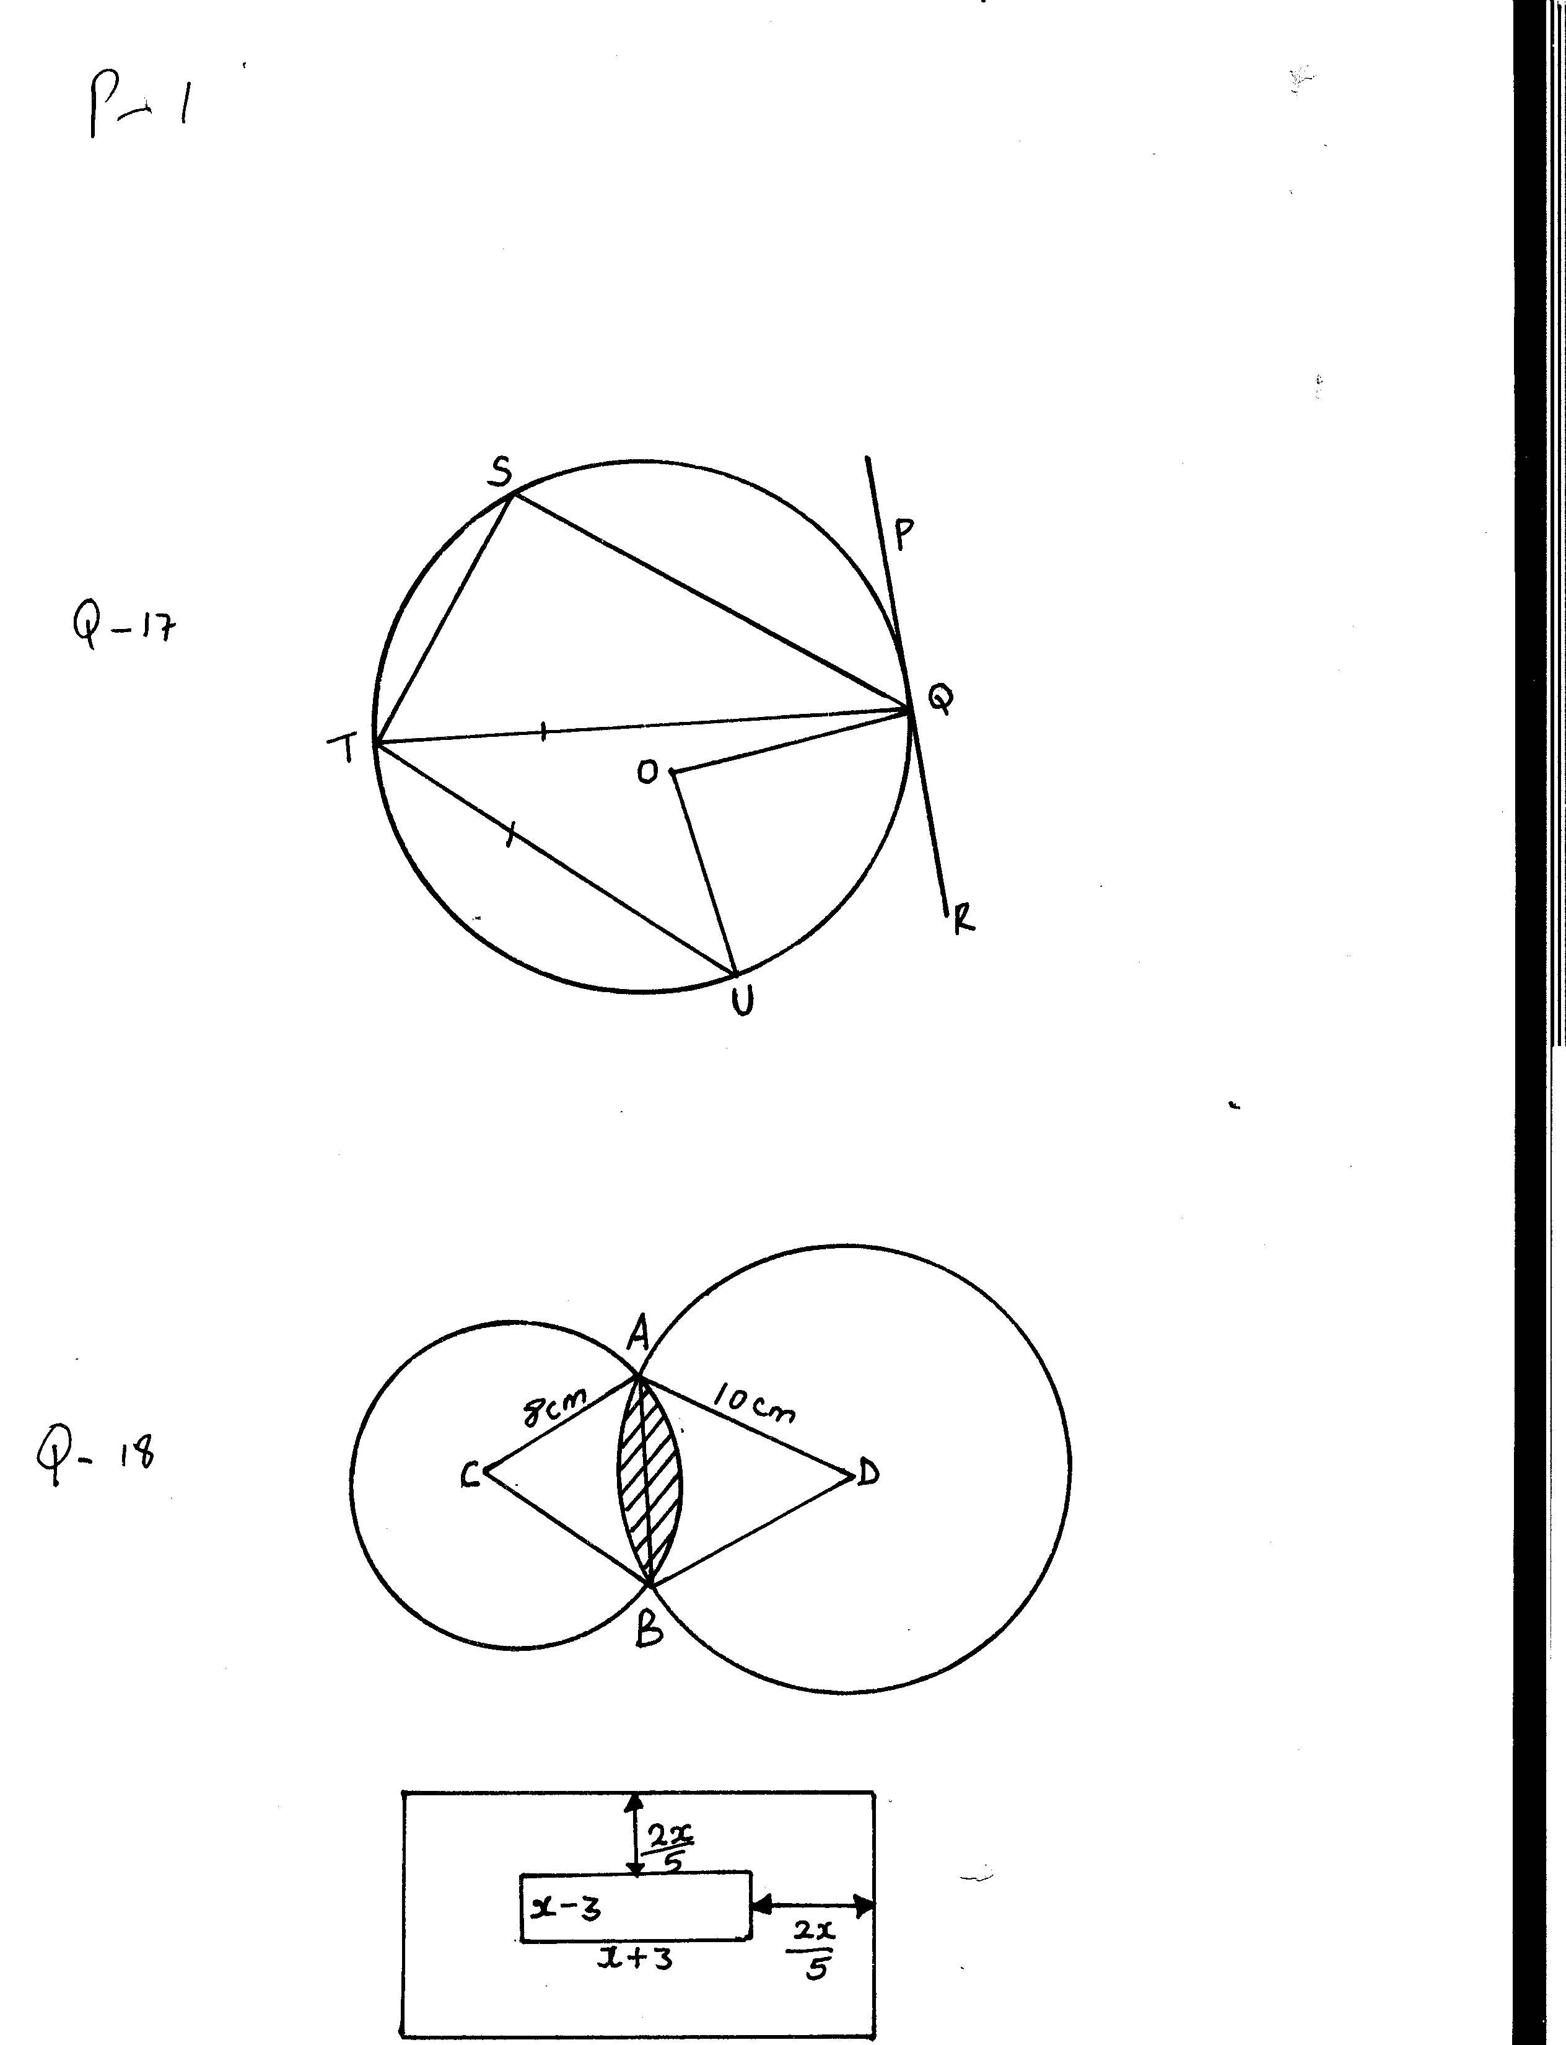

If the total area of the entire room is 315m2

(a) Calculate the value of x (5marks)

(b) Calculate the area of the carpeted margin (3marks)

(c) If the carpet cost sh750 per m2, calculate the total cost of the sealed

margin. (2marks)

22. A straight line L1 has a gradient – ½ and passes through point P(-1, 3). Another line L2 passes through the points Q(1,-3) and R(4,5). Find:

(a) The equation of L1 (2marks)

(b) The gradient of L2 (1mark)

(c) The equation of L2 (2marks)

(d) The equation of a line passing through a point S(0,5) and is perpendicular to L2 (2marks)

(e) The equation of a line through R parallel to L1 (2marks)

23. Triangle PQR is inscribed in the circle PQ=7.8cm, PR=6.6cm and QR=5.9cm.

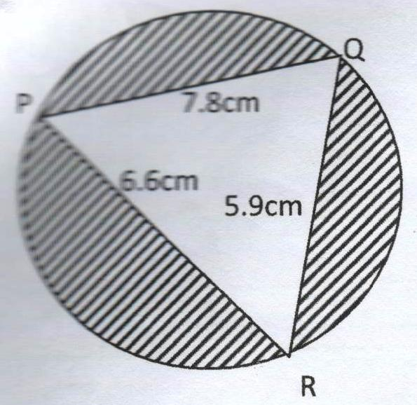

Find

(a) The radius of the circle, correct to one decimal place. (4marks)

(b) The angles of the triangle (2marks)

(c) The area of shaded region (4marks)

24. A particle travels in a straight line through a fixed point O. Its distance S

metres from O is given by

S=3t3 – 27t2 + 72t +4 where t is the time in seconds after passing O. Calculate

(a) It distance after 3 seconds (2marks)

(b) The value of t for which the particle is momentarily at rest. (3marks)

(c) The velocity of the particle when t=5 seconds. (2marks)

(d) The maximum velocity of the particle. (3marks)